# A study on the presentation dimension of cultural content in Chinese teaching materials from the perspective of intercultural communication theory

Yangyang Shao

Dalian Minzu University ,dalian,Liaoning,116605,China；

e-mail：15004116133@163.com

# 1. Introduction

With the accelerating pace of globalization, Chinese, as one of the world's major languages, has become increasingly prominent in international exchanges, economic cooperation, and cultural dissemination. According to the "China International Chinese Education Development Report (2024)", over 30 million people worldwide have enrolled in Chinese courses across more than 180 countries and regions. Language serves not only as a tool for communication but also as a carrier of culture. For Chinese learners, mastering linguistic knowledge is merely the first step in cross-cultural interaction. The ability to communicate appropriately and effectively in diverse cultural contexts ultimately depends on understanding and applying cultural connotations. Therefore, Chinese textbooks not only impart language knowledge but also play a crucial role in cultural transmission and the cultivation of intercultural competence.

Cross-cultural communication theory emphasizes that the ultimate goal of language learning extends beyond improving linguistic competence, but more importantly, it aims to cultivate learners 'ability to communicate effectively across diverse cultural contexts. Hall's High-context and Low-context Theory highlights how communicative patterns vary with contextual information levels in different cultures. Hofstede's Cultural Dimensions Theory reveals differences in values and behavioral patterns between cultures. Meanwhile, Byram's Intercultural Communication Competence Model underscores the organic integration of linguistic proficiency, sociolinguistic skills, cross-cultural attitudes, and knowledge. These theories provide a solid theoretical foundation for designing and presenting cultural content in Chinese language textbooks.

However, current Chinese language textbooks still exhibit shortcomings in cultural content presentation. Firstly, there are significant disparities in cultural coverage across different materials. Some textbooks emphasize the transmission of cultural knowledge while neglecting deeper cultural elements such as values and social customs. Secondly, their cultural presentations predominantly rely on static introductions, lacking comparative analysis with learners 'cultural backgrounds and dynamic application in communicative contexts. This situation not only hinders the development of students' intercultural communication skills but also diminishes the effectiveness of Chinese language international dissemination.

Building on this foundation, this study adopts a cross-cultural communication theory framework to establish analytical dimensions for cultural content presentation. Through systematic analysis of mainstream Chinese textbooks, we investigate the distribution patterns, presentation methods, and alignment with cross-cultural communication principles of cultural elements. The research specifically addresses three key questions: (1) What are the current presentation dimensions of cultural content in Chinese textbooks? (2) How do these dimensions differ in terms of distribution ratios and presentation approaches across materials? (3) Does the current presentation of cultural content align with the objectives of cultivating intercultural communication competence? This investigation aims to provide empirical evidence and theoretical references for textbook development and optimization, thereby better supporting the advancement of international Chinese education.

# 2. Literature review

## 2.1 Overview of cross-cultural communication theory

Cross-cultural communication theory, emerging as a significant interdisciplinary field since the mid-20th century through the convergence of linguistics, anthropology, and sociology, primarily examines cognitive patterns, communication strategies, and value differences among individuals across cultural contexts. Hall's (1976) High Context vs. Low Context Theory highlights that the degree of reliance on contextual information varies culturally: high-context cultures emphasize implicit meanings and nonverbal cues, while low-context cultures favor direct, explicit expressions. This framework provides a foundation for understanding implicit cultural elements in language learning.

Hofstede's Cultural Dimensions Theory (1980,2010) systematically reveals cultural differences through dimensions such as power distance, individualism versus collectivism, masculinity versus femininity, uncertainty avoidance, and long-term versus short-term orientation. This framework provides crucial insights for analyzing the presentation of cultural values and social norms in educational materials. Meanwhile, Byram's Intercultural Communicative Competence (ICC) model (1997) integrates language proficiency with cross-cultural attitudes, knowledge, and skills. It emphasizes that learners need not only linguistic competence but also the ability to comprehend, compare, and critically evaluate different cultures in intercultural communication.

In his 1993 study on the "third culture" concept, Kramsch proposed that language learners gradually develop cultural identity bridging their native culture and target culture through communication. This perspective provides a theoretical foundation for textbooks to facilitate cultural integration in content design. Overall, cross-cultural communication theory emphasizes the inseparability of language and culture, offering robust theoretical support for analyzing and optimizing cultural elements in Chinese language teaching materials.

## 2.2 Research status of cultural content in Chinese teaching materials

In recent years, with the rapid development of international Chinese education, cultural content in Chinese textbooks has gradually become a hot topic in academic circles. Existing research primarily focuses on aspects such as the types, distribution, presentation methods, and teaching functions of cultural content. For instance, Wang (2018) analyzed multiple mainstream Chinese textbooks and pointed out that the cultural content in these materials mainly revolves around "material culture" and "institutional culture," covering aspects like food, clothing, and festivals, while insufficient attention is paid to deeper cultural elements such as values and ways of thinking. Li (2020) further discovered that different editions of textbooks show significant differences in the coverage of cultural content, with some emphasizing knowledge-based introductions and others focusing on designing contextual communication tasks.

Some studies have attempted to analyze teaching materials through a cross-cultural perspective. For instance, Zhang (2021) applied Byram's ICC model to conduct statistical coding of the "HSK Standard Curriculum", revealing that while the textbook excels in knowledge dimension assessment, it falls short in comparative dimension evaluation and critical cultural awareness cultivation. Additionally, scholars have focused on the compatibility between cultural content and learners' backgrounds, arguing that current textbooks generally lack differentiated presentations tailored for learners from different cultural contexts, which hinders effective improvement of intercultural communication competence.

While existing research provides valuable references for this study, two limitations remain: First, the lack of unified standards in cultural dimension classification and the diversity of analytical frameworks without theoretical coherence; Second, insufficient quantitative research on cultural content, lacking comparative analysis across multiple textbooks. To address these gaps, this paper constructs a cultural content presentation dimension model based on intercultural communication theory. Through integrated qualitative and quantitative approaches, we conduct systematic analysis of mainstream Chinese textbooks to bridge the research gap in this field.

# 3. Methodology

## 3.1 Research Object

This study selects three mainstream Chinese textbooks with representative significance in international Chinese education for analysis: "Developing Chinese" (Beijing Language and Culture University Press), "HSK Standard Coursebook" (Beijing Language and Culture University Press), and "New Practical Chinese Textbook" (Beijing Language and Culture University Press). The selection rationale includes: First, these textbooks are widely used in Chinese language teaching institutions both domestically and internationally, covering all learning stages from beginner to advanced levels, demonstrating high representativeness and influence. Second, their content systems are relatively comprehensive, encompassing linguistic knowledge, communicative functions, and cultural information, facilitating systematic analysis of cultural dimensions. Third, the relatively recent publication dates of these textbooks reflect the latest editorial concepts and cultural presentation methods in contemporary international Chinese education.

In order to ensure the comparability of the analysis, this study selected one primary, intermediate and senior textbook respectively from each set of textbooks, a total of 9 textbooks, and counted the number of texts and the total number of words in each volume as the sample basis for subsequent cultural content coding and frequency calculation (see Table 1).

Table 1 Sample textbook information table

|  |  |  |  |  |  |
| --- | --- | --- | --- | --- | --- |
| Name of textbook | press | stage | Number of volumes | The total number of texts | Total words (approx.) |
| Develop Chinese | Beijing Language and Culture University Press | elementary | 1 | 24 | 18,500 |
| Develop Chinese | Beijing Language and Culture University Press | middle rank | 1 | 20 | 21,300 |
| Develop Chinese | Beijing Language and Culture University Press | senior | 1 | 18 | 25,200 |
| HSK standard tutorial | Beijing Language and Culture University Press | elementary | 1 | 15 | 17,800 |
| HSK standard tutorial | Beijing Language and Culture University Press | middle rank | 1 | 12 | 20,100 |
| HSK standard tutorial | Beijing Language and Culture University Press | senior | 1 | 10 | 22,400 |
| New Practical Chinese textbook | Beijing Language and Culture University Press | elementary | 1 | 14 | 16,900 |
| New Practical Chinese textbook | Beijing Language and Culture University Press | middle rank | 1 | 12 | 19,600 |
| New Practical Chinese textbook | Beijing Language and Culture University Press | senior | 1 | 10 | 23,100 |

## 3.2 Analysis framework

Guided by cross-cultural communication theory, this study establishes four core dimensions for cultural content presentation in Chinese textbooks: knowledge dimension, behavioral norms dimension, values dimension, and cultural comparison dimension. The knowledge dimension focuses on introducing material culture and institutional culture through knowledge-based content such as history, geography, and festivals. The behavioral norms dimension covers practical communication behaviors including etiquette, customs, and interaction rules. The values dimension addresses the underlying thinking patterns, ethical concepts, and social value orientations within cultural contexts. The cultural comparison dimension emphasizes contrasting target language cultures with learners 'native cultures to enhance cross-cultural understanding and critical thinking. This analytical framework not only systematically categorizes types of cultural information in textbooks but also provides clear criteria for quantitative statistics and qualitative analysis, facilitating comprehensive evaluation of textbooks' effectiveness in cultivating cross-cultural competence (see Figure 1).

Figure 1. Schematic diagram of framework construction of cultural content presentation dimension

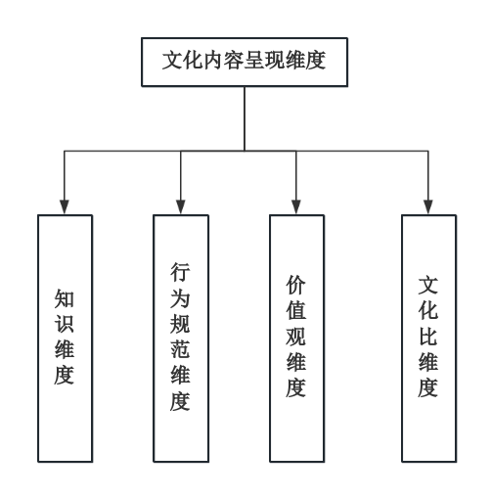

## 3.3 Coding and analysis methods

This study employs a combined qualitative and quantitative approach for analysis. The qualitative component utilizes content analysis, where each textbook passage is manually coded according to the cultural content presentation dimensions established in Section 3.2, ensuring accurate categorization of every cultural element. The quantitative component analyzes distribution patterns across different textbooks and educational levels through frequency statistics and percentage calculations.

The data were organized and statistically processed using Excel for basic frequency calculations, with SPSS employed for cross-analysis and significance testing to verify whether there are significant differences in cultural dimension distribution across textbooks. To ensure reliability of coding outcomes, two researchers independently conducted the coding process, with Cohen's Kappa coefficient used for reliability assessment. A Kappa value ≥0.80 indicates high consistency, 0.60–0.79 corresponds to moderate consistency, while values <0.60 require re-evaluation and adjustments. The reliability test results are presented in Table 2.

Table 2 Results of coding reliability test

|  |  |  |  |  |  |
| --- | --- | --- | --- | --- | --- |
| Coding team | sample number | Uniform coding | concordance rate （%） | Kappa price | Credibility evaluation |
| Coder A vs Coder B | 300 | 276 | 92 | 0.86 | High consistency |

# 4. Findings

## 4.1 Distribution of cultural content in each dimension

Statistical analysis of three mainstream Chinese textbooks reveals that the knowledge dimension holds the highest proportion across all materials, exceeding 30% in each case. This demonstrates a strong emphasis on introducing material and institutional culture through historical events and festival customs. The behavioral norms dimension accounts for approximately 24%-26% of the content, primarily covering social etiquette and interaction rules. The values dimension shows slightly lower coverage at 19%-22%, indicating room for improvement in presenting deeper cultural concepts. Notably, the cultural comparison dimension surpasses 24% in both the HSK Standard Curriculum and New Practical Chinese Textbook, compared to 18% in Developmental Chinese, highlighting some textbooks' stronger focus on cross-cultural comparisons. Overall, variations in cultural dimension distribution among textbooks reflect differences in editorial philosophies and teaching priorities.

Table 3 Frequency and proportion of cultural content in different dimensions in different teaching materials

|  |  |  |  |  |  |  |  |  |
| --- | --- | --- | --- | --- | --- | --- | --- | --- |
| Name of textbook | Knowledge dimension _ frequency | Knowledge dimension _% | Behavioral specification dimension _ frequency | Dimension of behavioral norms _% | Value dimension _ frequency | Value dimension _% | Cultural comparison dimension _ frequency | Cultural comparison dimension _% |
| Develop Chinese | 85 | 34 | 65 | 26 | 55 | 22 | 45 | 18 |
| HSK standard tutorial | 78 | 31.2 | 60 | 24 | 50 | 20 | 62 | 24.8 |
| New Practical Chinese textbook | 72 | 30 | 58 | 24.2 | 47 | 19.6 | 62 | 26.2 |

Figure 2. Bar chart of the proportion of cultural content presented in each dimension

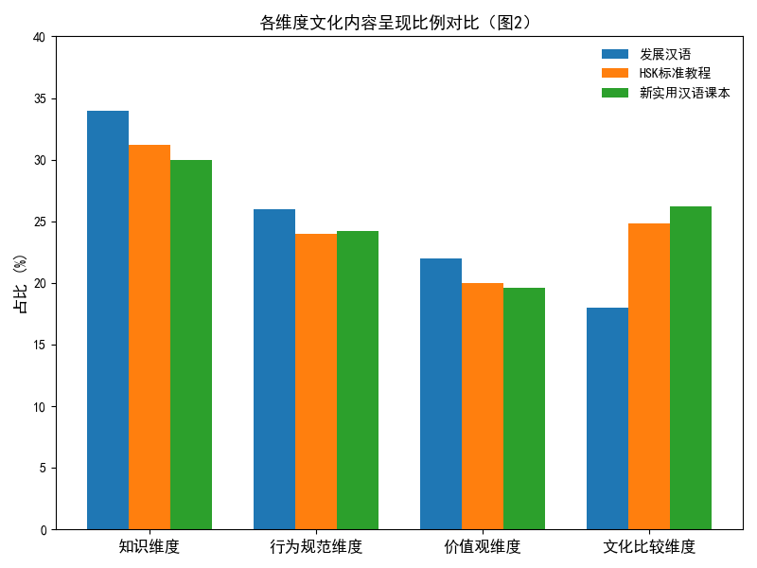

## 4.2 Cultural differences in teaching materials at different levels

Hierarchical analysis reveals that foundational textbooks primarily focus on "knowledge dimensions" (approximately 40%) and "behavioral norms dimensions" (30%), emphasizing the acquisition of cultural knowledge and etiquette rules. Intermediate textbooks significantly enhance "cultural comparison dimensions" (23.5%), guiding learners to compare and apply Chinese and foreign cultures in communicative contexts. Advanced textbooks further emphasize "value dimensions" (24.3%) and "cultural comparison dimensions" (27.1%), cultivating cross-cultural adaptability and critical judgment through deep cultural understanding. The overall trend indicates that textbook culture evolves from static knowledge to situational behavior, value comprehension, and cross-cultural comparison as learning levels progress, supporting the development of competence ranging from pragmatic appropriateness to cross-cultural competence. This outcome aligns with the gradual integration path of attitude-knowledge-skill progression in intercultural communication theory, providing evidence-based foundations for layered instructional design.

Table 4 Comparison of distribution of different levels of cultural dimensions

|  |  |  |  |  |  |  |  |  |  |
| --- | --- | --- | --- | --- | --- | --- | --- | --- | --- |
| top class | Knowledge dimension _ frequency | Knowledge dimension _% | Behavioral specification dimension _ frequency | Dimension of behavioral norms _% | Value dimension _ frequency | Value dimension _% | Cultural comparison dimension _ frequency | Cultural comparison dimension _% | amount to |
| elementary | 120 | 40 | 90 | 30 | 55 | 18.3 | 35 | 11.7 | 300 |
| middle rank | 105 | 30.9 | 85 | 25 | 70 | 20.6 | 80 | 23.5 | 340 |
| senior | 95 | 27.1 | 75 | 21.4 | 85 | 24.3 | 95 | 27.1 | 350 |

Figure 3. Line chart of cultural presentation trends

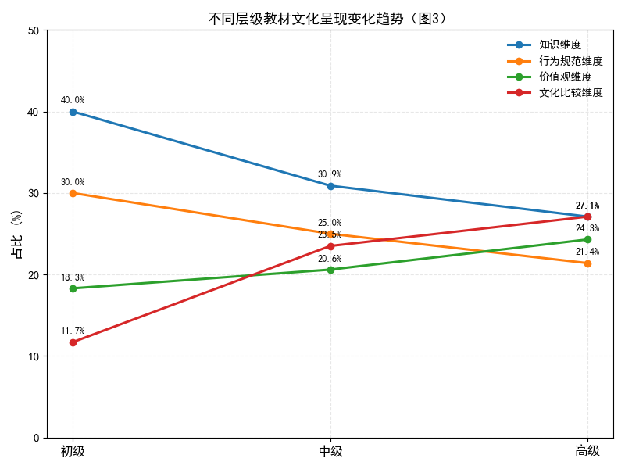

## 4.3 Cultural comparison and cross-cultural communication fit analysis

Statistical analysis reveals that the three textbooks demonstrate a progressive cultural comparison progression: The Developmental Chinese textbook (18.0%) leads the pack, followed by the HSK Standard Course (24.8%) and New Practical Chinese Textbook (26.2%), with the latter showing significant expansion in both communicative strategy comparisons and value-based analyses. Detailed breakdowns reveal developmental Chinese focuses on etiquette norms (37.8%), emphasizing proper expression and fundamental rules; HSK Standard Course achieves balanced development in both value comparison and communication strategies; while New Practical Chinese Textbook continuously enhances its value and communication strategies, supporting learners' transition from behavioral adaptability to cross-cultural understanding of value orientations and pragmatic approaches. The alignment radar chart indicates New Practical Chinese Textbook excels in interactive skills and critical cultural awareness, HSK Standard Course maintains overall balance, and Developmental Chinese shows stable performance in knowledge/attitude dimensions. Collectively, these textbooks demonstrate positive alignment with the ICC (Attitude-Knowledge-Skill-Critique) framework, though there remains room for improvement in advanced-level critical thinking and contextual interpretation skills.

Table 5 Statistics of cultural comparison content

|  |  |  |  |  |  |  |  |  |  |  |
| --- | --- | --- | --- | --- | --- | --- | --- | --- | --- | --- |
| Name of textbook | Cultural comparison _ total frequency | Cultural comparison and proportion (%) | Value comparison _ frequency | Value comparison percentage (%) | Frequency of etiquette specification comparison | Comparison of etiquette norms and proportion (%) | Frequency of communication strategies comparison | Communication strategy comparison and proportion (%) | Social system comparison frequency | Social system comparison percentage (%) |
| Develop Chinese | 45 | 18 | 10 | 22.2 | 17 | 37.8 | 11 | 24.4 | 7 | 15.6 |
| HSK standard tutorial | 62 | 24.8 | 16 | 25.8 | 20 | 32.3 | 16 | 25.8 | 10 | 16.1 |
| New Practical Chinese textbook | 66 | 26.2 | 19 | 28.8 | 18 | 27.3 | 18 | 27.3 | 11 | 16.7 |

Figure 4 Fit radar chart

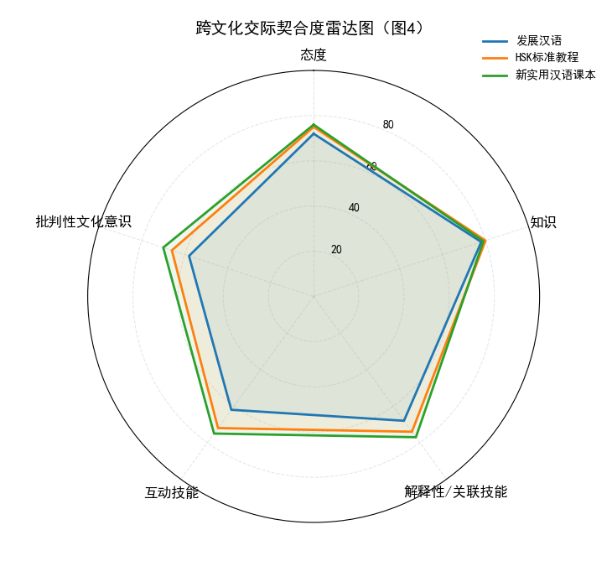

# 5. Discussion

## Correspondence between main findings and intercultural communication theory

The research findings indicate that the three textbook series predominantly focus on knowledge-based cultural content presentation, covering material culture (e.g., food, clothing, festivals) and institutional culture (e.g., social organizations, historical events). This approach aligns with Hall's high/low-context theory, as evidenced by the integration of high-context cultural features such as explanations of festival customs and implicit politeness strategies in social interactions. However, the relatively low emphasis on value dimensions and cross-cultural comparisons suggests that these textbooks fall short in guiding learners to deeply understand the underlying thought patterns and value orientations embedded within cultural contexts.

From the perspective of Hofstede's cultural dimensions theory, while textbooks touch upon concepts like power distance, collectivism, and individualism, these topics are predominantly presented implicitly without systematic cultural dimension explanations or comparative analyses. Particularly concerning are the insufficient coverage of uncertainty avoidance and long-term versus short-term orientation, which limits learners' comprehensive grasp of cross-cultural differences.

The Byram ICC model reveals that while the textbook excels in language and cultural knowledge (Knowledge) and effectively engages learners through relatable real-life scenarios to develop attitudes, it falls short in cultivating interpretation/relation skills and critical cultural awareness. This gap leaves learners without sufficient opportunities for deep analysis of cultural phenomena or critical reflection. Overall, while the textbook aligns with intercultural communication theory in foundational cultural input, there remains significant room for improvement in fostering advanced competence development.

## 5.2 Advantages and disadvantages of cultural content in teaching materials

From the perspective of strengths, these three textbooks demonstrate strong systematicity and practicality in cultural knowledge coverage. Their standout feature lies in comprehensive cultural knowledge integration, which not only encompasses traditional Chinese elements like Spring Festival, Mid-Autumn Festival, calligraphy, and tea culture, but also incorporates modern social elements such as subway commuting, online shopping, and environmental awareness. This enables learners to apply language flexibly across various contexts. Moreover, the content is presented through dialogues, stories, and news clips that resonate with daily life, effectively enhancing learners' motivation to use language and fostering cultural identity.

The textbooks still fall short in both depth and breadth of cultural coverage. Firstly, they inadequately present core values, with many cultural elements remaining superficial knowledge without delving into philosophical underpinnings, ethical principles, or social concepts. This prevents learners from fully grasping the underlying logic behind cultural behaviors. Secondly, while cross-cultural comparisons are featured in the HSK Standard Curriculum and New Practical Chinese Textbook, these discussions remain disproportionately limited in proportion and predominantly focus on etiquette and customs rather than deeper analyses of values and communication strategies. Furthermore, the materials generally lack multicultural perspectives, rarely incorporating cultural differences from other Chinese-speaking countries or regions, and fail to demonstrate engagement with global multiculturalism—a crucial aspect in today's interconnected world.

## 5.3 Textbook compilation and teaching enlightenment

Drawing on research findings and cross-cultural communication theory, future Chinese textbook development should focus on the following improvements. First, achieving balanced representation across cultural dimensions is essential. While maintaining strengths in knowledge-based content, greater emphasis should be placed on value systems and comparative cultural analysis. This will establish an integrated framework of "knowledge, norms, values, and comparison" that supports learners' progressive development from language acquisition to enhanced cross-cultural competence.

Textbooks should incorporate cross-cultural comparison tasks that extend beyond surface-level comparisons of etiquette and customs, including deeper dimensions such as values, ways of thinking, and social systems. By designing activities like cross-cultural discussions and case studies, learners can be guided to identify differences, understand them, and learn to adapt through comparative analysis.

Cultural content should be applied in authentic communicative contexts through contextualized activities. For instance, designing simulated international conferences, cross-border business negotiations, and cultural festival events can integrate cultural knowledge with communication skill training, thereby cultivating learners' attitudes, knowledge, skills, and critical cultural awareness. Additionally, incorporating task-based learning (TBLT) and project-based learning (PBL) concepts into cultural education enhances interactivity and engagement, fundamentally improving the effectiveness of cross-cultural communication.

# 6. Conclusions and prospects

This study, grounded in intercultural communication theory, constructs a four-dimensional analytical framework for cultural content presentation in Chinese textbooks and conducts systematic qualitative and quantitative analyses of three mainstream textbook series. The findings indicate that current materials excel in knowledge dimension and behavioral norms dimension, featuring extensive coverage of cultural knowledge closely aligned with daily life. However, there remain shortcomings in the proportion and depth of value orientation and cross-cultural comparison dimensions, particularly regarding fostering learners' critical cultural awareness and intercultural interpretation skills. Differences in cultural emphasis across textbooks and educational levels reflect distinct editorial philosophies and teaching objectives. Overall, while textbook cultural content aligns with intercultural communication theory at foundational levels, further optimization is needed for cultivating advanced intercultural competence. Future research could deepen exploration through three approaches: 1) Expanding sample scope to include more publishers and target groups of Chinese textbooks to enhance generalizability; 2) Combining classroom observations with learner interviews to validate the practical effectiveness of textbook cultural content in developing intercultural competence; 3) Introducing multimodal analysis methods to examine non-textual cultural presentations like images, videos, and audio. Through continuous integration of theory and practice, this approach could drive Chinese textbooks toward transitioning from "knowledge transmission" to "competency cultivation" in cultural content design, better serving international Chinese education in a globalized context.

# reference documentation

1. Hall, E. T. (1963). A system for the notation of proxemic behavior. American anthropologist, 65(5), 1003-1026.
2. Hofstede, G. (2011). Dimensionalizing cultures: The Hofstede model in context. Online readings in psychology and culture, 2(1), 8.
3. Byram, M. (2020). Teaching and assessing intercultural communicative competence: Revisited. Multilingual matters.
4. Kramsch, C. (2014). Language and culture. AILA review, 27(1), 30-55.
5. Cohen, J. (1992). Statistical power analysis. Current directions in psychological science, 1(3), 98-101.
6. Dongxing, Y. (2020). An evaluation of a Chinese language textbook: From students’ perspective. US-China Education Review, 10(1), 35-44.
7. Hsiang, T. P., Graham, S., Liu, X., & Zhou, Z. (2023). Teachers’ beliefs and practices in textbook selection and use when teaching Chinese as a second language. Reading and Writing, 36(7), 1651-1684.
8. Liu, Y. (2005). Discourse, cultural knowledge and ideology: A critical analysis of Chinese language textbooks. Pedagogy, culture & society, 13(2), 233-264.
9. Romashkova, S. (2024). A Study on Mandarin Teaching Materials Design for Academic Application Purposes for Russian Learners (Master's thesis, National Taiwan Normal University (Taiwan)).
10. Trihardini, A., & Wikarti, A.Trihardini, A., & Wikarti, A. (2021). A Need Analysis of Mandarin Conversation Teaching Materials Development. In Proceedings of the First International Conference on Literature Innovation in Chinese Language, LIONG (pp. 19-20).
11. Yann, S. C., Choo, P. T., Oi, L. C., & Chun, K. Y. (2021). Innovative in teaching Mandarin through scaffolding strategies/Yann Sheng Chan...[et al.]. E-Academia Journal, 10(2), 133-143.