**Performance synchronization in piano and vocal collaboration: A comparative study of rhythm and dynamics in art song performance**

Xiangliangzi Ning

School of Music ,Henan polytechnic University， Jiaozuo,Henan,454000, China

e-mail：[nxlz850426@163.com](mailto:nxlz850426@163.com)

Abstract: This study focuses on the expressive synchronization between piano and vocal performance in art song interpretation, with rhythm and dynamics as core research elements. It constructs a theoretical framework for their synchronization through analyzing the "framework and flow" relationship in rhythmic interactions and the multidimensional coordination patterns in dynamic synchronization. The research elucidates how rhythmic synchronization enhances musical clarity and emotional delivery efficiency, while dynamic synchronization plays a crucial role in amplifying emotional resonance and shaping artistic coherence. A practical strategy combining "cognition-training-practice" approaches is proposed, encompassing collaborative techniques, tiered practice methods, and instructional pathways. This systematic theoretical support and practical guidance provide comprehensive theoretical underpinning for improving collaborative expressiveness in art song performances, thereby deepening our understanding of the aesthetics of piano-vocal collaboration.

Key words: piano and vocal music; rhythm; dynamic; comparative study

**foreword**

Art songs represent a perfect fusion of "music and poetry," where the core charm of performance lies in the seamless coordination between piano and vocal elements. When rhythm misalignment or dynamic imbalance occurs during live performances, it often leads to fragmented emotional expression and diminished artistic impact. Although academic attention has been given to collaborative significance, systematic comparative studies on rhythm and dynamic synchronization remain insufficient. Grounded in performance aesthetics and collaboration theory, this study focuses on expressive synchronization as a key entry point. It analyzes the interactive mechanisms between piano and vocal elements in rhythm and dynamic dimensions within art songs, examines how synchronization affects emotional transmission and artistic conception, and proposes practical strategies for implementation.

**Theoretical basis of piano and vocal cooperation**

**(1) The role of piano accompaniment in art songs**

In art songs, piano accompaniment transcends being merely a vocal accompanist. As an artistic partner on equal footing with the vocal parts, it constructs the emotional foundation of the work through harmonic textures and responds to lyrical shifts via chromatic chord variations. At melodic transitions, piano interludes bridge vocal pauses to maintain musical coherence and narrative flow. By modulating dynamics and rhythm, the piano provides precise tempo support for vocal delivery, guiding performers to master breathing phrasing[1]. To convey nuanced emotions in art songs, the piano's rich tonal layers enhance vocal phrasing, creating a "musical painting fusion" that bridges composers' intentions with listeners' perceptions.

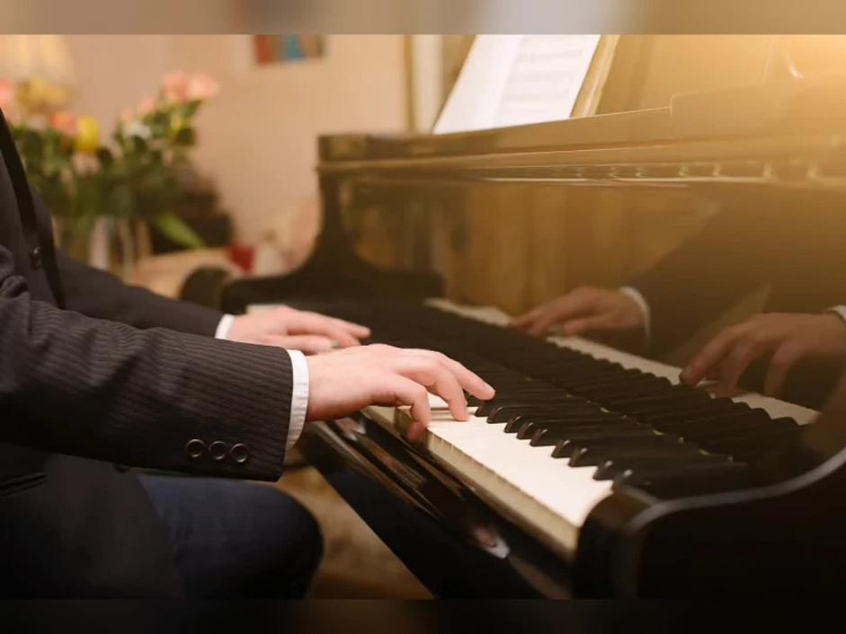

**(2) Rhythm and dynamic control in vocal performance**

Rhythm and dynamic control form the cornerstone of vocal performance. Rhythm control requires performers to maintain fundamental tempo stability while adapting flexibly to the lyrical tone and emotional nuances, avoiding mechanical rigidity while preserving the work's structural integrity. Dynamic control employs variations in volume intensity and timbre modulation to create musical layers—soft passages convey delicate emotions, while powerful outbursts express intense feelings. These two elements must be organically integrated: rhythmic expansion should facilitate natural dynamic transitions, dynamic shifts should be logically driven by rhythmic progression. Precise tempo control ensures vocal stability, while nuanced dynamic handling breathes life into melodies. Together, they elevate the artistic expressiveness and emotional resonance of vocal performances.

**II. Analysis of the synchronicity of rhythm in art song performance**

**(1) The theoretical framework of rhythm synchronization**

The theoretical framework of rhythmic synchronization is built upon musical time perception and collaborative aesthetics, with its core principle being the precise temporal alignment between piano and vocal performance. This framework comprises three key elements: rhythmic stability, tempo consistency, and flexible interpretation consensus. By adopting the "time synchronization threshold" from music acoustics as scientific basis, it enables both instruments to achieve millisecond-level rhythm synchronization. Additionally, it incorporates the "breath unification" principle from musical aesthetics, emphasizing that rhythmic synchronization should serve the emotional expression logic of the work. This framework provides systematic theoretical guidance for piano-vocal rhythmic collaboration, combining objective technical standards with subjective artistic consensus[2].

**(2) The interaction between piano and vocal music in rhythm**

The rhythmic interplay between piano and vocal performance creates a multi-layered synergy. The piano establishes a rhythmic framework through steady bass lines, providing vocalists with fundamental tempo support. Vocalists then adapt melodic rhythms according to lyrical cadences, forming an interplay of "structure and fluidity". In lyrical passages, both instruments synchronize their rhythmic breathing through nuanced rubato control. During climactic moments, the piano employs accentuated rhythmic patterns to propel powerful vocal expressions. This dynamic interaction transcends passive following – it evolves into a responsive mechanism through visual communication and physical cues, achieving organic coordination where "you lead, I follow; I move, you respond".

**(3) The influence of rhythm synchronization on the expression of art songs**

Rhythm synchronization holds paramount importance in art songs, directly determining the efficiency of emotional delivery and artistic integrity. Precise rhythmic alignment enhances musical clarity, enabling listeners to better grasp the narrative logic of the work. In emotional expression, synchronized rhythm allows the piano's harmonic tension and vocal emotional outbursts to synergize, amplifying musical impact—similar to how syncopated rhythms in tragic works intensify emotional resonance. Conversely, rhythm discrepancies fragment musical lines and diminish artistic expressiveness[3]. Moreover, flexible rhythmic synchronization breathes life into compositions, preserving artistic individuality within technical parameters while achieving a balance between precision and artistic freedom, ultimately elevating the work's aesthetic value.

**3. Analysis of synchronization in dynamic performance of art songs**

**(1) Theoretical framework of dynamic synchronization**

The theoretical framework of dynamic synchronization centers on the coordinated control of musical expressiveness, focusing on the consistency adjustment mechanisms between piano and vocal performance in dynamics, timbre, and emotional intensity. Its core principle lies in achieving synchronized emotional transmission through precise dynamic layer matching. This framework involves three key elements: First, corresponding dynamic levels—maintaining gradient synchronization between piano and vocal across the pp to ff dynamic range; Second, tonal harmony—where piano timbre is adjusted through touch techniques to create texture resonance with vocal timbre; Third, emotional resonance—aligning dynamic fluctuations based on shared interpretation of the work's essence. Theoretically, it integrates the "emotional resonance principle" from music psychology and the "holistic art theory" from performance aesthetics. Dynamic synchronization transcends mere technical coordination, emphasizing mutual artistic understanding. It follows the "complementary principle of primary and secondary elements" —reducing dynamic support in vocal-dominated passages while ensuring vocal performers build emotional groundwork in piano solo sections—thereby forming an organically unified artistic whole.

**(2) The dynamic interaction between piano and vocal music**

The dynamic interplay between piano and vocal performance creates multidimensional synergy throughout the musical work. Fundamentally, the piano establishes a stable dynamic foundation through evolving chord dynamics, while the vocalist modulates their vocal intensity according to lyrical emotional shifts, forming a "base and melody" dynamic framework. During lyrical passages, both instruments achieve breath synchronization through nuanced crescendos and decrescendos. The piano's soft touch harmonizes with the vocalist's breath control to create ethereal ambiance. At climactic moments, the piano's powerful chord explosions propel vocal crescendos, while emphatic accents establish emotional resonance. This dynamic interplay is further demonstrated in transitional moments: the piano's gradual softening creates space for vocal decrescendos, while vocal preparation prepares for piano fortissimos. Through subtle visual cues and physical communication, seamless transitions are achieved without noticeable disconnections or misalignments.

**(3) The influence of dynamic synchronization on the expression of art songs**

Dynamic synchronization plays a decisive role in the expressive power of art songs, directly influencing both the emotional impact and the integrity of artistic structure. In terms of emotional rendering, precise dynamic synchronization elevates musical emotion to its peak. For instance, in tragic works, when the piano's sudden rise in bass notes coincides with the vocal's explosive high notes, it instantly intensifies dramatic tension. Conversely, in lyrical pieces, synchronized gradual diminutions create lingering resonance. Structurally, dynamic synchronization divides music into sections through dynamic fluctuations: the piano and vocals 'strong-weak contrasts define phrasing boundaries, while progressive dynamics link musical phrases. It enhances detailed expression by synchronizing the piano's touch pressure with the vocalist's articulation, highlighting semantic emphases. Conversely, misaligned dynamics can fragment emotional delivery—when the piano intensifies while the vocals weaken, tension diminishes; when the vocal crescendo clashes with sudden piano diminution, coherence breaks. Only through dynamic synchronization can we achieve the artistic effect where 1+1>2.

**Fourth, synchronous practice strategies of rhythm and dynamic expression in art song performance**

**(1) The technique of piano accompaniment and vocal cooperation**

When collaborating between piano accompaniment and vocal performance, the foundation lies in deep mutual understanding and technical synergy. The pianist must thoroughly study the lyrics beforehand, accurately grasp the emotional flow of the piece, and establish dynamic contour lines based on musical notation. They then work with the singer to determine breathing points and key rhythmic shifts. During collaboration, the piano should modulate touch dynamics to echo vocal timbres: using soft articulation in lyrical passages to highlight delicate vocal lines, and employing full-range vibrato in passionate sections to intensify emotional tension. Eye contact serves as a crucial real-time adjustment mechanism – the pianist signals tempo changes through arm movements, while the singer conveys breathing needs with subtle head movements. For complex rhythms, both parties establish "core beat anchors" while maintaining basic rhythm consistency, allowing partial flexibility. The piano must master the timing of "primary-secondary transitions": softening accompaniment textures during vocal melodic displays, and guiding emotional shifts through tonal variations in interludes. This creates a dynamic equilibrium where "you lead, I support; you shine, I conceal," ultimately achieving seamless integration of technical precision and artistic expression.



**(2) Practice methods of rhythm and dynamic synchronization**

Rhythmic and dynamic synchronization training should follow a progressive approach from simple to complex, progressing from technical to artistic levels. In the foundational stage, the "segmented timing method" can be employed: divide musical works into sections based on phrases, establish a stable rhythmic framework using a metronome, and focus on precise synchronization of strong beat positioning. Dynamic exercises may begin with "dynamic level correspondence training" —both performers agree on six intensity markers from pp to ff—using "counting" techniques to synchronize vocal articulation with piano chords, thereby building coordination in dynamic perception. At the advanced stage, introduce "unmarked elastic practice": while maintaining basic rhythmic structures, freely adjust tempo variations according to lyrical emotion. The piano stabilizes the framework through bass lines, while the vocalist develops melodic lines. Alternatively, adopt the "reverse practice method" —letting the piano demonstrate dynamic changes, then having the vocalist mimic them, with vocal leading rhythm shifts and piano providing real-time coordination to enhance mutual adaptability. During regular practice, record collaborative audio recordings for playback analysis of rhythm misalignments and dynamic inconsistencies, allowing targeted corrections to gradually develop "intuitive synchronization without verbal cues".

**(3) The application of expressive synchronization in art song teaching**

In teaching practice, expressive synchronization requires establishing a three-stage instructional framework encompassing "cognition-training-practice". During the cognitive phase, work analysis sessions guide students to grasp the relationship between rhythm and dynamics. Through musical score examples, composers 'underlying intentions are explained while comparing differences in synchronized interpretation across versions. The training phase employs a "tiered progression method": elementary stages use simplified annotated scores to build foundational synchronization through "singing and playing along"; intermediate stages introduce unannotated art song fragments requiring collaborative rhythm adjustment and dynamic planning; advanced stages organize small group performances focused on correcting synchronization deviations. Teaching tools like dynamic curve charts for rhythm accents and dynamics, waveform comparison software for visual synchronization effects, and role-reversal exercises (where vocalists experience piano accompaniment perspectives and pianists attempt melodic singing) enhance technical understanding. Regular collaborative performances transform classroom training into practical experience, cultivating students' artistic collaboration awareness and expressive synchronization skills.

**epilogue ：**

The expressive synchronization between piano and vocal performance in art song singing represents an organic integration of technical precision and artistic resonance. This article systematically analyzes the synchronization of rhythm and dynamics, demonstrating their crucial roles in constructing musical narratives and conveying emotional depth. Rhythm synchronization forms the structural foundation for maintaining musical logic, while dynamic synchronization serves as the key element to intensify emotional tension. These two elements mutually reinforce each other to create a complete artistic expression. The proposed practical strategies and teaching approaches provide feasible solutions to synchronization challenges during collaborative performances. Future research could combine empirical analysis of specific works to explore differentiated synchronization techniques across different art song styles. By employing acoustic measurement technologies to quantify synchronization thresholds, this approach would offer more precise scientific guidance for artistic practice, continuously enriching the theoretical framework of piano-vocal collaboration.

**reference documentation ：**

[1] Yu Yanan. The Significance and Approaches of Cultivating Collaborative Piano Talents in Vocal Teaching [J]. Artist, 2024(08):114-116.

[2] Feng Min. Research on the Cooperative Relationship between Piano Accompaniment and Vocal Performance [D]. Nanchang University, 2024.

[3] Zhou Lei and Yu Zhiyong. The Artistic Form of Vocal Performance and Collaborative Piano [J]. Drama House, 2022, (18):99-101.

**Acknowledgements（基金项目）：**This paper is the phased result of the demonstration course project "Vocal Music Major" of Henan Graduate Education Reform and Quality Improvement Engineering Course 2025, No. YJS2025SZ32.