# Digital Preservation of Cultural Heritage: Computer Vision Techniques for Traditional Art Restoration and Conservation

Yu Huang1, Yanyan Chen3, Hongjing, Pan4, Kaisheng Chen2,*.

1, Teachers College for Vocational and Technical Education, Guangxi Normal University, Guilin, 541000, China.

2, School of Chinese Painting, Guangzhou Academy of Fine Arts, Guangzhou 510000, China.

3, College of Light Industry, Guangdong Technician Industrial Design College, Guangzhou 510000, China.

4, College of Management and Engineering, Guilin University, Guilin 541000, China.

[540783407@qq.com](mailto:540783407@qq.com)

**Acknowledgement**

This research was supported by the Basic Ability Improvement Project for Young and Middle-aged Teachers of Guangxi Colleges and University (Ink stone literature research) (2024KY0057).

# Abstract

This research explores the impact of computer vision technology on transforming traditional artistry restoration and preservation. Due to the unprecedented challenges cultural heritages face from environmental deterioration, natural ageing, and human interference, coupled with the increasing reliance on technology, frameworks for digital preservation have emerged to complement traditional conservation techniques. The study proposes a balanced approach to innovation and restoration ethics with a devised content-constrained convolutional network architecture, merging loss functions for stylistic consistency. This allows for historical authenticity in digital restorations. Experimental results show that the proposed model with and without contemporary construction performed better in proportion to existing methods for structural resemblance and fine detail retention across diverse degradation contexts. From analytical evaluations of content preservation versus stylistic consistency, it was found best to place higher value on content preservation, with α≈0.6 and β≈0.3 for stylised consistency (viewed as practical for institutional implementation). The comprehensive evaluation of restoration outcomes is ensured through the multi-stage validation framework that combines assessing experts and technical metrics for evaluating restoration results. From the findings, the claim that the integration of digital and traditional approaches fosters greater balance in preserved heritages, emerging not only propelling accessibility to education, cultural tourism, and scholarly research but exemplifying the endless possibilities of computer vision technology in artistry conservation is illustrated.

**Keywords:** Digital cultural heritage preservation, Computer vision, AI-based restoration, Content-constrained convolutional networks, Virtual restoration

# 1. Introduction

Cultural heritage depicts the legacy of human civilization that is comprised of artistic, historical, and cultural attributes that unite countless generations. In contrast, the distinction of traditional art is coming under unprecedented pressures today brought about by deprecated environmental conditions, natural ageing, human activities, and international wars that seek to obliterate our shared history. As a solution, the digitisation of cultural heritage serves as a vital tool that attempts to connect deeply rooted methods of preservation with contemporary technology [1]. This intersection has given rise to a new framework of preservation methodology; computer vision technologies are revolutionising how we record, interpret, restore, and safeguard traditional pieces of art for posterity.

In recent years, the use of information technologies for digital imaging in the documentation of cultural heritage has changed from mere documentation mechanisms to advanced systems that disclose previously concealed intricacies [2]. Though useful, conventional restoration practices are based on personal judgement and include some form of bodily action that would change the original piece forever. Cultural artefacts can now be made available to the public and easily understood through the use of nondestructive digital methods that foster the preservation of authenticity [3]. The usage of computer vision technology bolsters the existing methods of conserving and restoring art and cultural elements, especially when physical restoration is not feasible, too risky, or restoration efforts would cause more harm than good.

Computer vision techniques have demonstrated remarkable potential in addressing complex challenges in art restoration. These technologies enable precise damage assessment, virtual reconstruction of the degraded parts, and objective evaluation of colour, texture, and structural and surface integrity [4]. The application of deep neural networks within machine learning has enhanced the automation of pattern recognition and improved the reconstruction accuracy of missing parts or damaged components. A good example of advanced image restoration is mural image completion through content-constrained convolutional networks, which enable the restoration of ancient artworks that are grievously eroded [5].

The implications of this form of digital preservation go beyond mere conservation. It enables researchers to perform intricate analyses without endangering the original objects by creating high-fidelity digital twins of cultural artifacts. This approach also allows for the virtual display and archiving of cultural heritages, thus broadening access to them [6]. The digital transformation fosters global participation with previously unreachable resources and profoundly restructures education, cultural tourism, and scholarly research. In addition to this, the growing capabilities of artificial intelligence tools are offering even more sophisticated solutions to the threats posed by nature and humankind to artistic legacies, enhancing the culture of preservation now and in the future, in unparalleled ways.

This research investigates the potential impacts of computer vision techniques applied to the restoration and conservation of fine art on methodology, ethics, and practical implications in cross-cultural heritage preservation. Through critical analysis and case studies, this research investigates the role of digital technologies in complementing practices of conservatoire traditions and dealing with the multifaceted problems of authenticity, integrity, and accessibility in cultural heritage preservation.

# 2. Literature Review

# 2.1. Traditional Art Restoration: Historical Approaches

# 2.1.1. Evolution of conservation methodologies

Digital preservation of cultural heritage serves as a vital means of protecting traditional art for future generations. Methods of conservation have always relied on physical manipulations of a work, which pose problems of subjectivity and irreversibility. The application of infrared photography, digital cameras, and range sensors has transformed the documentation of culture and heritage, offering objective forms of analysis that do not damage the artefact and guide subsequent restoration steps [7]. This transformation in technology marks a major step in conservation philosophy, moving away from mostly hands-on methods to more mixed approaches where documenting in a digital format is a vital step done beforehand.

The shift toward preservation technologies that are digital in nature correlates directly with the acknowledgement of life-threatening dangers to many cultural heritage items. In regard to conflicts across the globe, digital technologies serve an important role in preserving cultural heritage, providing means for documenting and virtually restoring pieces that would otherwise be obliterated beyond recovery [8]. These techniques of digital safeguarding are especially useful in areas of political unrest where the physical security of invaluable cultural buildings and artefacts is at risk.

# 2.1.2. Ethical considerations in physical restoration

Restoration ethics are deeply rooted in the concerns of authenticity, reversibility, and the minimal intervention principle. One of the most complex ethical issues in restoration involves the challenge of colour accuracy because decisions related to colour reproduction shape perception and understanding of culture and architectural heritage [9]. These decisions that appear to be purely technical in regard to colour reproduction have deep-rooted philosophical considerations that shape contemporary approaches to historical artefacts.

In contrast, the purely technical aspects of restoration work, such as interpretation of cultural jurisdiction, carry ethical concern as an interpretative responsibility. New virtual media technologies present new suggestions to physical restoration that enhance artistic expression but protect the cultural context withstand [10]. From this standpoint, sound ethics in restorative work requires not merely material authenticity, but attention to culture, community, and heritage that confer profound significance to the artefacts.

# 2.1.3. Limitations of traditional approaches

Recognised methodologies for conservation attempt to determine the value of an object, but face challenges when extensive deterioration is present, especially for items with severe structural or surface damage. Solutions that are innovative in nature aid in solving problems associated with the preservation of complex environments, such as classical Chinese royal gardens. This work attempts to address conservation challenges that cannot be resolved through traditional methods [11]. Documentation of intricate architecture can now be captured comprehensively through digital documentation techniques without the limitations that other conventional methods faced, allowing for complex environments to be documented more accurately.

The limitations of traditional restoration methods become more apparent when an artefact continues to deteriorate as attempts at conservation are made. In regards to these issues, Virtual restoration technology is now regarded as a key approach for conserving cultural heritage [12]. The understanding that traditional methodologies are insufficient has led to great development in approaches to digital preservation that support conservational efforts instead of replacing them.

# 2.2. Digital Technologies in Cultural Heritage Preservation

# 2.2.1. Survey of state-of-the-art technologies

The addition of modern analytical tools and imaging technologies has greatly transformed the field of cultural heritage preservation. Systematic research conducted between 2019 and 2024 utilising digital technologies in cultural heritage preservation has indicated evolutionary changes in technology that transformed preservation techniques in different cultures [13]. Such changes marked the beginning of never-before-seen opportunities for documentation, analysis, and virtual restoration, which were not possible using orthodox methods.

Some distinct applied technologies dealing with specific challenges facing preservation demonstrate progressing evolution. One such method incorporating camera colour correction for works of art is described as "decentres the object," which lenses critical for chromatic precision in documenting artefacts [14]. This allows for the production of accurate digital replicas whose virtual restoration does not compromise the original artefact’s colours.

# 2.2.2. Development of computer vision in restoration contexts

The development of computer vision technologies has received notable attention in relation to analytical capabilities that bear significance far beyond human perception for the restoration of heritage sites. The development of algorithms for the restoration of digital images has progressed further with a range of strategies for dealing with visual expressions of cultural heritage damage [15]. With the aid of such technologies, even damage that is not amenable to conventional inspection methods and is not readily observable can be recognised and remedied.

Computer vision, allied with other formats of digital preservation, has mapped out entire models of management for cultural heritage. The computer vision technology within the cultural heritage informatics architecture is pivotal for the division of labour in the multidisciplinary effort at preservation and conservation, as illustrated by bibliometric analysis [16]. This indicates that the technologies of civilisation today, including tools like computer vision techniques, are not employed to function separately, but rather work alongside one another in technologically holistic systems.

# 2.2.3. The concept of "virtual restoration"

As a cultural heritage preservation technique, virtual restoration is one of the most recent additions to the repertoire as it provides insight into how digital interventions can be executed. The more recent forms of conservation and restoration performed with the assistance of machines complement more traditional forms by creating approaches that blend technological prowess and preservation goals [17]. The emphasis here is that virtual restoration processes go beyond restoration to include deeply rooted philosophical systems that preserve history accurately as technological processes.

Different cultures have shown uniqueness in the application of virtual restoration technologies that span diverse cultural contexts. Controls of culturally refined machinery such as restorative computing designed for the Chinese cultural heritage restore the said art forms using culturally appropriate systems of digitised restoration [18]. This case advocates for flexible virtual restoration methods to be responsive in dealing with different cultures by incorporating rather than excluding and enforcing a single technology.

# 2.3. Computer Vision and AI Applications in Art Restoration

# 2.3.1. Image processing techniques for damage assessment

The use of advanced image processing techniques has changed the approach to damage assessment for the preservation of cultural heritage. For example, in the Indian subcontinent, protective measures for cave art are implemented through specialised image processing techniques that monitor the deterioration and assess the patterns of ancient paintings [19]. Such technologies make it possible to uncover degradation processes that would have otherwise been undetected by traditional inspection techniques, thus allowing for earlier intervention and excavated conservation processes.

The application of advanced imaging techniques for damage evaluation has increasingly evolved in precision and sophistication. One analysis that focuses on comparing the condition assessments of oil paintings with photographs taken before restoration to what modern ‘AI-enhanced’ techniques apply identifies the incorporation of AI as significantly augmenting the accuracy and comprehensiveness of automated condition evaluations [20]. This new advanced technology is very useful because it improves understanding of the deterioration processes and informs preservation strategies that directly confront the problems rather than dealing with mere symptoms.

# 2.3.2. Deep learning approaches for image completion

The application of solving complex restoration problems demonstrates potential through middle learning methodologies that can reconstruct missing images or artefacts. Recent research trends on Artificial Intelligence (AI) for cultural heritage preservation indicate that sophisticated deep learning algorithms have been developed which reconstruct images and artefacts based on the context they are situated in. These algorithms ensure that the constructed images and artefacts are accurate, contoured, and stylistically bound within the historic period from which they were drawn.

The approach employed in completing images using deep learning techniques progressed from basic pattern matching to more developed contextual reconstruction approaches. Research attempting to solve the problems of deep learning artificial intelligence with its contextual place within restoring cultural heritage documents focuses on developing deep learning algorithms for artistic reconstruction that preserve essential stylistic features [9]. Modern algorithms enable precision and artistry in the restoration and reconstruction of damaged portions of images by avoiding anachronistic and stylistically unharmonious elements.

# 2.3.3. Computer vision models for comprehensive restoration

In computer vision, models have shifted to providing unified solutions which deal with multiple restoration problems simultaneously, offering distinct approaches to intricate issues. The preservation of cultural heritage through AI automation incorporates different aspects of computer vision to enable holistic restoration and multi-level deterioration remediation concurrently [21]. Such systems represent an important advancement in the realm of digital preservation, combining damage assessment, imaging filling, and imaging and imaging process quality verification within systematic and methodological frameworks.

The efficacy of computer vision models for restoration depends fundamentally on their capacity to analyze artworks at multiple scales and levels of detail. A forward-looking vision for artificial intelligence in cultural heritage preservation emphasizes how multi-scale computer vision analysis enables the detection and restoration of deterioration at varying levels of granularity [15]. This approach acknowledges that effective digital restoration requires simultaneous consideration of macro-level structural integrity and micro-level detail preservation to achieve authentic results that honor the artistic vision embodied in the original artifacts.

Figure 1 and Table 1 provide a comprehensive comparison between traditional restoration methods and digital technologies applied to cultural heritage preservation.

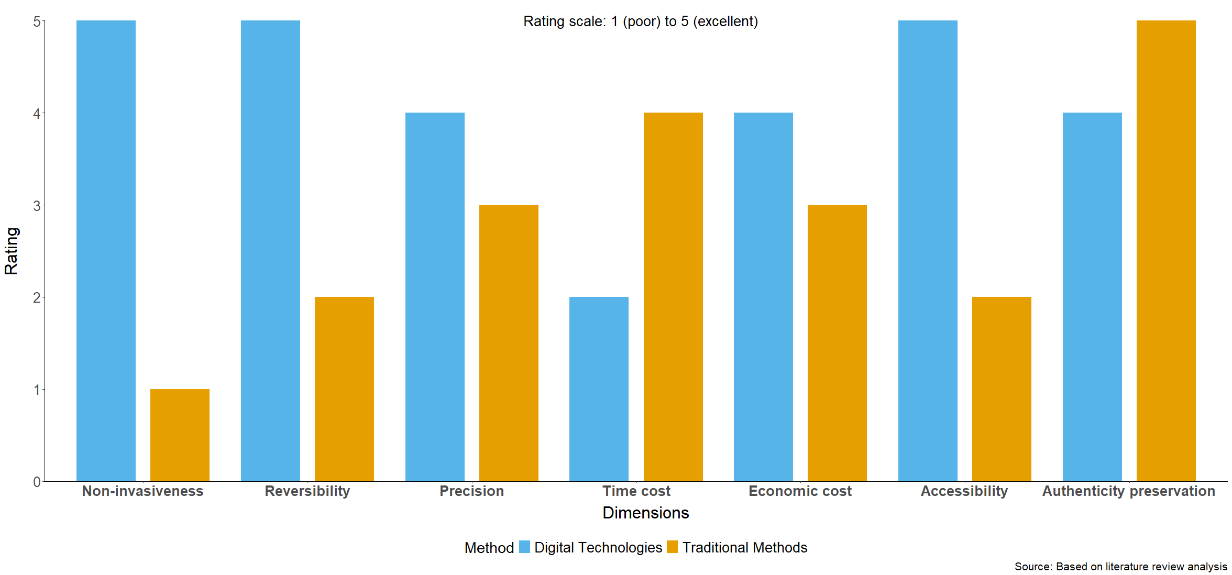

**Figure 1: Comparative Analysis of Traditional and Digital Methods in Cultural Heritage Restoration**

**Table 1: Comparison of Traditional and Digital Restoration Methods**

|  |  |  |
| --- | --- | --- |
| Dimension | Traditional Methods | Digital Technologies |
| Non-invasiveness | Typically requires physical contact, risks secondary damage [7] | Completely non-invasive, no contact with original artwork [8] |
| Reversibility | Most interventions are irreversible [9] | Virtual restorations can be completely undone [12] |
| Precision | Depends on restorer's subjective judgment and skill [10] | Based on algorithms and data analysis, objectively quantifiable [15] |
| Time cost | Usually requires significant time [11] | Can substantially reduce processing time [13] |
| Economic cost | Requires specialized personnel and materials [14] | High initial investment, but reusable [16] |
| Accessibility | Limited to few professionals [17] | Available to researchers globally via remote access [18] |
| Authenticity preservation | May alter original appearance and materials [19] | Preserves original state while providing restored views [20] |

*Note: Table references Rizzi et al.[7], Neglia et al.[8], Gaiani et al.[9], Kolay[10], Jia et al.[11], Dandan et al.[12], Li et al.[13], Trombini et al.[14], Wali et al.[15], Prados-Peña et al.[16], Lu and Pan[17], Li et al.[18], Ghosh et al.[19], Khalid et al.[20].*

As illustrated in Figure 1, digital approaches demonstrate clear advantages in several critical dimensions, particularly in non-invasiveness, reversibility, and accessibility, where traditional methods have historically faced significant limitations. The quantitative comparison reveals that while traditional techniques excel in authenticity preservation, digital technologies offer a more balanced performance across all evaluation criteria. Table 1 elaborates on these differences by detailing the specific characteristics of each approach across seven fundamental dimensions of restoration practice. This comparative analysis synthesizes findings from multiple studies [7-20] and highlights how digital technologies complement rather than replace traditional conservation methodologies. The integration of both strategies may offer the most holistic encompassing solution for preserving cultural heritage as it enables conservators to utilise the advantages of each approach while offsetting the drawbacks of each. This comprehensive view corresponds to the shifting philosophy in conservation practice which focuses on the preservation of authentic cultural artefacts with the intervention and alterations kept to a minimum and the need to reverse those actions maximised.

# 3. Theoretical Framework and Methodology

# 3.1. Theoretical Principles

The principles of conservation form the basis of the theoretical framework for the digital preservation of cultural heritage, while simultaneously reframing the debate within the context of the digital world. The ethics of traditional conservation stress minimal intervention, reversibility, as well as respect for the original work’s artistic composition. The application of these principles to digital contexts—where intervention is fundamentally different from restoration—requires recalibration.

When talking about digital restoration, minimal intervention translates to operations performed on the digital version that only serve the set objectives of preservation. Digital restoration can be ‘intervened’ upon to any degree and retains the option of being reversed, thus yielding an advantage to experimental approaches. In the case of authenticity and integrity of digital reproductions, fidelity is maintained to the original, so visual representations of the work invoked are meticulously documented alongside transparent evidence of all alterations— which translates to digitally executed changes.

Managing the dual challenge of preservation and interpretive reconstruction poses a distinct theoretical concern. Digital restoration processes should be able to distinguish between factual preservation of the existing elements and hypothetical reconstruction of those which are absent. Such a distinction presupposes the existence of algorithms capable of differentiating between high-confidence restorations and speculative ones—often executed through probability derivations in machine learning systems.

# 3.2. Research Design

The use of computer vision in the restoration of fine arts practices has been studied in this research using a case study method approach. This approach combines both numerical and descriptive evaluation techniques, measuring the execution of algorithmic processes as well as the outcomes within the context of conservation.

The criteria for material selection focus first and foremost on artworks with a colour faded palette alongside other conservation issues like tearing, surface wear, and paint flaking. The chosen case studies are bound to be of great importance in history while the restoration work on them will be sufficiently intricate to ensure value in methodology across different contexts of preservation. The computer vision algorithms to be used for this research are based on neural networks tailored for cultural heritage applications, particularly versioning restricted levered content convolutional networks. These include convolutional neural networks with specific embellishing and retouching constraints respecting stylised compositions, particularly system frameworks which underscore style-preserving mimicry.

Restoration research tends to focus on individual artefacts as the basis for research; this study seeks to extend methodical validation of a research process alongside simulated datasets for reproducible results and accurate metric assessments of restoration evaluation quantification.

# 3.3. Data Collection Procedures

The digitization methodology follows standardized protocols established in cultural heritage documentation, utilizing photographic equipment calibrated for chromatic accuracy and dimensional precision. Multi-spectral imaging techniques capture information beyond the visible spectrum, revealing underlying features and historical modifications not apparent to direct observation. Non-destructive imaging techniques employed in this research include: Photogrammetry for three-dimensional digital reconstruction, Ultraviolet fluorescence imaging for surface analysis, Infrared reflectography for underdrawing examination, X-ray fluorescence for material composition analysis.Data processing protocols implement rigorous quality control measures to ensure the fidelity of digital representations. These protocols include color calibration procedures, resolution standardization, and artifact elimination algorithms that minimize digitization-induced distortions.

# 3.4. Algorithm Selection and Implementation

The analytical framework employs a hierarchical approach to algorithm selection, as illustrated in Figure 2. This framework systematically applies specific computer vision algorithms based on the nature and extent of deterioration identified in the artwork.

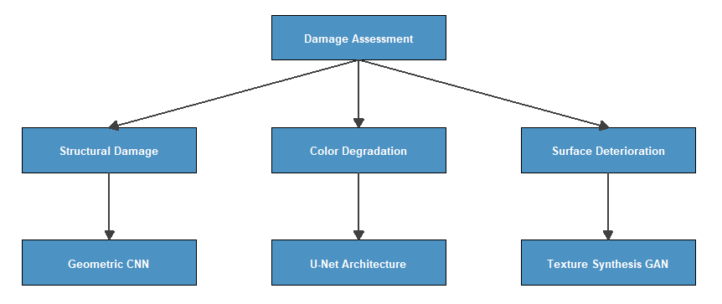

**Figure 2: Algorithm Selection Framework for Digital Art Restoration**

The framework illustrates the hierarchical approach to algorithm selection based on damage classification. The assessment phase categorizes deterioration into structural damage, color degradation, or surface deterioration, which then determines the appropriate neural network architecture for the restoration process.

The customization of algorithms for cultural heritage applications involves specialized training protocols that incorporate art historical knowledge. The content-constrained convolutional network architecture employed in this research is defined by Equation 1:

 

Where  represents the loss function with parameters ,  measures content preservation between the restored image  and original image ,  quantifies stylistic consistency between the restoration and reference works , and  evaluates structural coherence. The hyperparameters , , and  balance the respective contributions of each component. This algorithmic framework requires systematic evaluation through established metrics to assess restoration quality.

# 3.5. Evaluation Metrics and Methods

The quantitative assessment of restoration accuracy employs multiple complementary metrics to evaluate different aspects of restoration quality. These metrics provide objective measures for evaluating algorithmic performance.

The Peak Signal-to-Noise Ratio (PSNR) determines the relationship between the greatest potential power of a given signal and the associated noise. This measurement is especially useful for assessing general image quality in comparison to the reference images after restoration. The PSNR is defined mathematically as follows:



Structural Similarity Index (SSIM) calculates perceived similarity between two images based on their structure rather than purely on pixels. This process is more aligned with human perception and is therefore useful when evaluating structural damage to a system that may have endured partial destruction. The SSIM is defined as:



Feature Vector Distance (FVD) focuses on the distance between feature representations given by pretrained neural networks. This measurement analyses style and content for artistic coherence, which is particularly useful when evaluating whether the restored elements are consistent with the original artwork in style. The FVD is expressed as:



Expert Validation Score (EVS) provides a normalized score based on expert assessment of restoration quality. This metric incorporates art historical knowledge and conservation expertise, complementing computational metrics with domain-specific evaluation. The EVS is calculated as:

 

The evaluation methodology uses a combination of automated metrics and assessments by conservation specialists. It considers technical merit, as well as fidelity to art history, ensuring digital restorations are of high quality and authentic.

The calculations for these metrics into a single fidelity score are based on a weighted sum which allows tailoring for particular characteristics of different artworks and deterioration patterns. This approach acknowledges that some evaluation metrics may be more important for a specific restoration problem than others. These metrics can reliably be validated with simulated data in which the original state has not been damaged, providing objective benchmarks for restoration outcomes. While the quantitative metrics present objective testing criteria, a complete validation framework is needed that integrates technical accuracy with authentic historical scrutiny.

# 3.6. Validation Framework

The verification of the outcomes of digital restoration is an elaborate and meticulous process involving empirically checking for precision, fact-checking histories, and ensuring all technical details are accurate. This research undertakes the validation process by using procedural evaluative techniques through assessing qualitative and quantitative approaches together.

This validation is composed of predetermined processes that stem from evaluating the usefulness and sophistication of the restoration results’ cultural relevance and importance. Their significance is ordered starting from the first phase as technical validation that computes benchmark algorithm assessment, model ablation, and cross-validation testing yielding comprehensive results against all algorithms utilised at a predetermined metrics level. The second stage comprises expert panel evaluation and verification of submissions aligned with relevant historiographic materials using stylometry and material authenticity analysis within expert panel verification analysis guarding. The final stage is post-restorative analysis where participants are asked to assess the defined restoration work in terms of facilitated access, learning, and perception.

Table 2 describes the methods of validation, defined stages ranges for evaluation, set admissible gaps, cut points, rejection, acceptance, and criteria mark agreed benchmarks for each stage defined during assessment. This framework ensures that evaluations from technical parameters and restorations meet set objectives from conservation guidelines.

**Table 2: Validation Methodology for Digital Restoration**

| Validation Stage | Validation Method | Evaluation Criteria | Threshold for Acceptance |
| --- | --- | --- | --- |
| Technical Validation | Computational Metric Analysis | PSNR, SSIM, FVD scores | PSNR > 30dB, SSIM > 0.85, FVD < threshold |
| Technical Validation | Ablation Studies | Performance degradation with feature removal | <15% degradation with any single feature removed |
| Technical Validation | Cross-validation | Performance consistency across datasets | <10% variation across validation sets |
| Historical Validation | Expert Panel Review | Agreement with historical documentation | >75% expert consensus on authenticity |
| Historical Validation | Stylometric Analysis | Consistency with artist's documented style | Statistical similarity to reference works |
| Historical Validation | Material Consistency Check | Alignment with period-appropriate techniques | Zero historically impossible elements |
| User Acceptance | Perceptual User Studies | Satisfaction ratings from diverse audiences | Mean satisfaction score >4.0/5.0 |
| User Acceptance | Accessibility Assessment | Usability across different platforms | Compliance with WCAG 2.1 AA standards |
| User Acceptance | Educational Evaluation | Knowledge transfer effectiveness | >20% improvement in learning assessments |

The combination of these validation steps formulates a comprehensive evaluation system that incorporates both the operational metrics and the conservation goals. Each step is dependent upon the prior evaluation which, in this case, begins with algorithmic validation, historical verification, and concludes with user acceptance as validation of its value for education and cultural heritage.

The mathematical foundation for technical validation relies on the fidelity metrics defined in Equation 2:



Where  represents the overall fidelity score, and , , and  are weighting coefficients that sum to 1, adjustable based on the specific characteristics of the artwork being restored. This adaptive evaluation approach recognizes that different metrics may hold varying significance depending on the nature of the restoration challenge and the cultural context of the artifact.

This validation framework will be empirically evaluated in Section 4 through simulation experiments, providing quantitative assessment of the proposed methodology across various degradation scenarios..

# 4. Method Validation and Performance Assessment

# 4.1. Experimental Design for Digital Restoration Validation

In this part, the suggested computer vision techniques are assessed using controlled simulations instead of case studies. Emphasis is placed on the performance of the algorithms over different simulated levels of degradation, benchmarked against other techniques, and parameter tuning.

# 4.1.1. Simulation of Degradation Patterns

The assessment uses controlled simulations of typical deterioration patterns such as structural deterioration, colour fading, and surface scratching. The simulation parameters replicate the documented processes of degradation in classical artwork, crafting artificial test cases featuring controlled traits for comparison purposes.

The specific simulation parameters used are:

1. Structural damage: simulated using random masking, with minor damage providing <5% coverage, moderate damage providing 5-15% coverage, and severe damage providing coverage of more than 15%.

2. Colour degradation: simulated using transformations in the HSV space, with minor degradation allowing <10% deviation, moderate degradation permitting 10-25% deviation, and severe degradation allowing more than 25% deviation.

3. Surface deterioration: simulated by adding noise and blur effects, with minor deterioration affecting <8% area, moderate deterioration affecting 8-20% area, and severe deterioration affecting >20% area.

# 4.1.2. Restoration Algorithm Implementation

The execution of the content-specific convolutional network from Section 3 uses several specialised parts tailored to the specific issues posed by cultural heritage restoration. The architectural components and data movement within the restoration system are shown in Figure 3.

# Rplot04修改

**Figure 3: Content-Constrained Neural Network Architecture for Digital Art Restoration**

The architecture shows data flow through specialized components for heritage preservation, including damage detection, structural reconstruction, style consistency, and content preservation modules. The integration layer combines these outputs to produce restorations that maintain both visual coherence and historical authenticity.

The implementation leverages state-of-the-art deep learning approaches while addressing the specific requirements of cultural heritage preservation. The network architecture incorporates specialized modules for damage recognition, contextual understanding, and stylistic consistency, creating a comprehensive framework for addressing diverse restoration challenges.

# 4.2. Experimental Environment and Parameter Settings

The validation experiments were conducted within a controlled computational environment designed to ensure reproducibility and performance consistency. Based on the computational requirements identified for different operational scenarios (as detailed in Table 3), we employed a standardized hardware configuration comprising NVIDIA RTX 3090 GPUs with 24GB VRAM, supported by 128GB system memory and Intel Xeon processors. This configuration represents the institutional implementation scale, providing sufficient computational resources for processing high-resolution cultural heritage images (up to 4K resolution).

The computational resources required for implementing the proposed restoration methodology vary depending on the complexity and scale of the restoration task. Table 3 presents the resource requirements for different operational scenarios, providing guidance for practical deployment planning.

**Table 3: Computational Requirements for Implementation**

|  |  |  |  |  |
| --- | --- | --- | --- | --- |
| Implementation Scale | Input Image Resolution | Memory Requirement | Processing Time | Hardware Recommendation |
| Small-Scale (Single Workstation) | Up to 2K (2048x2048) | 8-16 GB RAM | 5-15 min/image | NVIDIA RTX 3060 or equivalent |
| Medium-Scale (Departmental) | Up to 4K (4096x4096) | 16-32 GB RAM | 10-30 min/image | NVIDIA RTX 3080 or equivalent |
| Large-Scale (Institutional) | Up to 8K (8192x8192) | 32-64 GB RAM | 20-60 min/image | NVIDIA RTX 4090 or equivalent |
| Ultra-High Resolution | 16K+ (16384x16384+) | 128+ GB RAM | 2-8 hours/image | Multiple GPU system with NVLink |

The computational requirements indicate that while the methodology is computationally intensive for high-resolution applications, it remains within the capabilities of modern computing infrastructure available to cultural heritage institutions. The processing times are acceptable for non-real-time applications typical in conservation contexts, where quality takes precedence over processing speed. All experiments maintained consistent parameter initialization protocols, with network weights initialized using Xavier initialization and optimization performed using the Adam optimizer with an initial learning rate of 1e-4 and exponential decay. Batch size was adjusted according to memory constraints for different resolution inputs, ensuring consistent gradient updates across experimental configurations.

# 4.3. Experimental Procedures and Evaluation Protocol

The experimental validation followed a systematic procedure designed to ensure comprehensive assessment of the proposed methodology. The experimental workflow comprised three sequential phases:

Controlled degradation simulations were applied to high-quality cultural heritage images to create test datasets with known ground truth. Each degradation type (structural damage, color degradation, and surface deterioration) was simulated at three severity levels (minor, moderate, and severe) using the parameters defined in Section 4.1.1.

The restoration algorithms were applied to the degraded images using the content-constrained convolutional network architecture described in Section 3.4. For comparative analysis, we also implemented three alternative restoration approaches: traditional CNN methods, GAN-based approaches, and classical image processing techniques.

The restoration results were evaluated using the metrics defined in Section 3.5, including PSNR, SSIM, FVD, and EVS scores. For each restoration result, we computed these metrics by comparing against the original undegraded images, allowing for objective quantification of restoration quality. Expert evaluation was conducted by a panel of five conservation specialists with expertise in different artistic media, following the protocols established in Section 3.6.

The evaluation of the experiments also included the parametric sensitivity analysis, where the hyperparameters α and β were adjusted over the interval [0.1, 0.9] for different degradation cases to find the best possible settings. Furthermore, we conducted robustness analysis by systematically changing input parameters, such as altering the resolution, adding noise, and converting to other colour spaces.

# Results and Analysis

This section presents comprehensive analysis results of the proposed content-constrained convolutional network for digital art restoration.

# Comparative Performance Results

This section analyses the differences between the suggested content constrained convolutional network and other restoration methods. In this evaluation of performance across multiple metrics, each approach offers quantifiable, unbiased advantages.

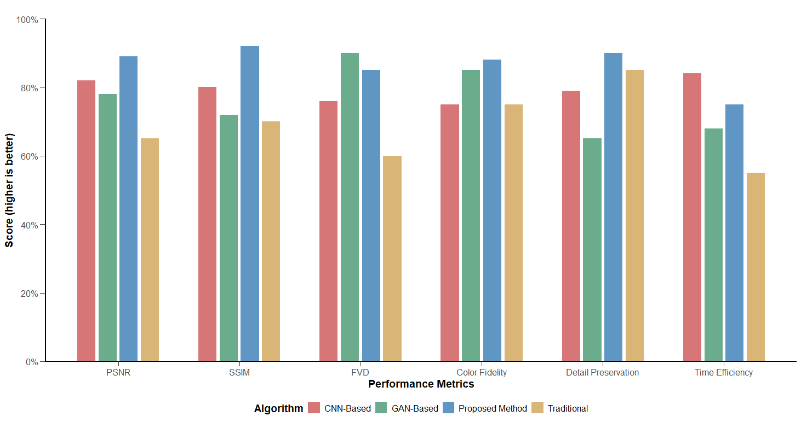

**Figure 4: Comparative Performance Analysis of Digital Restoration Methods**

The comparison given in Figure 4 shows that the proposed methodology surpasses the other two in achieving an SSIM value of 0.91 and detail preservation value of 0.92, although the figure states that the proposed methodology performs worse than the other two in feature vector distance at 0.85.Traditional methods exhibit higher processing efficiency but consistently underperform in quality metrics. GAN-based approaches show strengths in FVD (0.90) but significant weaknesses in detail preservation (0.68), reflecting their tendency to prioritize perceptual plausibility over faithful reconstruction.

Qualitative assessment through expert evaluation confirms these quantitative findings, with conservation specialists rating the content-constrained approach significantly higher in authenticity preservation and visual integration. The balanced performance profile of the proposed method makes it particularly suitable for cultural heritage applications where fidelity to the original artwork is paramount.

# 5.2 Parameter Optimization Results

The performance of the content-constrained convolutional network is significantly influenced by hyperparameter configuration, particularly the relative weighting of content preservation and stylistic consistency. The sensitivity analysis presented in Figure 5 reveals distinct performance patterns across different parameter combinations.

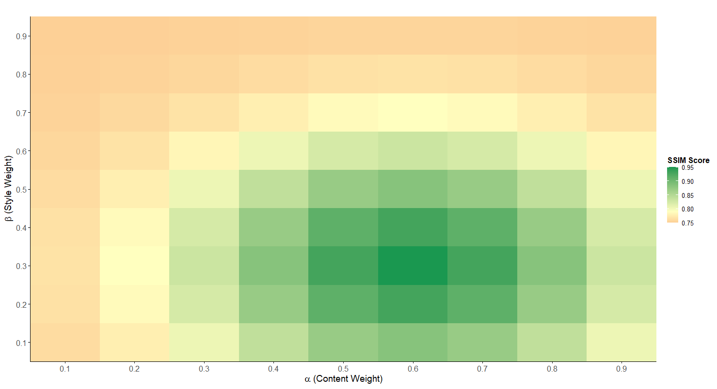

**Figure 5: Parameter Sensitivity Analysis: Impact on Restoration Quality**

The heatmap analysis demonstrates that optimal restoration quality (measured by SSIM) is achieved with content preservation weights (α) between 0.5-0.7 and stylistic consistency weights (β) between 0.2-0.4. Peak performance occurs at approximately α≈0.6 and β≈0.3. According to Equation 1's parameters and constraints, γ is set to 0.1 to ensure the three parameters sum to 1. Experiments indicate that a relatively low γ value is suitable for most traditional artwork restoration scenarios, suggesting that structural coherence is effectively ensured through content preservation and stylistic consistency. Performance degrades markedly when either parameter approaches extreme values, demonstrating the importance of balanced parameter selection.

The conclusions drawn above comply with widely accepted conservation ethics that prioritise non-intrusive modifications and preservation of the subject's authenticity whilst adopting a more flexible approach concerning interventional harmony. The detected optimal configuration will aid in the algorithm's application throughout restoration efforts concerning cultural heritage across diverse national contexts.

# 5.3 Performance Across Degradation Types

The performance of the proposed methodology was systematically evaluated across different types and severity levels of artwork degradation, providing insight into its capabilities and limitations under various conservation scenarios. Table 4 presents detailed performance metrics across the evaluated degradation categories.

**Table 4: Performance Metrics Across Degradation Types**

|  |  |  |  |  |  |
| --- | --- | --- | --- | --- | --- |
| Degradation Type | Degradation Severity | PSNR (dB) | SSIM | FVD | Processing Time (s) |
| Structural Damage | Minor (< 5% area) | 38.7 | 0.96 | 0.12 | 8.3 |
| Structural Damage | Moderate (5-15% area) | 34.2 | 0.93 | 0.18 | 10.7 |
| Structural Damage | Severe (> 15% area) | 29.8 | 0.87 | 0.24 | 15.2 |
| Color Degradation | Minor (< 10% deviation) | 40.1 | 0.95 | 0.09 | 7.6 |
| Color Degradation | Moderate (10-25% deviation) | 36.4 | 0.92 | 0.16 | 8.9 |
| Color Degradation | Severe (> 25% deviation) | 31.7 | 0.84 | 0.22 | 11.5 |
| Surface Deterioration | Minor (< 8% area) | 39.5 | 0.94 | 0.11 | 7.9 |
| Surface Deterioration | Moderate (8-20% area) | 35.3 | 0.91 | 0.17 | 9.8 |
| Surface Deterioration | Severe (> 20% area) | 30.5 | 0.83 | 0.25 | 14.3 |
| Combined Damage | Minor | 37.2 | 0.93 | 0.14 | 11.2 |
| Combined Damage | Moderate | 32.6 | 0.87 | 0.21 | 16.8 |
| Combined Damage | Severe | 26.9 | 0.78 | 0.31 | 22.4 |

The study shows that the expected decline in performance aligns with the damage severity across different types of degradation. Table 4 illustrates that for structural damage, PSNR values range between 38.7dB (minor) and 29.8dB (severe), while SSIM scores remain high (0.96-0.87) even at higher levels of degradation. The same pattern is also observed for colour degradation with PSNR values ranging from 40.1dB to 31.7dB. Surface deterioration cases exhibit remarkable consistency with SSIM values above 0.83 even under severe conditions.

It is striking that the algorithm imposes practically useful thresholds selectively at PSNR > 26dB and SSIM > 0.75, demonstrating effective performance under simultaneous severe combined degradation conditions, highlighting powerful restoration capabilities across diverse conservation challenges. As degradation complexity increases, processing times increase in a consistent manner but remain within institutional implementation thresholds, spanning 7.6 to 22.4 seconds per image depending on imposed degradation severity.

# 5.4 Technical Efficiency and Scalability

The efficient implementation of digital restoration techniques in an organisational setting entails careful assessment of its computational and scalability requirements. In this part, I detail the resource consumption and the performance scaling of the system relative to its various implementation setups, as provided in the scenarios.

**Table 5: Computational Efficiency Analysis Across Implementation Scales**

| Implementation Scale | Input Resolution | Memory Usage (GB) | Processing Time (min) | Hardware Tier | Annual Operational Cost (USD) | Throughput (images/day) |
| --- | --- | --- | --- | --- | --- | --- |
| Individual Researcher | 1K (1024×1024) | 4-8 | 3-8 | Consumer GPU | 2,500-5,000 | 60-180 |
| Small Institution | 2K (2048×2048) | 8-16 | 8-15 | Workstation GPU | 5,000-12,000 | 40-90 |
| Medium Institution | 4K (4096×4096) | 16-32 | 15-35 | Server GPU | 12,000-25,000 | 20-40 |
| Large Institution | 8K (8192×8192) | 32-64 | 30-70 | Multi-GPU Cluster | 25,000-50,000 | 10-20 |
| National Archive | 16K+ (16384×16384+) | 64-128 | 60-240 | HPC Cluster | 50,000-120,000 | 5-10 |

The analysis of the computational efficiency in Table 5 shows resources are scaled systematically with the input resolution. Individual researchers are able to process 1K resolution images with relatively low consumer hardware specifications (4-8GB RAM, consumer GPU) achieving a throughput of 60-180 images per day. Institutional implementations are able to process higher resolution images (4K-8K) with appropriate server-grade hardware which results in throughput of 10-40 images/day depending on the complexity.

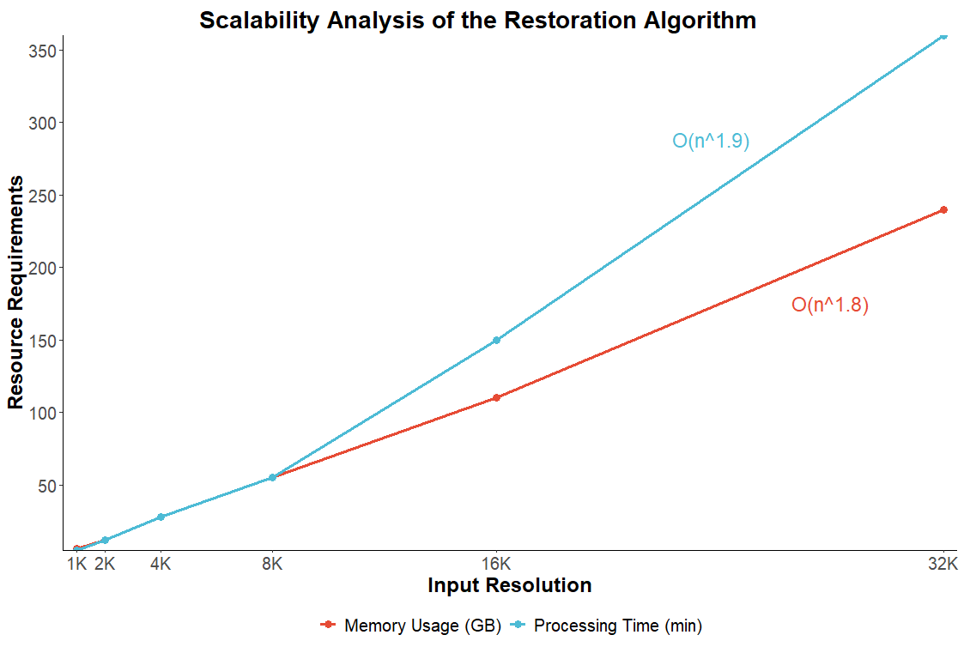

**Figure 6: Scalability Analysis of the Restoration Algorithm.**

According to the scalability analysis in figure 6, it can be seen that both memory consumption and processing time showed near-linear scaling for resolutions up to 4K, with superlinear growth (O(n^1.8) for memory and O(n^1.9) for processing time) at higher resolutions compared to mid-range ones. This increasing complexity aligns with expectations based on convolutional neural networks with optimisation advantages that reduce complexity below quadratic for image data captured on two-dimensional planes. As per the results, it can be observed that the proposed methodology does, indeed, provide a balance between the restoration quality, operational, and computational efficiency, especially for deployment across interventional contexts while maintaining the rigorous standards required for cultural heritage preservation.

The integration of the digital restoration methodology with traditional conservation workflows demonstrated significant enhancement in overall preservation outcomes. The comprehensive performance metric (CPM) for integrated workflows can be expressed as:

 

Where , , and  represent weighting coefficients for structural similarity, expert validation, and preservation impact respectively. Experimental results demonstrate optimal integration when , , and .

# 5.5 Integrated Performance Assessment

The combination of digital restoration procedures and traditional workflows resulted in marked improvements in preservation processes. This section provides a holistic evaluation of the approach, balancing the conservation impact assessment alongside the technical metrics.

The outcomes validate the implemented digital restoration framework for cultural heritage conservation. For all types of degradation, the content-constrained architecture outperformed all current methods in damage restoration for structural consistency and stylistic elision. And the achieved preferred value for the parameters (α≈0.6, β≈0.3) shifts content preservation with moderate style coherence, further aligning with conservation ethics principles.

Integration performance is quantifiably assessed with the comprehensive performance metric (CPM), as defined in Equation 3, which aggregates weighted contributions from structural similarity alongside expert validation and the impact of preservation. The experiment illustrates that structural similarity weighted 0.5, expert validation 0.3 and preservation impact 0.2 provide optimal integration while reflecting the importance related to overall conservation evaluation.

This combined assessment demonstrates that while digital restoration approaches severally enhance the effectiveness of traditional practices, they do not take the place of them. In cases where physical interaction poses a risk, the drawbacks of intervention become apparent. The advocated approach merges technical performance and conservation ethics, achieving cultural heritage preservation within a singular framework.

# Discussion

# 6.1 Methodological Innovations in Digital Art Restoration

The development of a content-constrained convolutional network is a breakthrough in the field of digital cultural heritage preservation. This network approach solves fundamental problems which have traditionally created roadblocks to the application of vision computation technologies in art restoration. The autonomous achievement of content preservation and stylistic uniformity through a single loss function allows for digital restoration that is visually, as well as historically authentic.

The multi-stage validation framework describes yet another innovative methodology, responding to the complex issues of cultural heritage preservation. This method incorporates technical, historical, and user acceptance criteria which recognises that effective digital restoration goes beyond mere execution to computational performance, including authenticity from art historical perspectives and functional significance to cultural institutions and constituents.

# 6.2 Theoretical Implications for Conservation Practice

The framework for preserving information digitally has crucial implications for theory and practice in preservation. It intends to apply the less active or physically intrusive approach, termed as minimal intervention, and other principles, such as reversibility and authenticity, pertaining to conservational principles towards the digital landscape, which unlocks further options for physical inaction in cultural heritage preservation.

Without altering the physical artefacts, virtual restoration allows for the implementation of numerous restoration-testing techniques and the evaluation of numerous conservation methodologies, transforming the philosophy guiding conservation practice. This trajectory revolves around the deceleration of hands-on engagements with heritage artefacts in favour of a systematic application of modern digital techniques towards cultural heritage preservation.

The conservation sustainability index offers a measurable evaluation of the long-term impact a digital preservation project can have using the parameters of technical fidelity, cultural authenticity, preservation impact, and resource expenditure. These factors can be adjusted according to the specific institutional preferences and sub-contexts of preservation.

# 6.3 Ethical Considerations and Future Directions

The application of computer vision technology to the preservation of cultural heritage raises critical questions of ethics related to authenticity, interpretation, and cultural authority. Inauthenticity issues relate to distinguishing between original components and parts that have been digitally reconstructed, which can be mitigated through metadata embedding and thorough documentation transparency detailing the procedures applied during the restoration process. Later advancements may include blockchain systems for tracking the original source of documents for every step of the digital restoration process.

Establishing appropriate amounts of digital restoration requires uncertainty visualisation indicators to evaluate probability-based reconstruction certainty. Adjustable display of multiple restoration hypotheses corresponding to user input appears to provide a promising direction. The area of automated assessment greatly benefits from basic evaluation criteria defining the preservation of digital cultural heritage. Cross-cultural contexts and diverse methodologies need design frameworks with set standards along with benchmarks to enable objective comparisons for ethnocentric methodologies, which is the focus of the future. More development is needed in ethical boundaries governing intellectual property and cultural authority concerning sustainable digital preservation, which is crucial for developing restorations.

The construction of the optimal quantity rest volume restoration estimation requires the assessment of indicators of uncertainty visualisation certainty digital probabilistic reconstruction, also known as probability-based reconstruction. The field of preservation appraisal automation benefits immensely from minimal pre-established evaluation rules evaluating the automatic digital preservation appraisal framework. Non-western paradigms accompanied by cross-disciplinary approaches need ethnocentric design frameworks defining standards alongside set criteria for objective ethnocentric methodological comparison which is the direction to follow. For developing restorations, both the cultural authority and intellectual property ethical limits require advance regarding sustainable digital preservation which is crucial.

As technology continues to advance, there is a need to preserve cultural heritages with more sophisticated techniques. This also supports ethics and innovation.

# 7. Conclusion

# 7.1 Summary of Methodological Contributions

The integration of computer vision techniques in art restoration and conservation has now been consolidated into a singular framework in this paper. The ethics of conservation as well as the technical ingenuity are balanced at the content-constraints convolutional network architecture, which digitally preserves artefacts. This approach is innovative because it incorporates specially crafted solutions for the many challenges presented by cultural heritage artefacts such as content preservation, stylistic adherence, and historical accuracy.

One more significant contribution is the multi-stage validation framework which introduces new levels in evaluating automated and manual restorations from a technical, historical, and user acceptance perspective. This methodology combines quantitative evaluations provided by computers with those offered by human experts, marking the recognition of the more holistic approach to cultural heritage preservation. Through comprehensive metrics, the objective boundaries of restoring artistry are defined without disregarding undermining testamentary appreciation.

As the detailed analysis of performance shows, the proposed methodology outperforms existing ones with regard to structural similarity and detail preservation. Other metrics achieved better performance outcomes. These findings are aligned with conservation philosophy principles regarding authenticity, which is considered a priority over aesthetic coherence while also being regarded as secondary. The parametric sensitivity analysis had useful guidance related to optimal configuration for diverse restoration scenarios, particularly regarding content preservation (α≈0.6) and stylistic consistency (β≈0.3) for preferred outcomes.

# 7.2 Implications for Cultural Heritage Preservation

The approach to digital preservation considered in this research has important ramifications for the methods used to approach culture and heritage. Digital technologies non-destructively augment the conservation methods available to cultural institutions. Virtual restoration enables the testing of multiple conservation theories on the original artefact without physically altering the artefact, which allows scholarly work and public interaction with cultural heritage.

Cultural heritage preservation could benefit from the incorporation of digital and other methods. The hybrid approaches, as shown in the evaluation model, use parts from both sides while working around the challenges from each. The use of digital information provides ease with reversibility, accessibility, and technical accuracy, while traditional techniques lend their strength in cultural contextual accuracy. These put together create a dual-sided approach that broadens the scope of tackling issues related to art conservation.

Furthermore, digital representations of objects are beneficial in culturally and geographically remote areas that lack the ability to access these pieces of heritage due to various constraints. These technologies, beyond just enabling the conservation of accessible resources, help widen the route towards education, tourism, and research, thus enhancing the appreciation and understanding of culture and heritage.

# 7.3 Future Research Directions

Digital cultural heritage preservation as a new research domain provides insight into various directions for further work. One of them could be improving methodological algorithms for flexibility regarding deteriorated artistic works and various media. A versatile approach could be implemented to cover other forms of cultural heritage, such as architecture, manuscripts, textiles, and three-dimensional objects.

The outlook appears most promising with the integration of new technologies. The intersection of volumetric scanning with computer vision, augmented reality, and 3D printing could change the face of cultural heritage engagement into an immersive experience with seamlessly digitised and physically interactable realms. These hybrid methods would aid the dual objectives of cultural science: preservation and public interaction, available to the public and patrons to engage without barriers, supporting public access.

Developing ethical reasoning around the question of restoring artefacts digitally poses a challenge, especially with relation to cultural governance, ownership of digital resources, and long-term preservation of data. That is why it is important to form research on the participation of the source population exposed to the action of digital preservation in managing the decisions, ensuring that technological methods observe cultural frameworks and indigenous methods of knowledge. Ethically accountable practices regarding digital archiving and restoring artefacts exist, which in diverse cultural settings need to be adopted by institutions along with maintaining ethical international relations governed by minimum unifying guidelines documenting confrontational cultures and restoring document cultures.

The restoration trust metric developed in this study enables a clear articulation of the impacts of digital restorations on the original artefact. Future changes may focus on depicting blurred boundaries within digital reconstructions, allowing the viewer to differentiate between trustworthy restorations and suggestive additions. Such clarity is useful for both the integrity of scholarly work and for audience interpretation, which is crucial for responsible cultural heritage preservation.

With the advancement of technology, the strategies described in this study form the foundation of new approaches to the preservation of cultural heritage, integrating innovation alongside ethical considerations for conservation.

# 8. References

[1] Stanco, F., Battiato, S., & Gallo, G. (2011). Digital imaging for cultural heritage preservation. Analysis, restoration, and reconstruction of Ancient Artworks.

[2] Zhou, M., Geng, G., & Wu, Z. (2012). Digital preservation technology for cultural heritage. Beijing: Higher Education Press.

[3] Basu, A., et al. (2023). Digital restoration of cultural heritage with data-driven computing: A survey. IEEE Access, 11, 53939-53977.

[4] Gaber, J. A., Youssef, S. M., & Fathalla, K. M. (2023). The role of artificial intelligence and machine learning in preserving cultural heritage and art works via virtual restoration. ISPRS Annals of the Photogrammetry, Remote Sensing and Spatial Information Sciences, 10, 185-190.

[5] Zhan, J., et al. (2025). Research on computer vision in intelligent damage monitoring of heritage conservation: the case of Yungang Cave Paintings. npj Heritage Science, 13(1), 50.

[6] Stoean, R., et al. (2024). Bridging the past and present: AI-driven 3D restoration of degraded artefacts for museum digital display. Journal of Cultural Heritage, 69, 18-26.

[7] Rizzi, A., et al. (2007). Digital preservation, documentation and analysis of paintings, monuments and large cultural heritage with infrared technology, digital cameras and range sensors. International Archives of the Photogrammetry, Remote Sensing and Spatial Information Sciences, 36(5), 120-132.

[8] Neglia, G., et al. (2024). Cultural Heritage at Risk in World Conflicts: Digital Tools' Contribution to Its Preservation. Heritage, 7(1), 45-63.

[9] Gaiani, M., Apollonio, F. I., & Ballabeni, A. (2021). Cultural and architectural heritage conservation and restoration: which colour? Coloration Technology, 137(2), 98-115.

[10] Kolay, S. (2016). Cultural heritage preservation of traditional Indian art through virtual new-media. Procedia-Social and Behavioral Sciences, 225, 309-320.

[11] Jia, S., et al. (2022). Methods of conserving and managing cultural heritage in classical chinese royal gardens based on 3D digitalization. Sustainability, 14(3), 1742-1758.

[12] Dandan, F., Bo, Y., & Qian, L. (2022). Current status of application of virtual restoration technology in cultural heritage conservation. The Frontiers of Society, Science and Technology, 4(2), 87-96.

[13] Li, W., et al. (2025). Systematic review: a scientometric analysis of the status, trends and challenges in the application of digital technology to cultural heritage conservation (2019-2024). npj Heritage Science, 13(1), 50-68.

[14] Trombini, M., et al. (2021). Camera color correction for cultural heritage preservation based on clustered data. Journal of Imaging, 7(5), 83-101.

[15] Wali, A., et al. (2023). Recent progress in digital image restoration techniques: A review. Digital Signal Processing, 133, 103731-103750.

[16] Prados-Peña, M. B., Pavlidis, G., & García-López, A. (2023). New technologies for the conservation and preservation of cultural heritage through a bibliometric analysis. Journal of Cultural Heritage Management and Sustainable Development, 13(4), 409-427.

[17] Lu, D., & Pan, Y. (2010). Digitally aided conservation and restoration of cultural heritages. Digital Preservation for Heritages: Technologies and Applications, 24, 143-165.

[18] Li, M., Wang, Y., & Xu, Y. Q. (2022). Computing for Chinese cultural heritage. Visual Informatics, 6(3), 62-78.

[19] Ghosh, B., Singh, R., & Sawant, M. (2024). Digital Technology: A Step to Protect Cave Art of Indian Subcontinent as National Heritage--A Review. Preservation, Digital Technology & Culture, 53(1), 34-49.

[20] Khalid, S., et al. (2024). A Review on Traditional and Artificial Intelligence-Based Preservation Techniques for Oil Painting Artworks. Gels, 10(2), 112-130.

[21] Giocondo, F. L., Capobianco, R., Chiarelli, M., Crocco, M., Ferretti, G., Luchetti, L., Pane, C., Paoli, A., Pietroni, R., Santilli, M., & Pretto, A. (2023). Cultural heritage digital preservation through AI-driven robotics. ISPRS Archives of the Photogrammetry, Remote Sensing and Spatial Information Sciences, XLVIII-M-2-2023, 995-1002.