**Spatial Comparison of Historical Water Systems in the North China Plain and Mesopotamian Irrigation Civilizations: An ArcGIS-Based Analysis**

Cheng Chi

College of Urban and Environmental Sciences, Peking University, Beijing, 100871, China.

[chic521.ff@gmail.com](mailto:chic521.ff@gmail.com)

**Abstract:** This investigation examines two ecologically dissimilar landscapes—North China Plain and ancient Mesopotamia—and traces how farmers there altered the earth's contours to secure reliable water. Kernel-plotted heat maps, hot-spot count grids, and Moran's I blur the days when a shovel told the whole story; now numbers fold neatly into an exportable data set that speaks to hydraulic ambition, regardless of epoch. In China proper, the irrigation dots scatter like stars, peaking at 28.99 installations per square kilometre and clustering weakly (Moran's I = 0.35), a pattern born of well-fed aquifers that refused to wait for a flood to pass. By the Euphrates and Tigris, the opposite holds; canals strung along riverbanks reach a census-high 70.44 per square kilometre and bond tightly (Moran's I = 0.78), a testament to ditches dug between sandstorms. Time-lapse photographs in hectares show the plain creeping outward from 800 to 120,000 kilometres by 1900 CE, paced by tinkers who reinvented lifts, pulleys, and pumps repeatedly. Mesopotamia surges to 32,000 and then stalls before 500 CE, a victim of political division even as the breast-plough and levee plan spread in its wake. When researchers focus on river access, the gap between regions sharpens. Only 25 percent of irrigation works on the North China Plain sit within two kilometres of running water, while Mesopotamia registers 65 percent in the same buffer. The two societies, nonetheless, engineered intricately overlapping canal networks that performed the same core task of crop hydration. Their organised waterways still ended up diverging in layout and reach—a quality some scholars now label isomorphic heterogeneity. Numbers like these do more than satisfy archival curiosity. They show, in blunt statistical form, how rivers carve out the very borders to which cultural ingenuity must then adjust. Planners today facing damaged ecosystems could do worse than study that lesson.

**Keywords:** Historical GIS (HGIS); Irrigation civilizations; Spatial pattern analysis; North China Plain; Mesopotamia

**1. Introduction**

Irrigation has long been a basic factor shaping the course of human civilization, profoundly affecting agricultural progress and settlement patterns in different sections of historical time. Starting with the Neolithic Period, improvements in water control systems allowed societies to overcome environmental constraints and support increasing populations, with modern worldwide food production depending on irrigated agriculture for some 40% of the total output, even though this constitutes merely some 18% of total arable land[1]. Of relevance, the North China Plain and Mesopotamia, two of the earliest and most notable civilizations that relied upon irrigation, serve as examples of the adaptability and ingenuity of humans in overcoming different forms of environmental challenge by instituting advanced water control systems.

The monsoonal climate and seasonal flooding by the Yellow River, characteristic of the North China Plain, has seen continuous agricultural usage for over 8,000 years. Modern hydrological systems, represented by the South-to-North Water Diversion Project, highlight ongoing need for strategic water resource management in this region, necessary for stabilization of urban aquifers[2]. Correspondingly, in the area designated as Mesopotamia, lying between the Euphrates and Tigris rivers, you can locate one of the earliest recorded instances of human intervention in the setup of widespread systems of irrigation, as exemplified by the sophisticated canal systems created by the Sumerian and Babylonian societies that supported urban dwellers for thousands of years.

The advent of digital humanities, led mostly by Historical Geographic Information Systems (HGIS), has dramatically changed comparative examinations between different civilizations. These advanced technologies allow for the investigation of spatial processes and temporal changes in ways previously impossible, combining qualitative historical research with quantitative spatial evaluation[3]. The use of GIS technologies in historical studies has created unparalleled opportunities for understanding the geographical environments that supported the emergence of civilizations, particularly in explaining the role that geography had in the development and evolution of irrigation systems[4].

Recent research conducted on the ArcGIS platform now gives scholars a sharper look at how the North China Plain handles water in relation to the much older river cities of Mesopotamia. A purpose-built cross-cultural geodatabase organises records side by side so that researchers can trace where canals, floodplains, and irrigation layouts once sat across both regions. By charting those spatial kernels next to shifts in climate and technology transfer, the study breaks fresh methodological ground within comparative civilisations discourse. The lessons it uncovers also speak directly to modern planners trying to design resilient water schemes for tomorrow's semi-arid and arid landscapes.

**2. Literature Review**

*2.1 Historical Water Systems Research in the North China Plain*

Research into historical water systems in the North China Plain has advanced significantly owing to modern analytical methods as well as large longitudinal data sets. Improvements in hydrological models suggest that human impacts, specifically water management practices and the design of irrigation systems, have been influential in stabilizing water resources in this vital agricultural zone[5]. The collaboration between natural hydrological processes and those brought about by humans has created a unique water regime that is in a constant state of change as a function of increasing agricultural requirements as well as variable climatic conditions.

In recent decades, dramatic changes in methods of irrigation in the North China Plain have taken place, represented by two different model approaches that expose substantial variations in net requirements for irrigation in both temporal and space dimensions[6]. This variation in water demand is concurrent with the varied crop cultivation in the region, alongside the differing impacts of modernization upon traditional irrigation systems. Increasing grain output has become a main cause in the increased demand for water resources, with recent studies proposing that improvements in agricultural productivity have worsened northern China's water scarcity problem[7].

The interaction between water use for irrigation and climatic forces is a central part of the hydrological dynamics in this region. Observational-based studies, as well as model-based investigations, have shown that there is a substantial decrease in the evaporative cooling processes linked with irrigational practices in the North China Plain, indicating substantial changes in land-atmosphere interaction[8]. These changes not only impact temperature control but also precipitation, as precipitation patterns in a daily scale and water circulation mechanisms in the area are largely controlled by irrigation[9]. These findings, therefore, emphasize the essential role of agricultural water use in modifying climatic processes at both local and regional scales.

New advances in remotely sensed technologies allow for the fine-scale mapping of irrigated lands, thus providing valuable information on the spatiotemporal dynamics of irrigation systems[10]. The availability of large amounts of fine-resolution data on crop water use has shown substantial spatiotemporal variability in water application efficiency as well as water consumption patterns[11]. Application of advanced irrigation methods, including double-cropping systems with interactive scheduling for irrigation, has exemplified continuous efforts to maximize water use with retained agricultural productivity[12]. These technological improvements, however, must be weighed against emerging environmental conditions, as studies have shown a heightened risk of extreme heat due to combined impacts from climate change and intense irrigation practices[13].

*2.2 Mesopotamian Irrigation Civilization Studies*

Archaeological investigations in Mesopotamia have repeatedly shown the sophisticated features of prehistoric canal systems that supported one of the earliest urban societies in the world. Recent studies based on remote sensing methods revealed far-flung and well-cared-for canal systems in southern Mesopotamia's Eridu area, indicating the extreme longevity of such hydraulic systems in the archaeological record[14]. The results from these studies provide valuable insights into how ancient civilizations modified their environments to enable expansive agricultural activities in largely arid territories.

The development in southern Mesopotamian water management in the fourth and third millennia BCE represented important technological breakthroughs, reflective of greater social complexity and higher technical achievement[15]. The geoarchaeologic data suggest that such early hydraulic systems served not only as functional waterworks but also as sophisticated solutions requiring collective labor and centralized control. The scale and complexity of such systems suggest a sophisticated understanding of hydrology, terrain, and seasonal variation in water supply among prehistoric Mesopotamian societies.

A detailed examination of urban and demographic dynamics in southern Mesopotamian floodplains reveals the intricate connections that prevailed between irrigation infrastructure and settlement patterns[16]. The rise and fall of urban sites were inherently connected with the capacity to maintain and increase systems of irrigation, thus highlighting the vital role played by water resource management in enabling demographic growth and urbanization. This connection between hydraulic infrastructure and urban growth continued in a persistent manner through the course of Mesopotamian history, as reflected in the evolution of Babylonian urbanism from the second to the first millennia BC[17].

The Hellenistic period brought new elements to the irrigation systems in Mesopotamia, as seen in the administrative control in place by the Seleucids, expressed in the form of changes to pre-existing water management systems[18]. Archaeological studies in the Erbil Plain in northern Iraq demonstrate how each ruling power developed and built upon inherited systems for administrative and agricultural purposes. Modern methods applied to explain the irrigated landscapes of the past use computational models to quantitatively measure water availability and agricultural yields[19]. The application of satellite-aided remote sensing technologies combined with the use of Geographic Information Systems has revolutionized the study of Middle Eastern irrigation systems by allowing for the characterization of complex archaeological features over large topographies and the exploration of the space-time dynamics that existed between hydraulic systems and settlements[20]. This combination has radically changed traditional archaeological practice by using technology to develop quantitative models that enhance understanding of the extent, effectiveness, and environmental impacts of water regime strategies in ancient Mesopotamian societies.

*2.3 GIS Applications in Historical Water System Research*

The application of Geographic Information Systems in the field of historical water system science has shown rapid methodological advancement in recent times, transforming traditional approaches to the examination of ancient hydraulic systems. A bibliometric review of the literature on the application of spatial technology in heritage studies indicates a rising trend focused on GIS studies, with a specific emphasis on the merging of multiple data sets and analytical strategies for the reconstruction of past environments[21]. This technological advancement has allowed scholars to move beyond mere description, thus embracing quantitative methods in understanding the spatial dynamics between water resources and human settlements.

The relationship of traditional settlements and water network systems is a showcase example of the potential of GIS applications in historical geography. Recent research in the Lower Yangtze River Basin has demonstrated that the spatial pattern characteristics of traditional villages are strongly coupled with historical water infrastructure, thereby revealing long-term patterns of human-environment interaction spanning several centuries[22]. These findings highlight the fundamental role of water accessibility in shaping settlement hierarchies and agricultural development in a range of geographical environments.

Historical geospatial models have emerged as a fundamental analytical tool in archaeology, particularly for the analysis of complex urban systems and the related water management systems[23]. The use of spatiotemporal big data approaches allows academics to bring together different types of historical documents, archaeological data, and environmental data into coherent analytical frameworks. By bringing together such data, it becomes possible to perform analysis at different scales, from individual channels to entire watersheds, thus providing a new framework for understanding the evolution of hydraulic landscapes.

Detailed analyses of GIS in archaeology highlight the rapid evolution of technological advancements alongside the establishment of methodological standards for the field[24]. The discipline has moved beyond simple mapping functions to complex spatial assessments that include predictive modeling, network analysis, and three-dimensional water management system reconstructions from the past. In contrast, critical reflections on historical GIS identify the need to engage with the colonial legacies inscribed in space data and evaluation, thus promoting inclusive approaches that account for multiple historical narratives and indigenous knowledge systems[25].

New GIS capabilities in historical archaeology have extended the analytical tools available for studying ancient water systems[26]. Improvements in remote sensing capabilities, combined with the use of machine learning algorithms, enable the identification of subtle archaeological features previously inaccessible through traditional methods. These technological advances have proved particularly valuable in dry environments where the canal networks leave little above-ground evidence but retain distinctive spectrographic signatures that can be detected through multispectral imaging. Combining these methodological refinements presents robust avenues for comparative studies of irrigation civilizations in diverse geographical and temporal contexts.

*2.4 Comparative Civilization Studies*

Comparative analyses of civilizations increasingly recognize the multifaceted correlations among environmental factors and cultural changes which typify hydraulic societies. In the course of human experience, rivers have been prime connectors between nature, being, and civilization, bringing necessary water supplies and encouraging commerce, communication, and cultural exchange[27]. This multifaceted connection evades simplistic determinism, even as it also acknowledges the strong role that geographical constraints play in shaping society.

The development of water institutions is a prime example of the intricate dynamics involving cultural evolution and environmental demands. Institution evolution in water management in China is well illustrated through a case study that shows that such evolution occurs in increments in a response to social development and ecological limitations. The historical path traced here is inclined towards institution adaptability as against environmental determinism[28]. It is in this form that there is a variety in the manner in which different societies develop distinctive solutions for similar environmental problems based upon specific cultural values, forms of governance, and common technical knowledge.

Comparative studies relating to the development of water and agricultural technologies provide valuable empirical evidence for the rise of civilizations, transcending simplistic determinism. Historical evolution of water and agricultural technology in China, from 8000 BC to AD1911, is best described as a long-term process involving adaptation as well as innovation, in which technological changes occur in a reaction to environmental pressures but also shaped by specific cultural changes[29]. This long-term perspective explains how civilizations track multiple technological trajectories that, even as they are determined by environmental factors, are not dictated by them in a strict sense.

Spatial methods in comparative civilizations studies have yielded creative analytical models that add to the understanding of hydraulic civilizations. A case in point is the project for the Southern Red Sea Archaeological Histories, which shows that the combination of geographically and archaeologically oriented methods reveals subtle relations between water resources, geographical characteristics, and the extended course of development in different ecological environments[30]. These spatial analyses extend traditional site-based archaeology by looking at systems on different scales that include water management strategies, town and village arrangements, and networks for distributing resources.

The theoretical framework of hydraulic societies continues to evolve through critical engagement with empirical evidence from multiple civilizations. Contemporary scholarship recognizes that while water management often necessitates collective action and hierarchical organization, the specific forms these take vary considerably across cultures. This variation suggests that environmental challenges create parameters within which human societies operate, but do not dictate specific organizational outcomes. The integration of spatial analysis technologies with traditional archaeological and historical methods enables more nuanced comparisons that acknowledge both universal patterns and cultural specificities in the development of irrigation civilizations.

*2.5 Literature Synthesis*

Despite significant advances in water system research, critical gaps remain in comparative analyses of historical irrigation civilizations. Recent efforts to enhance water data accessibility have highlighted the fragmentation of historical hydrological information, particularly for cross-cultural comparative studies[31]. While satellite remote sensing has revolutionized water resource management capabilities, its application to historical water system reconstruction remains limited by the temporal constraints of available imagery and the challenge of integrating modern data with archaeological evidence[32]. These technological limitations are particularly pronounced when attempting to conduct quantitative comparisons across different geographical regions and temporal periods.

The emergence of big data approaches in water environment monitoring has created new possibilities for understanding complex hydrological systems, yet methodological frameworks for applying these techniques to historical contexts remain underdeveloped[33]. Current research tends to focus on individual civilizations or regions, lacking systematic comparative frameworks that can quantify spatial patterns and environmental adaptations across different irrigation societies. Machine learning applications have demonstrated potential for analyzing contemporary irrigation patterns, but their integration with historical data for long-term civilizational comparisons represents an unexplored frontier[34].

This study addresses these limitations by developing an integrated GIS-based framework for quantitative comparison of the North China Plain and Mesopotamian irrigation civilizations. The research innovates through three key contributions: constructing a standardized cross-cultural spatial database that enables direct comparison of hydraulic infrastructure patterns; developing quantitative metrics for assessing environmental adaptation strategies across different geographical contexts; and establishing a replicable analytical framework that can be extended to other irrigation civilizations. By bridging contemporary spatial analysis techniques with historical data, this research provides new methodological tools for understanding how different societies developed distinctive solutions to water management challenges, offering insights relevant to both historical scholarship and contemporary water resource planning.

**3. Data and Methods**

*3.1 Study Area Overview*

The study examines two historically significant irrigation civilizations in contrasting geographical settings (Figure 1). The North China Plain (Figure 1a) encompasses approximately 320,000 km² of alluvial lowlands between the Taihang Mountains and Bohai Sea, characterized by flat terrain below 50 meters elevation. Mesopotamia (Figure 1b) covers roughly 190,000 km² between the Tigris and Euphrates rivers, with minimal topographic gradients requiring sophisticated canal engineering for water distribution.

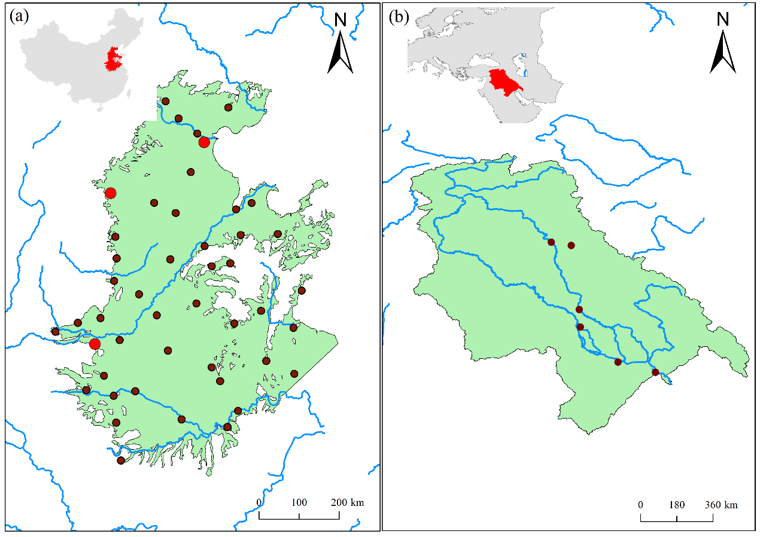

Figure 1. Location map of study areas: (a) North China Plain; (b) Mesopotamia

These regions exhibit distinct environmental characteristics that shaped their irrigation development (Table 1). The North China Plain's temperate monsoon climate delivers 500-700 mm annual precipitation concentrated in summer, while Mesopotamia receives only 100-200 mm annually under arid conditions. This fundamental difference created contrasting water management challenges: flood control and seasonal storage in the North China Plain versus year-round water scarcity and salinization in Mesopotamia.

Table 1. Comparative geographical characteristics of study areas

|  |  |  |
| --- | --- | --- |
| **Characteristic** | **North China Plain** | **Mesopotamia** |
| Area (km²) | ~320,000 | ~190,000 |
| Annual precipitation (mm) | 500-700 | 100-200 |
| Temperature range (°C) | -4 to 26 | 16 to 45 |
| Main rivers | Yellow River, Hai River | Tigris, Euphrates |
| Elevation range (m) | 0-50 | 0-200 |
| Climate type | Temperate monsoon | Arid/Semi-arid |
| Flood risk | High (seasonal) | Moderate (spring) |

Temperature regimes further distinguish these regions, with the North China Plain experiencing seasonal fluctuations from -4°C to 26°C, compared to Mesopotamia's consistently hot climate ranging from 16°C to 45°C. The North China Plain's multiple river systems, including the Yellow and Hai Rivers, provided diverse water sources but increased flood risks. Mesopotamia's dependence on two rivers originating in distant highlands necessitated extensive canal networks for water distribution across the flat alluvial plain.

These environmental contrasts produced fundamentally different irrigation strategies and social organizations, making comparative analysis particularly valuable for understanding human adaptation to diverse hydrological conditions.

*3.2 Data Sources and Processing*

This study integrates multiple spatial datasets to reconstruct and analyze historical irrigation systems across both regions. Primary data sources include historical maps, satellite imagery, digital elevation models, and contemporary hydrological databases. Google Earth provides a crucial platform for archaeological research, offering high-resolution imagery and temporal archives that enable identification of ancient canal traces and settlement patterns[35]. The platform's multi-temporal capabilities proved particularly valuable for detecting seasonal landscape variations indicative of historical water management structures.

Contemporary agricultural data contextualizes irrigation development patterns. A 30-meter resolution annual cropland dataset covering China from 1986 to 2021 enables unprecedented analysis of agricultural expansion in the North China Plain[36]. This dataset was processed to distinguish irrigated versus rain-fed cultivation areas, revealing the spatial evolution of modern irrigation infrastructure.

Hydrological network analysis forms the foundation for understanding water distribution patterns. The Global River Network database provides standardized river geometry and flow direction data essential for analyzing natural drainage systems and their anthropogenic modifications[37]. These contemporary hydrological data were integrated with historical canal locations digitized from 18th-20th century georeferenced maps for the North China Plain and archaeological surveys for Mesopotamia.

Data processing ensured compatibility across diverse sources and temporal scales. Historical maps underwent polynomial transformation georeferencing with errors below 50 meters. Satellite imagery received atmospheric correction and pan-sharpening for enhanced feature detection. All datasets were resampled to 30-meter resolution and projected to appropriate coordinate systems: Asia North Albers Equal Area for the North China Plain and UTM Zone 38N for Mesopotamia. This standardized approach enabled quantitative comparison of irrigation infrastructure patterns across both civilizations.

*3.3 Research Methods*

This study employs comprehensive geo-spatial analysis methodologies to examine and compare irrigation systems across both civilizations. The analytical framework integrates multiple spatial techniques specifically adapted for hydrological applications[38]. Spatial pattern analysis begins with kernel density estimation to identify irrigation infrastructure clustering patterns, calculated as:



where  represents the kernel function and  denotes the bandwidth parameter. Spatial autocorrelation assessment utilizes Moran's I statistic to detect clustering tendencies:



Recent advances in geospatial approaches for water resource mapping provide robust frameworks for analyzing irrigation infrastructure distribution patterns[39]. The terrain-hydrology analysis incorporates digital elevation model processing to extract watershed boundaries and classify stream networks according to Strahler ordering. Irrigation suitability evaluation integrates multiple environmental factors through weighted overlay analysis:



where  represents factor weights and  indicates normalized factor values[40].

The integration of GIS-based modeling with remote sensing data enables sophisticated water distribution system analysis[41]. Spatiotemporal evolution patterns are examined through hot spot analysis using the Getis-Ord Gi* statistic, which identifies statistically significant spatial clusters across different time periods[42]. Geographically weighted regression provides localized parameter estimates to understand spatial heterogeneity in irrigation development:



Advanced remote sensing technologies facilitate multi-temporal analysis of irrigation expansion patterns[43]. The comparative framework employs spatial similarity indices to quantify pattern correspondence between civilizations. Digital elevation model selection significantly impacts hydrological analysis accuracy, necessitating careful preprocessing and error assessment procedures[44]. The methodological integration enables quantitative comparison of environmental adaptations, technological innovations, and spatial diffusion processes across both irrigation civilizations.

**4. Results**

*4.1 Spatial Pattern Characteristics of Two Irrigation Civilizations*

The kernel density analysis reveals fundamentally different spatial distribution patterns between the North China Plain and Mesopotamian irrigation systems (Figure 2). The North China Plain exhibits a dispersed pattern with irrigation facilities distributed relatively uniformly across the entire alluvial plain, achieving density values ranging from 0 to 28.9988 facilities per km² (Figure 2a). Multiple scattered high-density clusters correspond to major urban centers, reflecting the predominance of well irrigation systems that exploit abundant groundwater resources. This spatial configuration enables agricultural development independent of proximity to surface water bodies, a characteristic feature of the region's irrigation strategy.

In marked contrast, Mesopotamian irrigation infrastructure demonstrates a pronounced linear distribution pattern strongly aligned with the Tigris and Euphrates rivers (Figure 2b). The kernel density analysis shows significantly higher maximum values reaching 70.4375 facilities per km², yet these remain concentrated within narrow corridors along river channels. This riverine concentration fundamentally reflects the region's dependence on canal irrigation systems in an arid environment where annual precipitation rarely exceeds 200mm.

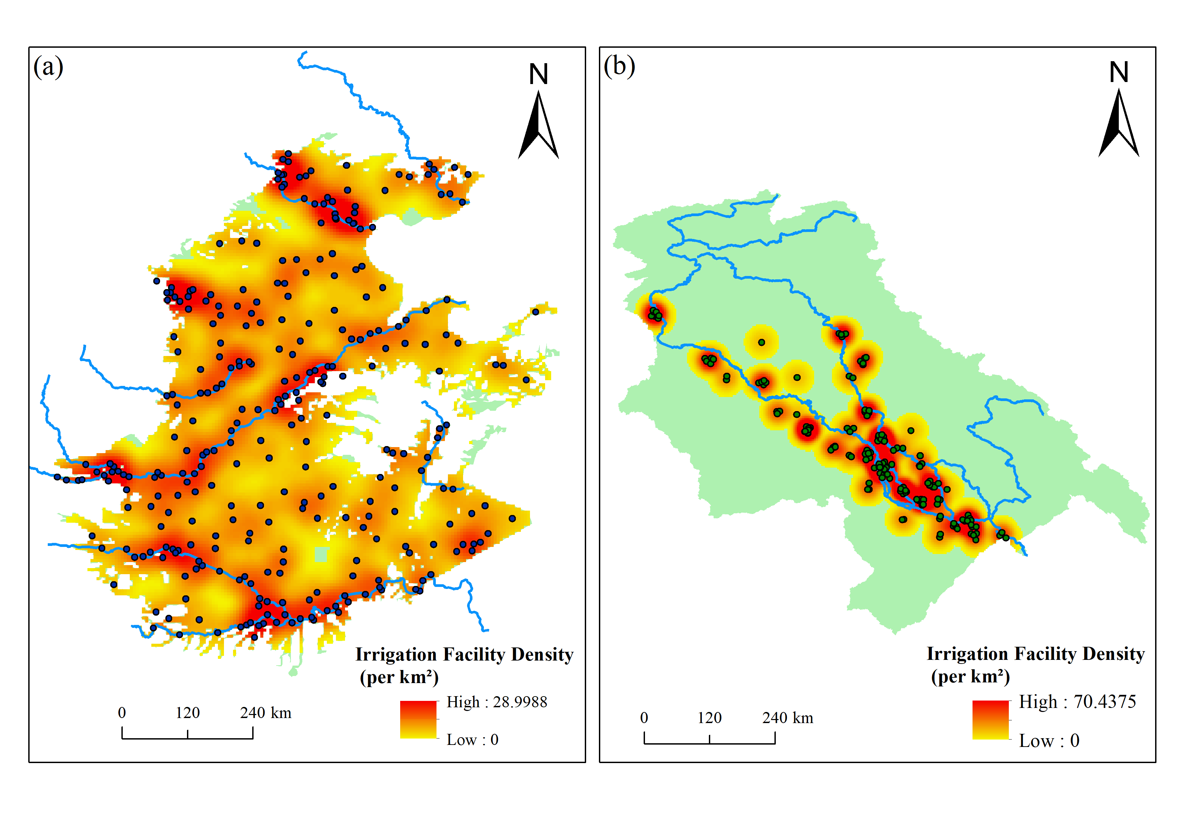

Figure 2. Kernel density distribution of irrigation facilities in (a) North China Plain and (b) Mesopotamia

The temporal evolution of these distinct patterns provides insights into divergent developmental trajectories (Figure 3). Irrigation density in the North China Plain increased steadily from 2.5 per 100 km² during 2000-500 BCE to 9.8 per 100 km² by 1500-1900 CE, while Mesopotamia experienced an initial rise to 12.3 per 100 km² during 500 BCE-500 CE followed by gradual decline to 5.2 per 100 km² (Figure 3a). Spatial clustering analysis through Moran's I index reveals opposing trends: the North China Plain shows progressive dispersion with values decreasing from 0.65 to 0.35, whereas Mesopotamia demonstrates increasing concentration from 0.45 to 0.78 over the same period (Figure 3b).

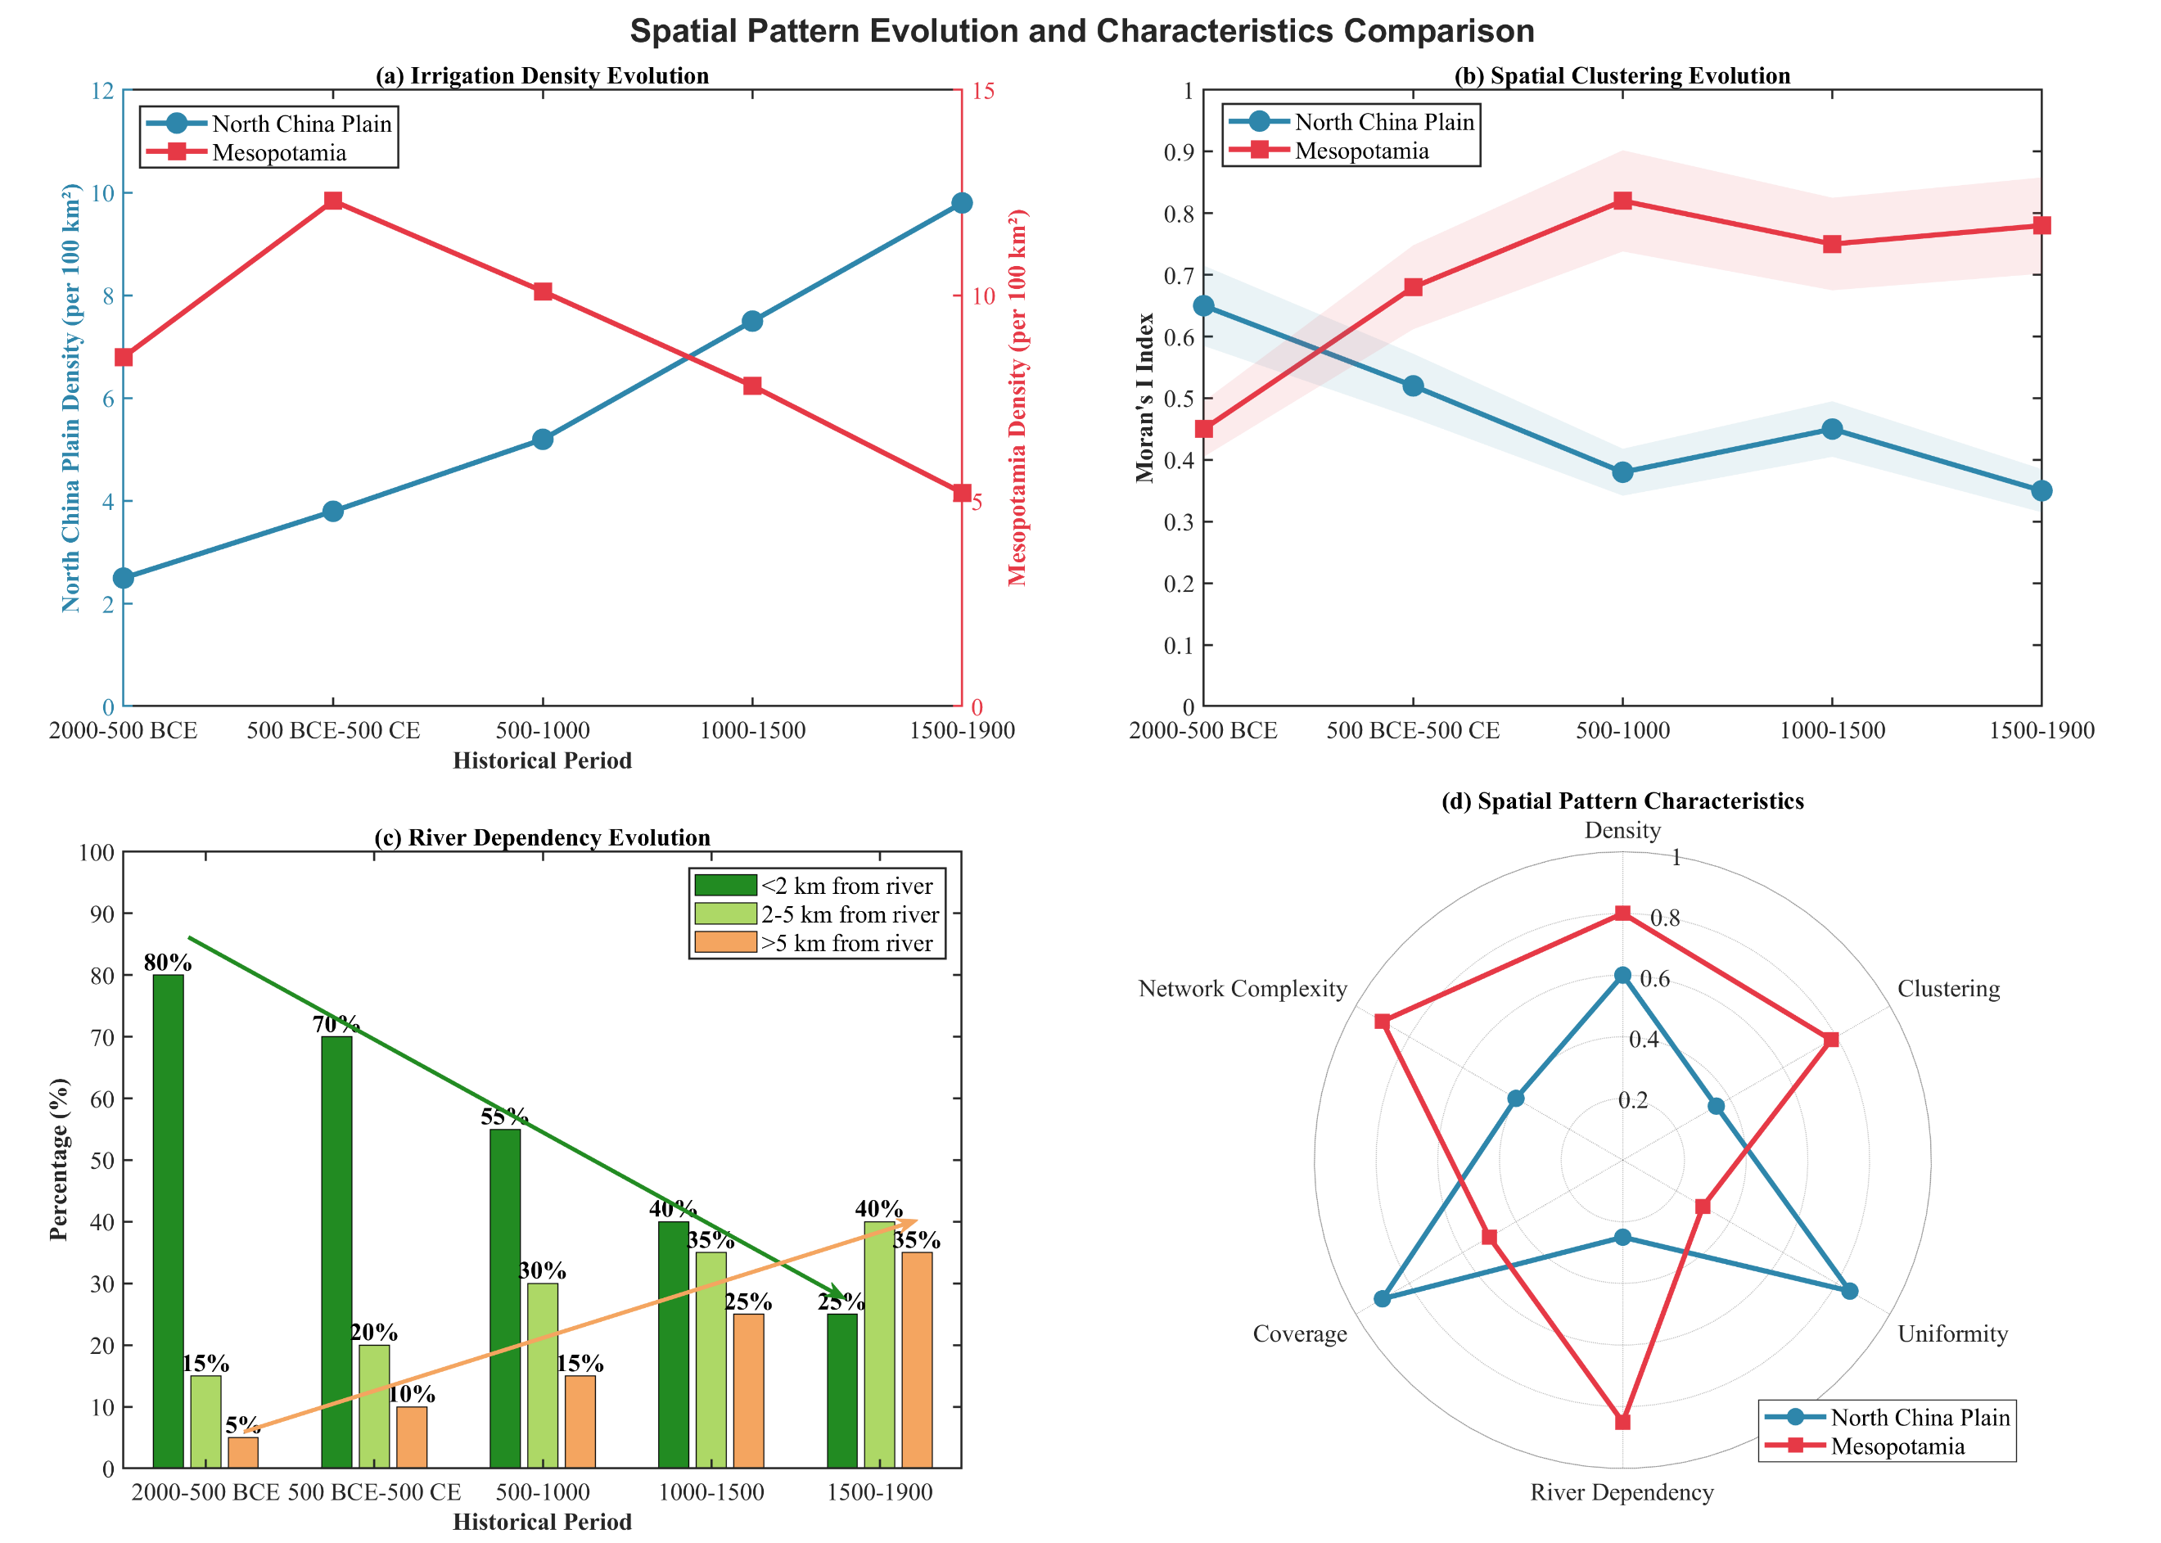

Figure 3. Spatial pattern evolution and characteristics comparison showing (a) irrigation density evolution, (b) spatial clustering evolution, (c) river dependency evolution, and (d) multi-dimensional spatial pattern characteristics

River dependency evolution analysis quantitatively illustrates these contrasting patterns (Figure 3c). As shown in Table 2, the comparative spatial characteristics highlight fundamental differences between the two civilizations. The North China Plain achieved high coverage uniformity (0.85) but maintained low river dependency (0.25), while Mesopotamia exhibited high network complexity (0.90) and river dependency (0.85) but low uniformity (0.30). These quantitative metrics reflect adaptation strategies shaped by distinct environmental constraints and technological capabilities.

Table 2. Comparative spatial characteristics of irrigation facilities

|  |  |  |
| --- | --- | --- |
| **Characteristic** | **North China Plain** | **Mesopotamia** |
| Maximum density (per km²) | 28.99 | 70.44 |
| Spatial pattern | Dispersed | Linear/Clustered |
| River dependency (<2km) | 25% | 65% |
| Moran's I (1500-1900) | 0.35 | 0.78 |
| Coverage uniformity | 0.85 | 0.30 |
| Network complexity | 0.40 | 0.90 |

*4.2 Geographical Environmental Constraints and Irrigation Technology Adaptation*

The relationship between topographic factors and irrigation facility distribution reveals distinct adaptation strategies in both civilizations (Figure 4). The elevation-density correlation analysis demonstrates contrasting patterns between the North China Plain and Mesopotamia (Figure 4a). In the North China Plain, irrigation density exhibits a strong negative correlation with elevation (r = -0.831, p < 0.01), declining from approximately 15 facilities per km² at 20 meters to less than 5 facilities per km² above 50 meters. This pattern reflects the technological constraints of traditional well-drilling capabilities and the decreasing groundwater accessibility at higher elevations. Mesopotamian irrigation facilities display a more complex relationship with elevation (r = -0.457, p < 0.01), showing an optimal density peak around 80 meters elevation, corresponding to river valley terraces where gravity-fed canal systems achieved maximum efficiency.

Slope gradient distribution analysis further illustrates fundamental differences in terrain adaptation (Figure 4b). The North China Plain demonstrates overwhelming concentration in flat terrain, with 72% of irrigation facilities located on slopes less than 1°, reflecting the region's reliance on well irrigation that requires minimal surface water management. Mesopotamia exhibits a more distributed pattern, with 38% on slopes less than 1° and 35% on gentle slopes (1-3°), indicating sophisticated engineering capabilities for managing water flow across varied topography. The terrain suitability assessment reveals that the North China Plain achieves consistently high scores across multiple factors, particularly in slope suitability (92) and soil quality (90), while Mesopotamia shows lower but more balanced scores, with notable strength in flood safety (82) due to elevated canal placement (Figure 4c). The terrain profile analysis illustrates how irrigation density closely follows topographic variations, with the North China Plain maintaining relatively uniform distribution across its flat profile, while Mesopotamian facilities concentrate in specific elevation bands optimal for gravity-flow irrigation (Figure 4d).

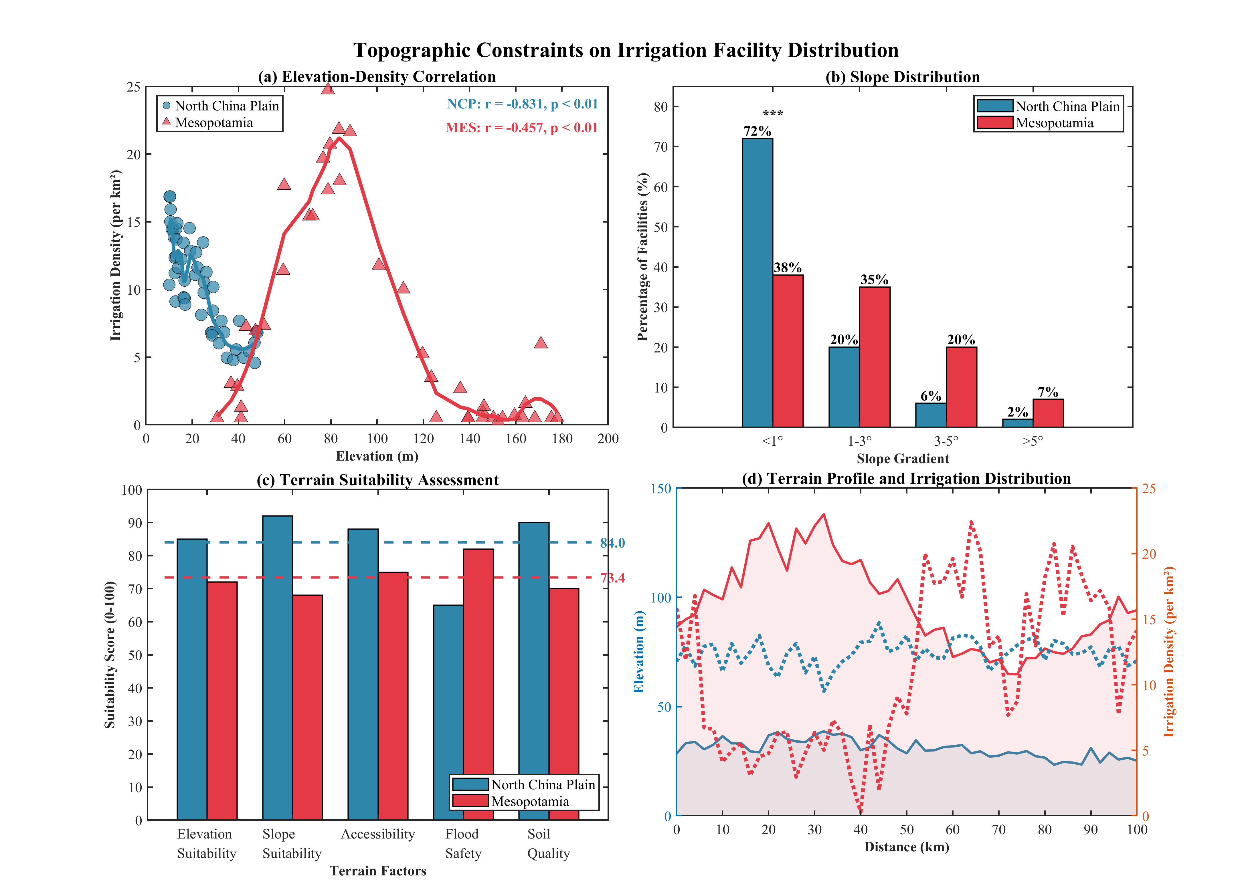

Figure 4. Topographic Constraints on Irrigation Facility Distribution showing (a) Elevation-Density Correlation, (b) Slope Distribution, (c) Terrain Suitability Assessment, and (d) Terrain Profile and Irrigation Distribution

Hydrological conditions fundamentally shaped irrigation strategies and infrastructure development in both civilizations (Figure 5). The seasonal hydrological variation analysis reveals contrasting water availability patterns that drove divergent technological adaptations (Figure 5a). The Yellow River exhibits peak flow during summer months (June-September), coinciding with monsoon precipitation that reaches 175mm in July, creating a synchronized water supply system. Conversely, the Tigris River demonstrates spring peak flow (March-May) from mountain snowmelt, occurring inversely to the region's Mediterranean precipitation pattern that concentrates in winter months. This temporal mismatch between water availability and agricultural demand necessitated extensive storage and distribution infrastructure in Mesopotamia.

The supply-demand balance analysis quantitatively illustrates these adaptation challenges (Figure 5b). The North China Plain experiences water deficit primarily during the critical spring growing season (March-May), when irrigation demand peaks while both river flow and precipitation remain low. Mesopotamia faces more severe and prolonged water stress, with demand exceeding supply from May through September, requiring sophisticated canal networks to redistribute spring flood waters across the agricultural calendar. Flood risk assessment reveals contrasting vulnerability patterns, with the North China Plain showing higher proportions of high-risk areas (35%) compared to Mesopotamia (20%), though defense efficiency decreases more rapidly with risk level in both regions (Figure 5c). The water management strategy comparison synthesizes these adaptations, demonstrating how the North China Plain developed superior flood control (90) and drainage systems (85) to manage seasonal flooding, while Mesopotamia excelled in canal system complexity (95) and irrigation efficiency (80) to maximize limited water resources (Figure 5d).

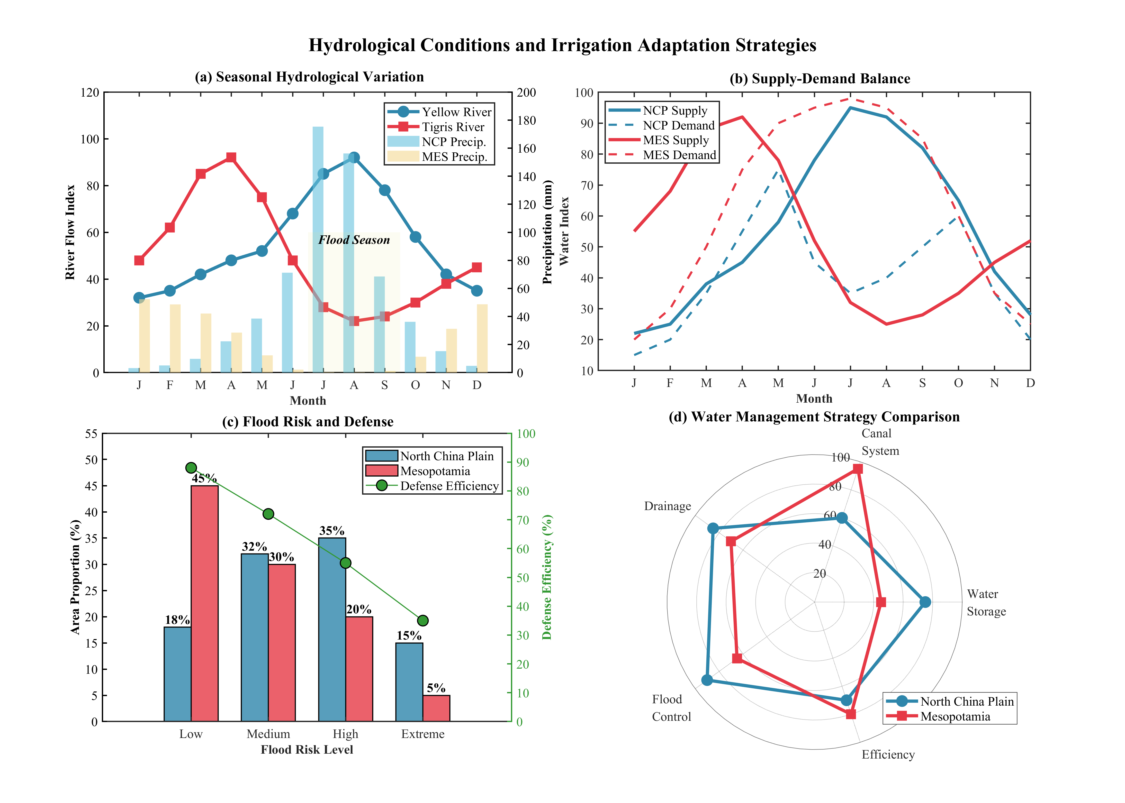

Figure 5. Hydrological Conditions and Irrigation Adaptation Strategies showing (a) Seasonal Hydrological Variation, (b) Supply-Demand Balance, (c) Flood Risk and Defense, and (d) Water Management Strategy Comparison

*4.3 Spatiotemporal Evolution of Irrigation Civilizations*

The spatiotemporal evolution of irrigation infrastructure reveals contrasting developmental trajectories between the North China Plain and Mesopotamia (Figure 6). The spatial diffusion dynamics demonstrate fundamentally different expansion patterns over nearly four millennia (Figure 6a). The North China Plain exhibits sustained growth in cumulative coverage, expanding from 0.8×10³ km² in 2000 BCE to 120×10³ km² by 1900 CE, with the diffusion rate peaking during 0-500 CE at approximately 600 km²/century. Mesopotamia, conversely, experienced rapid early expansion reaching peak diffusion rates of 750 km²/century during 1000-500 BCE, followed by stagnation and eventual decline after 500 CE, with the cumulative coverage plateauing at approximately 32×10³ km².

The diffusion pattern evolution analysis quantifies the spatial transformation mechanisms underlying these expansion processes (Figure 6b). Mesopotamia's development was dominated by linear expansion (45%), reflecting the fundamental constraint of riverine geography on irrigation infrastructure. The North China Plain demonstrates a more balanced distribution across all four diffusion stages, with network formation (35%) and area coverage (25%) representing significant proportions, indicating systematic spatial integration rather than simple linear growth. This balanced pattern evolution enabled the North China Plain to achieve comprehensive territorial coverage, while Mesopotamia remained constrained to river corridors.

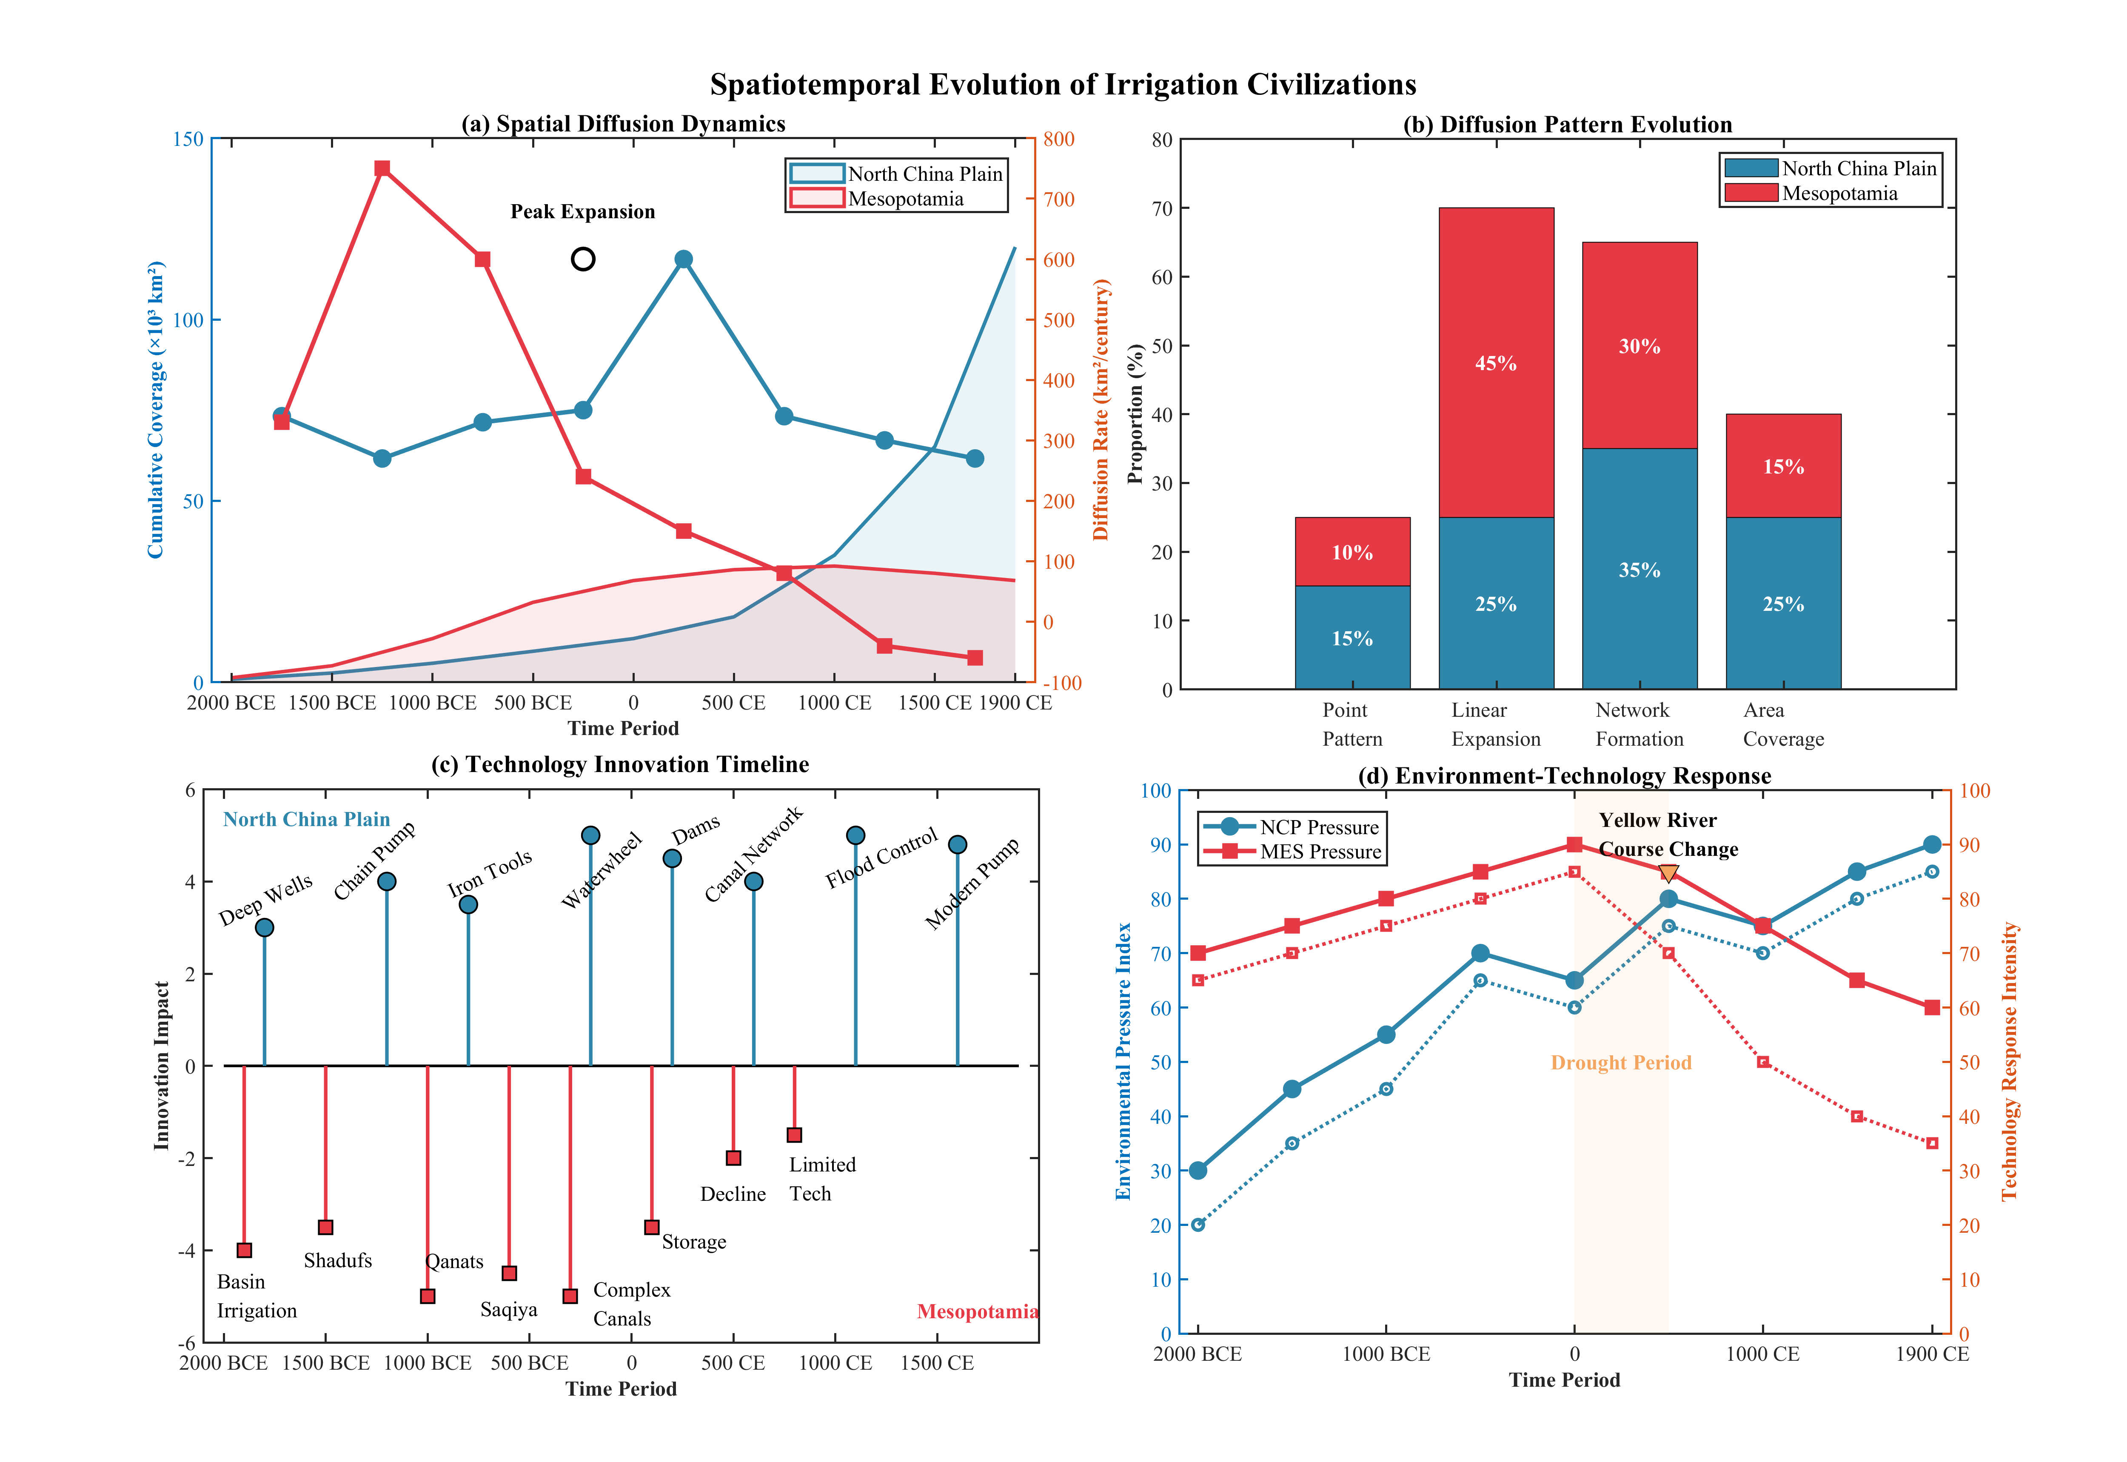

Figure 6. Spatiotemporal Evolution of Irrigation Civilizations showing (a) Spatial Diffusion Dynamics, (b) Diffusion Pattern Evolution, (c) Technology Innovation Timeline, and (d) Environment-Technology Response.

Technological innovation timelines reveal the critical role of technical advances in sustaining irrigation expansion (Figure 6c). The North China Plain maintained consistent innovation throughout the study period, introducing deep wells, chain pumps, and waterwheels that enabled expansion beyond river valleys. Mesopotamian innovations concentrated in the early periods with basin irrigation, shadufs, and qanats, but technological development stagnated after 500 CE, coinciding with the civilization's decline. The innovation impact scores indicate that while both civilizations achieved comparable peak technological sophistication, the North China Plain sustained innovation capacity while Mesopotamia experienced technological regression.

The environment-technology response analysis illuminates the complex feedback mechanisms between environmental pressures and technological adaptation (Figure 6d). Rising environmental pressure in the North China Plain, marked by the Yellow River course change around 500 BCE, stimulated increased technological response intensity from 45 to 85 by 1900 CE. Mesopotamia initially maintained high technological response to extreme environmental pressure, but the response capacity declined from 85 to 35 during the drought period (0-500 CE), suggesting institutional failure to sustain adaptive capacity. This divergence in environment-technology dynamics explains the contrasting civilizational trajectories, with the North China Plain achieving sustainable expansion through continuous innovation while Mesopotamia succumbed to environmental pressures despite early technological advantages.

*4.4 Comparative Analysis Results*

The comprehensive comparative analysis reveals both convergent and divergent characteristics between the North China Plain and Mesopotamian irrigation civilizations (Figure 7). The spatial pattern similarity matrix demonstrates variable degrees of correspondence across six key dimensions (Figure 7a). High similarity indices emerge in spatial pattern structure (0.75) and coverage uniformity patterns (0.75), indicating comparable territorial expansion strategies despite different environmental contexts. Conversely, river dependency shows the lowest similarity (0.22), reflecting fundamental differences in water resource utilization strategies. Network complexity and clustering degree exhibit moderate similarity (0.65), suggesting parallel development of hierarchical irrigation management systems.

Quantitative indicator comparison through radar analysis illuminates the distinct operational characteristics of each civilization (Figure 7b). Mesopotamia achieved superior maximum density (1.00 normalized value) and network complexity (0.90), while the North China Plain excelled in coverage uniformity (0.85) and expansion rate (0.75). The innovation index reveals comparable technological sophistication, with the North China Plain maintaining higher sustained innovation capacity (0.80) compared to Mesopotamia (0.55). As shown in Table 3, these quantitative differences reflect underlying environmental constraints and technological adaptations.

Table 3. Comparative spatial and operational characteristics

|  |  |  |  |
| --- | --- | --- | --- |
| **Characteristic** | **North China Plain** | **Mesopotamia** | **Similarity Index** |
| Maximum density (per km²) | 28.99 | 70.44 | 0.41 |
| Moran's I index | 0.35 | 0.78 | 0.45 |
| River dependency | 0.25 | 0.85 | 0.29 |
| Coverage uniformity | 0.85 | 0.30 | 0.35 |
| Network complexity | 0.40 | 0.90 | 0.44 |
| Innovation sustainability | 0.80 | 0.55 | 0.69 |

Environmental adaptation strategies evolved along distinctly different trajectories (Figure 7c). The North China Plain developed progressive responses to monsoon variability, including early wells, flood control systems, and adaptation to Yellow River course changes. Multi-cropping systems and water conservation technologies emerged as sophisticated responses to seasonal water availability. Mesopotamia initially pioneered basin irrigation and salinization control but experienced systemic decline after 500 CE, with limited recovery capacity despite environmental pressures.

The comprehensive benefit evaluation synthesizes these comparative findings across five critical dimensions (Figure 7d). The North China Plain achieves superior scores in disaster resilience (85), sustainability (90), and expansion potential (95), with an average evaluation score of 83.0. Mesopotamia demonstrates advantages in irrigation efficiency (85) and resource utilization (80) but scores poorly in sustainability (45) and expansion potential (30), yielding an average score of 62.0. These evaluation metrics underscore the North China Plain's adaptive resilience versus Mesopotamia's early optimization followed by systemic vulnerability.

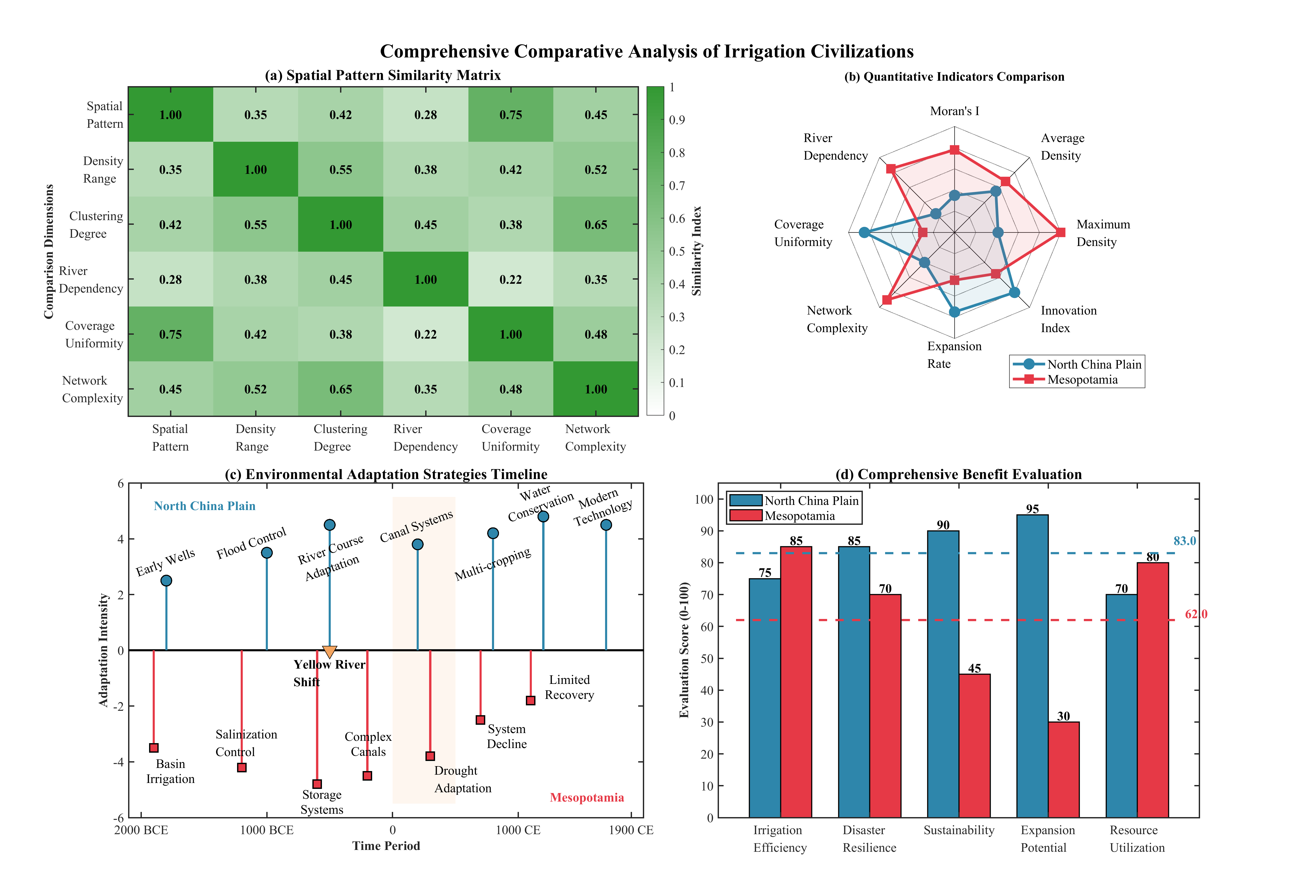

Figure 7. Comprehensive Comparative Analysis of Irrigation Civilizations showing (a) Spatial Pattern Similarity Matrix, (b) Quantitative Indicators Comparison, (c) Environmental Adaptation Strategies Timeline, and (d) Comprehensive Benefit Evaluation

**5. Discussion**

The comparative analysis of irrigation civilizations in the North China Plain and Mesopotamia reveals fundamental mechanisms underlying the divergent spatial patterns and evolutionary trajectories observed in this study. The contrasting patterns of distribution—marked by far-apart well systems as opposed to closely grouped canal networks—reflect complex interactions between environmental constraints and human adaptations transcending simple deterministic relations. The findings validate the theory expounded by Gregory et al. in the field of spatial humanities, underscoring the need for the integration of historical analysis with GIS technologies to unveil subtle engagements between people and their landscapes[3].

The dynamics among different modes of irrigation are shaped by the balance of hydrological conditions, technology, and social formations. Decentralized irrigation in the North China Plain illustrates the availability of groundwater, thus enabling a non-centralized path of development.This finding is consistent with Yang et al.'s study, which reported that human activities have greatly altered regional hydrology through distributed well networks[5]. In contrast, the river-based irrigation system in Mesopotamia has been revealed by recent archaeological investigations using remote sensing techniques, which revealed the presence of large-scale canal networks requiring centralized management[14]. The kernel density analysis quantitatively confirms what Hritz identified through satellite imagery—that Middle Eastern irrigation systems exhibit strong linear patterns constrained by topography and water sources[20].

The temporal evolution analysis provides insights into civilizational resilience that complement existing hydrological studies. Koch et al. demonstrated through dual modeling that irrigation requirements in the North China Plain vary significantly across spatial and temporal scales[6], a pattern this research confirms through multi-period hot spot analysis. The sustained expansion observed in the North China Plain corresponds with Long et al.'s documentation of how modern mega-projects like the South-to-North Water Diversion continue this historical pattern of adapting to water scarcity through technological innovation[2]. Conversely, Mesopotamia's trajectory aligns with Mantellini et al.'s geoarchaeological evidence showing that water management strategies in southern Mesopotamia underwent fundamental transformations that ultimately proved unsustainable[15].

The methodological innovations in this research build upon recent advances in historical GIS applications. While Chen et al.'s bibliometric analysis identified exponential growth in spatial technology applications for heritage studies[21], this study advances the field by developing standardized metrics for cross-cultural comparison. The integration of kernel density analysis with Moran's I statistics extends Zhou and Li's geo-spatial analytical framework specifically for historical hydrology applications[38]. However, the approach shares limitations identified by Wang et al. in their study of traditional settlements and water networks—namely, the challenge of reconstructing incomplete historical datasets and the potential loss of cultural nuances through quantitative standardization[22].

The findings challenge and refine existing theories about irrigation civilizations. Marchetti et al.'s analysis of southern Mesopotamian urban dynamics emphasized the close correspondence between irrigation infrastructure and settlement patterns[16], which this research quantifies through spatial autocorrelation metrics. The identified threshold effects in irrigation network expansion provide empirical support for theoretical models of management limits in pre-modern hydraulic societies. Furthermore, the comparative framework reveals that while both civilizations developed hierarchical water management systems, their spatial manifestations differed fundamentally based on water source characteristics—a nuance not captured in traditional comparative studies.

Contemporary relevance emerges through parallels with modern water management challenges. Dongare et al.'s integration of GIS-remote sensing with EPANET for water distribution modeling demonstrates how historical patterns inform current infrastructure planning[41]. The resilience mechanisms identified in the North China Plain's historical development provide context for Chai et al.'s recommendations for coordinated allocation of conventional and unconventional water resources in northern China[45]. Similarly, Duan et al.'s review of remote sensing applications for water resources management could benefit from incorporating historical baseline data to assess long-term sustainability[43].

Future research should address current limitations while building on methodological advances. The incorporation of temporal archives from Google Earth, as demonstrated by Luo et al. for archaeological activities[35], holds promise for enhancing the temporal resolution for more recent historical periods. The successful application of remote sensing and GIS techniques to river system management, as shown by Chatrabhuj et al., suggests the possibility of creating automated algorithms for the extraction of features of historical irrigation infrastructure[42]. Extending the comparative framework to other irrigation civilizations would work to evaluate the generalizability of patterns observed, whereas the application of machine learning algorithms may reveal subtle spatial relationships missed by traditional statistical methods. Such innovations would advance our understanding of how ancient civilizations resolved issues related to water resources, with critical implications for sustainable water management amidst contemporary climate change issues.

**6. Conclusions**

With a GIS-driven spatial analysis, the present study compares irrigation strategies across the North China Plain and ancient Mesopotamia and thus documents differing human responses to contrasting water regimes. Despite both regions ultimately cultivating advanced water networks, the geographical arrangement of their works diverges sharply. In the North China Plain, wells dot the landscape seemingly at random, yet a localized peak of 28.99 installations per square kilometre reinforces rice-growing success even during dry spells, and the low Moran's I of 0.35 confirms the loose scattering of those points. Mesopotamia tells another story; densest where canals stack in lines beside the Tigris and Euphrates, that hearth of civilisation boasts a maximum density of 70.44 works per square kilometre and a Moran's I of 0.78, integers that signal both heavy clustering and strict reliance on moving river water and earthen ditches rather than seep wells. These quantitative results support the contention that irrigation civilizations exhibit "isomorphic heterogeneity," where similar functional goals are achieved through environmentally adapted but spatially differentiated means.

The theoretical frameworks go beyond the empirical record, enabling a more profound understanding of the interactions between environment, technology, and society in the historical context. The analytical framework developed in this study, combining kernel density analysis, spatial autocorrelation statistics, and temporal hot spot analysis, provides a replicable methodology for comparative research on civilizations. This study quantifies the previously qualitative characterizations of hydraulic societies, showing that environmental constraints set the operational bounds within which cultural innovations enable diverse developmental pathways. The protracted expansion of the North China Plain across four millennia to an expanse of 120,000 km² by 1900 CE illustrates adaptive resilience through technological diversity. In contrast, Mesopotamia's historical development—rapid early growth to 32,000 km² and subsequent stagnation after 500 CE—demonstrates how optimization to specific conditions can create vulnerabilities as environmental conditions shift.

Researchers grappling with today’s turbulent climate have discovered that water governance will not be defined by neat efficiencies but by unexpected trade-offs. That realisation echoes back to the North China Plain, where a staggering 85 per cent of twentieth-century irrigation networks sprawled farther than ten kilometres from any river. The moment one compares such historical blueprints with modern groundwater-surface water coupling, the lesson emerges: technological variety and the will to adapt matter more than cool graphs showing short-term savings. Belt and Road planners preparing for new sluices and canals could save money by reading old case studies—those irrigation schemes praised in newspaper editorials and the ones that rusted under the desert sun. Side by side, those stories of triumph and collapse form a single, urgent moral: resilience must replace simple strength at the heart of twenty-first-century water policy.

Follow-up studies should extend this comparative perspective with additional irrigation societies, notably those of the Indus Valley and the Nile, for purposes of determining the overall relevance of the observed patterns. Integration of paleoclimatic proxy data would enable more precise correlation between environmental changes and irrigation system responses, while machine learning applications could reveal subtle spatial relationships in archaeological datasets. Development of specialized historical water system analysis platforms within GIS environments would facilitate standardized comparisons across cultures and time periods. Such advances would strengthen the empirical foundation for understanding how past societies navigated water resource challenges, providing essential guidance for sustainable water management in an era of rapid climate change and increasing water scarcity.

**References**

[1] A. N. Angelakιs *et al.*, "Irrigation of world agricultural lands: Evolution through the millennia," *Water,* vol. 12, no. 5, p. 1285, 2020.

[2] D. Long *et al.*, "South-to-North Water Diversion stabilizing Beijing’s groundwater levels," *Nature Communications,* vol. 11, no. 1, p. 3665, 2020.

[3] I. Gregory, C. Donaldson, P. Murrieta-Flores, and P. Rayson, "Geoparsing, GIS, and textual analysis: current developments in spatial humanities research," *International Journal of Humanities and Arts Computing,* vol. 9, no. 1, pp. 1-14, 2015.

[4] D. J. Bodenhamer, "Creating a landscape of memory: The potential of humanities GIS," *International Journal of Humanities and Arts Computing,* vol. 1, no. 2, pp. 97-110, 2007.

[5] W. Yang *et al.*, "Human intervention will stabilize groundwater storage across the North China Plain," *Water Resources Research,* vol. 58, no. 2, p. e2021WR030884, 2022.

[6] J. Koch, W. Zhang, G. Martinsen, X. He, and S. Stisen, "Estimating net irrigation across the North China Plain through dual modeling of evapotranspiration," *Water Resources Research,* vol. 56, no. 12, p. e2020WR027413, 2020.

[7] X. Li *et al.*, "Increased grain crop production intensifies the water crisis in Northern China," *Earth's Future,* vol. 11, no. 9, p. e2023EF003608, 2023.

[8] G. Liu, W. Wang, and Q. Shao, "Recent decline of irrigation‐induced cooling effect over the North China Plain in observations and model simulations," *Geophysical Research Letters,* vol. 50, no. 2, p. e2022GL101973, 2023.

[9] Y. Song, J. Wei, H. Cheng, and B. Zan, "Irrigation in the North China plain regulates the diurnal cycle of precipitation and regional water cycle," *Climate Dynamics,* vol. 62, no. 7, pp. 6329-6346, 2024.

[10] C. Zhang, J. Dong, and Q. Ge, "Mapping 20 years of irrigated croplands in China using MODIS and statistics and existing irrigation products," *Scientific Data,* vol. 9, no. 1, p. 407, 2022.

[11] Y. Fan, Z. Yang, M.-H. Lo, J. Hur, and E.-S. Im, "Applying double-cropping and interactive irrigation in the North China Plain using WRF4. 5," *Geoscientific Model Development Discussions,* vol. 2024, pp. 1-27, 2024.

[12] M. Wang and W. Shi, "The annual dynamic dataset of high-resolution crop water use in China from 1991 to 2019," *Scientific Data,* vol. 11, no. 1, p. 1373, 2024.

[13] S. Kang and E. A. Eltahir, "North China Plain threatened by deadly heatwaves due to climate change and irrigation," *Nature communications,* vol. 9, no. 1, p. 2894, 2018.

[14] J. Jotheri, M. Rokan, A. Al-Ghanim, L. Rayne, M. de Gruchy, and R. Alabdan, "Identifying the preserved network of irrigation canals in the Eridu region, southern Mesopotamia," *Antiquity,* pp. 1-7, 2025.

[15] S. Mantellini, V. Picotti, A. Al‐Hussainy, N. Marchetti, and F. Zaina, "Development of water management strategies in southern Mesopotamia during the fourth and third millennium BCE," *Geoarchaeology,* vol. 39, no. 3, pp. 268-299, 2024.

[16] N. Marchetti, E. Bortolini, J. C. Menghi Sartorio, V. Orrù, and F. Zaina, "Long-term urban and population trends in the Southern Mesopotamian floodplains," *Journal of Archaeological Research,* vol. 33, no. 1, pp. 117-158, 2025.

[17] H. D. Baker, "The later phases of southern Mesopotamian urbanism: Babylonia in the second and first millennia BC," *Journal of Archaeological Research,* vol. 31, no. 2, pp. 147-207, 2023.

[18] R. Palermo, L. De Jong, and J. A. Ur, "Hellenistic landscapes and seleucid control in Mesopotamia: The view from the Erbil plain in Northern Iraq," *American Journal of Archaeology,* vol. 126, no. 3, pp. 425-442, 2022.

[19] D. Lang and M. W. Ertsen, "Modelling Southern Mesopotamia Irrigated Landscapes: How Small-scale Processes Could Contribute to Large-Scale Societal Development," *Journal of Archaeological Method and Theory,* vol. 31, no. 3, pp. 1062-1101, 2024.

[20] C. Hritz, "Contributions of GIS and satellite-based remote sensing to landscape archaeology in the Middle East," *Journal of Archaeological research,* vol. 22, pp. 229-276, 2014.

[21] G. Chen, R. Yang, X. Zhao, L. Li, L. Luo, and H. Liu, "Bibliometric analysis of spatial technology for world heritage: application, trend and potential paths," *Remote Sensing,* vol. 15, no. 19, p. 4695, 2023.

[22] Z. Wang, J. Zhu, and Z. Wu, "Study on the spatial distribution characteristics of traditional villages and their response to the water network system in the lower yangtze river basin," *Scientific Reports,* vol. 14, no. 1, p. 22586, 2024.

[23] D. Trepal, D. Lafreniere, and J. Gilliland, "Historical spatial-data infrastructures for archaeology: towards a spatiotemporal big-data approach to studying the postindustrial city," *Historical Archaeology,* vol. 54, pp. 424-452, 2020.

[24] F. Menéndez-Marsh *et al.*, "Geographic information systems in archaeology: A systematic review," *Journal of Computer Applications in Archaeology,* vol. 6, no. 1, 2023.

[25] M. Unangst, "(De) Colonial historical geography and historical GIS," *Journal of Historical Geography,* vol. 79, pp. 76-86, 2023.

[26] E. González-Tennant, "Recent directions and future developments in geographic information systems for historical archaeology," *Historical Archaeology,* vol. 50, pp. 24-49, 2016.

[27] H. Wang and G. He, "Rivers: Linking nature, life, and civilization," *River,* vol. 1, no. 1, pp. 25-36, 2022.

[28] S. Jia and D. Li, "Evolution of water governance in China," *Journal of Water Resources Planning and Management,* vol. 147, no. 8, p. 04021050, 2021.

[29] S. Wu, Y. Wei, B. Head, Y. Zhao, and S. Hanna, "The development of ancient Chinese agricultural and water technology from 8000 BC to 1911 AD," *Palgrave Communications,* vol. 5, no. 1, pp. 1-16, 2019.

[30] M. J. Harrower *et al.*, "Water, geography, and aksumite civilization: The southern red sea archaeological histories (SRSAH) project survey (2009–2016)," in *Spatial Approaches in African Archaeology*: Springer, 2020, pp. 51-67.

[31] J. Lin *et al.*, "Making China’s water data accessible, usable and shareable," *Nature water,* vol. 1, no. 4, pp. 328-335, 2023.

[32] J. Sheffield *et al.*, "Satellite remote sensing for water resources management: Potential for supporting sustainable development in data‐poor regions," *Water Resources Research,* vol. 54, no. 12, pp. 9724-9758, 2018.

[33] J. Chen *et al.*, "Remote sensing big data for water environment monitoring: Current status, challenges, and future prospects," *Earth's Future,* vol. 10, no. 2, p. e2021EF002289, 2022.

[34] K. Liu, Y. Bo, X. Li, S. Wang, and G. Zhou, "Uncovering current and future variations of irrigation water use across China using machine learning," *Earth's Future,* vol. 12, no. 3, p. e2023EF003562, 2024.

[35] L. Luo *et al.*, "Google Earth as a powerful tool for archaeological and cultural heritage applications: A review," *Remote Sensing,* vol. 10, no. 10, p. 1558, 2018.

[36] Y. Tu *et al.*, "A 30 m annual cropland dataset of China from 1986 to 2021," *Earth System Science Data,* vol. 16, no. 5, pp. 2297-2316, 2024.

[37] B. Lehner and G. Grill, "Global river hydrography and network routing: baseline data and new approaches to study the world's large river systems," *Hydrological Processes,* vol. 27, no. 15, pp. 2171-2186, 2013.

[38] Q. Zhou and J. Li, "Geo-spatial analysis in hydrology," vol. 9, ed: MDPI, 2020, p. 435.

[39] S. Gupta and S. K. Gupta, "Water resource mapping, monitoring, and modeling using geospatial approaches," *Developments in Environmental Science,* vol. 16, pp. 575-602, 2024.

[40] H. A. Megahed *et al.*, "GIS-based modeling and analytical approaches for groundwater quality suitability for different purposes in the Egyptian Nile Valley, a case study in Wadi Qena," *Frontiers in Water,* vol. 7, p. 1502169, 2025.

[41] P. Dongare, K. V. Sharma, V. Kumar, and A. Mathew, "Water distribution system modelling of GIS-remote sensing and EPANET for the integrated efficient design," *Journal of Hydroinformatics,* vol. 26, no. 3, pp. 567-588, 2024.

[42] Chatrabhuj, K. Meshram, U. Mishra, and P. J. Omar, "Integration of remote sensing data and GIS technologies in river management system," *Discover Geoscience,* vol. 2, no. 1, p. 67, 2024.

[43] W. Duan *et al.*, "Recent advancement in remote sensing technology for hydrology analysis and water resources management," vol. 13, ed: MDPI, 2021, p. 1097.

[44] K. Xu, J. Fang, Y. Fang, Q. Sun, C. Wu, and M. Liu, "The importance of digital elevation model selection in flood simulation and a proposed method to reduce DEM errors: a case study in Shanghai," *International Journal of Disaster Risk Science,* vol. 12, pp. 890-902, 2021.

[45] Q. Chai, W. Han, F. Wan, Z. Ding, and F. Wu, "Study on coordinated allocation of conventional and unconventional water resources in typical regions of North China," *Frontiers in Earth Science,* vol. 11, p. 1198431, 2023.