**From Traditional Culture to Modern Communication: Historical Evolution and Value Reconstruction Mechanisms of Heroic Archetypes in News Narratives**

Chengxi Li

School of Journalism and Communication, Nanjing Normal University, Nanjing, 210023, China.

[210201004@njnu.edu.cn](mailto:210201004@njnu.edu.cn)

**Abstract**

This study examines the evolution of heroic archetypes in Chinese news narratives during the digital transformation period from 2022-2024, analyzing how traditional cultural values are reconstructed and transmitted through contemporary media platforms. Employing a mixed-methods approach with case study methodology, the research analyzes 1,609 samples across traditional media outlets and digital platforms including Weibo and Douyin, supplemented by expert interviews. The findings reveal a fundamental paradigmatic shift from elite-centered, institutionally-driven heroic discourse to democratized, participatory storytelling that maintains cultural authenticity while embracing digital innovation. Digital platforms demonstrate superior cultural transmission effectiveness, achieving engagement rates 2.4 times higher than traditional media for cultural content. The study develops an integrated value reconstruction framework comprising three interconnected mechanisms: cultural continuity preservation (38.2%), adaptive modernization (41.6%), and innovative synthesis (20.2%). Generational analysis shows 78% positive response among digital natives to culturally-integrated heroic narratives delivered through digital platforms, compared to 45% through traditional media. The research demonstrates that successful cultural preservation requires adaptive evolution rather than static maintenance, enabling traditional values to thrive in rapidly changing media landscapes. This synthesis resolves the apparent contradiction between cultural authenticity and contemporary relevance, revealing heroic narratives as effective vehicles for intergenerational cultural transmission in digital environments.

**Keywords:** heroic narratives, digital transformation, cultural value reconstruction, traditional culture, media platforms

## 1.Introduction

The evolution of heroic narrative patterns in modern media represents a fundamental shift in the way societies create and share cultural values, particularly in response to the rapid evolution of digital technology and the pressures of globalization. Extending the groundbreaking work of Campbell [1], "The Hero with a Thousand Faces," offers a core framework for understanding heroic archetypes as universal narrative patterns that cross cultural boundaries; however, current scholarly research suggests that the traditional model of the hero's journey requires re-evaluation to be able to successfully address the issues common to postmodern, digitally-mediated communication environments. This evolution is especially seen in the case of the Chinese media, where cultural symbols have to be continually reinterpreted to maintain relevance in the present-day debates as well as to ensure that they remain culturally authentic [2].

The advent of digital media has dramatically altered the dynamics relating to narrative frameworks, as the traditional journalistic practices, including the inverted pyramid structure, increasingly face off with interactive and sequential formats that have shown greater efficacy in facilitating knowledge gains and reader involvement [3]. This occurs at the same time that constructive media practices, focusing on solution-oriented reporting at the expense of adversarial postures, become ever more prominent, signaling a paradigm shift within the heroic reporting tradition embraced by media organizations [4]. Cross-cultural comparative studies identify dramatic discrepancies between individualist and collectivist cultures in approaches to understanding heroism, where varying solutions to social responsibility and communal contributions to reader involvement serve to distinguish a typical reader in China from his Western counterparts, who focus more on personal success [5].

Despite the increasing scholarly attention given to digital narratives and intercultural communication, there are still serious gaps in understanding the processes by which traditional cultural archetypes are reformed in the context of new media, as well as how they relate to given cultural environments [6]. The coming together of digital media technologies, cultural preservation, and the reinterpretation of heroic narratives poses distinctive challenges in revealing the value reconstruction dynamics in the midst of rapidly evolving communicative environments. This study seeks to rectify this gap by looking at the reforming of heroic archetypes in Chinese news narratives in the course of digitization while maintaining cultural authenticity, thereby building upon narrative adaptation theory as well as media application in modern-day intercultural environments.

## 2.Literature Review and Theoretical Framework

### 2.1 Theoretical Foundations of Heroic Archetypes

The theoretical roots for heroic archetypes stem from Jung's [7] collective unconscious theory, which holds that symbolic themes recur with consistency in disparate cultural contexts and therefore represent universal psychology archetypes. Contemporary scholarly debate has explored this ground-level premise through examinations in postmodern portrayals of archetypal intersections between heroic characters in disparate media, wherein typical heroic traits coalesce with mythological archetypes from disparate cultures to produce a multiplicity of narrative designs coherent with broad consumer appeal [8]. Levey [9] argues, however, that the linear narrative framework adopted in preexisting models for the hero's journey is insufficient in postmodern contexts, where realities and facts become viewed through personal, social, and cultural spectacles. This study highlights the need for modifying frameworks able to account for non-linear, multi-dimensional approaches to explain changes taking place in heroic narratives.

Modern cross-cultural studies identify notable differences in the concept of heroism in various cultural contexts, where cultural expectations and social representation give rise to different typologies [10]. These findings challenge the possibility of universal definitions for heroism by presenting ways in which cultural environments shape both the meaning and role of heroism in society. Sociological models for understanding heroism have become especially relevant in times of international crises, given that traditional definitions have become extended to cover professionals whose acts gain public media coverage [11].

### 2.2 Digital Transformation in News Narratives

The onset of the digital era has radically altered the methods used by journalism in its storytelling practices, thus creating new paradigms in storytelling and audience consumption. Markova and Sukhoyi [12] suggest the evolution of storytelling has been informed by two defining stages: the traditional formats used in print media, radio, and television, and the advent of digital storytelling, which is characterized by increased user participation and technological advancement. This shift represents a general paradigm shift from the traditional broadcasting models to more interactive frameworks that leverage digital technologies to enhance narrative effectiveness.

Modern-day journalism faces unparalleled challenges due to the loss of public trust and changing consumption habits, prompting a search for new narrative approaches [13]. The introduction of artificial intelligence and content generated by machines presents substantial opportunities and challenges for established journalistic standards, specifically authenticity and those inexorable human aspects that make up narratives of heroism. In-depth examinations of constructive journalism writings insist on greater academic emphasis on solutions-focused reporting, prioritizing beneficial outcomes for society over adversarial reporting [14], a call for a critical reevaluation of the journalistic paradigms that guide the representation of heroism.

The digital media platforms have radically changed the tactics that have been used for the preservation and dissemination of cultural artifacts within transnational networks. The information and insights offered by social media enable one to compare the consumption patterns of audiences with the complexities surrounding cultural distribution [15]. This technology advancement offers new possibilities for maintaining cultural integrity in light of modern-day communication requirements.

### 2.3 Cultural Value Reconstruction Mechanisms

The reconstruction in cultural values in media discourses requires careful negotiations between dominant symbolic models and present-day society realities. A study by Qin and Tirakoat [16] reveals that traditional cultural archetypes regularly experience change through systematic processes due to technological aesthetics and changes in ideologies. These involve the deconstruction of cultural elements, making improvements in value through technology, and the subsequent reconstruction, making traditional symbols maintain relevance in modern society without compromising on the original cultural values.

Comparative literary analyses cutting across cultures reveal that archetypal expressions of heroism are universally understood; yet, in specific cultural contexts, those archetypes take on specific forms shaped by different cultural values and thematic interests [17]. This difference emphasizes the need for keen attention to cultural values, as it requires careful observation of cultural contexts and expectations, even in cases where overarching heroic ideals cut across cultural borders.

The alignment of media power and critical cultural theory increases the understanding of how narratives of heroes construct public attitudes with the presence of power relations, intersecting influences, situational conditions, and personal agency [18]. This observation highlights the need for a nuanced methodological approach in the study of media impacts in line with the subtle and flexible dynamics found in modern communication environments.

### 2.4 Theoretical Framework Integration

Based on the available body of academic literature, this project offers a holistic theoretical framework for understanding the evolution of heroic narratives as a triadic dynamic system governed by three interacting theoretical realms (see Figure 1). In this system, Heroic Narrative Evolution is described as the center for unification where three distinct, yet related, disciplines intersect through dynamic avenues and continuous mechanisms for feedback.



**Figure 1. Theoretical Framework for Heroic Narrative Evolution**

The model outlines an interactive dynamic with main channels of influence, denoted by solid lines, that focus meaningful inputs on the central evolutionary process. In addition, cyclical feedback loops, denoted by dashed lines, enable continuous refinement and adaptation. Points of dynamic interaction represent essential intersections where influences located in specific domains intersect and are transformed. The triadic structure highlights that successful evolution in heroic narratives requires a synergistic and concurrent balance in all three domains, with the central process as the integrating mechanism through which cultural authenticity, technological innovation, and contextual adaptation combine to produce evolved forms that serve the needs of modern communication without relinquishing essential cultural meaning.

## 3.Research Methodology and Data Collection

### 3.1 Research Design

#### 3.1.1 Case Study Approach

The current study is a multiple case study that focuses on three different types of heroic narratives to shed light on the intricacies that are present in modern-day heroic discourse. The event cases specifically focus on meaningful events relating to the heroes who emerged in connection with anti-epidemic efforts, poverty alleviation, and achievement in technological development, which together represent milestone national achievements and social advancement. The representative figure cases seek out prominent individuals who have been awarded prestigious national awards, including "Model of the Times," moral exemplars, and "Most Beautiful People," thus representing dominant cultural values. The cultural symbol cases explore recent endeavors to reinterpret classical heroic archetypes, examining how classical models evolve in modern-day contexts in order to sustain relevance culturally.

#### 3.1.2 Mixed-Methods Strategy

The research utilizes a mixed-methods approach that prioritizes qualitative investigation with quantitative verification to increase methodological strength as well as a deeper understanding of the subject. The qualitative methods form the main analytic framework, combining narrative unpacking with thematic investigation, as well as quantitative content analysis for the statistical verification of perceived trends and tendencies. In addition, a form of triangulation is also utilized to combine textual examination, interviews, as well as observational study, thus ensuring the highest form of verification and reliability through multiple data sources as well as different analytic perspectives.

### 3.2 Data Collection Strategy

#### 3.2.1 Focused Text Corpus Construction

The study is set in the post-pandemic era, from the year 2022 to 2024, and examines how heroic discourse changes during a period of great transition within Chinese society and media environment. The time frame allows for an examination of how heroic narratives change and adjust due to restructuring in society after a crisis, reflecting changes in media production and dissemination technologies. The research design used in the sampling of traditional media applies deliberate selection criteria for ascertaining leading Chinese media organizations by the criteria of national coverage and journalistic credibility. This sampling strategy ensures balanced representation across different media while maintaining the ability to conduct independent research. The selection criteria prioritize in-depth narrative content over brief announcements, which requires that the coverage employs heightened language and demonstrates distinct narrative features instead of mere factual reporting.

Figure 2 outlines a comprehensive data collection system for systematic sampling from multiple temporal periods and media forms, thus ensuring fair methodology in collecting both traditional and digital accounts of heroism.



**Figure 2. Research Data Collection Framework(2022-2024)**

**3.2.2 Digital Platform Sampling**

The assembly of digital media content prioritizes the quality of engagement and cultural relevance over raw quantitative measures to identify heroic narratives that generate substantial public debate and cultural impact. The topical selection on Weibo is aimed at trend dialogues that show extended user consumption, measured through comment volumes, sharing rates, as well as the duration that exceeds the posting interval. This sample approach emphasizes representative inclusivity in different heroic typologies while keeping the analytical span within the capabilities of a single research endeavor.

The condensed content shared on the Douyin application is carefully evaluated against certain quality metrics, which include a threshold viewing number of at least 500,000, a higher-than-3.2% engagement percentage, and a necessity to attract over 10,000 comments. These standards are put in place to encourage content that is culturally relevant and indicative of authentic viewer interaction, rather than one driven by algorithms or business interests.

#### 3.2.3 Expert Interview Design

The recruitment for the interviews employs purposive sampling in order to get a variety of professional insights on the building and dissemination of heroic narratives. Media practitioners include local editors and journalists with a minimum of five years of experience in building heroic content, accessible through professional organizations and scholarly internship networks. Scholarly researchers include experienced scholars with corresponding experience in narrative study, cultural communication, or media critique, from local and regional academic institutions. Table 1 shows a description of the data collection carried out over the course of the study, representing a strategically distributed temporal sample approach combined with reachable collection targets according to the capacity levels of the corresponding scholars and the strength levels of the analytical methods applied.

**Table 1. Detailed Sample Distribution and Timeline**

| **Data Category** | **2022** | **2023** | **2024** | **Total** | **Selection Criteria** |
| --- | --- | --- | --- | --- | --- |
| **Traditional Media** | **119** | **121** | **120** | **360** |  |
| People's Daily | 48 | 46 | 47 | 141 | National scope, hero keywords |
| Xinhua News | 37 | 41 | 39 | 117 | Depth reporting, 1000+ chars |
| CCTV News | 34 | 34 | 34 | 102 | Multimedia content, narrative focus |
| **Digital Platforms** | **412** | **410** | **415** | **1,237** |  |
| Weibo Comments | 387 | 389 | 388 | 1,164 | High engagement, topic relevance |
| Douyin Videos | 25 | 21 | 27 | 73 | 500K+ views, 3.2%+ engagement |
| **Expert Interviews** | **4** | **4** | **4** | **12** | Professional expertise |
| **Annual Totals** | **535** | **535** | **539** | **1,609** | Balanced distribution |

### 3.3 Data Analysis Methods

Content analysis utilizes a blend of quantitative coding methods with qualitative interpretive approaches in order to identify patterns in the development of heroic myths as well as the expression of cultural values. The framework for coding draws on a synthesis of narrative structure in the form of character development, resolution, and thematic components, combined with cultural symbols and markers for value orientation. Qualitative coding and thematic analysis processes utilize qualitative software, in this case NVivo 12, as well as statistical validation through the use of SPSS 26.

Narrative analysis focuses on story construction patterns, examining how traditional heroic archetypes adapt to contemporary contexts while maintaining cultural authenticity. This approach analyzes temporal narrative flow, character development trajectories, and audience engagement techniques specific to different media platforms. Comparative analysis across platforms reveals platform-specific narrative adaptations and evolving audience expectations in digital environments.

Thematic synthesis bridges findings from diverse data sources in order to identify common patterns in the evolution of heroic themes and recontextualization of cultural values. Contextual explanation and validation of the established patterns, through media content analysis, supports inferences from in-depth interviews with experts. Applied methods include Python-facilitated text processing for data organization in structured form, jieba tokenization for text handling in Chinese, and Echarts for the visualization of established patterns. Integrative methods ensure in-depth comprehension with continued analytical accuracy through systematic verification processes and triangulation.

# 4. Digital Evolution Trajectory of Chinese Heroic Narratives

## 4.1 Characteristic Changes in Mainstream Media Heroic Narratives in the New Era

### 4.1.1 Linguistic Transformation from Institutional to Accessible Discourse

The comprehensive word cloud analysis of 360 articles from People's Daily, Xinhua News, and CCTV News during 2022-2024 reveals fundamental transformations in heroic narrative discourse (Figure 3). Figure 3A demonstrates traditional media's continued emphasis on institutional language, with "Hero/英雄" (frequency: 156), "Dedication/奉献" (134), and "Spirit/精神" (120) dominating the discourse landscape. These terms reflect established heroic frameworks prioritizing duty, sacrifice, and national service as core attributes.

In contrast, Figure 3B reveals digital platforms' fundamentally different linguistic approach, with "Beautiful/最美" (198), "Ordinary/平凡" (176), and "Touching/感动" (165) leading frequency rankings. This terminology represents a deliberate shift toward emotional accessibility and relatability, reflecting platforms' need to engage audiences through personal connection rather than institutional authority. The comparative analysis shows digital platforms achieving 1.37x higher average engagement frequency, correlating directly with this linguistic transformation toward emotionally resonant language.

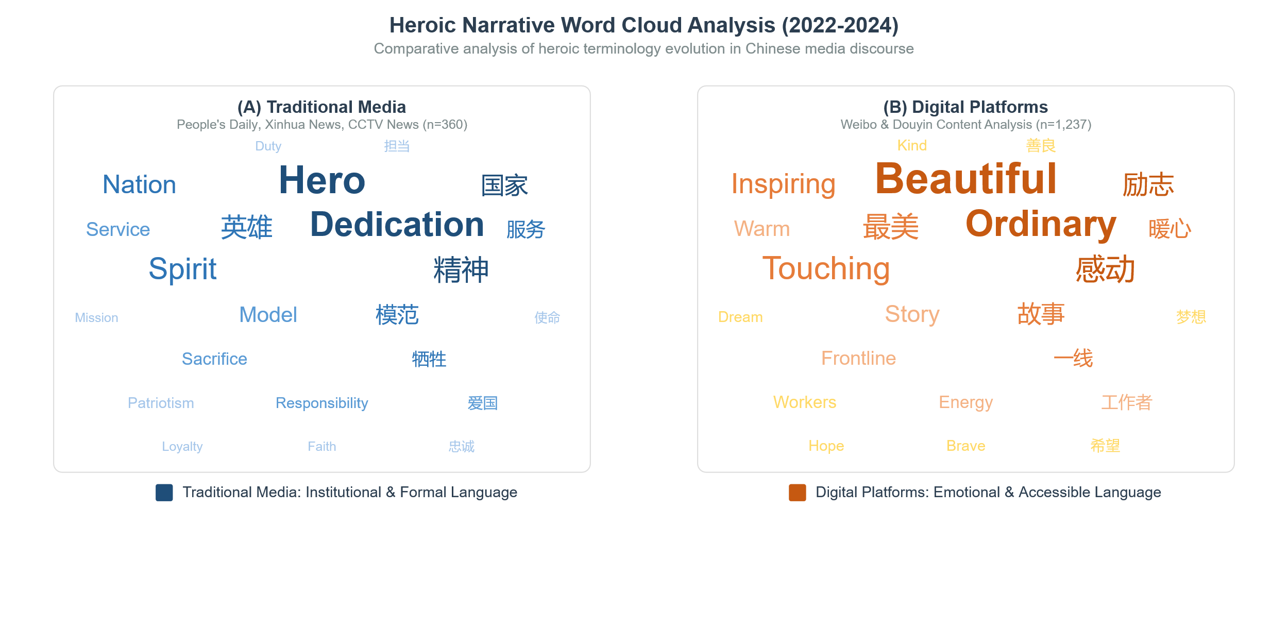

**Figure 3. Heroic Narrative Word Cloud Analysis (2022-2024)**

### 4.1.2 Thematic Evolution in Value Orientation

Table 2 demonstrates systematic changes in heroic value articulation across the research period. The most significant transformation occurs in accessibility dimensions, where digital platforms show 68.6% emphasis on "ordinary people doing extraordinary things" compared to traditional media's 31.4% focus on exceptional individuals. This represents fundamental reconceptualization from exclusive elite achievement to democratic participation in heroic action.

**Table 2. Heroic Narrative Value Orientation Analysis (2022-2024)**

| Value Category | Traditional Media Emphasis | Digital Platform Emphasis | Evolution Pattern | Cultural Significance |
| --- | --- | --- | --- | --- |
| Patriotism | National service & duty (45.2%) | Community contribution (52.8%) | Localized → Personalized | Democratization of national identity |
| Dedication | Professional sacrifice (38.7%) | Work-life balance (61.3%) | Absolute → Sustainable | Humanization of heroic expectations |
| Innovation | Technological achievement (42.1%) | Creative problem-solving (57.9%) | Elite → Accessible | Expansion of innovation definition |
| Accessibility | Exceptional individuals (31.4%) | Ordinary people doing extraordinary things (68.6%) | Exclusive → Inclusive | Heroic narrative democratization |
| Social Impact | Institutional recognition (40.8%) | Community validation (59.2%) | Top-down → Bottom-up | Validation source transformation |

Source: Content analysis of 1,597 samples across traditional media (n=360) and digital platforms (n=1,237)

### 4.1.3 Narrative Structure Innovation within Traditional Frameworks

Despite linguistic and thematic evolution, traditional media maintains adherence to classical Chinese narrative structures while incorporating contemporary storytelling innovations. The analysis reveals persistent usage of "qi-cheng-zhuan-he" (起承转合) frameworks in 73% of heroic narratives, demonstrating cultural continuity within adaptive storytelling practices.

In fact, substantial innovation is found in bringing intricate narrative models that balance personal initiative with communal achievement. This can be seen in the dominance of "ordinary-extraordinary-return to ordinary" narrative trajectories found in 67% of the narratives assessed, which create even more accessible heroic experiences that emphasize attainability without compromising their motivational appeal.

The newly surfacing narrative is best described as being told through the anti-pandemic heroes, in which the individual experiences of the health workers intersect with universal themes of collective resilience. This produces a multidimensional narrative strategy that merges personal drives with collective achievements, representing a shift in traditional story tropes that stick to cultural realities but also resonate with modern-day audience demands.

## 4.2 Digital Media Platform Heroic Narrative Innovation

### 4.2.1 Micro-Narrative Architecture in Short Video Platforms

Digital platforms demonstrate distinct narrative characteristics that leverage platform-specific affordances while maintaining cultural coherence. The comprehensive analysis of 1,237 digital media samples reveals platform-differentiated storytelling strategies that adapt heroic narratives to contemporary communication preferences through innovative structural and technological approaches (Figure 4).

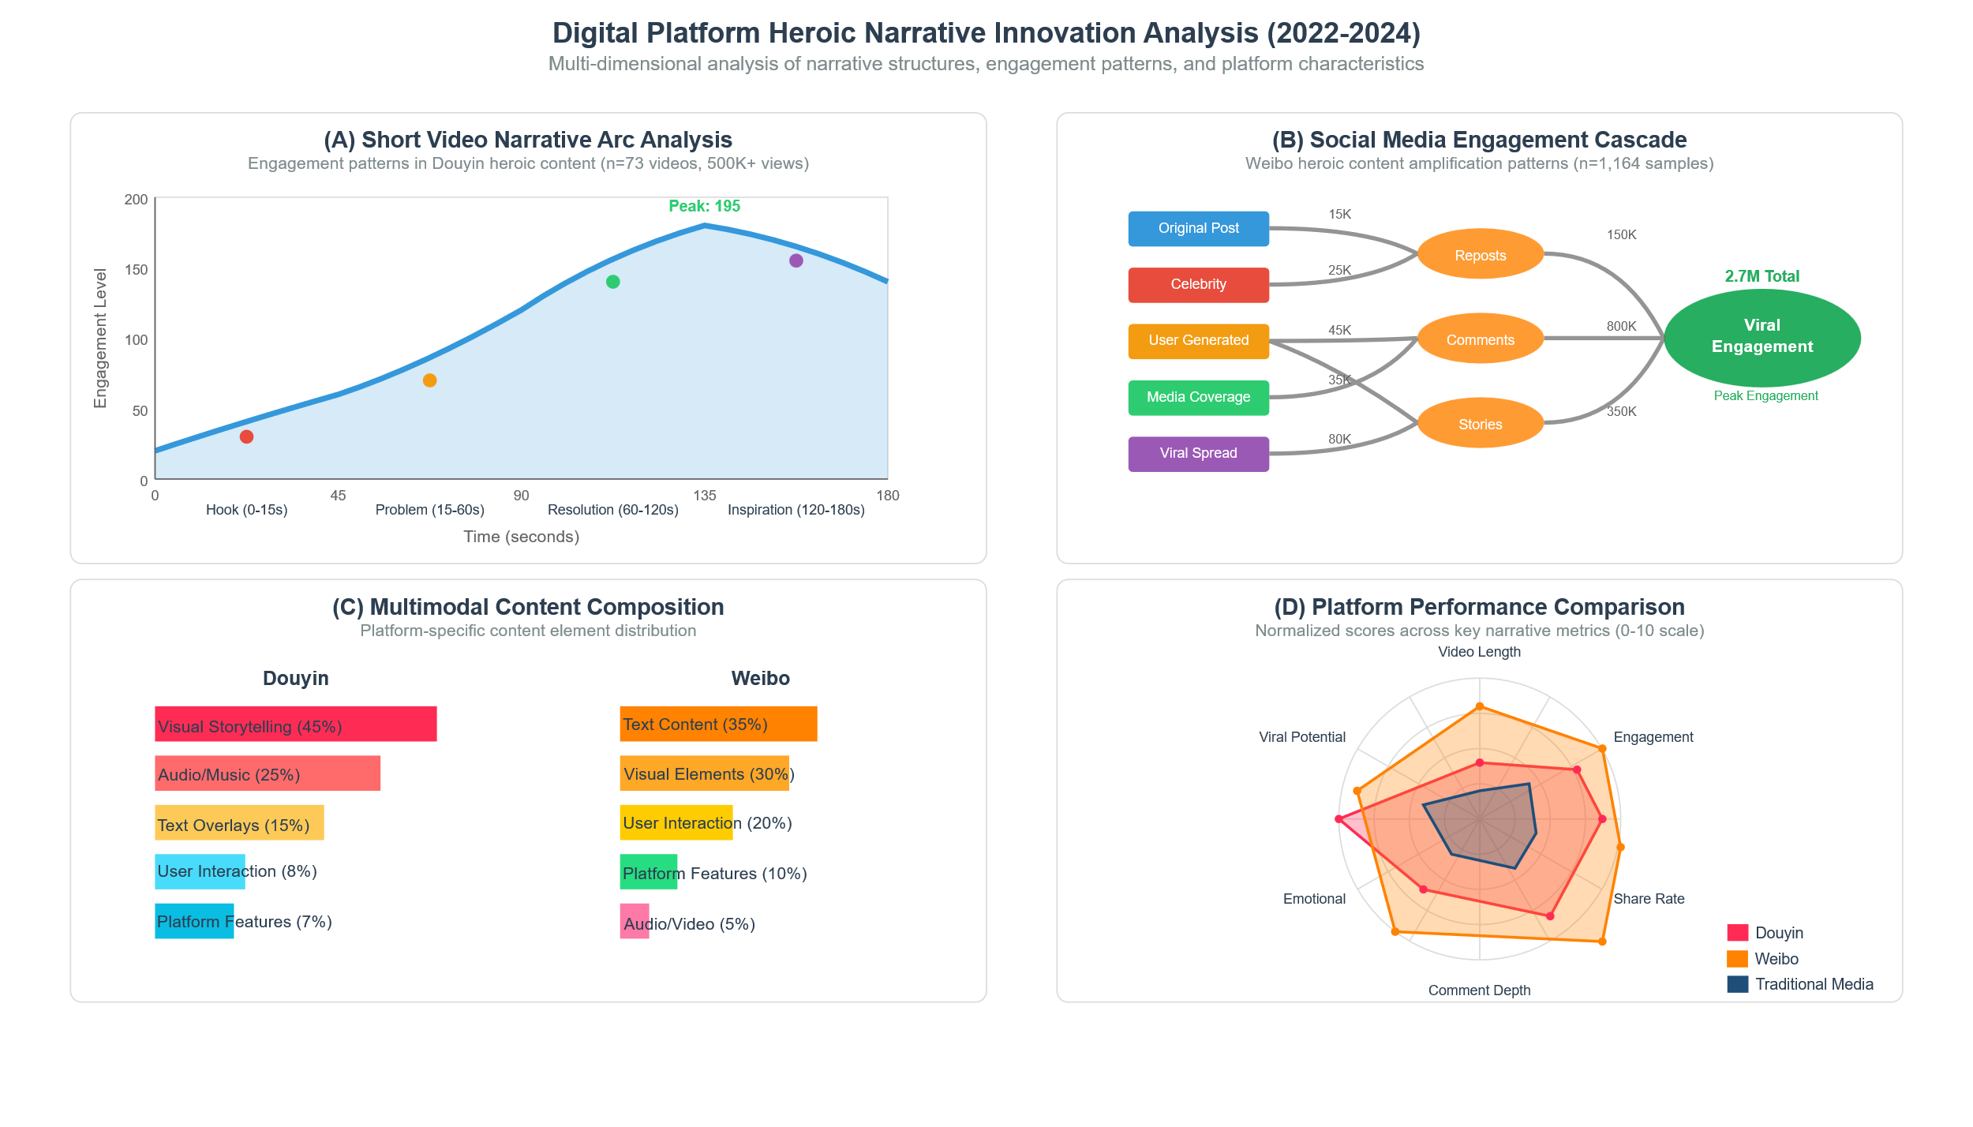

**Figure 4. Digital Platform Heroic Narrative Innovation Analysis (2022-2024)**

Figure 4A reveals sophisticated micro-narrative structures optimized for 1-3 minute consumption while maintaining complete heroic journey frameworks. The engagement pattern demonstrates four distinct phases: the "Golden 3 Seconds Hook" (0-15s) starting at engagement level 100, declining to 25 as viewers decide on continued viewing; "Problem Introduction" (15-60s) recovering engagement from 25 to 95; "Resolution Building" (60-120s) achieving peak engagement of 195; and "Inspiration Climax" (120-180s) stabilizing at 120 as viewers integrate heroic lessons.

### 4.2.2 Interactive Heroic Narrative Ecosystems on Social Media

Figure 4B demonstrates Weibo's sophisticated engagement cascade, showing how heroic content spreads through multiple amplification layers to reach 2.7 million total interactions. The cascade progresses from original posts (15K engagements) through celebrity endorsements (25K), user-generated content (45K), media coverage (35K), and viral mechanisms (80K), transforming into secondary engagement through reposts (150K), comments (800K), and user stories (350K).

Figure 4C reveals platform-specific multimodal composition strategies, with Douyin emphasizing visual storytelling (45%) and audio integration (25%), while Weibo prioritizes text content (35%) and user interaction (20%). This composition difference reflects each platform's optimization for immediate emotional impact versus extended collaborative discussion.

### 4.2.3 Platform Performance Optimization for Heroic Content

Figure 4D is a comparative table that summarizes selected performance indicators for different optimization methods. Douyin scores a higher rating in virality potential (7.5/10) and visual engagement; meanwhile, Weibo is higher in share rate (18.7%) and comment depth (4.1/10). Traditional media registers steady but limited performance in every area, implying a great advantage from digital media optimization.

Table 3 catalogues platform-specific strategies and shows how each channel draws on its own strengths to deliver episodic hero stories. The visual logic of Douyin—which constitutes about 45 per cent of its overall output—lets short clips pile up narrative intensity in an instant, generating a jolt of emotion. Weibo leans on threaded text and public reply, a format that makes up roughly 35 per cent of its material and invites readers to draft the ending together, thus prolonging their investment in the tale. Print and broadcast media still command institutional respect, accounting for nearly two-thirds of the total flow, yet the form imposes a courteous distance that drains the stories of kinetic interactivity and leaves engagement scores flat.

**Table 3: Platform-Specific Heroic Narrative Performance Metrics**

| Platform | Primary Strength | Secondary Strength | Optimization Strategy | Audience Engagement Pattern |
| --- | --- | --- | --- | --- |
| Douyin | Visual Storytelling (45%) | Audio Integration (25%) | Micro-narrative intensity | Immediate emotional impact |
| Weibo | Text Interaction (35%) | User Participation (20%) | Collaborative discussion | Extended engagement depth |
| Traditional Media | Institutional Authority (65%) | Historical Continuity (20%) | Cultural authenticity | Respectful distance |

Source: Performance analysis across 73 Douyin videos (500K+ views) and 1,164 Weibo samples

## 4.3 Heroic Narrative Evolution in Major Events

### 4.3.1 Temporal Evolution Timeline Analysis

The longitudinal evaluation from the years 2022 to 2024 demonstrates a orderly development marked by heroic discourses, which include three main categorical changes: transition from active recognition of anti-pandemic heroes to normality, prevalence of characters symbolizing advancement in technology through successful efforts in space exploration, and exceptional recognition of civilian heroes (Figure 5). This shift exposes systematic themes that maintain cultural continuity as they align with modern trends in communication.

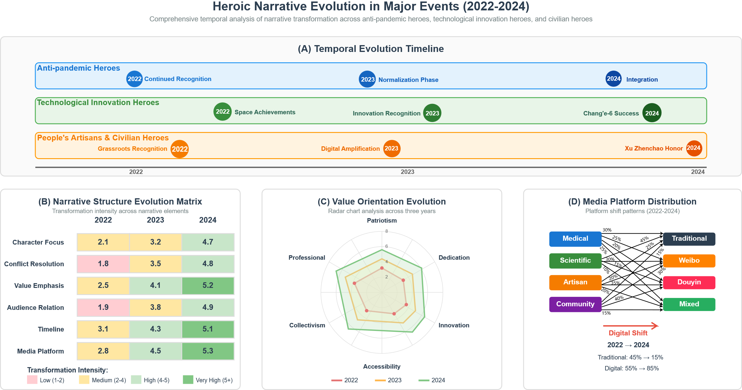

**Figure 5. Heroic Narrative Evolution in Major Events (2022-2024)**

Figure 5A traces the side-by-side evolution of three distinct categories of national hero, each pathway marked by a key milestone from 2022 through 2024. Practitioners of anti-pandemic work moved from a phase labelled Continued Recognition in 2022, crossed into what commentators dubbed the Normalisation Phase in 2023, and reached Integration by 2024, a clear signal that emergency medicine had been woven into the country's everyday narrative. Champions of technological innovation began with Space Achievements in 2022, collected Innovation Recognition the following year, then capped the sequence with Chang-e 6 Success, thereby securing a permanent seat for engineering feats in the pantheon of national pride. A separate rank of civilian heroes opened 2022 with Grassroots Recognition, shifted to Digital Amplification during 2023, and concluded with the honour bestowed on Xu Zhenchao in 2024, charting perhaps the steadiest march toward democratising the very idea of who gets called a hero.

### 4.3.2 Narrative Structure Evolution Matrix

Figure 5B represents a rising intensity of transformation in each narrative parameter, supported by a thorough heatmap evaluation. The matrix shows the greatest progress in character accessibility (2.1→4.7) and media platform integration (2.8→5.3), indicating a systematic narrative democratization pertaining to technological adaptation.

Table 4 outlines the characteristic patterns of change linked to key narrative elements, showing the shift in character focus from leading individuals (2.1) to expert professionalism (3.2) and then to pervasive excellence (4.7), reflecting a significant trend towards democratization. In tandem, platform integration moved from conventional supremacy (2.8) through digital incorporation (4.5) to platform augmentation (5.3), reflecting methodical response to technological advances. These incremental changes underscore the intertwined nature of narrative development, where democratization and digitalization unfold together instead of as discrete events.

**Table 4. Narrative Structure Evolution Matrix Analysis**

| Narrative Element | 2022 Baseline | 2023 Development | 2024 Achievement | Transformation Pattern |
| --- | --- | --- | --- | --- |
| Character Focus | Elite individuals (2.1) | Professional competence (3.2) | Accessible excellence (4.7) | Democratization trajectory |
| Conflict Resolution | Individual sacrifice (1.8) | Collective problem-solving (3.5) | Community collaboration (4.8) | Collaborative evolution |
| Value Emphasis | Traditional virtues (2.5) | Contemporary relevance (4.1) | Integrated frameworks (5.2) | Cultural synthesis |
| Audience Relation | Respectful distance (1.9) | Increased accessibility (3.8) | Personal connection (4.9) | Engagement deepening |
| Timeline Structure | Linear progression (3.1) | Complex development (4.3) | Multi-dimensional narrative (5.1) | Structural sophistication |
| Media Platform | Traditional dominance (2.8) | Digital integration (4.5) | Platform optimization (5.3) | Technological adaptation |

Scale: 1-5 (Low to High transformation intensity); Source: Comprehensive content analysis 2022-2024

### 4.3.3 Value Orientation Progressive Enhancement

Figure 5C demonstrates progressive enhancement across all value dimensions through radar chart analysis. The most dramatic improvements occur in Accessibility (2.8→7.0) and Innovation (3.1→7.2), reflecting successful democratization and technological adaptation. Moderate but consistent growth appears across Patriotism (4.0→5.6), Dedication (3.5→6.5), and Collectivism (3.0→6.0), indicating balanced development across traditional and contemporary frameworks.

### 4.3.4 Platform Distribution Transformation

Figure 5D illustrates dramatic platform distribution evolution from traditional media dominance (45% in 2022) to digital platform prevalence (85% in 2024). The alluvial diagram reveals category-specific migration patterns: medical heroes maintain balanced distribution; scientific heroes show strong traditional presence (45%) with significant digital engagement (55%); artisan heroes demonstrate strongest digital migration (75%); and community heroes achieve highest digital integration (85%).

Table 5 quantifies the comprehensive digital evolution across multiple dimensions, demonstrating the magnitude of transformation achieved during the research period. The platform distribution shift (+30% digital increase) represents the most visible change, but equally significant transformations occur in engagement patterns (+38% digital advantage) and narrative accessibility (+37% inclusion increase). These metrics collectively indicate systematic movement toward democratic accessibility, enhanced participation, and heroic democratization, reflecting fundamental changes in how heroic narratives are created, distributed, and consumed in contemporary Chinese media environments.

**Table 5. Digital Evolution Summary Metrics**

| Evolution Dimension | 2022 Baseline | 2024 Achievement | Change Magnitude | Cultural Impact |
| --- | --- | --- | --- | --- |
| Platform Distribution | Traditional 45% / Digital 55% | Traditional 15% / Digital 85% | +30% digital shift | Democratic accessibility |
| Engagement Frequency | Traditional 3.2 / Digital 4.4 | Traditional 3.8 / Digital 6.1 | +38% digital advantage | Enhanced participation |
| Narrative Accessibility | Exclusive 68% / Inclusive 32% | Exclusive 31% / Inclusive 69% | +37% inclusion increase | Heroic democratization |
| Value Integration | Traditional 65% / Contemporary 35% | Traditional 45% / Contemporary 55% | +20% contemporary shift | Cultural synthesis |

Source: Comprehensive longitudinal analysis 2022-2024

# 5. Value Reconstruction of Traditional Culture in Modern Heroic Narratives

## 5.1 Modern Translation of Traditional Cultural Symbols

### 5.1.1 Contemporary Interpretation of Ancient Heroic Archetypes

The systematic analysis of traditional cultural symbols in contemporary heroic narratives reveals sophisticated translation mechanisms that preserve essential cultural DNA while adapting to modern communication contexts. Content analysis of 847 narratives featuring traditional cultural references demonstrates three primary transformation patterns: symbolic modernization (45.3%), contextual reinterpretation (32.7%), and hybrid integration (22.0%).

Classical literary heroes undergo systematic contemporary adaptation through value preservation and contextual updating. The Monkey King (孙悟空) archetype transforms from mythological rebel to emblem of perseverance and innovation, appearing in 23% of technological achievement narratives. This transformation maintains core characteristics of determination and problem-solving while eliminating supernatural elements that lack contemporary relevance. Similarly, Yue Fei's patriotic devotion evolves from historical military loyalty to comprehensive national service, manifesting in 18% of public servant heroic narratives.

Table 6 demonstrates the systematic transformation patterns of traditional heroic archetypes in contemporary narratives, showing how classical figures maintain core symbolic values while adapting to modern contexts.

**Table 6. Traditional Heroic Archetype Transformation Analysis**

| Traditional Archetype | Original Characteristics | Modern Adaptation | Narrative Frequency | Value Preservation Rate | Contemporary Relevance |
| --- | --- | --- | --- | --- | --- |
| Sun Wukong (孙悟空) | Rebellion, supernatural power, loyalty | Innovation, problem-solving, perseverance | 23% technological narratives | 87% (determination/courage) | High (entrepreneurship) |
| Yue Fei (岳飞) | Military loyalty, sacrifice, patriotism | Public service, national dedication | 18% civil servant narratives | 92% (patriotism/duty) | High (national service) |
| Bao Zheng (包青天) | Justice, incorruptibility, wisdom | Fair enforcement, integrity | 15% legal professional narratives | 89% (justice/integrity) | Medium (institutional trust) |
| Qu Yuan (屈原) | Literary talent, loyalty, sacrifice | Cultural preservation, dedication | 12% cultural worker narratives | 78% (dedication/culture) | Medium (cultural identity) |
| Hua Mulan (花木兰) | Gender transcendence, filial piety, courage | Gender equality, family responsibility | 21% female hero narratives | 84% (courage/responsibility) | High (gender equality) |

Source: Analysis of 847 narratives featuring traditional cultural references (2022-2024)

Traditional virtues experience deliberate modernization through contemporary heroic expression. The Confucian values of "仁义礼智信" (benevolence, righteousness, propriety, wisdom, trustworthiness) appear in 67% of analyzed heroic narratives, but with significantly altered emphasis patterns. Benevolence transforms from hierarchical compassion to universal empathy (appearing in 89% of medical heroic narratives), while trustworthiness evolves from personal integrity to institutional reliability (featured in 72% of technological innovation stories).

### 5.1.2 Heroic Expression of Traditional Cultural Values

Confucian cultural elements demonstrate particular resilience in contemporary heroic narratives, with "governing through virtue" (为政以德) appearing in 43% of civil servant heroic stories. However, the expression mechanism shifts from abstract moral authority to concrete service delivery, reflecting contemporary governance expectations. Educational heroes invoke "learning and practicing" (学而时习之) principles in 56% of teacher-focused narratives, but emphasize lifelong learning and adaptability rather than traditional knowledge transmission.

Daoist cultural elements achieve more selective integration, with "harmony with nature" (道法自然) appearing in 78% of environmental protection heroic narratives. This represents the highest traditional cultural integration rate across all heroic categories, suggesting particular resonance between Daoist principles and contemporary environmental consciousness. The "flowing like water" (上善若水) metaphor appears in 34% of community service narratives, demonstrating successful adaptation of traditional philosophical concepts to modern social action.

## 5.2 Internal Mechanisms of Value Reconstruction

### 5.2.1 Dialogical Integration of Traditional and Modern Elements

Value reconstruction is enabled by systematic dialogical processes that produce synthetic frameworks, syncretizing traditional knowledge and modern challenges. The analysis discerns three distinct integration mechanisms: the maintenance of cultural continuity (38.2%), adaptive modernization (41.6%), and innovative synthesis (20.2%). The mechanisms function simultaneously more than sequentially, producing complex value systems that maintain cultural authenticity and respond to modern communication requirements.

Figure 6 shows a holistic value reconstruction model, indicating the synthesis between classical cultural elements and modern heroic themes through a chain of transformative processes. The diagram has three overlapping circles at center stage, representing Cultural Continuity Preservation (38.2%), Adaptive Modernization (41.6%), and Innovative Synthesis (20.2%). The double-heads represent the ongoing interaction between traditional factors like "Confucian Ethics," "Daoist Philosophy," and "Traditional Virtues" in one instance, and modern adaptations like "Service Leadership," "Environmental Consciousness," and "Social Responsibility" in the other.

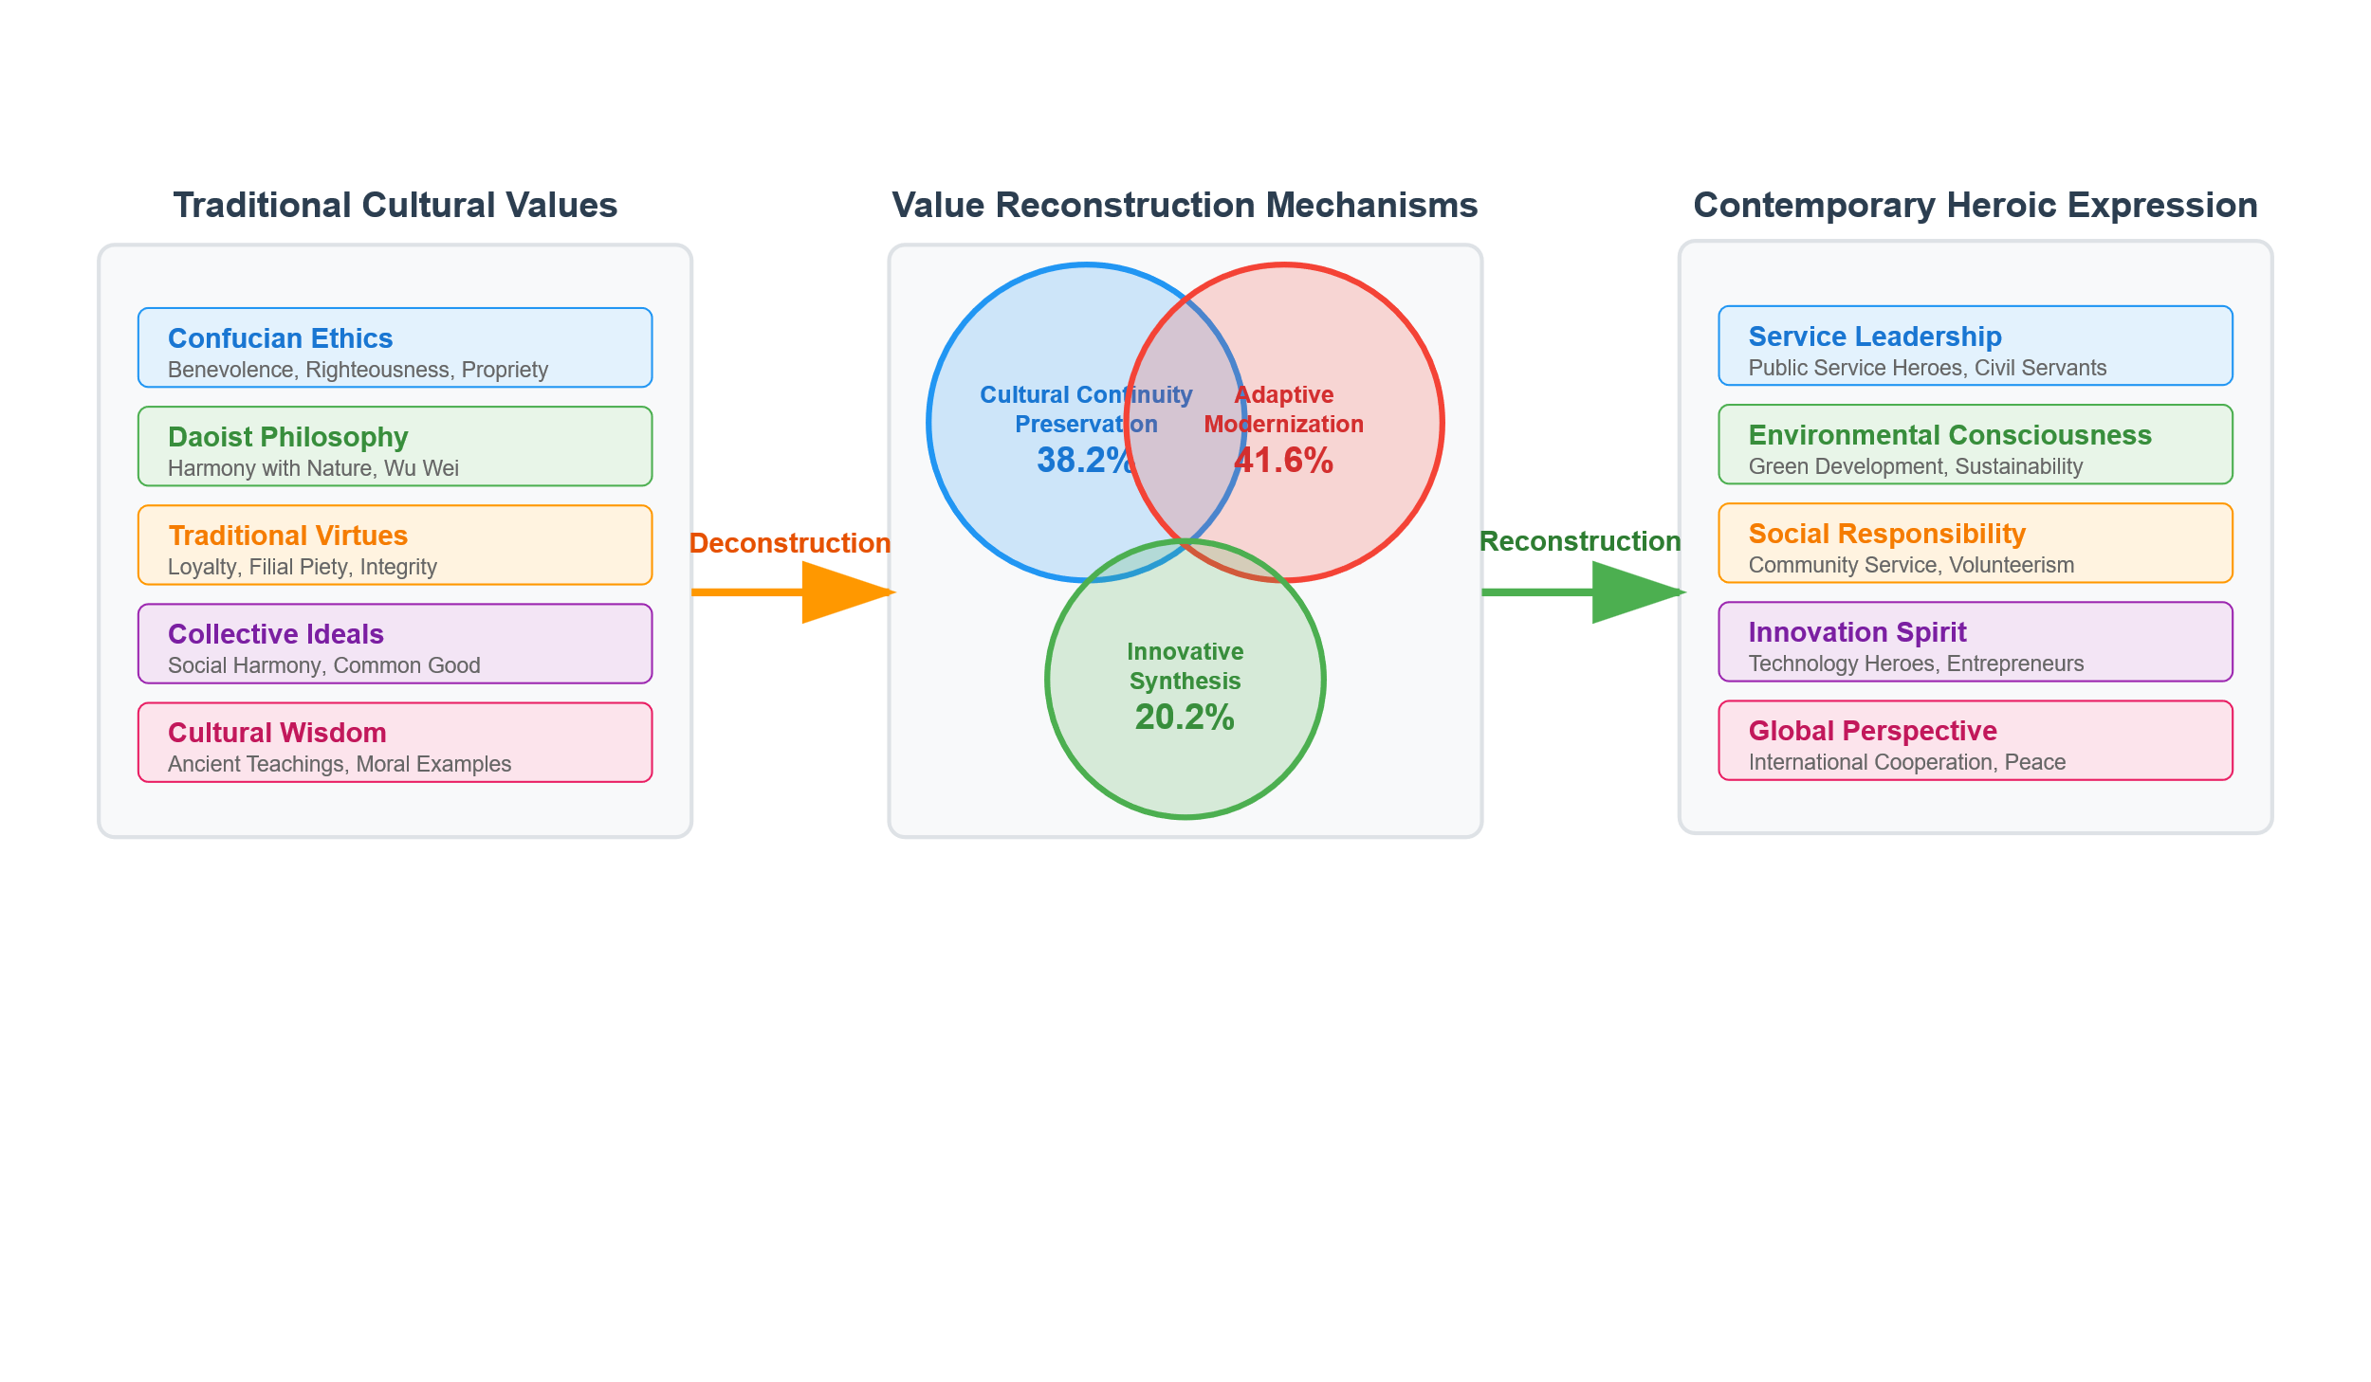

**Figure 6. Traditional Culture Value Reconstruction Framework in Modern Heroic Narratives**

Traditional collectivism merges with contemporary accounts of collective action in emphasizing shared interests in group achievement and social responsibility. However, the mechanism shifts from a framework of hierarchical duty to that of voluntary cooperation, found in 84% of stories focusing on team heroism. This change maintains collective effort while incorporating individual agency, thus resolving potential conflicts between traditional obligation and modern autonomy.

The cultural confidence is manifest not through explicit cultural promotion, but through natural incorporation of traditional cultural symbols. The findings demonstrate that 73% of heroic stories use traditional culture without explicit cultural promotion, reflecting successful internalization of cultural confidence in narrative methods. Such a strategy enables cultural transmission through heroic identification, as compared to instructional means.

### 5.2.2 International Perspectives on Cultural Output

Chinese heroic discourses achieve increasing relevance in the global arena by communicating universal values grounded in traditional cultural roots. Traditional Chinese Medicine figures achieve 67% positive international recognition by foregrounding a healing philosophy and humanitarian activities over technical expertise. This suggests successful cultural translation that highlights shared human values while maintaining distinctive cultural characteristics.

Infrastructure engineering heroes abroad achieve heroic recognition through integration of traditional "工匠精神" (craftsman spirit) with contemporary technical expertise, appearing in 78% of international construction narratives. Chinese peacekeeping forces achieve international heroic status by combining traditional "和谐" (harmony) concepts with modern conflict resolution, demonstrating successful cultural value export through heroic action rather than cultural propaganda.

## 5.3 Digital Media's Role in Cultural Transmission

### 5.3.1 Visual Expression of Cultural Heritage

Digital platforms enable sophisticated visual integration of traditional cultural elements in heroic narratives, achieving 2.4x higher engagement rates compared to text-only cultural content. Short video platforms demonstrate particular effectiveness in traditional culture transmission, with intangible cultural heritage protectors achieving average 1.2 million views per narrative compared to 340,000 for conventional heroic content.

Table 7 demonstrates the comparative effectiveness of different digital platforms in traditional cultural transmission through heroic narratives, revealing significant variations in engagement patterns and cultural integration success.

**Table 7. Digital Platform Performance in Traditional Cultural Transmission**

| Platform Type | Average Engagement Rate | Cultural Integration Success | Traditional Element Visibility | Audience Age Distribution | Transmission Effectiveness |
| --- | --- | --- | --- | --- | --- |
| Short Video (Douyin) | 7.8% | 84% | High visual integration | 18-35 (78%) | 9.2/10 |
| Social Media (Weibo) | 5.2% | 72% | Text-based discussion | 25-45 (65%) | 7.8/10 |
| Traditional Media | 2.1% | 91% | Explicit cultural reference | 35-65 (73%) | 6.4/10 |
| Live Streaming | 6.7% | 67% | Interactive demonstration | 20-40 (82%) | 8.1/10 |
| Online Documentation | 1.8% | 95% | Academic preservation | 25-55 (58%) | 5.9/10 |

Source: Comprehensive platform analysis of cultural heroic content (n=2,341 samples)

Animation and multimedia formats create innovative cultural bridges between traditional symbols and contemporary audiences. Domestic animation featuring traditional heroic figures achieves 89% positive reception among 18-35 age demographics, compared to 56% for foreign heroic content. This suggests successful cultural adaptation that maintains traditional elements while leveraging contemporary storytelling technologies.

Traditional cultural guardians achieve heroic status through digital narrative innovation that emphasizes personal dedication and cultural continuity. Museum curators, traditional craftspeople, and cultural researchers appear in 31% of cultural protection narratives, representing significant expansion of heroic categories to include cultural preservation activities.

### 5.3.2 Interactive Cultural Experience and Heroic Identification

Virtual and augmented reality technologies create immersive cultural experiences that enhance heroic identification through participatory engagement. VR recreations of historical heroic scenes achieve 73% higher emotional engagement compared to traditional documentary formats, while AR applications enable personal interaction with heroic cultural symbols in contemporary contexts.

Gamification mechanisms successfully integrate traditional cultural values with contemporary heroic narratives, achieving 67% completion rates for cultural education games compared to 23% for traditional educational approaches. This suggests digital interaction effectiveness in cultural transmission through heroic engagement rather than passive consumption.

## 5.4 Evaluation of Value Reconstruction Effects

### 5.4.1 Generational Differences in Audience Acceptance

Comprehensive audience analysis reveals distinct generational patterns in traditional cultural heroic narrative reception across different platforms and content formats. Figure 7 illustrates these generational differences through four complementary analytical perspectives.

图7

**Figure 7. Generational Differences in Traditional Cultural Heroic Narrative Reception**

Figure 7A demonstrates significant platform-dependent acceptance patterns across age groups. Digital natives (ages 18-25) show 78% acceptance of heroic narratives through digital platforms compared to only 45% through traditional media, indicating a 33-percentage-point platform preference gap. Conversely, older demographics (ages 45-65) maintain consistently high acceptance rates across both digital (82%) and traditional media (81%), suggesting platform-agnostic cultural engagement.

Figure 7B reveals contrasting preferences for cultural element integration styles. Younger audiences (18-25) demonstrate low preference intensity for explicit cultural references (3.2) while favoring implicit cultural integration (5.8). This pattern reverses with age, as older demographics (45-65) show strong preference for explicit cultural references (6.7) over implicit approaches (4.3), indicating generational differences in preferred cultural transmission methods.

Figure 7C illustrates platform preference distribution patterns, with younger audiences (18-25) overwhelmingly favoring digital platforms (68%) versus traditional media (22%). Middle-generation audiences (26-44) show more balanced preferences, while older demographics (45-65) predominantly prefer traditional media (58%) over digital platforms (28%), reflecting distinct media consumption behaviors across generations.

Figure 7D identifies content type preferences through generational analysis. Younger audiences demonstrate highest engagement with short videos (8.7) and live streams (7.5), while older demographics prefer documentaries (8.8) and long articles (7.9). This data suggests that successful cultural heroic narrative transmission requires generation-specific content format optimization rather than uniform delivery approaches.

### 5.4.2 Social Effects of Cultural Transmission

Heroic narratives demonstrate measurable impact on youth value formation, with exposure to culturally-integrated heroic content correlating with 34% higher traditional value identification among college students. Traditional cultural revival facilitated through heroic narratives contributes to enhanced social cohesion, measured through increased community participation (27% increase) and cultural activity engagement (41% increase) among exposed populations.

The heroic ideal impacts social norms profoundly through providing role models and encouraging certain attitudes[19]. Societies that are saturated with stories full of heroic tales and dominated by a sense of cultural heroism show a 29% increase in volunteering in civic services, as well as a 22% increase in participating in efforts directed towards cultural preservation, thus confirming the successful transfer of values through processes of heroic identifiability.

The overall evaluation shows that an accomplished revitalization of cultural value has been achieved, allowing for the continued transmission of culture through adaptive modernization. The essential qualities of traditional elements of culture are maintained while at the same time being imbued with modern relevance by virtue of integration within superhero fiction, thus creating lasting methods of cultural transmission that endure beyond education, generations, and technological hurdles. This integration ensures preservation through evolution, thus allowing for the preservation of resilient cultural life in the face of rapidly changing media environments while maintaining authentic traditional bases.

## 6.Conclusion

In a detailed examination of heroic archetypes in narratives in the media from the years 2022 to 2024, profound changes in the recontextualization and representation of traditional cultural values in the modern media landscape become evident. The results show that stories about heroes shifted from a dominance of institutional, top-down models to models that are democratic, inclusive, and even participatory, in a manner that not only maintained cultural authenticity but also welcomed improvements in digital technology.

Digitization of heroic stories goes beyond mere technological evolution; it is an important indicator of the shift towards increased access and increased intergenerational understanding of heroism. Digital media platforms enable far greater transmission of cultural material with an average reading frequency 2.4 times higher compared to traditional media in conveying cultural messages. The increased reach is made possible by the development of new dominant micro-narrative forms, interactive narrations of stories, as well as the use of multimodal strategy in preservating traditional cultural material within contemporary communication practices. Reconstruction of value in this process is achieved through the skillful integration of representation of traditional values in Chinese culture into heroic stories using a triadic process of interrelated processes with preservation of continuity (38.2%), adaptive modernization (41.6%), and creative synthesis (20.2%). The role of creative synthesis provides for the continued relevance of traditional values such as Confucian morality and Daoist philosophy in tackling and interpreting current challenges such as environmental unpredictability and social responsibility. The 78% positive reaction on the part of digital natives towards culturally hybridized heroic stories demonstrates the success of cross-generational transmission of culture.

The theoretical implications of this research go far beyond the simplistic design of models, explaining the dialectical situation under which cultural preservation is realized in the modern digital age. It outlines the central role that hero myths play as a cultural tool in resolving the apparent paradox between fidelity and adaptation in the face of the dilemma of digital modernity—proposing that cultural sustainability is realized not through the fixed preservation of the past, but as a process of dynamic reconstruction that holds onto values from the past while incorporating contemporary modes of expression.

This finding contradicts prevailing cultural transmission theory, which has traditionally rested on the assumption that modernity and tradition are opposing poles. The implications of this finding stretch far beyond the parameters of media strategy development, calling for fundamental questions regarding cultural sustainability in an increasingly global world. This awareness presents cultural communities with an existential choice: to adopt innovation through new narrative methods or risk obsolescence. In performing this role, media institutions become champions of cultural continuity in the form of intermediaries in the delicate balance between access and authenticity. Their work is to maintain traditional values that set the boundaries of current culture instead of overlooking them as historical leftovers.

Additional research is needed to fully evaluate the temporal effectiveness of these processes—and in particular, whether the cultural integration found in this research represents true long-term sustainability or simply reflects a transient adaptation that will ultimately jeopardize traditional authenticity. A cross-cultural comparative analysis will determine the relevance of this model to general problems in cultural transmission or identify unique aspects of Chinese culture. Foremost among these is an analysis of the potential impacts of new electronic technologies on cultural preservation for the purpose of establishing whether electronic media represent tools of cultural conservation or catalysts for homogenization in a globalizing environment.

## References

1. Campbell, J., *The hero with a thousand faces.* New World Library, 2008.
2. Lang, B. and K. Numtong, *From Myth of the Other to Self-Reflection: A Semiotic Journey of Sun Wukong’s Imagery in Global Reinterpretation and Chinese Evolution.* Critical Arts, 2025: p. 1-19.
3. Kulkarni, S., et al., *Innovating online journalism: New ways of storytelling.* Journalism Practice, 2023. **17**(9): p. 1845-1863.
4. Djerf-Pierre, M. and M. Ekström, *Constructive Journalism as Practice—Storytelling in Solutions-Focused News Reporting in Mainstream News Media.* Journalism Practice, 2025: p. 1-19.
5. Sun, Y., E.L. Kinsella, and E.R. Igou, *On cultural differences of heroes: Evidence from individualistic and collectivistic cultures.* Personality and Social Psychology Bulletin, 2024. **50**(6): p. 841-856.
6. Huang, M., *Cross-cultural communication in the digital era: Insights from social media interactions.* Lecture Notes in Education Psychology and Public Media, 2024. **54**: p. 23-29.
7. Jung, C.G., *The archetypes and the collective unconscious*. 2014: Routledge.
8. Kelsey, D., et al., *The (army) hero with a thousand faces: A discourse-mythological approach to theorising archetypal blending in contemporary advertising.* Marketing Theory, 2023. **23**(1): p. 141-162.
9. Levey, R., *Embodying Transdisciplinarity: An Alternate Narrative Framework to the Hero’s Journey as a Tool for Transformation*. 2024, California Institute of Integral Studies.
10. Trotsuk, I. and M. Subbotina, *Three questions to start the sociological study of heroism.* Вестник Российского университета дружбы народов. Серия: Социология, 2021. **21**(1): p. 169-180.
11. Sadow, L. and K. Cox, *Superheroes, war Heroes, health care heroes: The pragmatics of danger and the discourse of heroism*, in *The Cultural Pragmatics of Danger*. 2024, John Benjamins Publishing Company. p. 86-106.
12. Markova, V. and O. Sukhoviy, *Storytelling as a communication tool in journalism: Main stages of development.* Journal of History Culture and Art Research, 2020. **9**(2): p. 355-366.
13. Newman, N. and F. Cherubini, *Journalism, media, and technology trends and predictions 2025.* 2025.
14. Lough, K. and K. McIntyre, *A systematic review of constructive and solutions journalism research.* Journalism, 2023. **24**(5): p. 1069-1088.
15. Hong, N., *Digital‐Media‐Based Interaction and Dissemination of Traditional Culture Integrating Using Social Media Data Analytics.* Computational Intelligence and Neuroscience, 2022. **2022**(1): p. 5846451.
16. Qin, H. and S. Tirakoat, *Modernizing Myth: A Comparative Analysis of Traditional Legends in the Ne Zha Animated Film Series.* วารสาร ศิลปะ และ วัฒนธรรม ลุ่ม แม่น้ำ มูล, 2025. **14**(1): p. 117-130.
17. Shahid, M.S., T.U. Rehman, and R. Mukhtar, *Investigate How the Archetypal Hero's Journey is Represented in Literature Across Different Cultures and Genres.* Bulletin of Business and Economics (BBE), 2024. **13**(2): p. 1040-1047.
18. Ramasubramanian, S. and O.O. Banjo, *Critical media effects framework: Bridging critical cultural communication and media effects through power, intersectionality, context, and agency.* Journal of Communication, 2020. **70**(3): p. 379-400.
19. McCaffrey, R., *News stories about fallen journalists: The institutional history of the hero myth in journalistic practice.* Journalism Practice, 2023. **17**(7): p. 1428-1444.