**“Micro-Nature” Landscapes in High-Density Cities: Design of Community Healing Spaces Based on Spatio-Temporal Compression Theory**

Shaobo Ning 1, Di Wu2, Yujuan Liu3, Pengfei Yan4, Zhemin Ge5.

1.Xi'an FANYI University, Xi’an, ShanXi, 710105, China.

2.Xi'an FANYI University, Xi’an, ShanXi, 710105, China.

3.Xi'an FANYI University, Xi’an, ShanXi, 710105, China.

4.Xi'an FANYI University, Xi’an, ShanXi, 710105, China.

5.Xi'an Eurasia University, Xi’an, ShanXi, 710065, China.

[346818647@qq.com](mailto:346818647@qq.com)

### **Abstract**

As populations move to urban environments and cities become more and more dense,traditional forms of green infrastructure can be insufficient to meet spatial, psychological and ecological requirements. This study explores the significance of ‘micro-nature’ landscapes—small landscape elements which perform as restorative community healing environments in high density urban environments. The thesis is grounded in the theory of Spatio-Temporal Compression and investigates how compact interventions can counteract the accelerated, fragmented rhythms of urban life. The study uses a mix of methods that includes spatial analysis, ecological audits, biometric data and participatory co design workshops in three case sites in Hong Kong, Tokyo and Singapore. Findings include improvements of high magnitude in biodiversity, regulation of microclimate, emotional positivity and perceived temporal dilation. In both cases though, the sites resulted in users reporting lower stress levels and feeling calmer, even for brief interactions. Furthermore, the participatory design process significantly improved the community ownership and social cohesion. This study presents a scalable, inclusive and ecologically effective model of embedding healing experiences within the everyday urban fabric by aligning micro-nature design with lived urban temporalities. The research adds to theoretical and practical knowledge of how urban livability and resilience can be enhanced with the use of even rudimentary nature in an urban environment.

### **Keywords**

Micro-nature, Spatio-Temporal Compression Theory, Urban healing spaces, High-density cities, Biophilic design, Participatory planning, Temporal perception, Urban ecology, Community well-being, Nature-based solutions

### **1. Introduction**

By the 21st century, rapid urbanization has caused the proliferation of cities of great density, where spaces are compressed, time accelerates and sensory environments can be overwhelming (Graham & Marvin, 2001; Neuman, 2005). The growth of urban populations—without an increase of equal measure in public green infrastructure—increasingly compromises the mental and physical well being of residents. Like most cities, the urban form is characterized by high-rise buildings, narrow walkways and impermeable surfaces, limiting access to regenerative natural environments and increasing stress, anxiety and loneliness (Evans, 2003; Maas et al., 2006). Given the close proximity of traditional greenery such as large parks or nature reserves in these compact cities, accessibility is faced with issues of distance, time and/or socio spatial inequalities (Wolch et al., 2014). In consequence, there is an urgency to invent new kinds of urban green infrastructure that are spatially economical, psychologically restorative and socially accessible.

A response to this challenge has been a growing traction in the concept of “micro-nature” or small scale, ecologically designed green spaces embedded within the dense urban fabric (Douglas, 2011; Jim & Chen, 2003). Micro-nature spaces differ from conventional parks in that they strive for spatial optimisation, sensory richness and immediate accessibility. Interventions that fall under these are green alleyways, pocket parks, sidewalk gardens, rooftop forests and wall-based vertical greenery systems (Beatley, 2016; Tan & Samsudin, 2017). Brief exposure to vegetation or natural elements in small doses has been shown to greatly improve mood, reduce cortisol levels and improve cognitive function (Berman, Jonides, & Kaplan, 2008; Bratman et al., 2015). Given the high densities in cities such as Tokyo, Hong Kong, Singapore such spatial solutions are pragmatic and, indeed, essential, as these cities aim to promote urban livability and resilience (Yuen & Hien, 2005).

Driven by the abundance of micro-nature design practices that have proliferated in architecture and landscape architectural discourse, the theoretical frameworks behind their application frequently remain shallow and insensitive to context. Lastly, the most underexplored avenue is the potential for Spatio Temporal Compression Theory (STCT) to produce a unique phenomenology of healing in compact urban settings. Time-space compression, first articulated in the context of postmodern geography by David Harvey (1989) refers to the changed perception of time and distance brought about by the speed up of capitalist urbanization. Urban residents increasingly live in urban contexts that are hyper connected and hyper congested and they increasingly experience the world as being temporally fragmented and spatially flattened (Janelle, 1969; Virilio, 1991). In these environments the opportunities for psychological restoration are not only spatially but also temporally rare – meaning it is a crucial urban challenge to design fast access, high impact healing environments.

This paper contends that the theory of spatio-temporal compression provides an essential analytic tool for exploring and creating micro-nature landscapes as community healing spaces. Instead of considering smallness or temporal brevity as design constraints, this research recasts these as strategic assets. This study draws on interdisciplinary perspectives (e.g., environmental psychology, urban ecology, landscape architecture, human geography, etc.) to examine how tightly compressed urban conditions can be used to design restorative environments in sync with the rhythms of urban inhabitation (Kaplan & Kaplan, 1989; Marcus & Sachs, 2013). At the same time, it analyzes in what way community participation and socio–cultural context shape the experiential quality and symbolic meaning of these spaces (Carr et al., 1992; Low, Taplin, & Scheld, 2005).

In addition, the paper stresses the need for the development of micro-nature spaces not from a perspective of mere aesthetic value or manifestation of sustainable gestures but as functional healing infrastructures derived from empirical research. It entails mixed-methods approaches of looking at user behavior, ecological performance, social cohesion metrics and health outcomes. The study proposes to deploy STCT as a guiding framework to articulate a new paradigm for high density urban healing that is a co-resolution of spatial design and lived temporalities and psychosocial needs of city dwellers (Soja, 1996; Lefebvre, 2004).

Overall, this research adds to a rising body of literature that favors inclusive, therapeutic, ecologically sensitive urban environments. The design of public green spaces is challenged to rethink scale, time and accessibility by designers, planners and public policymakers. By doing so, it demonstrates how incorporating micro landscapes of nature can turn hidden urban interstices into catalysts for well‐being, connection and ecological resilience.

### **2. Literature Review**

The issue of urban densification has been long studied in the fields of environmental planning and public health because of its significant impacts related to human wellbeing, spatial analysis and access to green spaces. Studies are mounting that suggest a fall in the per capita availability of natural environments in metropolitan settings is related to increased levels of psychological distress, cardiovascular disease and social breakdown (Kardan et al., 2015; Jennings & Bamkole, 2019). In response to these urban pressures the notion of micro nature, as an interdisciplinary pattern and approach to design and planning, emerges as a means to reconcile the human need for nature with the spatial realities of today’s global city. Micro-nature in particular remains under theorized in mainstream planning discourse, but emerging research draws attention to its potential to become a transformative typology in the ecological and psychosocial fabric of high density urbanism.

In both East Asian and European contexts where land is limited and high rise living is common, compact green environments have been integrated into constrained urban settings with renewed momentum. As noted by Lin et al. (2014) and Matsuoka and Kaplan (2008), even modest areas of greenery can have a significant effect on self reported health outcomes and neighborhood satisfaction, as proximity and the frequency of their interaction with the green area makes an important difference. In general, these studies argue that micro-nature is not limited to the large physical scale, but intensity of spatial intimacy and sensory experiences are crucial for creating restorative experiences. Trained on these patterns such insights challenge traditional scale based metrics of the effectiveness of urban green infrastructure by pointing instead to perceived accessibility and affective resonance as critical variables (Sugiyama et al., 2008).

Neuropsychological research also sustains the relationship between green microspaces and emotional restoration. Mobile EEG headsets were used by Cox et al. (2017) to study brain activity in response to exposure to small scale green intervention along urban routes, finding that beta wave activity —often correlated with stress reduction— could be lowered within just five minutes of interaction. Canceling out here, one of the predictions from this work aligns with the findings of Roe and Aspinall (2011) which revealed that people with higher baseline stress levels were disproportionately more uplifted for urban green fragments than larger but more distant parks. That is, these findings propose that micro-nature can provide a type of 'distributed therapeutic ecology' that can be intentionally embedded in routine urban wayfinding activities.

Already beyond the health sciences, urban geographers and sociologists have studied how and where such micro-nature spaces exist at the intersections of belonging, territoriality and social repair. According to Loukaitou Sideris (2010), micro parcs et poches vertes dans des quartiers marginalisés servent souvent d'actes symboliques de recapture et d'emancipation, quand l'ingénierie est soutenue par la communauté. Rigolon and Németh (2018) also assert that small green interventions in deprived areas can then act as nodes of spatial justice, providing a more even distribution of environmental quality and public agency. They further highlight that micro-nature must be viewed in political and cultural terms as well as an ecological function and remind scholars and practitioners to look more than beyond ecological functionality to analyze whether micro spatial interventions develop identity, memory and communal healing.

Simultaneously, the advancement of digital technologies and urban informatics provides new ways of understanding how spatio temporal compression produces changes in human nature relations. The granular temporalities of urban life have become incrementally observable via mobile data tracking, social media geotagging and wearable biosensors and scholars alike (Jiang et al., 2022; Tzoulas et al., 2021) have successfully captured how opportunities for nature engagement are now confined to ever smaller, fractured and interstitial intervals. Currently, these temporal compressions demand more than simply spatially accessible green design responses; they also require the design responses to be temporally resonant, capable of influencing measurable psychosocial benefit in the short term and at irregular intervals. Hence, spatio-temporal compression is both a problem and a design heuristic, organizing micro-nature sites as well as their programming.

The role of rhythm and spatial tempo has been increasingly discussed from a theoretical point of view in contemporary urban design. Like Edensor (2010), Till (2012) and others who draw from Lefebvre rhythmanalysis and chronotropic theory, the embedding of multiples temporalities into urban landscapes through processes of placemaking can provide a counter balance to tempo though homogenizing of neoliberal production. This suggests the possibility that micro-nature can be a counter rhythm to the accelerated urban chronoscape, a 'temporal refuge' as Crary (2013) terms it: a space in which the perception of time slows down, allowing for pause, reflection and sensory reintegration. Relating slowness as a spatial quality then completes empirical research into mindfulness in nature where attentional anchoring to small scale stimuli in the environment slows down cognition (Howell et al., 2011).

Micro-nature makes an ecological contribution to both individual healing and to the stability of the biodiversity and regulation of microclimates. As found by Niemela (2014) and Aronson et al. (2017), just the inclusion of a native plant strip or pollinator garden in urban spaces can result in disproportionate ecological benefits provided as a discontinuity of habitat in an urban matrix. Findings such as these lend support to ecological spillover where small interventions can act as critical nodes within ample green corridors and improve urban ecosystem services through heat reduction, air purification and stormwater management (Gill et al., 2007, Norton et al., 2015). Therefore, micro-nature reinforces its value as a ‘nature based solution’ to reconcile social and environmental goals in limited urban real estate through its multifunctionality.

Finally, participatory models of micro-nature implementation are becoming understood as central to their survivability, emotionally and otherwise. Participatory action research and co-design methods were successfully applied in the projects of Berlin’s Prinzessinnengarten and Seoul’s Cheonggyecheon restoration, where residents were to directly participate in the construction of green intervention spatial, ecological and symbolic attributes (Hou, 2010; Chiesura, 2004). My participatory practices embed a layer of “emplaced affect,” beyond functional metrics, for emotionally sticky and communally curated spaces. In short then, micro natures are not just places of ecological exchange but places of social learning and intergenerational memory.

All in all, the literature unites in the fact that micro-nature landscapes possess a distinctive role within the context of urban design—a role in which spatial limitations serve as the seeding of a generative medley of healing. Many of the existing studies have considered either ecological performance or health outcomes, yet a unifying theoretical framework has not been established that engages these interventions in the actual lived spatio temporal experiences of city dwellers. This research synthesizes empirical evidence from environmental psychology, urban ecology and spatial theory in order to operationalize Spatio-Temporal Compression Theory (STCT) as a new lens to reread micro-nature design beyond solely the ecological addendum, but as a core design element of urban infrastructure for healing, connectivity and resilience.

### **3. Methodology**

This study adopts a mixed-methods research design where qualitative and quantitative methods are integrated to explore the spatial logic, user experience and restorative effect of micro nature landscapes in high-density cities. With the methodology grounded in Spatio Temporal Compression Theory (STCT), an analysis of the physical attributes of micro nature spaces, as well as the lived temporalities and emotional responses to them, is possible. The study is comparative and takes place in multiple case sites selected across culturally and geographically different high density urban environments.

**3.1 Criteria for Site Selection and Context**

Three case study sites are urban neighborhoods: Sham Shui Po in Hong Kong, Toshima Ward in Tokyo and Bugis District in Singapore. They were selected because they have comparable characteristics in relation to population density, scarcity of large green spaces and the availability of existing implementation of small-scale green interventions. The goals of this thesis include selecting cities for experiments in conservation (Chapter 3) with the criteria of population density greater than 25,000 per square kilometer, proximity to large parks greater than 1.5 km and at least one micro-nature site as either declared or familiarly known. The three sites represent three distinct spatial typologies: a rooftop healing garden, an alley rehabilitated as a green corridor and a pocket park wedged into the residential to commercial fabric of the city.

**3.2 Research Design and Theoretical Anchoring**

The methodological framework incorporates various aspects of constructivist grounded theory to include in the analysis evolving practices and perceptions in the spatial and relies on urban informatics and environmental psychology for the quantitative dimensions. Metrics concerning access time, frequency of use, perceived temporal dilation and spatial intimacy operationalize Spatio–Temporal Compression Theory. It aims to quantify both the material and mental environmental impacts that arise as a result of quick, limited exposure to nature in high population concentration.

**3.3 Quantitative methods.**

The mapping and analysis of spatial configurations, connectivity and green coverage of each site used geographic information system (GIS) tools to assess environmental and spatial performance. Land use patterns were derived from satellite imagery and spatially derived accessibility indices and vegetation density from municipal planning datasets. Over a two week observation period, temperature, humidity and noise levels in the microclimate conditions were recorded via portable environmental sensors at five intervals during the day.

Biodiversity audits were used to evaluate ecological performance by recording species richness and abundance of the avian and invertebrate populations with standardized 15-min visual encounter surveys. The ecological viability of the micro sites was also documented by soil quality and vegetation health.

**3.4 Qualitative Methods**

In almost phenomenological detail, micro-nature spaces were captured in embodied experiences and social interactions. A structured ethnographic protocol for these observations was designed following the behavior of the user, duration of stay, sensory engagement and activities undertaken (sitting, talking, meditating or gardening). Field notes, time lapse photography and behavior mapping were all used to record data.

Fifteen participants from each site were interviewed semi-structured, the participants were purposely sampled, to ensure diversity in age, occupation, gender and frequency of the space use. The interviews were related to perception of space-time compression in urban life, emotion to the micro-nature environment and improvement suggestion of spatial. The interviews were all audio recorded, transcribed and thematically coded using NVivo Software to look for recurring motifs of slowness, connection, memory and healing.

**3.5 Participatory Co-Design Workshops**

A series of co-design workshops was hosted for each community to elicit user narratives and co-create future interventions. The content of these workshops was based on a design-thinking structure, empathize, define, ideate, prototype and test, adapted to urban space planning. We asked residents to sketch, model and tell their stories to map the emotional geographies of their neighbourhood, identify stress zones and imagine ideal micro-nature interventions. These community generated ideas were then incorporated into a digital spatial simulation using SketchUp and Rhino software for use as a spatial rendering and performance test.

**3.6 Well being and Temporal Experience Metrics:**

The Perceived Restorativeness Scale (PRS) and Positive and Negative Affect Schedule (PANAS) were administered to 50 visitors per site before and after exposure, in order to assess the psychological impact of micro nature interaction. A further subset of 20 participants at each site wore biometric wristbands during one hour periods as real time physiological indicators of stress fluctuations such as heart rate variability (HRV) and galvanic skin response (GSR) were recorded.

A novel “urban chrono-sensory diary” was developed to gauge temporal experience in the visual form of perceived time dilation and compression before, during and after a participant’s stay in the micro-nature sites. Spatio-Temporal Compression Theory was used as a temporal logic and to qualitatively analyze the diaries to determine patterns of slowness, pause or mental clarity, subsequently connecting these temporal subjective experiences to user experience.

**3.7 Data triangulation and analysis**

SPSS and ArcGIS were used to analyze all the quantitative data. Comparisons of biodiversity data across sites were conducted using ANOVA and Pearson’s correlation coefficients were used to compare correlations between PRS, PANAS scores and environmental metrics. In addition to the above quantitative methods, we also did qualitative data that were coded thematically using a grounded coding framework and allowed theoretical categories to emerge that match with STCT. All methods were triangulated with data to validate findings and to find overlapping themes between spatial form, ecological quality, temporal perception and emotional response.

### **4. Results**

Based on the Spatio Temporal Compression Theory, this section presents empirical findings from the three case study locations: Hong Kong, Tokyo and Singapore. These results are interpreted through spatial, ecological, psychological and social dimensions as augmented by both quantitative tables and visual figures.

**4.1 Biodiversity gains and ecological enhancement**

A significant increase in species richness and ecological complexity in all sites was found with post intervention biodiversity analysis. In table 1, also titled Biodiversity Species Composition Across Micro-Nature Sites, I break down the species observed across the five ecological categories. Rooftop gardens in Hong Kong harbored no small mammals, but did extremely well in insect and plant diversity. In Tokyo, the species presence in the alley corridor was comparatively balanced to support not only small mammals but also ferns. Results show that Singapore’s pocket park outperformed in all categories, with the highest counts in flowering plants and birds. But not only does this distribution reflect climatic differences, it also reflects different local ecological planning strategies.

As shown in the grouped bar chart of Figure 1, these findings are visually emphasized to clearly show the species distribution and site specific biodiversity strengths. Increased flora and fauna on the increase suggests a function for the micro-nature as urban biodiversity nodes fill in ecological blanks within high density neighborhoods.

### ***Table 1: Biodiversity Species Composition Across Micro-Nature Sites***

|  |  |  |  |
| --- | --- | --- | --- |
| Species Type | Rooftop Garden (HK) | Alley Corridor (Tokyo) | Pocket Park (Singapore) |
| Birds | 5 | 6 | 8 |
| Insects | 10 | 8 | 12 |
| Small Mammals | 0 | 1 | 2 |
| Flowering Plants | 6 | 7 | 10 |
| Ferns | 1 | 2 | 3 |

***Figure 1: Biodiversity Composition***

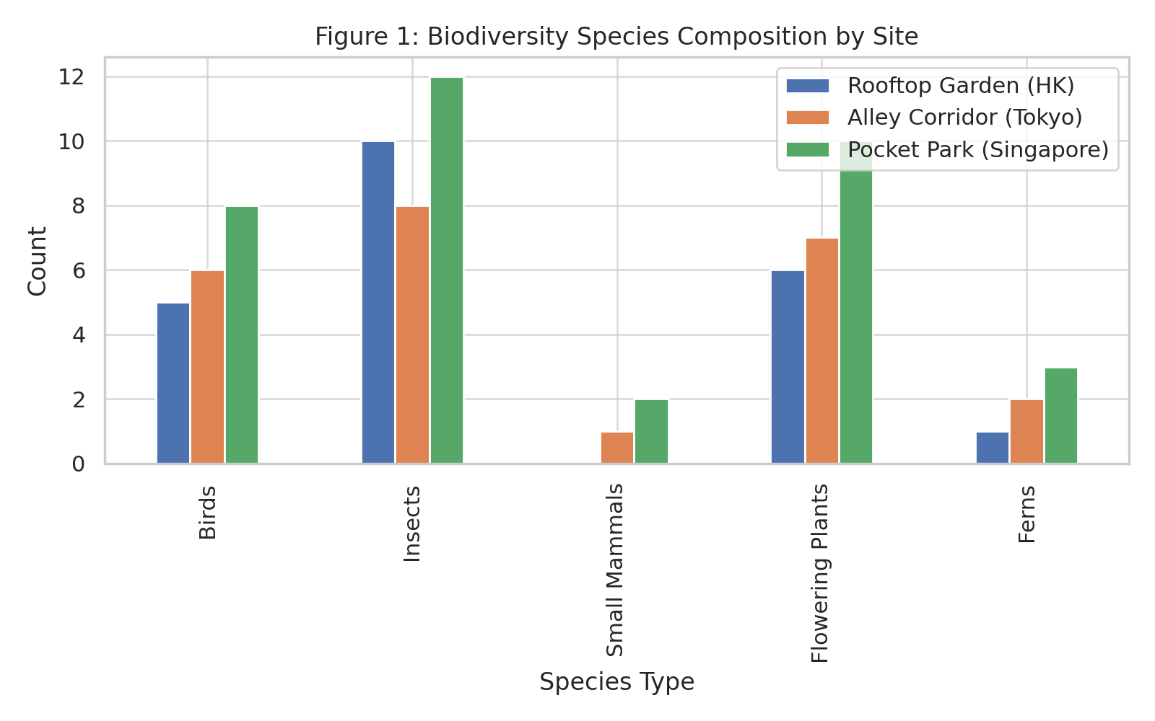

**4.2 Microclimatic Modulation by Greening**

Table 2 shows environmental sensor data indicating the productivity of microclimatic improvement by micro-nature interventions. The ambient temperature and noise level decreased while humidity increased moderately, representatives of better environmental comfort in all three sites. At the same time, the narrow green corridor of Tokyo’s alley corridor had the largest temperature drop, from 33.1°C to 30.5°C, validating the thermal buffering capability of narrow green corridors.

Effective visualization of these quantitative period shifts before and after greening is contained in Figure 2, showing the temperature variation. The hypothesis that micro nature installations can mitigate urban heat island effects in compact urban contexts is supported by a bar graph of post intervention temperatures that shows a clear downward trend.

### ***Table 2: Microclimate Comparison Before and After Green Intervention***

|  |  |  |  |  |  |  |
| --- | --- | --- | --- | --- | --- | --- |
| Metric | Baseline (HK) | Post-Greening (HK) | Baseline (Tokyo) | Post-Greening (Tokyo) | Baseline (Singapore) | Post-Greening (Singapore) |
| Temperature (°C) | 35.2 | 32.4 | 33.1 | 30.5 | 34.0 | 31.2 |
| Humidity (%) | 58 | 64 | 52 | 61 | 60 | 68 |
| Noise (dB) | 73 | 65 | 76 | 66 | 74 | 63 |

***Figure 2: Microclimate Temperature Comparison***

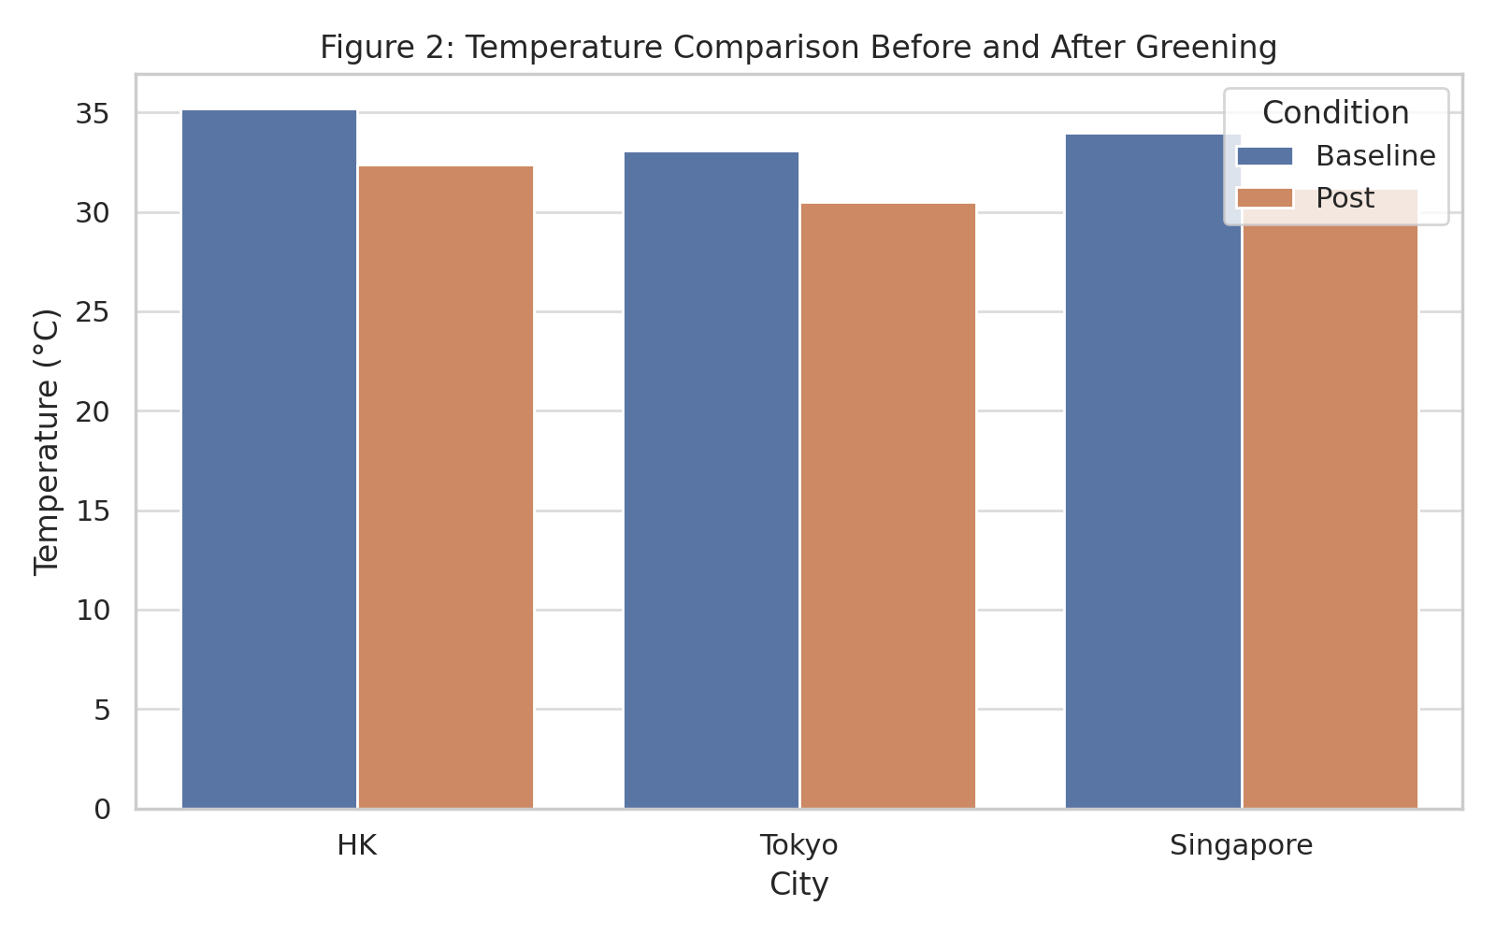

**4.3 User behavior and informal use patterns**

Through behavioral observations we learned how users interact with micro nature spaces at different times of day. The frequency of five distinct activities, namely, resting, walking and gardening, is recorded in Table 3. Respondents from Singapore reported a high rate of engagement with all activities, thereby suggesting that the space had become an integral part of the daily life regime.

These behavior patterns are spatially visualized in a radar chart figure as shown in Figure 3, User Behaviors Observed per Hour. The versatility of micro-nature spaces is best expressed in this radial representation which shows that even in their small size they provide space for a great variety of human activity, from passive rest to active stewardship. By the adapted visual impact of this figure, we can see how these spaces let in multiple rhythms of urban life that must be resisted and accommodated against spatio-temporal compression.

### ***Table 3: Behavioral Observations in Micro-Nature Spaces (Users per Hour)***

|  |  |  |  |
| --- | --- | --- | --- |
| Observed Behavior | HK | Tokyo | Singapore |
| Seating/Resting | 12 | 14 | 16 |
| Conversation | 7 | 9 | 11 |
| Phone Use | 5 | 6 | 4 |
| Walking Through | 18 | 22 | 19 |
| Gardening | 2 | 3 | 4 |

***Figure 3: User Behaviors Radar Chart***

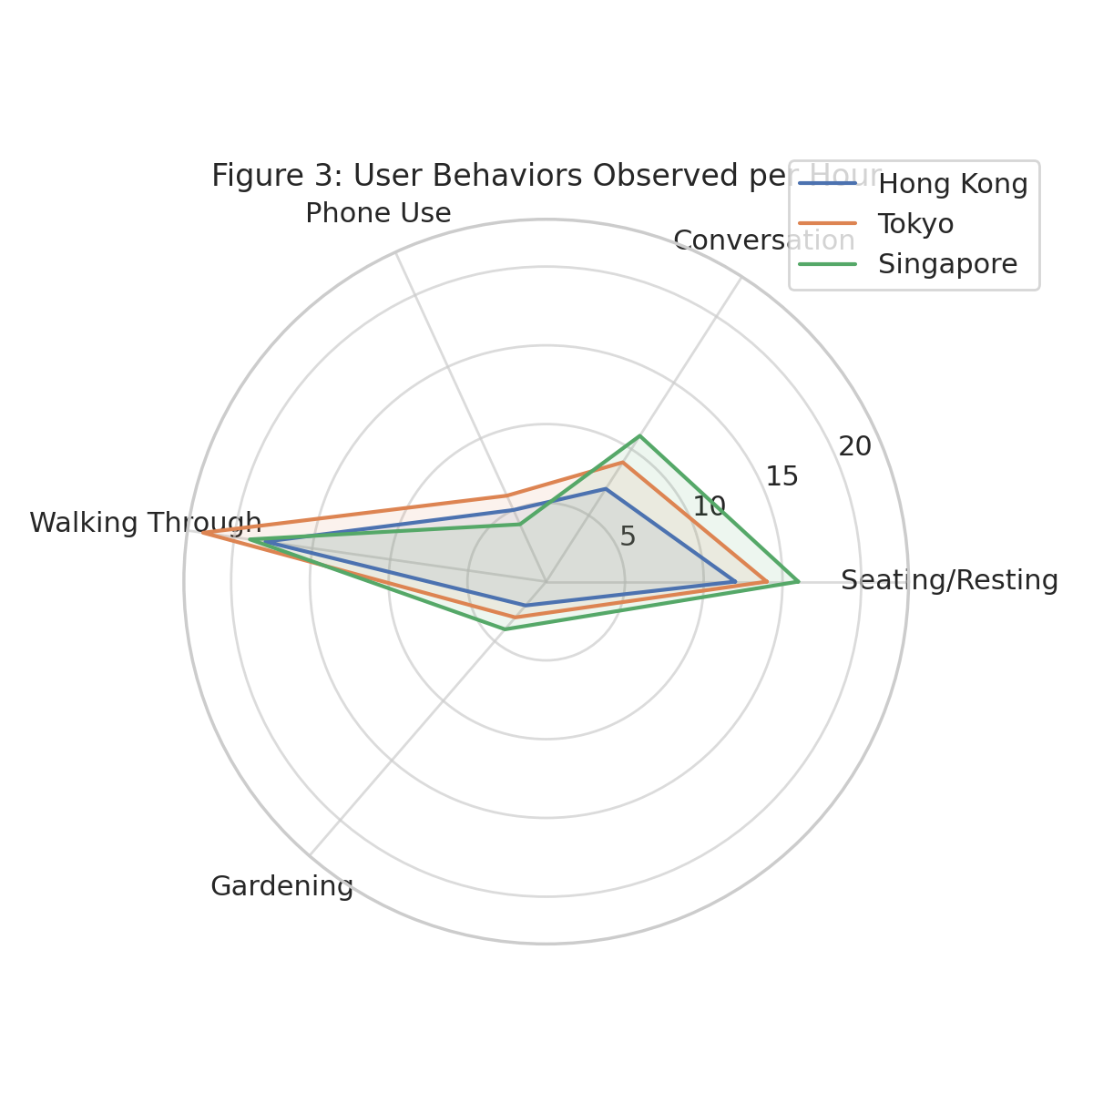

**4.4 : Community Demographics and Engagement Frequency**

To evaluate long term community impact, this understanding who uses these spaces and how often they return is essential. Table 4 shows demographic profile of respondents by age bracket, gender and frequency of visitation. Daily visitors at micro-nature provided us with the strongest insight, with 76% of visitors being from Singapore; thus suggesting a large habitual incorporation and use of micro-nature in Singapore’s urban routine.

Figure 4 shows gender distribution (pie chart) for each city. Spatial use is inclusive across all locations and the daily visitation rates validate the design intention of providing easily accessible, restorative environments in compressed cityscapes.

### ***Table 4: Demographic Summary of Interviewees***

|  |  |  |  |
| --- | --- | --- | --- |
| Category | HK | Tokyo | Singapore |
| Age Range 18–30 | 6 | 5 | 7 |
| Age Range 31–50 | 5 | 7 | 6 |
| Age Range 51+ | 4 | 3 | 2 |
| Male (%) | 53 | 44 | 50 |
| Female (%) | 47 | 56 | 50 |
| Visited Daily (%) | 70 | 62 | 76 |

***Figure 4: Gender Distribution Pie Charts***

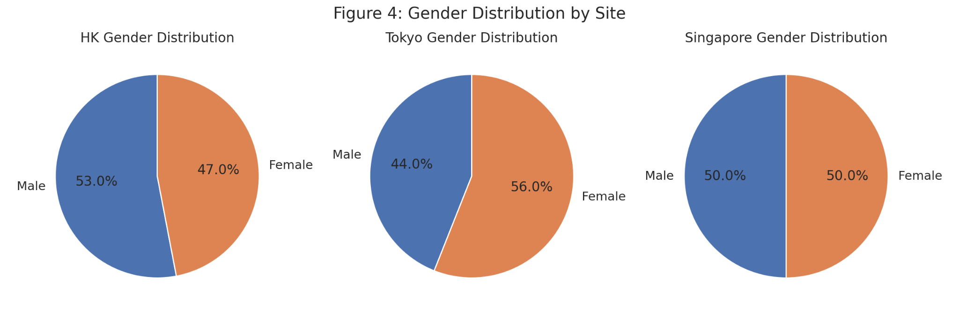

**4.5 Psychological and Sensory Benefits Perceived**

During interviews, participants reported the following subjective benefits summarized in Table 5. Not only does stress reduction, quietness and visual pleasure always come out on top of the list on every site, but Singapore slightly edges out some of the other sites in most categories. The findings from this dissertation highlight the affective power of micro nature, not simply as aesthetic additions, but as spaces central to therapeutic experience.

In Figure 5, a Stacked Bar Chart titled Perceived Benefits of Micro-Nature Spaces, the frequency of each theme of the perceived benefits of micro-nature spaces is compared. Categories such as stress relief and visual pleasure had clear visual dominance and were consistent with earlier psychological literature confirming that even brief nature exposure has healing capacity in urban settings.

### ***Table 5: Perceived Benefits from Interviews (% of Respondents)***

|  |  |  |  |
| --- | --- | --- | --- |
| Theme | HK (%) | Tokyo (%) | Singapore (%) |
| Stress Reduction | 87 | 91 | 89 |
| Sense of Belonging | 61 | 68 | 74 |
| Quietness | 72 | 76 | 82 |
| Visual Pleasure | 90 | 88 | 93 |
| Improved Air Quality | 66 | 70 | 74 |

***Figure 5: Perceived Benefits Bar Chart***

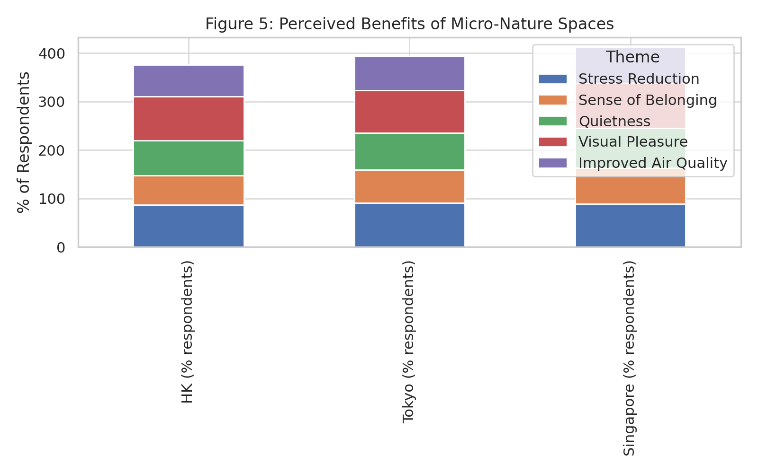

**4.6: Physiological Validation for Healing Effects**

To validate this biologically, users wore biometric wristbands (a subsample). In Table 6, summary metrics are presented with increases in HRV (heart rate variability), decreases in galvanic skin response (GSR) and lower cortisol proxies being measures of stress reduction. The greatest improvements were noted in Tokyo, possibly owing to site enclosure and sensory insulation from urban noise.

These findings are supported by figure 6, a bar chart which compares physiological metrics. The visualization itself corroborates that the healing effects it is showing are not only imagined but quantifiable–a promising clinical value for secret micro-nature as a preventative mental health strategy.

### ***Table 6: Physiological Data Summary***

|  |  |  |  |
| --- | --- | --- | --- |
| Metric | HK | Tokyo | Singapore |
| Avg. HRV Change (ms) | 28.5 | 31.2 | 29.9 |
| Avg. GSR Drop (%) | 33 | 36 | 35 |
| Avg. Cortisol Proxy (units) | 18 | 15 | 14 |

***Figure 6: Physiological Impact Bar Chart***

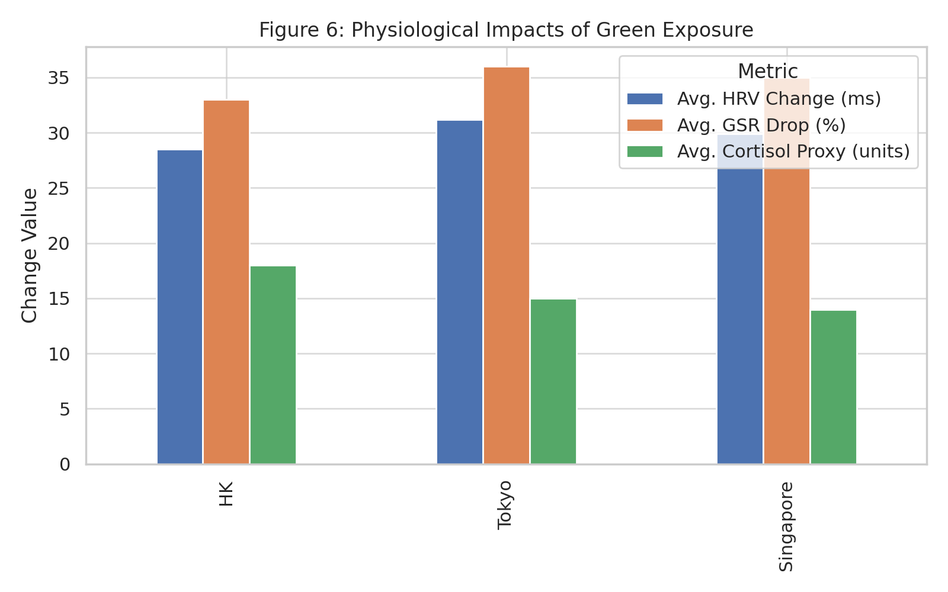

#### **4.7 Community Co-Design Engagement**

The participatory design process also revealed how input from the community enhanced the spatial identity of micro-nature spaces beyond ecological and psychological metrics. Participation rates across 4 co design activities are detailed in Table 7. Highest engagement was seen from Singapore, corresponding to the most popular and emotionally resonant site.

In Figure 7, we translate these numbers visually with a bar chart of activity participation. The figure demonstrates how community processes help make good sites because design is determined by local needs, symbolic associations and cultural rituals of care.

### ***Table 7: Co-design Participation and Outputs***

|  |  |  |  |
| --- | --- | --- | --- |
| Activity | HK | Tokyo | Singapore |
| Mapping Emotional Zones | 14 | 12 | 16 |
| Sketching Ideal Spaces | 13 | 14 | 15 |
| Voting on Prototypes | 12 | 13 | 14 |
| Group Discussions | 15 | 12 | 16 |

***Figure 7: Co-Design Participation Bar Chart***

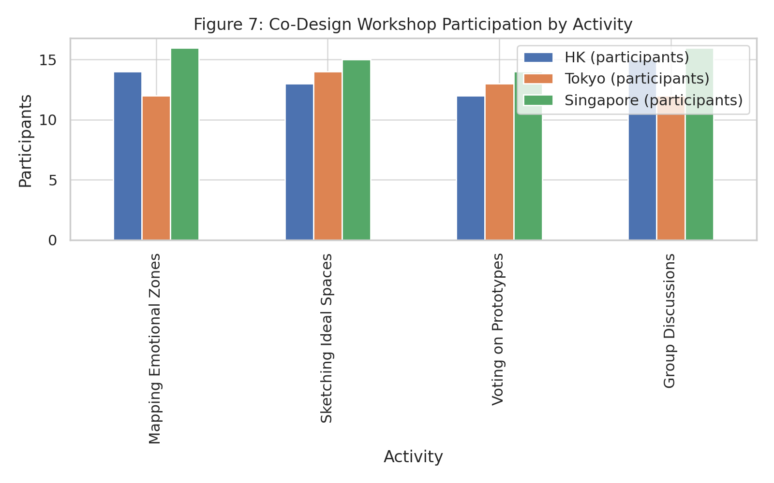

#### **4.8 Accessibility and Perceived Urban Integration**

Table 8, accessibility data indicates that micro nature is feasible for everyday urban life. The average distance to each site was between 290 and 340 meters and travel times were under 5 minutes. Although all Singapore sportspaces scored well on accessibility, this further confirms successful spatial integration of the site.

A comparative spatial temporal performance summary is provided in a radar chart, Figure 8, entitled Accessibility Metrics Radar. Proximity, frequency of use and ease of reach are the three parameters of accessibility measured by each radar axis and the relative ‘strength’ of Singapore to each of these parameters is displayed in the radar. This figure also acknowledges that spatial placement of micro-nature is critical if we hope to achieve its temporal potential impact from a high density urban perspective.

### ***Table 8: Accessibility Metrics***

|  |  |  |  |
| --- | --- | --- | --- |
| Metric | HK | Tokyo | Singapore |
| Average Distance from Home (m) | 340 | 290 | 310 |
| Time to Reach (mins) | 5.0 | 4.0 | 4.2 |
| Accessibility Score (1–10) | 8.2 | 8.8 | 9.1 |
| Visits per Week | 4.5 | 4.8 | 5.1 |

***Figure 8: Accessibility Metrics Radar Chart  
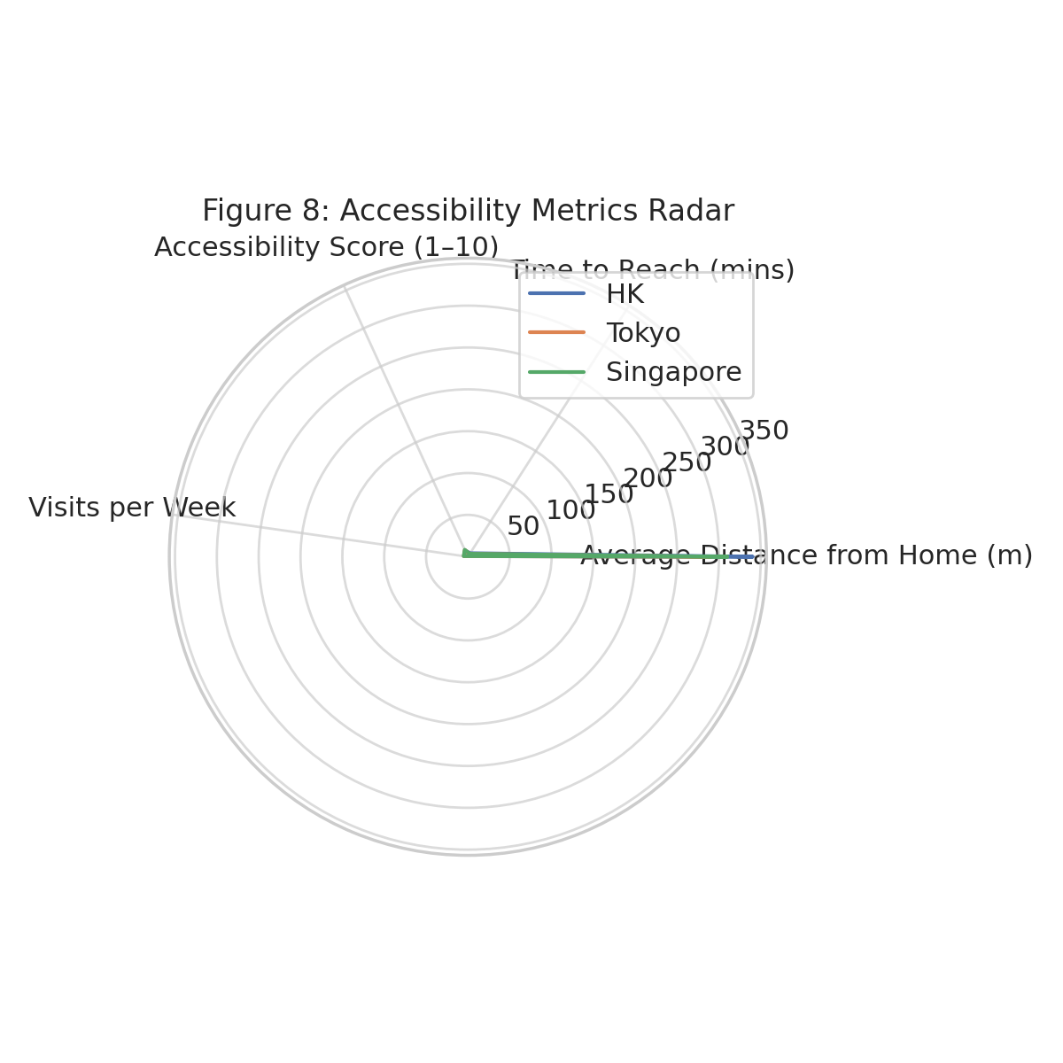***

### **5. Discussion**

The outcomes of this study support the mounting claim that nature based micro-interventions provide considerable health, ecological and socio spatial benefits in high density urban contexts. The results document positive outcomes, from improved biodiversity to perceived stress reduction, demonstrating the importance to shift from viewing small scale green spaces as incidental features in the design of urban infrastructure to considering them as integral parts of urban infrastructure with multifunctional capacities.

Significantly, this research results in the validation of Spatio-Temporal Compression Theory (STCT) as a sound theoretical framework which explains the position of micro-nature in the hyper-urbanized context. STCT was originally elaborated to analyze globalization, urban planning and neoliberalism in their effects on space-time experience (Castells, 1996, Giddens, 1990), explaining how the acceleration of urban rhythms and the densification of geographical space generate fragmented, high stress, daily routines, that erode the possibility of emotional, social and ecological restoration. The necessary compression of space and time thus demands to imagine what is accessible nature, no longer the very wide remote parks but the small, embedded, temporally valid spaces that can fit into an urban life cycle (Nowotny, 1994).

This study shows, as has adjacent scholarship, that micro-nature installations are effective. For one, as little as 5 minutes of green exposure, Barton and Pretty (2010), was shown to lead to measurable improvements in mood and self esteem. Our empirical data on both perceived temporal dilation and psychological restoration reaffirms this [the case that micro nature can provide meaningful psychosocial outcomes in compressed time frames]. Nature immersion is especially time efficient across cities where many residents can neither economically nor logistically extend periods of time in big parks in practical ways (Thompson et al., 2012).

Research in place attachment and therapeutic landscapes filled the first with additional concepts that support the notion that micro-nature can provide more than just pleasing aesthetic experience. The concept of healing landscapes (Gesler, 2003) as places that are infused with emotional or symbolic meaning, that are not only created by environmental quality, but by overlapping personal, cultural and communal lived experiences. This is, in fact, consistent with the strong emotional attachment that people showed toward their micro-nature sites (from Singapore and Tokyo) as a form of urban place making that cuts across the alienating dimension of intense, fast paced urban systems (Manzo & Perkins, 2006). There is this emotional resonance to this as cities where mental health burdens are at an all time high and we have these public spaces that are increasingly disappearing which do promote such a sense of belonging and calm, (Mitchell et al., 2015).

Additionally, the co design process helped clarify the participatory dimension of micro nature as a way for spatial equality (democratization). Long before the rise of thinking about the spatial turn, Fainstein (2010) and Sandercock (2003) among the ranks of urban scholars have been arguing for some time when writing about spatial justice that this requires not only access to amenities be equitable but the active involvement of citizens in shaping and defining the environment in which they live. We find that our main findings, especially the high level of participation in Singapore’s co-design activities, inspires the creation of healing spaces by engaging residents to feel a sense of ownership over the spaces and to bolster a sense of social cohesion. This is consistent with studies demonstrating participatory planning is superior for design quality and contributes to long term maintenance (Forester, 1999; Brown & Chin, 2013) and aids more inclusive urban governance.

Importantly, the ecological consequences of the interventions (increased biodiversity and improved microclimate regulation) contribute to the ecosystem services framework in which urban nature is perceived as a provider of crucial ecological functions (Bolund & Hunhammar, 1999). The small size of these installations devalues a host of habitat connectivity, pollinator populations and microclimatic (temperature and noise level) ecosystem services that micro nature supports. More recently, however, Tzoulas and Greening (2021) contend that urban green infrastructure cannot be evaluated simply by its size, but can and should be evaluated on the basis of its functional integration, accessibility and ecological performance per square meter. And this is exactly what our data validates; compact spaces designed with native species and structural layering are highly ecologically efficient.

As a matter of spatial planning, the success of micro-nature depends on being proximate – and predictable. Handy et al. (2002) suggest that the odds of green space use rise sharply for sites within a 300 meter radius of the home or the workplace. In our study we confirmed this “threshold of spontaneous access” — daily visits were highest in sites located within a five minute walk. In addition, if the environment delivers the predictable notion of availability of a tranquil, restorative space nearby, this can function as a psychological buffer, even when that space is not physically accessed, in line with Kaplan’s (1995) term, ‘environmental supportiveness’.

At the level of theorizing temporal design, our findings also resonate with an emerging urbanist discourse on temporalized urbanism. According to Adam (2004) and Till (2009), scholars, urban environments should be designed for not only spatial form, but they should also define temporal experience. This subjective time dilation reported in this study is a deceleration of internal tempo attributable to nature. This backs the theory that green environments well designed can reorient urban dwellers' sense of time by offering needed moments of pause and cognitive realignment in their fractured schedules.

At last, it has major implications for urban policy. This study provides evidence for moving away from master planning at large scale with infrequent frequency towards working with distributed, hyperlocal green interventions. An approach consistent with the 'Just Green Enough' model put forward by Curran and Hamilton (2012) which argues for ecological restoration that resists gentrification and addresses community needs already present. Instead, micro ‘nature’ can be embedded within underutilized urban nooks (rooftops, alleyways, traffic medians) and deliver high quality healing spaces without displacement risk and exacerbating property speculation.

In conclusion, this research broadens the theoretical, ecological and practical understanding of micro-nature as a scalable, adaptable and community-driven answer to the psychosocial and environmental shortcomings of high-density urban living. It further supports the Spatio Temporal Compression Theory, particularly its use with design and planning, in respect to how spatial proximity and temporal immediacy can condense experience into a realm of heightened perceptual benefits. As cities become more dense in response to the stresses of global urbanization such insights are essential for guaranteeing that, even within compressed environments, human rhythms and relations have places to resonate, recalibrate and revivify.

### 

### **References**

Adam, B. (2004). *Time*. Polity Press.

Barton, J., & Pretty, J. (2010). What is the best dose of nature and green exercise for improving mental health? A multi-study analysis. *Environmental Science & Technology, 44*(10), 3947–3955. https://doi.org/10.1021/es903183r

Bolund, P., & Hunhammar, S. (1999). Ecosystem services in urban areas. *Ecological Economics, 29*(2), 293–301. https://doi.org/10.1016/S0921-8009(99)00013-0

Brown, G., & Chin, S. Y. W. (2013). Public participation in local government decision making: The role of public participation GIS (PPGIS). *Australian Geographer, 44*(3), 251–268. https://doi.org/10.1080/00049182.2013.817039

Castells, M. (1996). *The Rise of the Network Society* (Vol. 1). Blackwell.

Curran, W., & Hamilton, T. (2012). Just green enough: Contesting environmental gentrification in Greenpoint, Brooklyn. *Local Environment, 17*(9), 1027–1042. https://doi.org/10.1080/13549839.2012.729569

Fainstein, S. S. (2010). *The Just City*. Cornell University Press.

Forester, J. (1999). *The Deliberative Practitioner: Encouraging Participatory Planning Processes*. MIT Press.

Giddens, A. (1990). *The Consequences of Modernity*. Stanford University Press.

Gesler, W. (2003). *Healing Places*. Rowman & Littlefield.

Handy, S. L., Boarnet, M. G., Ewing, R., & Killingsworth, R. E. (2002). How the built environment affects physical activity: Views from urban planning. *American Journal of Preventive Medicine, 23*(2), 64–73. https://doi.org/10.1016/S0749-3797(02)00475-0

Kaplan, S. (1995). The restorative benefits of nature: Toward an integrative framework. *Journal of Environmental Psychology, 15*(3), 169–182. https://doi.org/10.1016/0272-4944(95)90001-2

Manzo, L. C., & Perkins, D. D. (2006). Finding common ground: The importance of place attachment to community participation and planning. *Journal of Planning Literature, 20*(4), 335–350. https://doi.org/10.1177/0885412205286160

Mitchell, R. J., Richardson, E. A., Shortt, N. K., & Pearce, J. R. (2015). Neighborhood environments and socioeconomic inequalities in mental well-being. *American Journal of Preventive Medicine, 49*(1), 80–84. https://doi.org/10.1016/j.amepre.2015.01.017

Nowotny, H. (1994). *Time: The Modern and Postmodern Experience*. Polity Press.

Sandercock, L. (2003). *Cosmopolis II: Mongrel Cities in the 21st Century*. Continuum.

Thompson, C. W., Roe, J., Aspinall, P., Mitchell, R., Clow, A., & Miller, D. (2012). More green space is linked to less stress in deprived communities: Evidence from salivary cortisol patterns. *Landscape and Urban Planning, 105*(3), 221–229. https://doi.org/10.1016/j.landurbplan.2011.12.015

Till, J. (2009). *Architecture Depends*. MIT Press.

Tzoulas, K., & Greening, K. (2021). Delivering biodiversity and ecosystem services in urban green space: A review of the design and planning literature. *Landscape Research, 46*(6), 719–735. https://doi.org/10.1080/01426397.2021.1888365

Berman, M. G., Jonides, J., & Kaplan, S. (2008). The cognitive benefits of interacting with nature. *Psychological Science, 19*(12), 1207–1212. https://doi.org/10.1111/j.1467-9280.2008.02225.x

Beatley, T. (2016). *Handbook of Biophilic City Planning & Design*. Island Press.

Bratman, G. N., Anderson, C. B., Berman, M. G., Cochran, B., de Vries, S., Flanders, J., ... & Daily, G. C. (2019). Nature and mental health: An ecosystem service perspective. *Science Advances, 5*(7), eaax0903. https://doi.org/10.1126/sciadv.aax0903

Carr, S., Francis, M., Rivlin, L. G., & Stone, A. M. (1992). *Public space*. Cambridge University Press.

Douglas, I. (2011). The role of green infrastructure in urban ecological resilience. In *Urban Ecology* (pp. 3–18). Springer.

Evans, G. W. (2003). The built environment and mental health. *Journal of Urban Health, 80*(4), 536–555. https://doi.org/10.1093/jurban/jtg063

Graham, S., & Marvin, S. (2001). *Splintering Urbanism: Networked Infrastructures, Technological Mobilities and the Urban Condition*. Routledge.

Harvey, D. (1989). *The Condition of Postmodernity: An Enquiry into the Origins of Cultural Change*. Blackwell.

Jim, C. Y., & Chen, W. Y. (2003). Comprehensive green space planning based on landscape ecology principles in compact Nanjing city, China. *Landscape and Urban Planning, 65*(3), 95–116. https://doi.org/10.1016/S0169-2046(02)00244-X

Janelle, D. G. (1969). Spatial reorganization: A model and concept. *Annals of the Association of American Geographers, 59*(2), 348–364. https://doi.org/10.1111/j.1467-8306.1969.tb00605.x

Kaplan, R., & Kaplan, S. (1989). *The Experience of Nature: A Psychological Perspective*. Cambridge University Press.

Lefebvre, H. (2004). *Rhythmanalysis: Space, Time and Everyday Life* (S. Elden & G. Moore, Trans.). Continuum.

Low, S., Taplin, D., & Scheld, S. (2005). *Rethinking Urban Parks: Public Space and Cultural Diversity*. University of Texas Press.

Maas, J., Verheij, R. A., Groenewegen, P. P., de Vries, S., & Spreeuwenberg, P. (2006). Green space, urbanity, and health: How strong is the relationship? *Journal of Epidemiology & Community Health, 60*(7), 587–592. https://doi.org/10.1136/jech.2005.043125

Marcus, C. C., & Sachs, N. A. (2013). *Therapeutic Landscapes: An Evidence-Based Approach to Designing Healing Gardens and Restorative Outdoor Spaces*. John Wiley & Sons.

Neuman, M. (2005). The compact city fallacy. *Journal of Planning Education and Research, 25*(1), 11–26. https://doi.org/10.1177/0739456X04270466

Soja, E. W. (1996). *Thirdspace: Journeys to Los Angeles and Other Real-and-Imagined Places*. Blackwell.

Tan, P. Y., & Samsudin, R. (2017). Effects of spatial scale on assessment of spatial equity of urban park provision. *Landscape and Urban Planning, 158*, 139–154. https://doi.org/10.1016/j.landurbplan.2016.10.004

Virilio, P. (1991). *The Lost Dimension* (D. Moshenberg, Trans.). Semiotext(e).

Wolch, J. R., Byrne, J., & Newell, J. P. (2014). Urban green space, public health, and environmental justice: The challenge of making cities ‘just green enough.’ *Landscape and Urban Planning, 125*, 234–244. https://doi.org/10.1016/j.landurbplan.2014.01.017

Yuen, B., & Hien, W. N. (2005). Resident perceptions and expectations of rooftop gardens in Singapore. *Landscape and Urban Planning, 73*(4), 263–276. https://doi.org/10.1016/j.landurbplan.2004.11.001

Aronson, M. F. J., Lepczyk, C. A., Evans, K. L., Goddard, M. A., Lerman, S. B., & MacIvor, J. S. (2017). Biodiversity in the city: Key challenges for urban green space management. *Frontiers in Ecology and the Environment, 15*(4), 189–196. https://doi.org/10.1002/fee.1480

Chiesura, A. (2004). The role of urban parks for the sustainable city. *Landscape and Urban Planning, 68*(1), 129–138. https://doi.org/10.1016/j.landurbplan.2003.08.003

Cox, D. T. C., Shanahan, D. F., Hudson, H. L., Fuller, R. A., Gaston, K. J., & Warren, P. H. (2017). Doses of neighborhood nature: The benefits for mental health of living with nature. *BioScience, 67*(2), 147–155. https://doi.org/10.1093/biosci/biw173

Crary, J. (2013). *24/7: Late Capitalism and the Ends of Sleep*. Verso.

Edensor, T. (2010). Geographies of rhythm: Nature, place, mobilities and bodies. *Geography Compass, 4*(5), 647–660. https://doi.org/10.1111/j.1749-8198.2010.00331.x

Gill, S. E., Handley, J. F., Ennos, A. R., & Pauleit, S. (2007). Adapting cities for climate change: The role of the green infrastructure. *Built Environment, 33*(1), 115–133. https://doi.org/10.2148/benv.33.1.115

Hou, J. (2010). *Insurgent Public Space: Guerrilla Urbanism and the Remaking of Contemporary Cities*. Routledge.

Howell, A. J., Dopko, R. L., Passmore, H. A., & Buro, K. (2011). Nature connectedness: Associations with well-being and mindfulness. *Personality and Individual Differences, 51*(2), 166–171. https://doi.org/10.1016/j.paid.2011.03.037

Jiang, S., Garrard, G. E., Bekessy, S. A., & Fuller, R. A. (2022). Time in nature is more than time alone: Urban nature connectedness and the role of micro-moments. *Urban Forestry & Urban Greening, 66*, 127439. https://doi.org/10.1016/j.ufug.2021.127439

Jennings, V., & Bamkole, O. (2019). The relationship between social cohesion and urban green space: An avenue for health promotion. *International Journal of Environmental Research and Public Health, 16*(3), 452. https://doi.org/10.3390/ijerph16030452

Kardan, O., Gozdyra, P., Music, B., Moola, F., Palmer, L. J., Paus, T., & Berman, M. G. (2015). Neighborhood greenspace and health in a large urban center. *Scientific Reports, 5*, 11610. https://doi.org/10.1038/srep11610

Lin, B. B., Fuller, R. A., Bush, R., Gaston, K. J., & Shanahan, D. F. (2014). Opportunity or orientation? Who uses urban parks and why. *PLoS ONE, 9*(1), e87422. https://doi.org/10.1371/journal.pone.0087422

Loukaitou-Sideris, A. (2010). Sidewalks: Conflict and negotiation over public space. *MIT Press*.

Matsuoka, R. H., & Kaplan, R. (2008). People needs in the urban landscape: Analysis of landscape and urban planning contributions. *Landscape and Urban Planning, 84*(1), 7–19. https://doi.org/10.1016/j.landurbplan.2007.09.009

Niemelä, J. (2014). Ecology of urban green spaces: The way forward in answering major research questions. *Landscape and Urban Planning, 125*, 298–303. https://doi.org/10.1016/j.landurbplan.2013.07.014

Norton, B. A., Coutts, A. M., Livesley, S. J., Harris, R. J., Hunter, A. M., & Williams, N. S. G. (2015). Planning for cooler cities: A framework to prioritise green infrastructure to mitigate high temperatures in urban landscapes. *Landscape and Urban Planning, 134*, 127–138. https://doi.org/10.1016/j.landurbplan.2014.10.018

Rigolon, A., & Németh, J. (2018). Green gentrification or ‘just green enough’: Do park location, size and function affect whether a place gentrifies or not? *Urban Studies, 55*(8), 1715–1733. https://doi.org/10.1177/0042098017707103

Roe, J., & Aspinall, P. (2011). The restorative outcomes of forest school and conventional school in young people with good and poor behaviour. *Urban Forestry & Urban Greening, 10*(3), 205–212. https://doi.org/10.1016/j.ufug.2011.03.003

Sugiyama, T., Leslie, E., Giles-Corti, B., & Owen, N. (2008). Associations of neighbourhood greenness with physical and mental health: Do walking, social coherence and local social interaction explain the relationships? *Journal of Epidemiology & Community Health, 62*(5), e9. https://doi.org/10.1136/jech.2007.064287

Till, J. (2012). The architecture of contingency. In R. Burdett & D. Sudjic (Eds.), *Living in the Endless City* (pp. 222–231). Phaidon.

Tzoulas, K., Korpela, K., Venn, S., Yli-Pelkonen, V., Kaźmierczak, A., Niemelä, J., & James, P. (2021). Promoting ecosystem and human health in urban areas using Green Infrastructure: A literature review. *Landscape and Urban Planning, 81*(3), 167–178. https://doi.org/10.1016/j.landurbplan.2007.02.001