**Vocational College Students Entrepreneurship Competence Cultivation Reform - A Comparative Perspective in Entrepreneurship Education**

Yun Hao1,

1. Employment Guidance Department， Shanxi Vocational and Technical College ，ShanXi Province, 030012 , China

Corresponding author: 18636143186@163.com

**Abstract:**

Entrepreneurship competence has become a central focus in the reforms of higher vocational education. The development of this competence involves not only understanding its core components but also constructing frameworks that align with modern economic needs. In the context of higher vocational college students, the connotation of entrepreneurship includes not just the skills of starting and managing businesses, but also the mindset of innovation, risk-taking, and adaptability. A theoretical model has been proposed to guide the development of these competencies. By comparing the training methods in Canadian polytechnic institutes, it is clear that while China is making strides, there remains a gap in terms of the pace and effectiveness of implementation. The Canadian system emphasizes hands-on learning and integration with industry, which China can adapt to enhance its education system. A proposed path forward for Chinese higher vocational colleges includes strengthening entrepreneurial curricula, fostering partnerships with industries, and focusing on practical learning experiences.

**Keywords:** Entrepreneurial skills, Vocational education, Innovation training, Technical colleges, Startup education, Career readiness

1. **Introduction:**

In today's global economy, entrepreneurship has emerged as a key driver of economic growth. The study of entrepreneurial phenomena began in the mid-18th century, accelerated in the 1980s, and has continued to gain momentum in recent years. Early research on entrepreneurship primarily focused on the role of entrepreneurs, their personality traits, behavioral characteristics, and the influence of their social and cultural backgrounds. As research progressed, scholars from various fields such as economics, management, finance, sociology, psychology, education, law, business ethics, public policy, and urban planning began contributing to entrepreneurship studies, with an increasing focus on process-oriented research. This shift in research emphasis has led to a broader range of perspectives in entrepreneurship studies, moving from economic theory and personality psychology to resource-based, opportunity-based, and social capital theories.

Within the entrepreneurial ecosystem, college student entrepreneurs represent an important group whose potential should not be underestimated. However, there is currently no systematic theory specifically addressing college students' entrepreneurship. Most of the existing research on college student entrepreneurship relies on general entrepreneurship theories, without distinguishing it as a unique subfield. Various schools of thought have emerged regarding the factors that influence entrepreneurial success. The "risk" school focuses on the entrepreneur's ability to manage risk, while the "leadership" school highlights the importance of leadership skills. The "innovation" school emphasizes the entrepreneur's ability to innovate, and the "cognitive" school examines the psychological traits that enable entrepreneurs to identify opportunities and navigate risks. The "social" school stresses the significance of the entrepreneurial environment and resource networks, while the "management" and "strategy" schools underscore the need for strong management skills. Lastly, the "opportunity" school centers on the entrepreneur's ability to identify and capitalize on opportunities. Each of these schools offers valuable insights that can be integrated into a comprehensive framework for understanding college students' entrepreneurial competence.

As we enter the knowledge economy era, the development of entrepreneurial competence among college students has become a central issue in promoting "mass innovation, mass entrepreneurship," which has gained widespread attention. However, research on the definition and components of entrepreneurial competence among college students, particularly in higher vocational colleges, remains underdeveloped. Moreover, there is a growing mismatch between the entrepreneurial training programs offered by higher vocational colleges and the actual needs of the job market. To address this gap, Chinese universities and colleges need to reform their entrepreneurship education systems and draw on the successful experiences of developed countries.

One such example is Canada, which, alongside the United States, has become a leader in entrepreneurship education. Over the past 60 years, Canada's entrepreneurship education system has undergone three key phases: the embryonic stage, the development stage, and the prosperity stage. The Canadian model is characterized by three main features: a progressive approach to entrepreneurship education, a well-structured curriculum system, and strong practical training opportunities. Based on the competency theory and Canada's entrepreneurship education model, this paper proposes a tailored entrepreneurial competency model for higher vocational college students in China. Additionally, it suggests strategies for improving the entrepreneurial talent training programs in Chinese vocational colleges to better align with market demand, ultimately enhancing the entrepreneurial competence of students and preparing them for success in an increasingly competitive global economy.

1. **Entrepreneurial Competence in Higher Vocational College Students: Connotation and Elements.**

**2.1. Connotation**

According to Chandler and Hanks (1994), under ideal conditions with a well-established system and favorable entrepreneurial environment, the key factor limiting an entrepreneur’s success is their entrepreneurial competence. Scholars, both domestically and internationally, have defined entrepreneurial competence through the lenses of psychology, behaviorism, and sociology, analyzing the psychological traits, cognitive behaviors, and functions of entrepreneurs to explain entrepreneurial phenomena. Historically, most research focused on the individual aspects of entrepreneurship, particularly the personal characteristics of entrepreneurs. The academic consensus now recognizes that entrepreneurial competence can be divided into individual and organizational competencies. Individual entrepreneurial competence refers to the characteristics and abilities of entrepreneurs necessary to execute entrepreneurial tasks within an organization.

Building on this, this paper defines the entrepreneurial competence of higher vocational students from the perspectives of characteristics and abilities. From the characteristics standpoint, entrepreneurial competence reflects the students' attributes during the entrepreneurial process, such as personality traits, skills, and knowledge. From the ability perspective, it encompasses all the competencies required for students to successfully engage in entrepreneurial activities within an organization, representing the capabilities of entrepreneurs who possess high-level personal characteristics and can effectively fulfill their roles (Thomas W.Y. Man, Theresa Lau, K.F. Chan, etc.). As Bird (1995) highlights, the entrepreneurial competence of higher vocational college students is influenced by various factors, including entrepreneurial experience, training, education, and family background.

**2.2 Key Dimensions of Entrepreneurial Competence**

As research on the dimensions of entrepreneurial competence has progressed, the focus has gradually shifted from static psychological analysis to a dynamic approach that is centered around the entrepreneurial process and environment. The key findings on the dimensions of entrepreneurial competence are summarized in Table 1.

Table 1: Studies on the aspects of entrepreneurial competence.

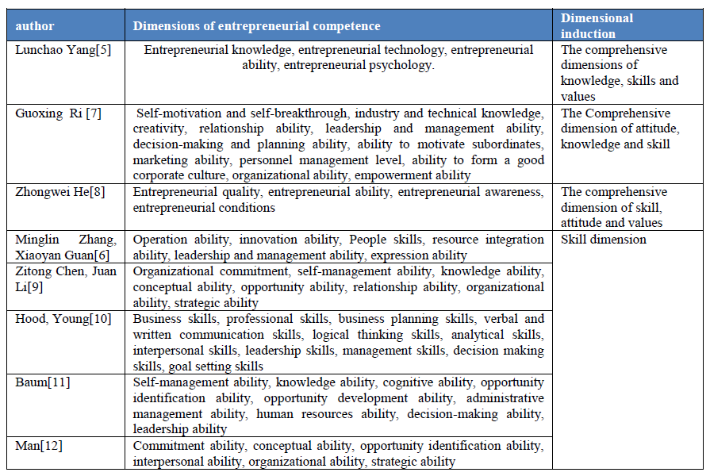

In summary, based on existing research, both Chinese and international scholars agree that the key dimensions of entrepreneurial competence include entrepreneurial knowledge, entrepreneurial skills, entrepreneurial abilities, entrepreneurial awareness, entrepreneurial spirit, entrepreneurial action, leadership, and collaborative skills. These can be broadly categorized into five dimensions: knowledge, skills, behavior, attitude, and values.

* 1. **The Entrepreneurial Competence Development Model of Canadian Applied Technology Institutes**

The primary objective of entrepreneurship education at the Canadian Institutes of Applied Technology is to develop students' entrepreneurial competence, mindset, psychological resilience, and knowledge. Over time, this approach has evolved into four key components: entrepreneurship curriculum education, hands-on entrepreneurship practice, entrepreneurial centers, and social support systems, as well as third-party evaluation agencies and entrepreneurial consulting firms. These elements work together to integrate the theory of entrepreneurial competence throughout the entire training process, from classroom learning to practical entrepreneurial experience and the actualization of entrepreneurial ventures.

**2.3.1 The Impact of Entrepreneurial Courses on Education**

To enhance the entrepreneurial abilities of college students, a variety of entrepreneurship education methods and approaches should be implemented. The theoretical education provides foundational knowledge, covering subjects such as entrepreneurship stories, entrepreneurial policies, market environments, industry analysis, marketing, legal aspects related to entrepreneurship, risk management, financial management of entrepreneurial enterprises, internal control design, and areas like finance, human resources, and marketing. These courses equip students with the essential skills and knowledge needed for entrepreneurship.

In terms of curriculum design, entrepreneurship education emphasizes the integration of curriculum structure with a focus on entrepreneurship and entrepreneurial qualities. It aims to strengthen the teaching of entrepreneurial knowledge and foster entrepreneurial abilities. Unlike the traditional pyramid model of education, entrepreneurship education adopts a circular model, where all courses revolve around strategic alliances, resource networks, alumni support, and entrepreneurial guidance, with entrepreneurship at the core.

Furthermore, within the circular model, there are two distinct types of entrepreneurship education: compound and integrated. In the compound model, the entrepreneurship curriculum includes introductory courses on entrepreneurship or small businesses, often supplemented with simultaneous interpretation courses. This simpler curriculum is typically adopted by schools that are still developing their entrepreneurship education programs. The integrated entrepreneurship education model, on the other hand, is implemented through dedicated departments or centers for entrepreneurship. Schools using these models assign faculty members to focus solely on teaching and research in the field of entrepreneurship education.

**2.3.2 Entrepreneurship Practice-Based Education**

To develop college students' entrepreneurial practical skills, the Canadian Institute of Applied Technology emphasizes extracurricular entrepreneurial activities alongside classroom teaching. These activities are designed to integrate theory with practice and include business plan writing training, entrepreneurial case competitions, and business simulation competitions. Among these, business plan competitions and incubator simulation activities effectively combine the theoretical knowledge and practical skills students acquire. These activities not only reinforce theoretical concepts but also enhance students' practical abilities. By engaging in these entrepreneurial practices, students learn to identify business opportunities, propose ideas, draft business plans, mobilize resources to launch businesses, and ensure the survival of their ventures. This hands-on experience provides valuable insight into the entire entrepreneurial process, boosting their entrepreneurial capabilities and establishing a strong foundation for future ventures. Through such competitions, the school fosters essential skills such as teamwork, communication, risk management, and analytical thinking. As a result, these activities form a core component of the overall entrepreneurship training system.

**2.3.3 Entrepreneurship Incubators and Social Assistance**

The Entrepreneurship Center at the Canadian Institute of Applied Technology is a dedicated institution designed to support entrepreneurship education. It takes several forms, including alumni-run enterprises that offer financial backing for the school and serve as a platform for practical experience, school-run enterprises with a strong practical focus, and entrepreneurship practice centers that provide real-world experience for students. Institutions like the South Alberta Institute of Technology (SAIT), Olds College, and Bow Valley College have established research and innovation centers, entrepreneurial incubators, and entrepreneurship centers. These centers not only serve as launch pads for student startups but also function as hubs for the transformation of entrepreneurship education and research & development outcomes in universities.

Canada’s social support infrastructure for entrepreneurs operates on three levels: federal, provincial, and community (municipal). This support primarily includes access to entrepreneurship information, technological assistance, and financial resources. Social support institutions also design policies tailored to different entrepreneurial groups, such as students. Entrepreneurs, from the inception of their business ideas to the stable growth of their companies, receive guidance and assistance aligned with the specific stages of their entrepreneurial journey. Once venture capital firms (recognized by reputable financial institutions) or relevant government bodies (including schools) acknowledge an entrepreneur’s innovative research or outcomes, they can access financial support, guarantee-free loans, and benefit from various entrepreneurship support policies, including legal protections, regulations, and partial tax exemptions. Through the Entrepreneurship Center and social support system, college students can successfully transition from entrepreneurial concepts to actual business ventures.

**2.3.4 Third-Party Assessment and Entrepreneurial Advisory Services**

The third-party evaluation agency assesses entrepreneurship education in Canadian universities by measuring the achievement of entrepreneurial objectives. This evaluation process tracks the entrepreneurial skills and attitudes of graduates, analyzes the results, and offers strategies to enhance the effectiveness of entrepreneurship education. Additionally, Canadian universities have established standardized market research institutions that study and forecast employment demands and potential gaps in the labor market. The insights derived from these studies serve as the foundation for developing new entrepreneurship courses.

Entrepreneurial consulting firms, such as Highwood Community Consulting, are non-profit organizations that bridge the gap between business, government, youth programs, and communities to support local economic development. Their primary mission is to foster small enterprise growth and create job opportunities. These consulting companies assist entrepreneurs in developing business structures, operational plans, legal frameworks, and financial analyses. They also provide loan evaluation services for small businesses, including small and medium-sized enterprise loans, credit evaluations, and qualification standards. Furthermore, they offer ongoing business consulting, resources, training, and development services, while actively promoting regional economic growth through business training and community-based activities.

* 1. **Theoretical Framework of Entrepreneurial Competence in Higher Vocational Students**

Building on a review and analysis of previous research on entrepreneurial competence both domestically and internationally, this paper aims to further define the components of entrepreneurial competence in higher vocational students. To achieve this, a combination of qualitative and quantitative research methods will be employed to establish a comprehensive model for the entrepreneurial competence of higher vocational students, as illustrated in Figure 1.

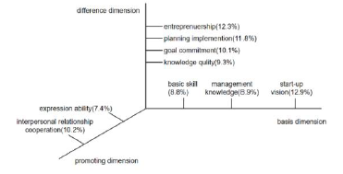

**Figure 1:** Construction model of entrepreneurial competence of Vocational College Students

***2.4.1 Research Methods and Data Source***

**2.4.1.1 Qualitative Method: Content Analysis of Interviews**

This qualitative research is based on interview data gathered from 21 participants across 5 Applied Technology Colleges in Canada, including 9 students, 2 department heads responsible for entrepreneurship guidance, 5 entrepreneurship tutors, and 5 students involved in entrepreneurship competitions or activities. The purpose of this study is to clarify and construct a model for the structure of entrepreneurial competence in vocational college students through an analysis of the interview content.

**2.4.1.2 Quantitative Method: Survey Questionnaire**

A total of 300 questionnaires were distributed to two Higher Vocational Colleges in Hebei Province, resulting in 278 responses and 164 valid questionnaires. The data from these valid responses primarily serves to validate the theoretical model derived from the qualitative research, as well as to assess the impact of different model elements on entrepreneurial performance.

**2.4.2 Research Process and Results**

From the combined qualitative and quantitative analysis, the research process follows several steps. First, the interview outline is developed based on the five aspects of entrepreneurial competence—knowledge, skills, behavior, attitude, and values—previously identified. Second, through in-depth interviews, 150,000 words of interview data are collected and organized. Third, the coding results are analyzed for reliability and validity, leading to the identification of nine key elements of entrepreneurial competence across three dimensions for vocational college students. Finally, using a questionnaire survey, the impact of these nine dimensions on entrepreneurial performance is validated. The results show that the dimensions of entrepreneurial competence have a positive effect on entrepreneurial performance, with the degree of influence ranked from low to high as follows: Basic Dimensions—entrepreneurial vision (12.9%), management knowledge (8.9%), basic skills (8.8%); Differentiation Dimensions—entrepreneurship (12.3%), planning and implementation (11.8%), goal commitment (10.1%), knowledge quality (9.3%); Promotion Dimensions interpersonal collaboration (10.2%) and communication skills (7.4%).

As illustrated in Figure 1, entrepreneurial vision, along with the essential knowledge and skills, forms the foundational elements that enable students to engage in innovation activities. Entrepreneurship, planning and execution ability, goal commitment, and cultural development represent the distinctive elements that differentiate successful entrepreneurs. Meanwhile, strong interpersonal relationships and communication skills, while not the external "hard power" for entrepreneurial success, play a critical role in activities such as market development and attracting investment. This paper also highlights that students need not only the basic elements of knowledge and skills, but also internal qualities like entrepreneurship, plan execution, goal commitment, and cultural development.

The research clearly outlines the components of entrepreneurial competence for higher vocational college students and their relative impact, offering a valuable basis for reforming entrepreneurship talent training programs in these institutions.

1. **Factors and Discrepancies in the Entrepreneurial Competence of Students in Chinese Higher Vocational Colleges.**

The Canadian Institute of Applied Technology primarily focuses on vocational and technical education, offering professional-level training starting from the school level. Its training objectives are centered on cultivating highly skilled talent for local regions or communities. The training model integrates work-based learning, closely linking with enterprises and industries. Therefore, Canadian institutions are similar to China’s higher vocational education colleges in terms of type and educational level.

Currently, there remains a significant gap between China’s vocational colleges and those in developed countries, particularly in terms of fostering students' entrepreneurial competencies. This gap is largely due to the disconnect between talent development programs and market demands. By comparing the entrepreneurial competency training content between Chinese and Canadian vocational college students, this paper aims to identify the underlying reasons for the disparity. Table 2 presents a comparison of the entrepreneurial competence training programs for students in Chinese and Canadian vocational colleges.

Table 2. Comparison of Entrepreneurial Competence Training Contents between Chinese and Canadian College Students

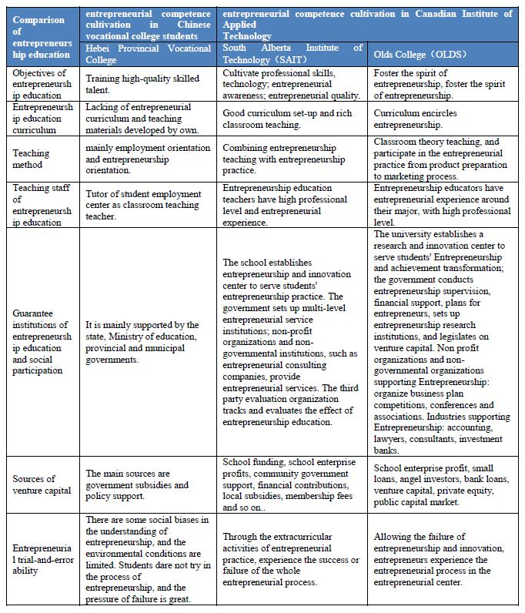

A comparison of entrepreneurship education between Chinese and Canadian universities, along with an analysis of entrepreneurial competency dimensions, reveals a significant gap between China's higher vocational colleges and Canadian entrepreneurship education. This gap is primarily reflected in several aspects: most Chinese higher vocational colleges, similar to general universities, focus predominantly on imparting knowledge and skills, with an emphasis on general education (liberal education) and humanistic studies, as advocated by Newman. However, the approach to learning varies across different historical periods and countries. The early Italian universities, for instance, were based on medical and law schools, covering a limited range of subjects, while institutions like the University of Paris and Oxford embraced a broader academic scope. In the 19th century, universities with a focus on applied technology emerged, prompting Newman to argue that universities should not only focus on a specific discipline but instead aim to explore general knowledge. He believed that the pursuit of knowledge for its own sake, rather than for utilitarian purposes, should be the core aim of university education, emphasizing the development of spirit and mind. Although China’s higher vocational education has made progress through demonstration projects focused on skill training, it has yet to establish a clear and effective positioning.

In contrast, the Canadian Institute of Applied Technology (CBE) follows a competency-based education (CBE) model, which prioritizes skills and abilities over academic qualifications or traditional knowledge systems. CBE recognizes competencies acquired through practical experience and incorporates strict scientific management alongside flexible, diverse modes of delivery. Students can enroll at different levels, with learning methods and timelines tailored to individual needs. Programs vary in duration and graduation time, allowing for small-scale, high-quality, and diverse offerings. This approach challenges traditional educational systems that are structured around academic disciplines, placing the development of professional competencies as the central goal of vocational training.

Competency-based education has become a global trend in vocational education and training since the 1960s. Its foundation lies in developing post-operational skills and emphasizes vocational education systems based on competencies. The concept originated from the U.S. training programs for veterans following World War II and was later adopted for vocational teacher training in the U.S. In the 1980s, CBE spread to Canada and gained further influence across Europe, Australia, and other regions, significantly impacting vocational education. By the late 1980s and early 1990s, Commonwealth countries such as the U.K., Australia, and New Zealand restructured their national vocational education systems based on CBE principles, propelling competency-based vocational education to the forefront of global education reform. Due to its notable advantages, CBE garnered widespread attention and became a popular direction for vocational education reform worldwide.

The Canadian Institute of Applied Technology centers its curriculum on market demand, shaping programs and courses accordingly. The government plays an active role by enhancing the position of enterprises in vocational education through policies such as tax incentives, encouraging deeper industry participation. Many members of the university’s board of directors and academic committees come from industry backgrounds, and the professional advisory committees consist of industry managers and experts who provide valuable insights, resources, and funding for the institution. These industry leaders also play a crucial role in shaping the curriculum and professional programs. Teaching at the institution is centered around practical skills development, with hands-on courses comprising the majority of the curriculum, while theoretical learning plays a smaller role.

In contrast, China’s higher vocational education still faces several challenges, including a lack of entrepreneurial knowledge, a weak entrepreneurial culture, insufficient entrepreneurial support resources, and a low level of entrepreneurship education. The main issues lie in an incomplete entrepreneurship education curriculum, a skewed understanding of entrepreneurship, a shortage of practical experience among entrepreneurship educators, and an underdeveloped entrepreneurial ecosystem. Based on these findings, this paper proposes reform strategies for cultivating entrepreneurial competencies among vocational college students, aiming to address these gaps and improve the quality of entrepreneurship education in China.

1. **Strategies for Reforming the Development of Entrepreneurial Competence in Higher Vocational College Students.**

In conclusion, there are several unsatisfactory aspects in the development of entrepreneurial competence among students in China’s higher vocational colleges. These issues stem from various factors, including shortcomings within the government, enterprises, as well as the colleges and the students themselves. Based on the entrepreneurial competence model for higher vocational college students, it is essential to enhance the development of students' entrepreneurial skills by focusing on the following areas: firstly, offering general entrepreneurship courses to develop students’ entrepreneurial vision, business management knowledge, and foundational business skills (basic dimension); secondly, selecting students with entrepreneurial intentions and fostering their entrepreneurial mindset, planning and execution abilities, goal commitment, and cultural awareness, while also emphasizing interpersonal cooperation and communication skills throughout the talent development process (promotion dimension). This comprehensive approach will help nurture students' overall entrepreneurial competence. To improve the current state of entrepreneurship education and students' self-development in higher vocational colleges, it is important to focus on three key areas to strengthen the cultivation of students’ entrepreneurial abilities.

**4.1 Enhancing the Framework of Entrepreneurial Curriculum**

Drawing inspiration from the well-established curriculum system of entrepreneurship education at the Canadian Institute of Applied Technology, the development of the curriculum should be competency-based, industry-oriented, and involve multiple stakeholders. It should include comprehensive market research to create an entrepreneurship curriculum that aligns with market demands. A general entrepreneurship curriculum should be established, covering topics such as entrepreneurship policies, market dynamics, marketing strategies, relevant legal frameworks, and risk management. This will help guide students in understanding the entrepreneurial landscape and develop the foundational skills required for successful entrepreneurship.

In comparison to Canadian educators, many teachers in China lack firsthand entrepreneurial experience. To address this, China can adopt a "bring in and send out" approach, inviting foreign experts and engaging successful entrepreneurs as part-time instructors. Additionally, efforts should be made to gradually develop a pool of outstanding local educators, enabling the creation of a high-quality teaching team with a global perspective in entrepreneurship education.

**4.2 Creating Entrepreneurial Spaces on Campus and Establishing Practical Platforms**

Building on theoretical course content, the concept of "maker" is introduced to establish campus maker spaces, enhancing entrepreneurial skills through hands-on practice. Vocational colleges collaborate with enterprises to create a low-cost, accessible, and open innovation and entrepreneurship service platform, driven by market-oriented mechanisms and professional services. This platform primarily serves college students and young entrepreneurial teams with an entrepreneurial mindset. It provides affordable office spaces and public service facilities to reduce entrepreneurial costs. Additionally, through partnerships with start-up service organizations, the platform offers essential services such as business registration, staffing, recruitment, financial and tax services, intellectual property assistance, as well as professional services including management consulting, mentorship, project guidance, venture capital connections, entrepreneurial roadshows, and virtual incubation. These services help increase the survival and growth rate of entrepreneurial teams, foster the successful transformation of entrepreneurial ideas, and enable the sustainable operation of feedback mechanisms, which ultimately play a crucial role in enhancing practical entrepreneurial abilities.

* 1. **Enhancing Entrepreneurial Risk Education and Expanding Social Support**

Given the limited social experience and entrepreneurial skills of many college students, the path to entrepreneurship can be particularly challenging. Therefore, incorporating risk education into entrepreneurship programs is crucial. Risk education should help entrepreneurs carefully evaluate various risks, such as project selection risks, capital risks, social relationship risks, competition risks, and decision-making risks. Entrepreneurs should learn to distinguish between controllable and uncontrollable risks and be taught strategies to manage and mitigate these risks effectively.

Social support for entrepreneurship is primarily driven by government policy at the macro level. It is essential to protect entrepreneurs' legitimate rights and interests through policies, systems, and legal frameworks tailored to their needs. To address the challenges entrepreneurs, face, a personalized system of preferential policies, loan assistance, and comprehensive employment and entrepreneurial services should be established. Furthermore, creating a professional third-party business consulting service system will provide entrepreneurs with specialized support, including feasibility assessments, expert management advice, financial forecasting, loan applications, and entrepreneurial loans for college students.

1. **Conclusion**

The arrival of the "mass entrepreneurship and innovation" era highlights the critical need to enhance the entrepreneurial competence of vocational college students, who are increasingly recognized as essential drivers of economic growth, technological advancement, and societal innovation. As the demand for skilled entrepreneurs continues to grow, it becomes imperative to equip students with the practical skills, creative thinking, and entrepreneurial mindset needed to thrive in today’s competitive business landscape. Developing a comprehensive entrepreneurial competency model offers a strong theoretical foundation for reforming vocational education, helping to bridge the gap between traditional academic training and the practical skills demanded by the job market.

In this context, the Canadian entrepreneurship education system provides valuable insights into creating a more effective and industry-relevant curriculum. Its focus on competency-based learning, integrating practical skills with academic knowledge, is a model worth emulating.

To achieve a transformative impact, it is essential to establish a collaborative, dynamic ecosystem that involves all relevant stakeholders, including government bodies, industry leaders, and educational institutions. By fostering partnerships and pooling resources such as expertise, funding, information, and platforms, a comprehensive support structure can be created for aspiring entrepreneurs. This integrated approach will not only strengthen entrepreneurial education but also empower vocational college students to make a seamless transition from learning to entrepreneurship, ultimately ensuring their success in an ever-evolving market.

**References:**

[1] Gaylen N. Chandler, Steven H. Hanks. Market attractiveness, resource-based capabilities, venture strategies, and venture performance[J]. Original Research Article, Journal of Business Venturing, 1994, 9(4): 331-349.

[2] Thomas W.Y Man, Theresa Lau, K.F Chan. The competitiveness of small and medium enterprises: A conceptualization with focus on entrepreneurial competencies[J]. Original Research Article, Journal of Business Venturing, 2002, 17(2):123-142.

[3] Bird, J. B. Time and entrepreneurship [J].Entrepreneurship theory and practice. 1995, 22 (2) : 5-10

[4] Feng Hua, Du Hong. An Analysis of the Relationship Between Entrepreneurial Competence and Entrepreneurial Performance[J].Techno-economics&Management Research, 2005, (6) : 17-18.

[5] Yang Lunchao. Exploration on the Elements System of Entrepreneurial Ability of Economic and Management College Students[J]. Education and Vocation, 2008, (14): 158-160.

[6] Zhang Minglin, Guan Xiaoyan. On the Structure and Evaluation System of College Students' Entrepreneurial Quality [J]. Commercial Times, 2008, (16): 69-79.

[7] Rui Guoxing, Hua Ying. The Study of Comprehensive Evaluation Model of Entrepreneurial Team Entrepreneurial Capacity in Student Business Plan Competition[J]. Journal of Northeast Normal University(Social Science), 2009, (6) : 224-227.

[8] He Zhongwei Ren Yu. Evaluation of Entrepreneurial Ability of Agricultural Higher Vocational College Students Based on AHP[J]. Journal of Agricultural Economics, 2010, (12): 111-116.

[9] Chen Zitong, Li Juan.The Construction of College Students' Entrepreneurial Competency Model[J]. Economic Research Guide, 2011, (16) : 294-296.

[10] Hood. J., Young,. Entrepreneurship’s requisite areas of development: a survey of top executives in entrepreneurial firms [J]. Journal of Business Venturing 1993:35-115.

[11] Baum. J. R.. The relationship of trials, competencies, motivation, strategy, and structure to venture growth [D]. PhD dissertation, University of Maryland, College Park, MD, 1994.

[12] Man. T., Lau. T., Chan. K. F. The competitiveness of small and medium enterprises. A conceptualization with a focus on entrepreneurial competencies [J]. Journal of Business Venturing 2002:42-123.

[13] Han Tiwen, Lian Lin, Dong Zhongqi. Exploration of Dimensions of Skilled Talent Team Competency Based on Qualitative Research[J]. Science and Technology