**Results of Reflections on the Drivers and Mechanisms of ESG Corporate Performance Creation Based on Stakeholder Perspective**

**Shuyu chen1,a,**\***, Tianze Zhang2,b**

1Hong Kong Institute of Business Studies, Lingnan University Hong Kong, China

2School of Data Science, Lingnan University Hong Kong, China

achenshuyu2023@163.com

btianzezhang@ln,hk

**Abstract:** The ESG concept, as a visual expression of the concept of sustainable development, plays an important role in the development of China's current economic construction. As the main body of the market economy, enterprises are also an important carrier for realizing high-quality economic development and sustainable development of the society, and the ESG performance of enterprises has been highly valued by all walks of life, which advocates that enterprises should pay attention to the financial performance and at the same time, explore the performance of the environment, social responsibility, and corporate governance, so as to promote the enterprises to accurately identify the opportunities and risks in the more and more competitive market environment, and comprehensively practice the path of sustainable development. development path. Therefore, after understanding the ESG driving model and the role of internal and external stakeholders, this paper starts from the perspective of stakeholder support to explore the impact of an enterprise's ESG performance on its performance, and to validate the impact of its ESG performance on the enterprise's bi-dimensional innovation and its path, so as to obtain the results of the relevant impact analysis.

**Keywords:** stakeholders; ESG; corporate performance; market response; market performance

**1. ESG Driven Model**

In this paper, the study starts from the perspective of internal and external stakeholder drive, and clarifies that the internal stakeholder drive includes both shareholders and employees, and the internal stakeholder drive includes consumers, partners and competitors, the government, and the society Based on this, we construct a stakeholder-centered drive model, and the main structure is shown in Figure 1 below:

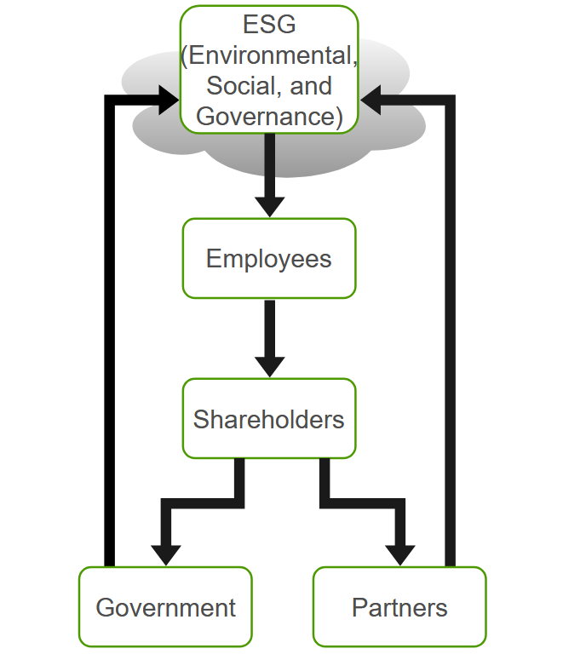

Fig. 1 Structure of the ESG driver model

Combined with the above model, it can be seen that the employees who are in the internal stakeholders can directly improve the acquired performance by participating in the production and operation activities of the enterprise, and the ESG disclosure information of the enterprise will reduce the regulatory cost of the shareholders and improve the investment benefit of the shareholders; the consumers who are in the external stakeholders can realize the increase of the enterprise performance through the purchasing behaviors, and its three can increase the performance of the enterprise by exerting pressure on the enterprise, which will prompt the enterprise to positively fulfill ESG responsibilities and indirectly increase corporate development performance. From an overall perspective, internal stakeholders can use direct ways to participate in corporate business activities to positively influence corporate ESG performance, while external stakeholders choose different ways to promote ESG. Under the joint influence of internal and external stakeholders, enterprises are more inclined to actively improve their ESG performance in order to maintain their market competitiveness and position while realizing high-quality transformation and sustainable development.

**2. Internal and external stakeholder-driven enterprises**

2.1 Internal stakeholders

Employees and shareholders, as internal stakeholders of the enterprise, will be directly involved in the economic activities of the enterprise and have a close connection with the creation of the enterprise performance, the enterprise can only realize the corresponding business objectives by maintaining the attraction of internal stakeholders, proposing appropriate development strategies and truly meeting their development needs. On the one hand, shareholders, as the source of capital provision for the enterprise, comprehensively think about the investment risks faced in the development of practice, and systematically study the operating conditions and profitability of the enterprise. High-quality ESG performance can effectively constrain the rights and interests of management, alleviate the degree of information asymmetry, accumulate more fertility capital, and reduce the occurrence of occasional risk events, thus enhancing the investment efficiency of the enterprise. For investment personnel, corporate ESG performance is one of the main influencing factors to be considered in investment decision-making, with the aim of fully grasping the basic situation of the investment and prompting the enterprise to actively fulfill its ESG responsibilities while obtaining more efficient benefits. On the movie side, employees are the direct creators of corporate performance, entrepreneurship and corporate culture, as well as the most core stakeholders of corporate development, and viewing them as the core secondary indicators under the social framework in the ESG assessment system can not only comprehensively examine the credit risk of corporate development, but also effectively warn of the risk of corporate innovation. Among them, the driving role for employees is shown in Figure 2 below:

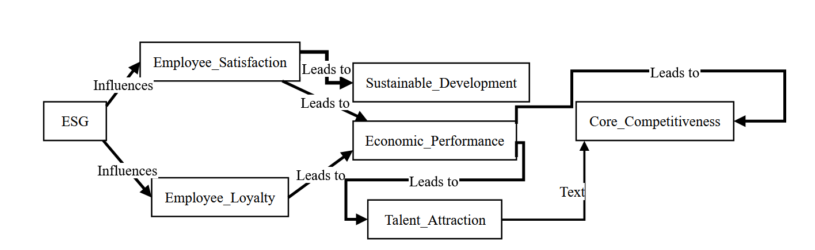

Fig. 2 Structure of the role mechanism of driving employees based on ESG theory

2.2 External stakeholders

External stakeholders refer to the individuals or groups that participate in the business activities of the enterprise in an indirect way, which mainly include consumer groups, government departments, partners, competitors and social organizations. Among them, consumers are the fundamental way for enterprises to obtain capital flow, and satisfied customers are a kind of special assets, which can bring future economic returns for the development of the enterprise.The enterprises with good ESG can provide high-quality services for the consumer group, help the consumer group to solve the problems of the products, and positively guide the consumers to establish the sustainable development of the concept of consumption, and pay attention to enhancing the adhesion of consumers to the enterprise, which can further improve the credibility of the enterprise and the effectiveness of marketing and promotion. further increase the enterprise credibility and the effectiveness of marketing promotion. The corresponding driving mechanism is shown in Figure 3 below:

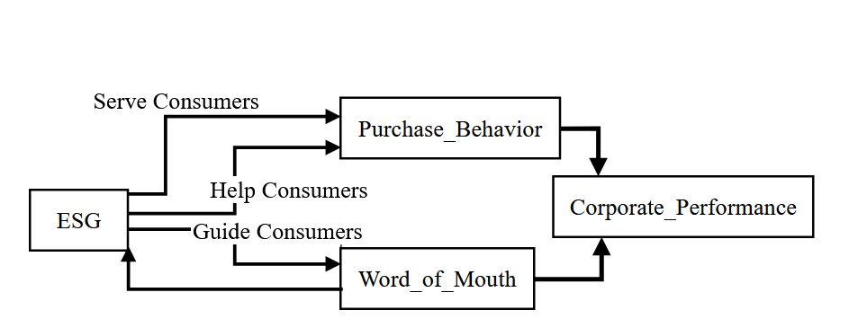

Fig. 3 Structure of the mechanism of action for driving consumer groups based on ESG theory

Partners and competitors are also very important external stakeholders, if the enterprise has good ESG performance, then it proves that the enterprise has better economic efficiency, good performance in environmental, social responsibility and corporate governance benefits, and can make more partners understand the enterprise financial situation, and actively participate in economic construction cooperation. From the competitor's perspective, the competitor's ESG performance affects the consumer group's consumption concept and purchasing behavior. When the consumer group's consumption concepts are changing towards sustainability, if the ESG performance of the enterprise stops, then customers are likely to be lost.

According to China's basic national conditions, government departments as an important main body to participate in social and public affairs, the social responsibility obligation of enterprises and the willingness to participate in social and public affairs is low.ESG concepts are in line with the requirements of high-quality and sustainable development, and have a positive effect on the improvement of the employment environment, social responsibility, and protection of the ecological environment, etc., therefore, the government departments will put forward relevant preferential policies to urge the enterprises to conscientiously perform the ESG responsibilities. Although government departments have a positive impact on the supervision of enterprises' environmental and social responsibilities, under some conditions, government departments are faced with a dilemma, and some enterprises will let their economic activities destroy the ecological environment in order to maximize their profits. In response to this phenomenon, enterprises need to be supervised by society when fulfilling their ESG responsibilities, which can guide public opinion to reduce the economic benefits of enterprises, effectively supervise the development behavior of enterprises, and prompt enterprises to strictly fulfill their ESG responsibilities.

**3. A study of the impact of a firm's performance on firm performance**

3.1 Financial performance evaluation methods

Considering stakeholders as an important criterion for categorizing the data study, looking for financial information related to them in the database utilizing the run to transform the financial data metrics into composite metrics, extracting multiple constituent scores, and making sure that each of the constituent scores presents as much of the company's financial information as possible.

First, the original data matrix is constructed based on the sample companies and the selected financial indicators. Assuming that n sample companies are included vertically and m financial indicators are included horizontally in the X matrix of financial performance evaluation, the following matrix can be obtained:

$$X=\left(\begin{matrix}x_{11} & x_{12} & ... & x_{1p} \\ x_{21} & x_{22} & ... & x_{2p} \\ ... & ... & ... & ... \\ x_{n1} & x_{n2} & ... & x_{np}\end{matrix}\right)$$

In the above matrix, Xnprepresents the pth financial indicator data of the nth listed company.

Second, standardized processing of raw data, the corresponding formula is as follows:

$$x_{ij}^{'}=\frac{xij-\overset{¯}{x_{j}}}{\sqrt{Var\left(x_{j}\right)}}$$

In the above equation, $x_{ij}^{'}$ represents the mean value of the variable and $\sqrt{Var\left(x_{j}\right)}$ represents the standard deviation of the variable.

Third, to accurately determine the suitability of financial indicators for principal component analysis, the KMO value and the Bartlett's ball test can usually be regarded as the main basis, and only if the relevant indicators have a KMO value of more than 0.5, they meet the criteria for principal component analysis.

Fourth, the principal components are extracted with the following formula:

$$e_{j}=\frac{λ_{j}}{\sum_{i=1}^{p}{ }λ_{j}}E_{m}=\sum_{j=1}^{m}{ }e_{j}$$

In the above equation, ejrepresents the contribution of a feature value and Emrepresents the sum of the contribution of the first m feature values.

Fifth, specify the principal components and their corresponding formulas. After all the components have the meanings they represent, the corporate financial composite score function is obtained by calculating and analyzing the component scores as follows:

$$e_{j}=\frac{λ_{j}}{\sum_{i=1}^{p}{ }λ_{j}}E_{m}=\sum_{j=1}^{m}{ }e_{j}$$

In the above equation, Firepresents the ith principal component, which contains a total of m principal components; Xirepresents the ith financial indicator, which contains a total of p financial indicators.

In the experimental research, the evaluation index system shown in Table 1 below was selected, and the main direction of enterprise construction and development was clarified, and then the relevant enterprises were selected as the comparison case, and the data were analyzed based on the Stata operation, and the results shown in Table 2 below were finally obtained:

Table 1 Enterprise financial performance evaluation index system

|  |  |  |
| --- | --- | --- |
| **Stakeholders** | **Evaluation Indicators** | **Calculation Formula** |
| Creditors | Liquidity Ratio | Current Assets / Current Liabilities |
|  | Debt to Asset Ratio | Total Liabilities / Total Assets |
| Employees | Equity Ratio | Total Liabilities / Shareholders' Equity |
|  | Employee Profitability | Cash Paid to Employees and Dividends / Operating Income |
| Government | Tax Ratio | Tax Amount / Operating Income |
| Consumers | Revenue Growth Rate | (Current Year Revenue - Previous Year Revenue) / Previous Year Revenue |
|  | R&D Investment Intensity | R&D Expenditure / Operating Income |
| Suppliers | Accounts Payable Turnover Ratio | Cost of Goods Sold / Average Accounts Payable |
|  | Cash to Accounts Payable Ratio | Operating Cash Flow / Accounts Payable |

Table 2 Results of the evaluation of the financial performance of enterprises

|  |  |  |  |  |
| --- | --- | --- | --- | --- |
| **Year** | **F1** | **F2** | **F3** | **F (Comprehensive)** |
| 2019 | 0.2274 | 0.3408 | 0.0144 | 0.2215 |
| 2020 | 0.7314 | 0.5508 | 0.5013 | 0.6565 |
| 2023 | 0.7583 | 0.4936 | 0.4677 | 0.6822 |
| 2022 | 0.7834 | 0.8272 | 0.7432 | 0.7943 |
| 2023 | 0.9839 | 0.5901 | 0.6892 | 0.6046 |
| 2024 | 1.4611 | 0.8529 | 0.7271 | 0.9157 |

Combined with the analysis of the above table, it can be seen that the study shows that after joining the ESG rating in 2018, the enterprises under the conditions of stakeholder support have independently improved their ESG investment and enhanced their ESG construction, and the overall trend has been gradually rising since then, and in addition to declining in 2023 due to the impact of epidemics and the rise in the cost of raw materials, and other objective factors, the good ESG performance has prompted enterprises to improve their business strategies rapidly after suffering from the impact of epidemics, and further improve the economy and effectiveness of practice development. After the impact of the epidemic, enterprises are still able to quickly improve their business strategies, effectively respond to the supply and demand conflicts in the supply chain, further improve the economy and effectiveness of practical development, and quickly seize the opportunity to strengthen their competitiveness in carbon and target.

3.2 Methodology for measuring market performance of enterprises

Considering Ritas the firm's real rate of return at day t, and Rmtas the market rate of return at day t, the daily return of GEM in the same period is chosen as the market rate of return, from which the computational model shown below is constructed:

$$R_{it}=α+βR_{mt}+ε_{t}$$

In the above equation, $α+β$ represents the regression coefficients of the equation and $ε_{t}$ represents the error fork term, on the basis of which the linear regression results of analyzing firms' real returns and GEM's daily returns for the same period are estimated.

In analyzing the model used for the long-term market response, it refers to the buy-and-hold excess return BHAR, which is formulated as follows:

$$BHAR_{i}=\prod_{t=0}^{T}{ }\left(1+R_{it}\right)-\prod_{t=0}^{T}{ }\left[1+E\left(R_{it}\right)\right]$$

In the above equation, R represents the stock return of the sample firms in month t, E(R) represents the expected stock return of the sample firms in month t, and T represents the time period examined.

The five trading days after the event date are regarded as the event window period, on the basis of which the actual return of the firms and the return of the Venture Index for the same period are selected for Excel linear regression analysis, and then the regression function is constructed as follows:

$$R_{it}=1.4938R_{mt}+0.0025$$

On this basis, the abnormal rate of return of the analyzed firm during the window period and the cumulative abnormal rate of return during the window period are calculated and analyzed by the following formulas:

$$AR_{it}=R_{it}-R_{it}^{'}$$

$$CAR_{(t_{1},t_{2})}=\sum_{t_{1}}^{t_{2}}{ }AR_{it}$$

In the above formula, Ritrepresents the real rate of return of the firm during the time window period, and CAR(t1, t2)represents the sum of the cumulative abnormal rate of return of the firm during the period (t1, t2). The actual study can obtain the results of the indicator changes as shown in Table 3 below:

Table 3 Analysis of the results of changes in the indicators of the experimental study

|  |  |  |  |  |  |  |
| --- | --- | --- | --- | --- | --- | --- |
| **Time Point** | **Date** | **Actual Return Rate Ra​** | **Composite Return Rate Rm​** | **Predicted Return Rate Rp​** | **Abnormal Return Rate AR** | **Cumulative Abnormal Return Rate (CAR)** |
| 0 | 2023/01/21 | 5.71% | 1.73% | 3.61% | 2.11% | 2.11% |
| 1 | 2023/01/22 | 5.78% | 0.94% | 2.52% | 3.26% | 5.36% |
| 2 | 2023/01/25 | 3.74% | -0.74% | 0.22% | 3.52% | 8.88% |
| 3 | 2023/01/26 | 5.83% | -0.23% | -1.93% | 7.76% | 16.64% |
| 4 | 2023/01/27 | 9.33% | 0.45% | 1.86% | 7.48% | 24.12% |
| 5 | 2023/01/28 | 5.23% | -2.91% | -0.28% | 7.99% | 32.12% |

Combined with the analysis of the above table, the abnormal yield of the enterprise has been showing a continuous upward trend, and the cumulative abnormal yield on the 5th day can reach 32.2%, and has obtained a more positive response in the capital market. After participating in the domestic rating for the first time, the enterprise began to increase the investment and development of ESG, and obtained excellent results in the applied research on environment, society and corporate governance, and the enterprise's own sustainable development ability is getting stronger and stronger, and there are more investors participating in the enterprise's construction and reform.

3.3 Impact of Dual Innovation in Firms

In order to test the effect of firm performance on the composition of firms' dual innovation, a regression model was constructed as shown below:

$${Explora}_{it}=α_{0}+α_{1}{ESG}_{it}+∑{Control}_{it}+δ_{h}+δ_{t}+ε_{it}{Exploriu}_{it}=α_{0}+α_{1}{ESG}_{it}+∑{Control}_{it}+δ_{h}+δ_{t}+ε_{it}$$

In the above equation, $a$ 
 represents the estimated parameter values of the independent and control variables, Exploraitrepresents the breakthrough innovation performance of the ith firm in year t, Exploriuitrepresents the incremental innovation performance of the ith firm in year t, Controlitrepresents the control variables, $δ_{h}$ 
 represents the industry fixed effects, $δ_{t}$ 
 represents the year fixed effects, and $ε_{it}$ 
 represents the randomized disturbance term.

Referring to the mediation effect test procedure proposed by existing scholars' studies, the test analyzes the mediation effect of R&D investment between firms' ESG performance and dual innovation, where Investitrepresents the level of R&D investment of the ith firm in year t. The specific model is shown below:

$${Invest}_{it}=α_{0}+α_{1}{ESG}_{it}+∑{Control}_{it}+δ_{h}+δ_{t}+ε_{it},{Explora}_{it}=α_{0}+α_{1}{ESG}_{it}+α_{2}{Invest}_{it}+Σ{Control}_{it}+δ_{h}+δ_{t}+ε_{it}{Exploriu}_{it}=α_{0}+α_{1}{ESG}_{it}+α_{2}{Invest}_{it}+∑{Control}_{it}+δ_{h}+δ_{t}+ε_{it}$$

At the same time, a cross term between the degree of digital transformation and the performance of enterprises is introduced, where Digitalitrepresents the level of digital transformation of the ith enterprise in year t. The specific model is shown below:

$Explorait=α_{0}+α_{1}Invest_{it}+α_{2}Digital_{it}+α_{3}Invest_{it}×Digital_{it}+∑Control_{it}+δ_{h}+δ_{t}+ε_{it}$ $Explorius_{it}=α_{0}+α_{1}Invest_{it}+α_{2}Digital_{it}+α_{3}Invest_{it}×Digital_{it}+∑Control_{it}+δ_{h}+δ_{t}+ε_{it}$

The coefficient of determination, R(2),assesses the fit of the model and is given in the following formula:

$$R^{2}=1-\frac{SS_{res}}{SS_{tot}}$$

In the above equation, SSresrepresents the residual sum of squares and SStotrepresents the total sum of squares.

The test of significance of the regression coefficients is the t-test, which can determine whether the regression coefficients are significantly non-zero or not, and the specific formula is as follows:

$$t=\frac{{\hat{β}}_{i}}{SE({\hat{β}}_{i})}$$

In the above equation, ${\hat{β}}_{i}$ represents the estimated value of the regression coefficient and $SE({\hat{β}}_{i})$ represents the standard deviation of the regression coefficient.

The formula for calculating the standard deviation is as follows:

$$SE({\hat{β}}_{1})=\sqrt{\frac{SS_{res}}{(n-2)∑(X_{i}-\overline{X})^{2}}}$$

In the above equation, n represents the number of samples and $X$ represents the average value of the independent variables.

Descriptive analysis based on the above model can find that the standard deviation of enterprise breakthrough innovation and progressive creation can reach 1.581 and 1.582 respectively, and the minimum value of enterprise ESG score is 11.98, and the maximum value is 47.11.The results of the experimental data show that under the existing competitive environment, ESG investment as a focus of attention in the capital market, both government departments and enterprises should formulate effective measures for ESG, actively guide enterprises to comprehensively practice ESG concepts, strictly supervise the ESG investment behavior of enterprises, prompt enterprises to actively disclose ESG reports, establish professional ESG databases, and facilitate investment institutions to obtain ESG data information of enterprises, improve ESG performance of enterprises, and increase the development of ESG investment. In addition, ESG investment will be promoted based on the evaluation system of ESG, which serves as an effective bridge between ESG disclosure and investment application, and is also the basic condition for enterprises to obtain ESG investment. At this stage, the authoritative organizations that provide ESG data include the Social Value Investment Alliance, Business Way Rong Green, etc. However, ESG, as a foreign investment concept and evaluation standard, must be based on the consideration of China's basic national conditions, and encourage and support the joint participation of the government, the community, and the enterprises, so as to improve the ESG evaluation system, comprehensively promote the concept of ESG industry development, and prompt the construction and management of the Chineseization of ESG evaluation.

**Conclusion**

In summary, practicing ESG concept is both an effective way for enterprises to identify opportunity risks and an important measure for enterprises to realize sustainable development goals. Therefore, when establishing the management system, enterprises should clarify the path of ESG implementation, actively recommend ESG practice work, and effectively disclose ESG information, so as to contribute to the construction of the road of socialism with Chinese characteristics while obtaining more economic benefits.

References

[1] Jiajie Wei. Drivers and mechanisms of ESG corporate performance creation from a stakeholder perspective[J]. Technology Entrepreneurship Monthly, 2023, 36(11):87-92.

[2] Yongsheng LIN, Yifan ZHANG, Zhanfeng DONG. Analysis of corporate ESG performance drivers from a global perspective[J]. China Environmental Management, 2024, 16(1):16-26.

[3] Yongchun HUANG, Di LIN, Shangshuo WU, et al. ESG Performance, R&D Investment and Dual Innovation--An Introduction to the Moderating Role of Firms' Digital Transformation[J]. Resources and Industry, 2024, 26(4):75-90.

[4] Junren Ming, Yaxian Feng, Zhangyang Xu, et al. ESG performance and corporate green innovation performance: influence mechanism and empirical evidence[J]. Journal of Accountancy and Finance, 2023(24):28-32.

[5] Jiaojiao Chen, Heyu Ding, Xuemei Zhang. Does ESG performance affect customer relationship stability? [J]. Securities Market Herald, 2023(3):13-23.

[6] Qianyu Zhang, Yuerun Chen, Yuetang Wang. The driving effect of "reverse hybridization" on ESG of private enterprises[J]. Economic Issues, 2025(2):87-98.

[7] Jun Liu. Research on the Motivation and Performance of Corporate Green Governance under ESG Concept [J]. Modern Industrial Economy and Informatization, 2024, 14(7):150-153.

[8] Wei Li. Research on the relationship between ESG performance and financial performance of manufacturing companies[J]. Small and medium-sized enterprise management and technology, 2024(12):42-44.

[9] Wenxia Cai, Linlin Deng, Yu Liu. ESG performance and corporate financial performance under the dual-carbon goal - based on the moderating role of external pressure[J]. Financial Theory and Practice, 2023(6):69-81.

[10] Qinfeng Shi, Feng Long, Xianming Duan, et al. The impact of ESG performance on corporate performance and incentive mechanism[J]. China Environmental Management, 2024, 16(4):34-43.

[11] Junwei LIU, Qiuchen LIANG, Hua LIU. The impact of dual motives of ESG disclosure on corporate green innovation performance - the mediating role of green image and the moderating role of value perception[J]. Science and Technology Progress and Countermeasures, 2024, 42(1):113-121.

[12] D. Yu. ESG performance and corporate environmental performance: effect assessment and mechanism testing[J]. Modern Economic Discussion, 2024(10):91-103.

[13] Yongjian Li, Wenyi Luo. How ESG promotes corporate innovation and development-an analysis based on supply chain resilience[J]. Supply Chain Management, 2023, 4(7):81-96.

[14] H. Zhang, X. Huang, Y. P. Li. Research on the mechanism of the impact of ESG performance on corporate performance--empirical evidence based on Chinese A-share listed companies[J]. Wuhan Finance, 2024(3):69-77.

[15] Manru Huang. Research on the impact of ESG performance on corporate innovation performance[J]. Market Forum, 2024(4):21-25.

[16] Zhuoying LI, Ziyao GAO, Qianyu LIN. Research Review and Prospect on the Influence Effect and Role Mechanism of ESG Disclosure on Corporate Performance[J]. Modern Business, 2024(19):55-58.

[17] Ya Sun, Junyu Liang. Literature review on the impact of ESG investment on corporate performance[J]. Journal of Economic Management (Chinese and English Edition), 2024, 13(2):95-98.

[18] Xinyi Tang. An investigation of the influence mechanism of small and medium-sized enterprises' innovation ability, ESG performance and corporate performance[J]. Commercial Economy, 2025(5):143-146.

[19] Aiping Zhu, Hongshan Wei. The relationship between ESG performance and corporate performance - A study of the moderating effect based on digital transformation[J]. Friends of Accounting, 2024(2):44-52.

[20] Xinlan Wang, Jie Zhang, Nan Wang. ESG Disclosure, Debt Financing Cost and Firm Performance - Empirical Evidence Based on Listed Companies in Pharmaceutical Manufacturing Industry[J]. Friends of Accounting, 2023(13):82-91.