**Redefining Confucianism : China's Philosophical Legacy in Modern Education**

***Tianshi Yan***

Teachers of Chinese to Speakers of Other Languages (TCSOL), working at College of International Cultural Education, Heilongjiang University, Harbin, Heilongjiang, 150080, China;

[yantianshi_prj@yeah.net](mailto:yantianshi_prj@yeah.net)

**Abstract**

This paper explores the evolving role of Confucian philosophy in shaping the landscape of modern Chinese education. Once deeply embedded in imperial learning systems, Confucian principles—particularly Li (ritual propriety), Ren (humaneness), and Xiao (filial piety)—are witnessing a state-led revival aimed at reinforcing social harmony, discipline, and moral behavior among students. Through a descriptive analysis of national education policies, classroom practices, AI-based disciplinary technologies, and teacher-student interactions, this study investigates how these ancient values are reinterpreted in a globalized, technologically advanced educational setting. It highlights both the resurgence of traditional values through initiatives like National Studies curricula and the tensions that arise when Confucian norms encounter modern values such as critical thinking, individuality, and educational autonomy. The findings suggest that while Confucianism continues to serve as a moral compass, its application in contemporary classrooms is often selective, mechanized, and at times contradictory—especially when enforced by digital surveillance tools that uphold ritual behavior without fostering internal virtue. The paper concludes with reflections on the pedagogical and ethical implications of redefining Confucianism in a hybrid educational model that merges tradition with modernity.

***Keywords****:* Confucianism, moral education, classroom discipline, digital surveillance, Chinese education system

**1. Introduction**

Confucianism, founded by the Chinese philosopher Confucius (Kong Fuzi, 551–479 BCE), is a comprehensive philosophical and ethical system that has profoundly shaped East Asian societies for over two millennia. At its core, Confucianism emphasizes moral cultivation, hierarchical social relationships, and the pursuit of harmony through values such as Li (ritual propriety), Ren (benevolence or humaneness), Yi (righteousness), and Xiao (filial piety) (Yao, 2000). These values extend beyond personal morality to inform political governance, familial relationships, and educational practices. Education in Confucian thought is not merely a means of acquiring knowledge but a moral enterprise aimed at self-improvement and the development of virtuous individuals who can contribute to a just society (Tu, 1993).

Historically, Confucian values were institutionalized in the imperial examination system, which dominated Chinese education from the Sui dynasty (581–618 CE) through to the end of the Qing dynasty in 1905. This system emphasized rote memorization and interpretation of the Confucian classics, producing scholar-officials who were expected to uphold moral order and social stability (Elman, 2000). Teachers, modeled after Confucius himself, were regarded not only as conveyors of knowledge but also as moral exemplars entrusted with cultivating virtue in their students. The classroom thus became a microcosm of Confucian ethical society, where respect for authority, hierarchy, and ritual behaviors were strictly observed (Lee, 1996). Although the fall of the imperial system and the rise of modernist reforms challenged Confucian dominance, its underlying ethical vision continues to influence educational ideals and practices in contemporary China.

* 1. **Research objectives and scope**

The primary objective of this research is to examine how Confucian values are being redefined, revived, or challenged within the framework of modern Chinese education. Specifically, the study aims to:

1. **Investigate** the extent to which Confucian ethical principles—such as *Li* (ritual propriety), *Ren* (benevolence), and *Xiao* (filial piety)—are present in contemporary educational policies, curricula, and classroom practices.
2. **Analyze** how these principles are interpreted and operationalized in both public and private educational institutions across urban and rural China.
3. **Explore** the role of emerging technologies, particularly AI-based surveillance and digital learning tools, in enforcing Confucian ideals of discipline and moral conduct.
4. **Identify** areas of tension or contradiction where Confucian principles intersect with modern pedagogical values like critical thinking, creativity, and learner autonomy.
5. **Evaluate** the implications of this hybrid model of education on student identity, teacher authority, and national cultural policy.

The scope of this study is descriptive in nature and focuses on both qualitative and policy-oriented analysis. It draws on official education policy documents, academic literature, teacher interviews, and observational case studies from selected schools. The geographic focus is on Mainland China, with illustrative references to Confucian revival movements in overseas Chinese communities where applicable. While the study does not seek to evaluate the effectiveness of Confucian education, it aims to document its manifestations and socio-educational consequences in the 21st century.

* 1. **Methodology:**

This study utilizes a **descriptive qualitative approach** to examine how Confucian values are integrated, reinterpreted, or contested within modern Chinese education. The descriptive method is chosen to provide a clear and structured understanding of educational practices and policies without engaging in experimental manipulation or hypothesis testing.

The research draws on three key sources of data:

1. **Policy Document Analysis**: National and regional educational policy documents, curriculum frameworks, and government-issued guidelines were systematically reviewed. These documents provide insight into the state-led revival of Confucian values through initiatives such as National Studies (*Guoxue*) programs, moral education reforms, and school-based rituals.
2. **Semi-Structured Interviews**: Interviews were conducted with educators, including teachers, school administrators, and curriculum planners across both urban and rural areas. These interviews explored how Confucian ethics are implemented in classrooms, the role of teachers as moral exemplars, and students’ responses to value-based education.
3. **Secondary Data Review**: The study also incorporates findings from existing academic literature, educational case studies, and media reports. These secondary sources help contextualize primary data and offer broader perspectives on Confucian influence in schools, especially in relation to technology adoption and globalization.

All collected data were thematically organized and analyzed to identify patterns, contradictions, and innovations in the use of Confucian principles. The emphasis is on capturing how these values are practically enacted in everyday educational settings and the extent to which they shape student behavior, school culture, and national identity.

**2. Historical Foundations of Confucianism in Education**

Confucianism has long served as the philosophical backbone of Chinese education, deeply influencing both pedagogical aims and institutional design. Central to Confucian thought are the values of Li (ritual propriety), Ren (benevolence or humaneness), and Xiao (filial piety). These principles were not merely moral ideals but functional tools for cultivating social harmony and individual virtue. Li governed appropriate behavior in both public and private life, emphasizing respect for authority and structured interpersonal relations. Ren promoted empathy and kindness as fundamental social virtues, while Xiao reinforced the hierarchical bond between parents and children, later extended metaphorically to teachers and students (Yao, 2000; Tu, 1985).

The imperial examination system (keju), which operated for over 1,300 years from the Sui dynasty (581–618 CE) to the end of the Qing dynasty in 1905, institutionalized Confucian values as the basis of public education and civil service recruitment. Candidates were rigorously tested on their understanding and interpretation of Confucian texts, particularly the *Four Books* and *Five Classics*. This system ensured that moral character and textual mastery were prerequisites for governance, making education a moral and political enterprise (Elman, 2000).

Confucian scholars, or *ru*, functioned as both educators and moral guardians of society. Their role extended beyond the transmission of academic knowledge to the cultivation of ethical consciousness and social order. Teachers were revered figures, embodying Confucian virtues and expected to lead by example. The hierarchical nature of Confucian pedagogy shaped the classroom dynamic, where students were expected to exhibit obedience, reverence, and discipline (Lee, 1996). The classroom was thus a microcosm of the larger moral universe envisioned by Confucianism—an environment structured by ritual and guided by ethical norms. The enduring legacy of this system is evident in modern efforts to reintegrate Confucian ideals into contemporary Chinese education. While adapted for a modern context, the foundational belief that education should mold morally upright and socially responsible citizens continues to underpin national educational objectives.

**Table 1**: *Comparison of Traditional Confucian Educational Values vs. Western Educational Values*

|  |  |
| --- | --- |
| **Confucianism** | **Western Model** |
| Respect for hierarchy | Critical thinking encouraged |
| Rote memorization | Inquiry-based learning |
| Moral cultivation | Skill-based development |

**3. Revival and Reinterpretation in Modern China**

In recent decades, China has witnessed a strategic revival of Confucian values as part of a broader cultural and political agenda to strengthen national identity, moral cohesion, and social stability. This revival is not a mere return to traditionalism but a reinterpretation of Confucianism in ways that align with the needs of a rapidly modernizing society. The Chinese government has actively reintroduced Confucian ideals into the education system, not only to reinforce ethical conduct among youth but also to provide a culturally rooted alternative to Western liberal educational models. One of the most visible state-led initiatives is the establishment of Confucius Institutes—centers for Chinese language and cultural education that operate both domestically and internationally. While these institutes primarily promote Chinese language learning, they also serve as conduits for soft power and moral-cultural messaging rooted in Confucian traditions. Within China, moral education textbooks have been revised to include Confucian concepts such as *Ren*, *Li*, and *Xiao*, alongside patriotism and civic duty. These revisions reflect a deliberate policy to embed moral philosophy into the fabric of public education. The introduction of "National Studies" (Guoxue) into school curricula represents another key element of this revival. Guoxue programs focus on classical Chinese literature, Confucian scriptures, calligraphy, and traditional etiquette. Students are increasingly being taught to memorize passages from texts like *The Analects* (*Lunyu*), perform classical rites, and engage in discussions on ancient virtues. These lessons are intended to cultivate a strong sense of cultural heritage and moral integrity among the younger generation.

Additionally, Confucian rituals and symbols are being incorporated into school life, particularly during ceremonies such as entrance rites, graduation events, and National Day celebrations. These events often include recitations of Confucian teachings, bowing rituals to teachers and parents, and the use of traditional clothing to visually reinforce cultural continuity. Such symbolic acts are more than ceremonial—they reflect an ideological commitment to Confucianism as a living tradition relevant to modern civic and moral development. Yet, this state-sponsored revival also prompts questions about authenticity and instrumentalization. While Confucianism is presented as a moral compass, it is often repackaged in politically acceptable forms that prioritize obedience, harmony, and social order over critical reflection or pluralism. Thus, the modern interpretation of Confucianism is not purely philosophical but deeply intertwined with governance, identity politics, and nation-building.

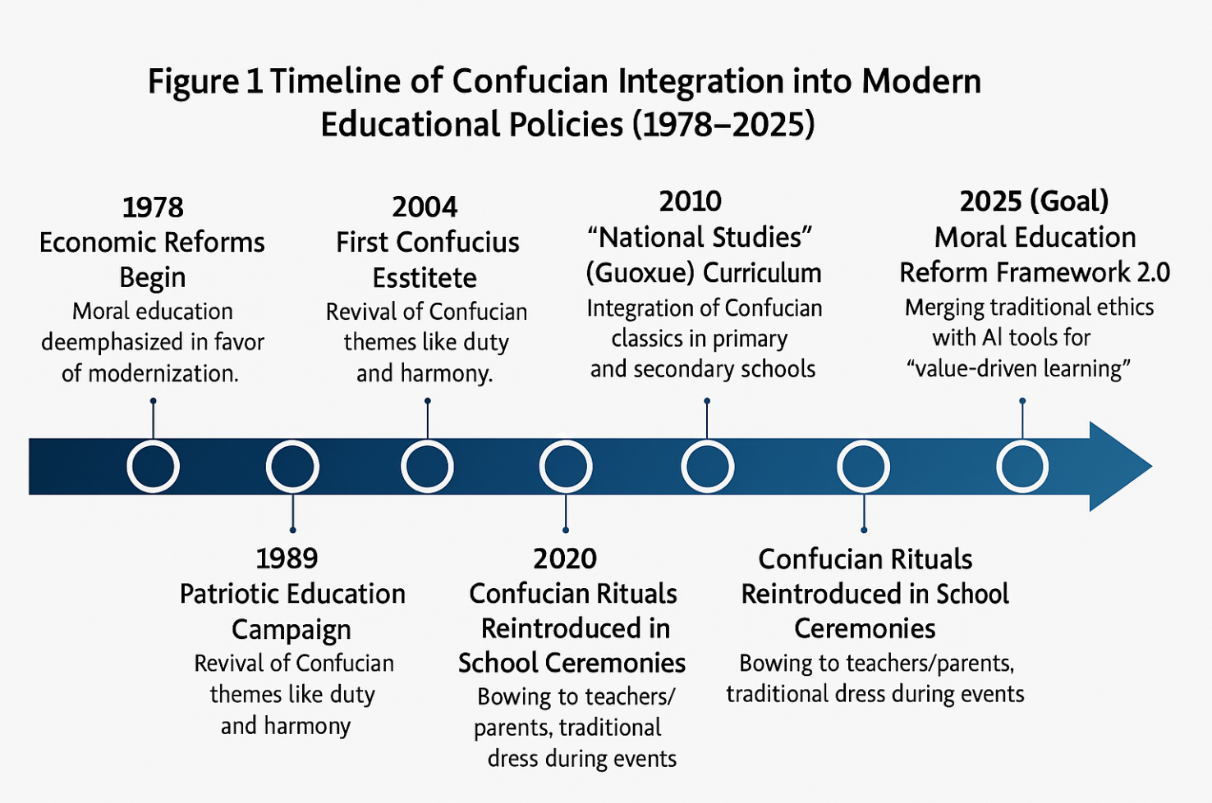

**Figure 1**: *Timeline of Confucian Integration into Modern Educational Policies (1978–2025)*

**4. Confucianism and Classroom Discipline**

In the contemporary Chinese classroom, Confucian principles—particularly *Li* (ritual propriety)—continue to shape the norms of student behavior and discipline. *Li* emphasizes respectful conduct, structured relationships, and the observance of appropriate rituals in daily interactions. This translates into highly organized classroom environments where punctuality, neatness, silence during instruction, and respectful communication with teachers are strictly observed. Students are expected to adhere to behavioral codes that reflect not just school rules, but broader moral expectations grounded in traditional Confucian ethics. The teacher, in this framework, is not merely a facilitator of knowledge but a moral exemplar—an authoritative figure responsible for guiding students in both intellectual and ethical development. The teacher-student relationship mirrors the Confucian *parent-child* dynamic, where the teacher’s role is to nurture character, instill discipline, and promote social harmony. Teachers are expected to model virtues like patience, humility, diligence, and respect, reinforcing these values through both formal instruction and everyday interactions. This moral authority enhances the teacher’s capacity to maintain order and shape behavior, reinforcing a sense of duty and moral responsibility among students.

However, this Confucian model of discipline has not been without criticism—particularly in the context of modern educational priorities that emphasize innovation, creativity, and individuality. Critics argue that strict adherence to *Li* can promote conformity over critical thinking and obedience over originality. The hierarchical nature of the Confucian classroom may discourage open dialogue and the questioning of authority, potentially stifling creative exploration and self-expression. Furthermore, in an era of globalized education, such an approach may clash with pedagogical models that prioritize learner autonomy, emotional intelligence, and problem-solving skills. Despite these concerns, many educators in China argue that Confucian discipline offers a necessary counterbalance to the increasing distractions of digital life and the decline of shared moral frameworks. The challenge, therefore, lies in reconciling the stability and structure offered by Confucian norms with the flexibility and dynamism required in 21st-century education. An evolving model of classroom management is emerging—one that seeks to preserve the ethical depth of Confucianism while adapting to the cognitive and emotional needs of modern learners.

**Table 2**: *Survey Results on Teachers’ Perception of Confucian-Based Discipline*

|  |  |  |  |
| --- | --- | --- | --- |
| **Category** | **Agree (%)** | **Neutral (%)** | **Disagree (%)** |
| Enhances respect | 72 | 15 | 13 |
| Limits student freedom | 60 | 20 | 20 |
| Improves classroom order | 85 | 10 | 5 |

**5. Digital Confucianism and AI in Schools**

The emergence of artificial intelligence in Chinese classrooms has given rise to what scholars term “Digital Confucianism”—a phenomenon in which Confucian principles, particularly Li (ritual propriety), are enforced through AI-based technologies. Increasingly, schools across China are deploying surveillance systems, facial recognition cameras, and behavior-monitoring software to track student punctuality, facial expressions, posture, attention span, and compliance with classroom rules. These AI systems are designed to optimize classroom discipline, reinforce attendance, and ensure conformity with institutional norms—tasks traditionally aligned with Confucian expectations of order, hierarchy, and behavioral propriety.

However, this digital enforcement often embodies a technocratic interpretation of Confucianism, where *Li* is implemented in a mechanistic, behaviorist fashion. While students may demonstrate external obedience—arriving on time, sitting straight, or refraining from distractions—these actions are often driven by surveillance rather than internalized moral values. In classical Confucian thought, discipline was not an end in itself but a means to cultivate Ren (benevolence), or genuine moral character. Digital systems, by contrast, lack the capacity for moral dialogue, ethical reasoning, or empathy, raising concerns about hollow compliance and the erosion of human-centered virtue formation. This technological shift repositions teachers as mediators between Confucian ethics and automated enforcement. While AI handles surveillance and data collection, teachers must interpret these results and decide how to respond—whether through counseling, moral instruction, or punitive measures. In doing so, they are burdened with reconciling two often conflicting paradigms: the humanistic, virtue-driven model of Confucian pedagogy and the behaviorist, metrics-driven logic of algorithmic systems. Teachers thus serve as moral buffers, attempting to reinsert ethical nuance and relational sensitivity into a system increasingly governed by data and automation. The rise of Digital Confucianism raises profound questions: Can virtue be cultivated through monitoring? Does enforced ritual without emotional engagement constitute true moral education? And, perhaps most importantly, is there a risk that Confucianism is being reduced to a tool of behavioral control, stripped of its philosophical depth and ethical richness? These tensions highlight the need for a balanced educational approach—one that honors Confucian values but resists their reduction to programmable routines.

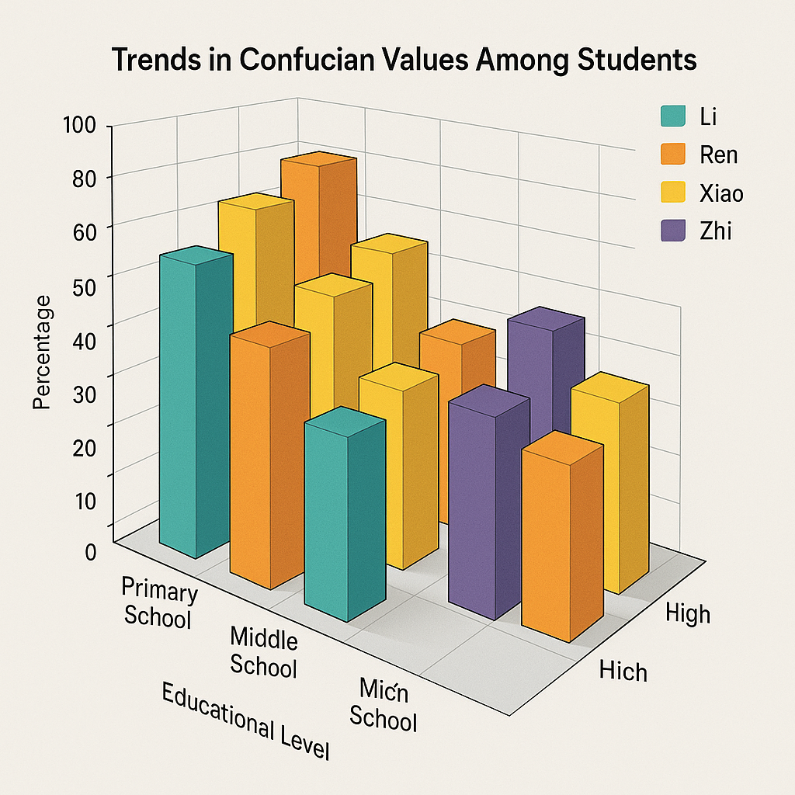

**Figure 2**: *Conceptual Model: AI-Enforced Rituals vs. Human-Centered Virtue Development*  
(Diagram comparing AI-driven behavioral enforcement with teacher-led moral reasoning)

**6. Cross-Cultural Challenges and Globalization**

As China's educational system becomes increasingly exposed to global influences, it faces a growing tension between traditional Confucian collectivism and Western individualism, especially in international and bilingual schools. Confucian values emphasize social harmony, respect for hierarchy, and prioritization of group welfare over personal ambition. In contrast, Western educational paradigms tend to promote individual agency, self-expression, critical inquiry, and egalitarian teacher-student relationships. This philosophical divergence can create pedagogical friction in international classrooms where Chinese students are encouraged to question authority or assert their opinions—behaviors that may contradict their cultural upbringing rooted in respect and humility. This tension is particularly evident in Chinese diaspora communities, where parents and community institutions attempt to preserve Confucian values in foreign educational environments. Weekend schools, heritage programs, and Confucius Institutes abroad often teach not only language but also core principles such as filial piety, modesty, and reverence for teachers and elders. However, children growing up in multicultural societies may experience identity conflict, caught between Confucian expectations at home and liberal-democratic values at school. Educators in diaspora settings face the complex task of mediating these cultural codes without alienating students from either identity system.

Globalization has also dramatically reshaped youth attitudes toward traditional Confucian values within China itself. Exposure to global media, Western social norms, and international educational content has fostered a generational shift in values. Young people are increasingly valuing personal freedom, emotional expression, and digital connectivity, sometimes at odds with Confucian ideals of restraint, duty, and intergenerational deference. This is evident in changing family dynamics, attitudes toward marriage and career, and shifting notions of success and morality. Despite this, Confucian values have not disappeared; rather, they are being negotiated and reinterpreted. For many Chinese youth, tradition and modernity coexist in hybrid forms: they may practice filial piety through digital means (e.g., messaging parents daily), or show group loyalty while asserting individual interests. Educators, both in China and abroad, are thus challenged to design culturally sensitive curricula that respect Confucian heritage while embracing the diverse, globalized identities of their students.

**7. Conclusion**

The revival and reinterpretation of Confucianism in modern Chinese education reflect a complex intersection of tradition, state policy, technology, and globalization. Once the moral foundation of imperial schooling, Confucian values such as Li, Ren, and Xiao are being selectively reintegrated into contemporary classrooms through national curricula, rituals, and even digital surveillance systems. These values continue to shape classroom discipline, teacher-student relationships, and the moral goals of education, offering a sense of cultural continuity and ethical structure in an era of rapid change. However, this reapplication of Confucianism is not without tension. In many cases, Confucian ideals are adapted in ways that emphasize outward behavioral conformity over inward moral cultivation—especially when enforced through artificial intelligence technologies. This raises important ethical questions about whether virtue can be programmed, or whether the use of AI risks reducing Confucianism to a tool of control devoid of its philosophical depth.

Furthermore, the globalized educational landscape challenges Confucian collectivism by introducing students to values of individualism, critical thinking, and pluralism. Whether in international schools within China or among Chinese diaspora communities abroad, educators and students alike must navigate the often contradictory demands of preserving cultural heritage while participating in a global knowledge economy. In conclusion, Confucianism remains a living tradition within Chinese education—but one that is constantly evolving. Its enduring presence lies not in rigid adherence to ancient practices, but in its adaptability and reinterpretation in response to modern needs. The future of Confucian education may well depend on the ability of teachers, policymakers, and communities to balance ethical continuity with pedagogical innovation—ensuring that Confucian values serve not only order, but also the development of thoughtful, humane, and globally conscious learners.

**References**

1. Elman, B. A. (2000). *A Cultural History of Civil Examinations in Late Imperial China*. University of California Press.
2. Lee, W. O. (1996). The cultural context for Chinese learners: Conceptions of learning in the Confucian tradition. In D. Watkins & J. Biggs (Eds.), *The Chinese Learner: Cultural, Psychological, and Contextual Influences* (pp. 25–41). CERC and ACER.
3. Tu, W. M. (1993). *Way, Learning, and Politics: Essays on the Confucian Intellectual*. State University of New York Press.
4. Yao, X. (2000). *An Introduction to Confucianism*. Cambridge University Press.
5. Bell, D. A. (2008). *China's New Confucianism: Politics and Everyday Life in a Changing Society*. Princeton University Press
6. Yang, R. (2007). China’s strategy for the international promotion of higher education: A case study of the Confucius Institute. *The Asia Pacific Journal of Education*, 27(2), 191–204.
7. Tan, C. (2012). The culture of education policy making: Curriculum reform in Shanghai. *Critical Studies in Education*, 53(2), 153–168.
8. Zhao, S. (2009). The ideology of Confucian revival in Chinese education. *International Education Studies*, 2(2), 57–63.
9. Li, J. (2005). Mind or virtue: Western and Chinese beliefs about learning. *Current Directions in Psychological Science*, 14(4), 190–194.
10. Chan, D., & Rao, N. (2010). The paradoxes revisited: The Chinese learner in changing educational contexts. In C. K. K. Chan & N. Rao (Eds.), *Revisiting the Chinese Learner* (pp. 315–349). Springer.
11. Feng, Y. (2020). Algorithmic discipline and the reconfiguration of moral education in China. *Global Media and China*, 5(2), 178–192.
12. Wang, Y. (2021). Digital Confucianism in Chinese smart education: A critical perspective. *International Journal of Educational Development*, 82, 102382.
13. Zhao, S. (2019). From Confucian values to AI surveillance: Education, control, and ethics in China. *Asia Pacific Journal of Education*, 39(4), 527–541.
14. Kim, T. (2016). Confucianism and the discourse of individual rights in East Asia. *International Journal of Educational Development*, 47, 44–52.  
    Liu, H. (2017). Chinese diaspora and the cultural politics of Confucian education. *Diaspora Studies*, 10(1), 34–50.
15. Zhang, W., & Bray, M. (2018). Confucianism and globalisation: A Chinese educational perspective. *Comparative Education*, 54(2), 207–223.