**The Role of Overseas Cultural Relics Exhibitions in Cultural Diplomacy and International Communication: A Case Study of the “Exhibition of Archaeological Finds of the People's Republic of China”**

Che Liu*, *Yang Su

School of Media and Communication, Shanghai Jiao Tong University, Shanghai, China

*Corresponding Email: cheliusjtu@outlook.com

**Abstract:** Overseas archaeological exhibitions can be seen as distinctive media for traditional Chinese cultural and artistic expressions. They would undertake the mission of “cultural diplomacy” especially during crucial historical periods. This article takes “the Exhibition of Archaeological Finds of the People's Republic of China” in the 1970s as a case study, which was the first exhibition of Chinese art to be presented to Western countries in the form of the overseas archaeological exhibitions. It will analyze how did China formulate a foreign art communication strategy and hold the overseas archaeological exhibitions before formally establishing diplomatic relations with Western countries. It will further explain the unique efficacy and significance of China's overseas archaeological exhibitions in the process of rebuilding diplomatic relations and cultural exchanges between China and the West. This case study might offer valuable insights for contemporary international alignment in the spheres of cultural and artistic communication as well as international museum programs.

**Key words:** The Exhibition of Archaeological Finds of the People's Republic of China; Cultural diplomacy; International communication

The cultural relics excavated in China are the crystallization of Chinese art, culture and history. As a significant avenue for international art dissemination, overseas exhibitions of cultural relics comprise artifacts embodying the essence of Chinese art across different periods, presented to foreign audiences through distinctive narrative approaches and “diplomatic protocols”. The overseas exhibitions of cultural relics hold significant research value in international communication and cultural diplomacy. Through excavated artistic masterpieces, they delineate the development and creativity of Chinese history and culture, disseminating Chinese civilization and art. These exhibitions present a “credible, amiable, and respectable” image of China, fulfilling the national mission of cultural diplomacy by promoting Chinese fine arts, culture, and history internationally. However, there is a notable lack of specialized studies focusing on the cultural diplomatic efficacy of overseas exhibitions of cultural relics. Few studies systematically interpret the contribution of these exhibitions to cultural diplomacy missions and international communication from the perspective of cultural diplomacy. There is a lack of adequate research and positioning regarding the “Exhibition of Archaeological Finds of the People's Republic of China”, which played significant roles in cultural diplomacy and the international communication during specific historical periods. Therefore, this article will focus on the period in the 1970s when China rebuilt diplomatic relations and restored cultural and artistic exchanges with Western countries. It will explore how these exhibitions “opened doors” of Western countries at the end of the Cold War, fulfilling China's historic mission of cultural diplomacy and the international communication.

**1. Exhibition Dates, Locations, and Content**

The 1970s was a historical juncture when China and Western countries changed from adversarial relations to friendly development, and also a period of changes and turbulence, opportunities and challenges in international relations. Influenced by the Cold War context, the international relations between the People's Republic of China (PRC) and Western countries had been consistently hostile before this period. During the period of international relations transformation, the initial establishment of diplomatic relations between China and Western nations in the 1970s did not commence with state diplomacy but rather through cultural diplomacy. A pivotal initiative in this regard was the inaugural overseas exhibition of Chinese archaeological artifacts in Western countries, known as “the Exhibition of Archaeological Finds of the People's Republic of China”. From 1973 to 1978, “the Exhibition of Archaeological Finds of the People's Republic of China” toured 14 countries and regions for a total of 16 times. The countries (regions) where the exhibitions were held were mostly Western nations with little or no cultural exchange with China at that time. These exhibitions caused a tremendous sensation in the host countries (Figures 1, 2, 3), attracting a total of 6.543 million visitors and breaking attendance records set by museums in countries such as the UK and the USA. Specific details are provided in the table below (Table 1):

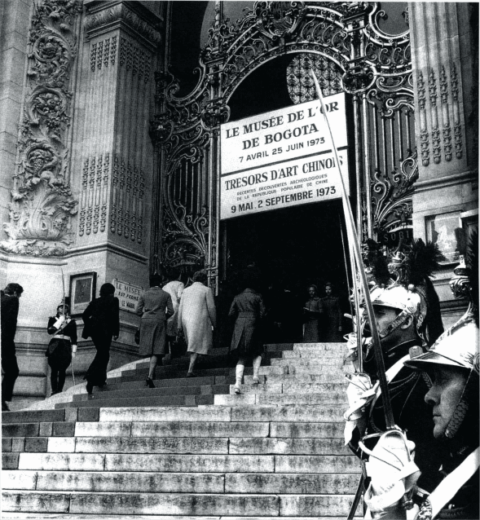

Figure 1. Visitors entering the Petit Palais during the exhibition in France

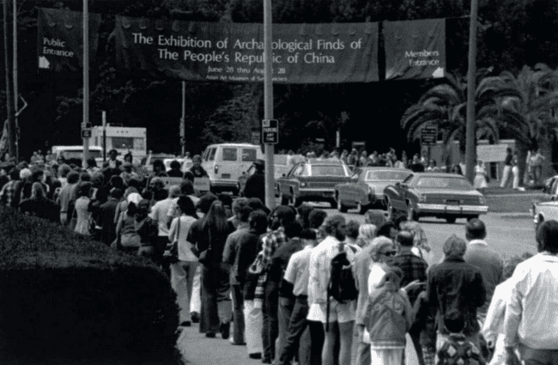

Figure 2. Visitors lining up at the entrance of the Asian Art Museum in San Francisco during the exhibition in the United States

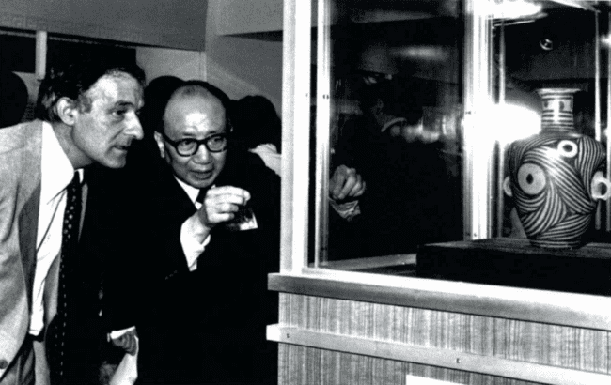

Figure 3. Visitors viewing the exhibition

Table 1: Exhibition date and country (region) of the “Exhibition of Archaeological Finds of the People's Republic of China”[1]

|  |  |  |  |  |
| --- | --- | --- | --- | --- |
| Number | Exhibition Period | Nation  (region) | Host **Institution/Place** | Audience (in thousands) |
| 1 | 1973.5.8～9.2 | France | Petit Palais | 365 |
| 2 | 1973.6.9～9.30 | Japan | Tokyo National Museum, Kyoto National Museum | 530 |
| 3 | 1973.9.28～1974.1.23 | Britain | Royal College of Art, London | 771 |
| 4 | 1973.12.28～1974.2.28 | Romania | Bucharest National Museum of Art | 100 |
| 5 | 1974.2.21～4.20 | Austria | Austrian Museum of Arts and crafts, Vienna | 240 |
| 6 | 1974.4.3~6.2 | Former Yugoslavia | Belgrade people's Museum | 70 |
| 7 | 1974.5.12～7.16 | Sweden | Stockholm National Far East Antiquities Museum | 194 |
| 8 | 1974.7.5～10.3 | Mexico | National Museum of Anthropology of Mexico | 150 |
| 9 | 1974.8.8～11.16 | Canada | Royal Ontario Museum, Toronto | 228 |
| 10 | 1974.12.4～1975.1.26 | Netherlands | Amsterdam National Museum | 115 |
| 11 | 1974.12.13～1975.8.28 | America | National Gallery of Art in Washington, Nelson Museum of Art (Kansas), Asian Art Museum in San Francisco | 1800 |
| 12 | 1975.2.19～4.6 | Belgium | Brussels Palace of Art | 100 |
| 13 | 1976.10.1～1977.1.1 | Philippine | Manila legislative building | 800 |
| 14 | 1977.1.19～6.29 | Australia | Victoria Museum in Melbourne, New South Wales Art Museum in Sydney, South Australia Art Museum in Adelaide | 500 |
| 15 | 1977.10.2～1978.2.26 | Japan | Nagoya Museum, Kitakyushu Municipal Art Museum, Tokyo Xiwu Art Museum | 320 |
| 16 | 1978.4.18～6.11 | Hong Kong, China (British rule period) | China Export Commodities Exhibition Hall (Star walk, Tsim Sha Tsui, Kowloon) | 260 |
|  | Total |  |  | 6543 |

Since 1971, to meet the enthusiastic expectations and invitations from multiple countries including Europe, America, and Japan, Premier Zhou Enlai (1898–1976), along with Yu Zhan (1921–1992, then Vice Minister of Foreign Affairs) and Wang Yeqiu (1907–1987, Director of the State Administration of Cultural Heritage), discussed, planned, and selected two proposals and two sets of exhibits for the “Exhibition of Archaeological Finds of the People's Republic of China” , aiming to enable simultaneous exhibitions in two countries. Including excavated artifacts, related replicas, and supporting exhibits, the first set comprised 385 items, exhibited sequentially in France, the UK, Austria, Switzerland, Canada, and the USA. The second set, initially consisting of 236 items (later reduced to 221 after its debut in Japan), was shown in Japan, Romania, former Yugoslavia, Mexico, the Netherlands, and Belgium. Subsequently, adjustments were made to both sets based on specific demands, with exhibitions held sequentially in the Philippines (100 items), Australia (257 items), Japan (101 items), and Hong Kong (136 items). Throughout the touring exhibitions, newly excavated Chinese archaeological discoveries, including the Terracotta Warriors and Horses of the First Emperor of Qin, were incorporated into the displays. Despite variations in exhibits, both exhibitions followed a consistent overall framework, arranged chronologically from the Paleolithic Era to the Ming Dynasty. The exhibition is divided into three sections based on the prevailing stages of social development at the time: Primitive Society (60,0000 BCE—4000 BCE), Slave Society (21st century BCE—475 BCE), and Feudal Society (475 BCE—1840 CE)[2].In the later stages of the exhibition, new academic research findings were incorporated, and the chronological division of the first section, Primitive Society, was adjusted to span from 1.7 million years ago to 4000 BCE[3]。Each section and dynasty is represented by significant excavated artifacts, including the reconstructed head of Peking Man, the prehistoric Yangshao culture “Painted pottery basin with human-mask and fish design”, the Shang Dynasty “Elephant-shaped bronze zun (wine vessel)”, the Spring and Autumn period “Square bronze hu (wine vessel) by Zeng Zhongfu”, the Warring States period “Bronze dou (food vessel) with kui-dragon design inlaid with gold”, the Qin Dynasty “Pottery figure of a bowman,” the Western Han Dynasty “Jade suit sewn with gold thread (and jade head-rest)” (Figure 4) and “Jade suit sewn with silver thread,” the Eastern Han Dynasty “Bronze galloping horse”, the Wei and Jin periods “Tomb brick with hunting scene”, the Tang Dynasty “Tri-colour pottery horse” and “Tri-colour pottery horse and groom”, the Song Dynasty “Ding Kiln Carved Long-neck Porcelain Vase”, and the Yuan Dynasty “Blue and white porcelain plate with double-fish and lotus pond design”. Among the most notable artifacts are the “Jade suit sewn with gold thread” from the Mancheng Han Tomb, the “Jade suit sewn with silver thread” from the Xuzhou Tushan Han Tomb, the “Galloping Horse Treading on a Flying Swallow” (also known as the “Bronze galloping horse”) from Leitai, Wuwei in Gansu, and the recently excavated Terracotta Warriors from Lintong, Shaanxi. In addition, some ancient artworks that were difficult to transport overseas were reproduced by an art group consisting of artists such as Chen Dazhang. These reproductions included works like the “Court ladies on wall painting in Tomb of Princess Yungtai (copy)2”, allowing the “Exhibition of Archaeological Finds of the People's Republic of China” to showcase achievements in various major aspects of ancient Chinese art as revealed by archaeological discoveries.

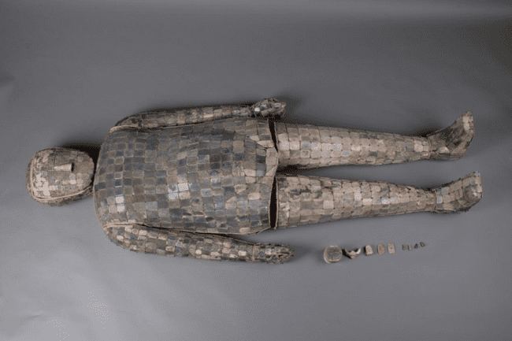

Figure 4. "Jade Suit Sewn with Gold Thread" (Length: 182 cm, Shoulder Width: 52 cm) from the Western Han Dynasty, Henan Museum Note: Excavated in 1985 from Tomb No. 1 at Xishan, Yongcheng, Shangqiu, Henan Province. The jade suit is composed of sections for the head, torso, arms, hands, legs, and feet, with two additional triangular arm ornaments. The body had decayed by the time of excavation, and the jade suit was flattened by soil pressure.

**2. Cultural Diplomacy Mission of the Exhibition**

The Battle of Zhenbao Island in 1969 became a turning point for Sino-Soviet relations[4], and also a turning point for diplomatic relations between China and Western capitalist countries including the United Kingdom. The Sino-Soviet border issue has always been an unsolved historical issue between the two countries. In the early days of the founding of the People's Republic of China, Sino-Soviet relations were close, and the border issue was naturally shelved. However, in the late 1950s, Chinese and Soviet parties had fundamental differences on policies, and finally the two sides fought in the Zhenbao Island area on the Sino-Soviet border on March 2, 1969[5] . The international situation has also changed along with the Sino-Soviet relations. The Sino-Soviet border conflict in 1969 and the subsequent nuclear threat from the Soviet Union made China deeply aware of the seriousness of the national security problem[6], and also China began to question the hostile attitude of Western capitalist countries in diplomacy. During this period, driven by the mutual imperative to counter the Soviet Union, China and Western countries such as the United Kingdom and the United States discreetly conveyed gestures of amity toward each other.On November 11, 1971, with the support of European countries headed by Britain and France, China regained its seat in the United Nations. From a historical perspective, countries that have not established diplomatic relations or have been diplomatically hostile typically undergo multiple phases of testing before achieving formal diplomatic recognition. Throughout this process, the manner, extent, and response to the release of friendly signals significantly influence the development of these relationships. In the case of China, cultural diplomacy marked the beginning of friendly exchanges between China and Western countries. Prior to the “Exhibition of Archaeological Finds of the People's Republic of China” tour in Western countries, the groundbreaking sports diplomacy event of 1971, known as “ping-pong diplomacy” between China and Western nations like the United States, served as a prelude to easing tensions and subsequent cultural diplomacy efforts[7]. The Chinese table tennis team's visits to the United States and the United Kingdom facilitated the improvement of Sino-British relations and laid the groundwork for U.S. President Richard Nixon's (1913—1994) visit to China in February 1972[8]. The following month, China and the United Kingdom formally established diplomatic relations[9]. Additionally, in September of the same year, the governments of China and Japan issued a joint statement on the normalization of diplomatic relations. This period can be seen as the first peak in China's restoration and establishment of diplomatic relations with non-socialist Western countries[10]. Through interactions with the Western world, which had different ideologies, China gradually underwent a transformation in its diplomatic policy8, gaining initial recognition of Western interest in international cultural communication, and laying a feasible international political environment for the “Exhibition of Archaeological Finds of the People's Republic of China”.

The changing international situation has led to a new pattern of interests, transforming the attitudes between the Chinese government and Western governments from hostility to friendship. The international political landscape is rapidly evolving towards multidimensional exchanges and cooperation between China and the West. Cultural diplomacy has become one of the significant forms of diplomacy during this epoch-making period. Western interest in Chinese history, culture, and art has been longstanding. In the 1970s, leaders such as Nixon, Tanaka Kakuei (1918-1993), Heath, and Georges Jean Pompidou(1911-1974) from the United States, Japan, United Kingdom, and France respectively, visited the Forbidden City and the Great Wall during their visits to China. They appreciated China's traditional cultural and artistic relics, not only conveying a friendly gesture to the Chinese government and people, but also further enhancing Western public interest in Chinese culture and art.At this time, China's diplomatic policy had already begun to shift from party-based diplomacy rooted in ideological considerations to government-led diplomacy emphasizing national interests. The government started promoting cultural interactions and exchanges between nations, while domestic political changes further facilitated this development trend[11]. From a practical standpoint, with changes in international relations and a deeper understanding of the efficacy of “cultural diplomacy”, the Chinese government has shifted its diplomatic policy towards Western countries from confrontation to dialogue and cooperation. Diplomacy has become more astute and flexible, with diplomatic strategies transitioning from passive to proactive.Driven by the keen interest shown by leaders and the public from various countries in Chinese archaeological artifacts during their visits to China, the concept of “cultural relic diplomacy” emerged, prompting plans to organize exhibitions of Chinese excavated cultural relics in Western countries.

Hosting high-level overseas exhibitions of cultural relics requires professional expertise. Premier Zhou Enlai and other national leaders, with Premier Zhou Enlai at the core, keenly perceived the changes in international political dynamics during this period and the necessity and urgency of cultural diplomacy. They decisively removed political interference of the time, rehabilitated archaeologists and art experts who had been labeled as counter-revolutionaries or capitalist roaders during the Cultural Revolution, and began preparations to establish the Exhibition Committee for the “Exhibition of Archaeological Finds of the People's Republic of China”. In July 1971, Premier Zhou Enlai approved Guo Moruo's(1892-1978, then President of the Chinese Academy of Sciences) “Report on Organizing the Exhibition of Cultural Relics Abroad and Establishing a Preparatory Team”, and immediately established a preparatory team with Wu Qingtong (1924—2016), Deputy Secretary-General of the State Council as the team leader, Wang Yeqiu as the deputy team leader, Xia Nai (1910—1985) and Wang Zhongshu (1925—2015) as members2. In August, the central government issued the “Notice of the State Council on Selecting and Sending Excavated Cultural Relics to Foreign Exhibitions” (hereafter refers to as the “Notice”) to provinces, municipalities, and autonomous regions nationwide. The “Notice” was also copied to several departments, including the General Office of the Central Committee, the Central Military Commission, the Cultural Group of the State Council, the Ministry of Foreign Affairs, the Chinese Academy of Sciences, and cultural and historical institutions such as the Chinese Revolutionary Museum, the Chinese History Museum, the Palace Museum, the Beijing Library, the Cultural Relics Publishing House, and the Institute of Cultural Relics Protection. From then on, under the coordinated leadership of Premier Zhou Enlai, preparations for the “Exhibition of Archaeological Finds of the People's Republic of China” rapidly commenced.

On May 8, 1973, the first exhibition of Chinese excavated cultural relics in a Western country, known as the “Exhibition of Archaeological Finds of the People's Republic of China”, was held as scheduled at the Petit Palais in Paris, France. Michel Jobert (1921–2002), the French Minister of Foreign Affairs, and Maurice Druon(1918–2009), the Minister of Culture, were among the dignitaries who attended the celebration. Guo Moruo provided the inscription for the exhibition, and Wang Yeqiu led the delegation at the opening ceremony. On June 9, another set of exhibits from the “Exhibition of Archaeological Finds of the People's Republic of China” opened at the Tokyo National Museum in Japan. Japanese Prime Minister Kakuei Tanaka attended the opening ceremony and delivered a speech, accompanied by key officials and private individuals, including Kenzo Nakashima (1903–1979), President of the Japan-China Cultural Exchange Association. After concluding its display at the Tokyo National Museum on July 29, the “Exhibition of Archaeological Finds of the People's Republic of China” continued its exhibition at the Kyoto National Museum from August 11 to September 30. Subsequently, these two exhibitions, along with additions of excavated relics over five years, embarked on an international tour, showcasing over 500 essential artifacts excavated since the founding of the People's Republic of China to Western scholars and audiences for the first time. Despite the different exhibits at each venue, audiences across countries showed consistent enthusiasm, resulting in active attendance, positive media coverage, and deepened Western appreciation and understanding of Chinese culture and art. The “Exhibition of Archaeological Finds of the People's Republic of China” achieved tremendous success (Figure 5).

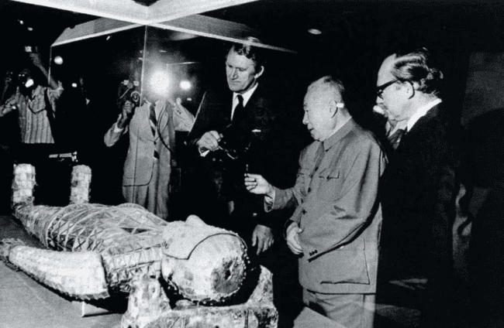

Figure 5. During the Exhibition of Archaeological Finds of the People's Republic of China" in Australia(January to June 1977), Wang Yeqiu introduces the exhibits to Australian Prime Minister Fraser.

1. **International Communication and Cultural Diplomacy Strategies**

In the 1970s, after more than 20 years of severed diplomatic ties between China and Western countries, there was a strong curiosity and eagerness among Western populations to learn about traditional Chinese culture and art. Exhibitions showcasing excavated artifacts, which were low in political connotations yet demonstrated the creative prowess of ancient Chinese art, became the most welcomed form of cultural and artistic exchange. Under the leadership of Premier Zhou Enlai, the exhibition committee's team of experts developed a series of criteria for selecting exhibits. Apart from the artistic and historical value of the artifacts themselves, the criteria for selecting these artifacts inevitably revolved around the objectives of cultural diplomacy. The multifaceted considerations for selecting exhibits fully reflected the cultural diplomacy and international communication strategies of that time.

Firstly, the “Exhibition of Archaeological Finds of the People's Republic of China” serves a dual mission of cultural diplomacy and external communication. Among these, the artistic quality of the excavated artifacts is fundamental to its external communication efforts and forms the foundational appeal of the exhibition. The broader significance and value beyond the aesthetics of the exhibition only become effective when the artistic merit of the exhibits themselves remains notably high[12]. Therefore, to fulfill its critical mission of external communication, high aesthetic value becomes a crucial criterion for selecting exhibits. In the “Notice”, the second item states, “Selected artifacts should... possess significant historical, artistic, scientific, and other values, with exquisite shape, patterns, and prominent colors”. The first part articulates the requirements for the content of the artifacts, while the latter part emphasizes the visual qualities, reflecting the State Council's criteria for selecting artifacts based on their artistic aspects. Based on the distinctive aesthetic characteristics of Chinese art, showcasing artifacts with beautiful “shape, patterns, and colors” is essential to effectively attract viewers and provide a strong visual impact to Western audiences, in order to achieve the purpose of international communication. This was highly suitable for the needs of China during that period. In the early years of the People's Republic of China, there was significant isolation between Chinese and Western populations. Moreover, some Western media outlets with ulterior motives consistently provided one-sided coverage, making it difficult for many Westerners to objectively and comprehensively understand New China[13]. However, after visiting the exhibition, a British visitor wrote in the exhibition guestbook: “I have never been to China, nor do I understand China. In the past, I only knew a little about China through newspapers and magazines, which portrayed a terrifying image of poverty and backwardness, labeling it as 'the sick man of East Asia'. Now, it seems that newspapers and magazines are unreliable, and I trust everything presented in today's exhibition”13. It shows the profound impact of oversea relic exhibitions on international communication effectiveness and national image.

The consideration of aesthetic standards is also evident in the “Report on the Preparation of Chinese Excavated Cultural Relics Exhibition for Display in France”, which states, “The exhibits primarily depict the long history and culture of our Chinese nation, the wisdom and creativity of the working people.” The report clearly shows that the leaders deeply understand the impact and significance of artistic exhibitions in Western countries, emphasizing that the theme of the exhibition is the long history and culture of the Chinese nation, as well as the wisdom and creativity of the working people, which is a true reflection of the political atmosphere and context at that time. The use of the term “working people” reflected the ideological opposition between China and Western countries at that time, characterized by a lack of positive communication. Emphasizing “working people” not only reflected the Marxist position but also helped avoid internal political resistance during the exhibition preparations. After the founding of People's Republic of China, Western countries adopted policies of political non-recognition, economic blockade, and military encirclement against it. On October 3, 1949, the United States announced its continued recognition of the Kuomintang government and encouraged other countries such as those in North Atlantic Treaty Organization and Latin America to follow suit in not recognizing New China. Concurrently, the United States manipulated the United Nations to obstruct China from obtaining a legitimate seat, imposed trade and export controls on China, and enforced an economic blockade. Additionally, military alliances targeting China were formed with neighboring countries and regions such as Japan and the Philippines, creating a military encirclement. In this complex and hostile international environment, China sought international recognition, promoted the long history and culture of the Chinese nation, which supported China's legitimacy and continuity, and aimed to break through political blockades.

In addition to aesthetic considerations of the exhibits themselves, although the artifacts rarely carry political connotations, the selection of exhibits involves political considerations regarding international public opinion. The “Notice” elaborates on the purposes of organizing an exhibition of excavated cultural relics from the People's Republic of China: firstly, to promote the great achievements of the “proletarian cultural revolution”; secondly, “to enhance cultural exchanges and friendly interactions between our country and peoples of various countries around the world”. Furthermore, the “notice” mentions the “Cultural Revolution” that took place from 1966 to 1976 on two occasions, emphasizing that selecting relics excavated during this period illustrates China's political, strategic, and targeted approach to international art exhibitions and dissemination. From the perspective of exhibition audience, the age of cultural relics is a significant criterion for assessing their artistic and historical value, but the time when artifacts were excavated does not directly correlate with their artistic value. However, from a political standpoint, selecting artifacts excavated after the founding of the People's Republic of China and during the Cultural Revolution aims to showcase the importance placed on cultural endeavors during these periods. Using physical evidence and excavated artifacts to respond to international public opinion is a direct manifestation of the international dissemination of overseas cultural exhibitions. One overseas Chinese visitor commented after viewing the exhibition, “in the past, newspapers said that Chinese revolutionaries disregarded ancient culture and destroyed cultural relics. Today's exhibition proves the tremendous efforts made by the Chinese Communist Party to protect cultural relics”.13 This approach not only upholds the national image of New China but also reaffirms the concept of the People's Republic of China on the international stages.

The international communication of exhibitions extends beyond the dissemination of Chinese culture and art. Under the theme of cultural diplomacy, it also proclaims China's territorial sovereignty and diplomatic principles by selecting the excavation sites of the exhibits. The fourth paragraph in the text of the “Report” mentions that “29 provinces, municipalities and autonomous regions have exhibits, the most is Shaanxi Province with 80 exhibits, the least is Inner Mongolia Autonomous Region with one exhibit, and Taiwan Province with two exhibits, two exhibits from the Tibet Autonomous Region, and two exhibits from the Zhenbao Island area.” In this report, it specially emphasized on “Taiwan Province” and “Tibet Autonomous Region” which PRC has always hoped to be recognized by the international community, especially Western countries, as PRC part. Firstly, the report specifically highlights the “Zhenbao Island area,” “Taiwan Province,” and “Tibet Autonomous Region” in parallel, utilizing the regional origins of the exhibits to proclaim territorial sovereignty. This approach employs exhibitions to reflect China's territorial boundaries and reaffirm diplomatic principles. Through this strategy of regional narrative communication, Western audiences are made aware of China's territorial sovereignty concept while appreciating Chinese fine arts. The two exhibits from “Zhenbao Island” illustrate China's stance on sovereignty in that region. Meanwhile, “Taiwan Province” and the “Tibet Autonomous Region” have been ongoing hotspots in international discourse since the founding of the People's Republic of China, continually provoked and highlighted by capitalist Western nations. Using the excavation sites of exhibits to assert China's territorial sovereignty is a strategic and deliberate cultural diplomacy tactic, demonstrating a sophisticated and tactical approach to international communication. By selecting artifacts excavated from these regions and displaying them in the “Exhibition of Archaeological Finds of the People's Republic of China”, integrated within a unified narrative framework of China's five-thousand-year history, visiting Western leaders and audiences are made cognizant of China's historical boundaries and the significance of these archaeological discoveries in Chinese cultural and art history. The exhibition's portrayal of cultural and historical continuity functions akin to a diplomatic assertion affirming that “these regions have historically been integral parts of China”. Utilizing excavated artifacts as historical evidence reinforces China's sovereignty, promotes the principle of unity among diverse ethnic groups, and embraces the concept of a multicultural and inclusive society. This underscores the substantial value of overseas cultural exhibitions in cultural diplomacy.

International communication and cultural diplomacy are bidirectional. As the initiator of the exhibition, China has a greater volume and more dimensions of information transmission. Western countries, as the hosts of the exhibition, incorporate common exhibition elements of cultural diplomacy and international communication in the political interactions, speeches, and forewords of the “the Exhibition of Archaeological Finds of the People's Republic of China”. In the forewords of the exhibitions and the greetings from dignitaries, there is sincere gratitude to the Chinese people and government for generously lending the cultural relics for their citizens to appreciate, with some explicitly mentioning the friendship between the two countries[14][15]. In the exhibition greetings from various organizations in Japan, including the Tokyo National Museum, the Kyoto National Museum, the Japan-China Cultural Exchange Association, and the Asahi Shimbun, it is explicitly stated, “this exhibition reaffirms the close two-thousand-year history between the two countries and hopes to serve as a new starting point for future friendship and mutual understanding.” Tanaka Kakuei expressed in his congratulatory remarks, “China's outstanding culture has continuously exerted a profound influence on Japan... I sincerely respect the extraordinary care and goodwill of the Chinese government,” and “I sincerely hope that Sino-Japanese friendship will further develop and deepen in the future.” Chinese Ambassador to Japan, Chen Chu emphasized at the end of his greetings, “through this exhibition, it will definitely add new brilliance to the traditional friendship and cultural exchanges between the people of China and Japan”[16]. All three emphasized at the beginning of their remarks that “the Exhibition of Archaeological Finds of the People's Republic of China” commemorates the normalization of Sino-Japanese relations. The preface by the Ministry of Foreign Affairs also underscores the significance of this exhibition for bilateral friendship. Using these statements as examples, the host countries have clearly indicated their hope that exhibitions focused on cultural and artistic exchanges will enhance bilateral relations and friendship between the two countries, thus demonstrating the cultural diplomatic significance carried by exhibitions of relics.

1. **Political Interaction -- the Exhibition in the UK**

The British government's attention and support for “the Exhibition of Archaeological Finds of the People's Republic of China” provided an appropriate political environment that facilitated its timely realization and unprecedented success. However, from the perspective of the exhibition's planning process, the actions of the British government constituted an interaction of diplomatic and cultural exchanges between China and the UK. According to a statement from the Embassy of the People's Republic of China in the United Kingdom, Britain and China established temporary chargé d'affaires-level diplomatic relations on June 17, 1954. Until the year before the exhibition, on March 13, 1972, China and the UK established diplomatic relations, upgrading their diplomatic relations to the ambassadorial level. The British government acknowledged the position of the Chinese government that Taiwan is a province of the People's Republic of China and decided to withdraw its official representative office from Taiwan[17]. In October of the same year, the British Foreign Secretary made his first visit to China. The following year, Foreign Minister Ji Pengfei (1910-2000) made a return visit to the UK[18]. The transformation of Sino-British political relations from long-term hostility and estrangement towards friendship is not only a natural outcome of the changes in the international landscape[19] but also serves as the political foundation for initiating cultural and artistic exchanges between the two nations.

The United Kingdom became the second country, following France, to host the first set of exhibits (385 items) of the “Exhibition of Archaeological Finds of the People's Republic of China”. On September 2, 1973, after the closure of the exhibition at the Paris City Museum, the Chinese exhibition delegation needed to transport the artifacts from Paris airport to London, United Kingdom. On September 26, 1973, Wang Yeqiu, the head of the Cultural Relics Bureau of the Chinese Ministry of Culture, led the exhibition delegation to London. Senior officials from the UK's Foreign and Commonwealth Office and Central Office of Information warmly received them at the airport[20]. The following day, British Prime Minister Edward Heath broke usual diplomatic protocol by personally meeting the members of the Chinese delegation at the exhibition site. Through the joint efforts of Chinese and British staff, “the Exhibition of Archaeological Finds of the People's Republic of China” opened on September 28 at the Royal Academy in London, with Prime Minister Heath presiding over the opening ceremony. In the opening speech, Heath was stated, “the British government warmly welcomes the significant improvement in relations with the Chinese government” (Figure 6). Queen Elizabeth II also visited the exhibition accompanied by Chinese officials20 (Figure 7). On October 11, 1973, the British Ambassador to China bid farewell to the exhibition delegation.

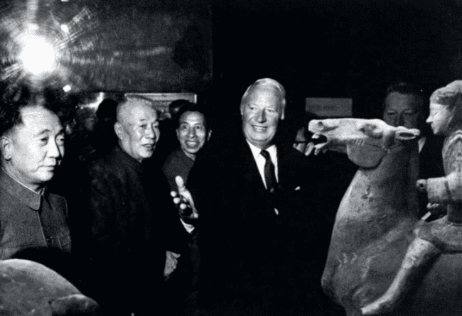

Figure 6. From September 1973 to January 1974, during the "Exhibition of Archaeological Finds of the People's Republic of China" at the Royal Academy of Arts in London, Wang Yeqiu accompanied British Prime Minister Heath on a tour of the exhibition.

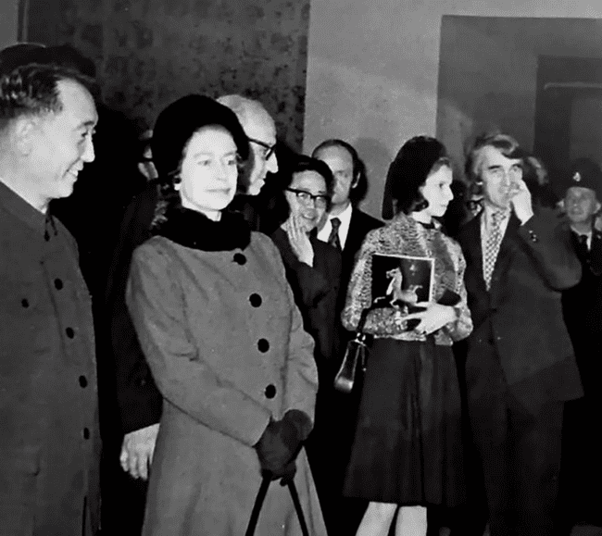

Figure 7. On November 8, 1973, Queen Elizabeth II of the United Kingdom visited the "Exhibition of Archaeological Finds of the People's Republic of China", accompanied by Chinese Ambassador to the UK, Song Zhiguang, among others.

“The Exhibition of Archaeological Finds of the People's Republic of China” in London closes with over 770,000 visitors, breaking all records for art exhibitions held in London. The Chinese Ambassador to the UK, the Chairman of The Times, and over 200 ambassadors and other diplomats from more than 60 countries were invited to visit the exhibition. On the evening of January 21, 1974, the Chinese Ambassador to the UK, Mr. Song Zhiguang (1916-2005), hosted a banquet for the exhibition. Mrs. Margaret Hilda Thatcher (1925-2013), who was then the Minister of Education and Science and later became the Prime Minister of the United Kingdom, attended the event upon invitation. During this period, driven by a “profits-first” diplomatic policy towards China[21], the British government enthusiastically utilized “the Exhibition of Archaeological Finds of the People's Republic of China” as a platform to convey a friendly diplomatic stance towards China. This largely aligned with China's cultural diplomacy intentions, achieving a mutually beneficial diplomatic objective. Other aspects of bilateral engagement also increased during this time, such as the record-breaking trade total of $632.16 million USD in 1973, rising to $725.87 million USD in 197419. Therefore, “the Exhibition of Archaeological Finds of the People's Republic of China” serves as an international communication approach and a cultural diplomacy initiative for China and an opportunity for Western countries to express political attitudes.

1. **Conclusion**

Through a synthesis of historical facts and analysis, it becomes evident that during the Cold War era, the emergence of new national interests and the diplomatic needs of both China and the West, driven by shifts in international relations, were the primary reasons behind the initiation and staging of the “Exhibition of Archaeological Finds of the People's Republic of China”. Under the guidance of Premier Zhou Enlai, archaeologists and cultural heritage professionals overcame the challenges of organizing overseas exhibitions of cultural relics during the sensitive period, adhering to specific standards to meticulously select nationally excavated artifacts within a limited time frame, emphasized the novelty and artistic merit of archaeological discoveries and efficiently completed the exhibition planning, leading to unprecedented success and profound impact in Western countries. This effort deepened scholarly and public understanding of Chinese art, culture, and history, and played a crucial role in international communication. The archaeological artifacts possess credible chronological parameters and accompanying rich information, providing scientific foundations for the identification and in-depth study of Chinese art collections in Western museums, holding significant importance for advancing the study of Chinese art overseas, thereby expanding the global influence of Chinese cultural arts and promoting China's outstanding traditional culture.

In the political context of that time, this series of traveling exhibitions skillfully utilized the artifacts and exhibition structure to showcase the diplomatic principles and political stance of the Chinese government. It responded to international public opinion while preserving the national image, asserted territorial sovereignty while conveying a pursuit of peace, and harnessed the valuable soft power of Chinese cultural arts. This approach garnered exceptionally warm diplomatic responses from Western countries, helping China to break through diplomatic isolation during a challenging period and accelerate its international relations into a new phase. In the process of rebuilding diplomatic and cultural exchanges between China and Western countries, the historical significance of the “Exhibition of Archaeological Finds of the People's Republic of China” cannot be ignored. This exhibition not only pioneered the hosting of overseas cultural relic exhibitions in Western countries but also made significant contributions to cultural diplomacy for China and a exemplar for international communication for world.

**Reference:**

1. China Cultural Relics Exchange Center, ed. (2011). Glorious Mission: Forty Years of Chinese Cultural Relics Exchange. Beijing: Cultural Relics Publishing House. 1-29,33.
2. Exhibition Committee of the Exhibition of Archaeological Finds of the People's Republic of China (Ed.). (1976). Selected Relics Excavated in the People's Republic of China. Cultural Relics Publishing House.
3. Huang, M. (Ed.). (1978). The Exhibition of Archaeological Finds of the People's Republic of China(2nd ed.). The Committee for the Exhibition of Archaeological Finds in China Hong Kong.
4. Tagirova, A. (2023). Constructing a "border" with China: The Russian approach. Asian Perspective, 47(3), 371-392.
5. Editorial Office of China Military Encyclopedia(Ed.). (2007). Encyclopedia of China · Military affairs (2nd Edition). Beijing: Encyclopedia of China Publishing House.
6. Cho, H.-B. (2021). *Nuclear coercion, crisis bargaining, and the Sino-Soviet border conflict of 1969*. Security Studies, 30(4), 550-577.
7. Crean, J. (2021). A new sphere of influence: Table tennis diplomacy and the National Committee on U.S.-China relations. Journal of American-East Asian Relations, 28(2), 109-132.
8. Harper, J. L. (2022). *Nixon in China, February 1972: Revisiting the “week that changed the world.”* Survival, 64(2), 45–51.
9. Embassy of the People's Republic of China in the United Kingdom of Great Britain and Northern Ireland. (2023, September 25). Overview on China-UK Relations. Retrieved from <http://gb.china-embassy.gov.cn/eng/ChinaUKRelations/introduction/>
10. Möller, K. (2002). *Diplomatic relations and mutual strategic perceptions: China and the European Union.* The China Quarterly, 169, 10–32.
11. Chan, S.-K. (2024). *Relics and rapprochement: The intricacies of cultural diplomacy in China’s first archaeological exhibition in the U.S. during the Cold War era.* Museum History Journal, 17, 76–94.
12. Balfe, J. H. (1987). *Artworks as Symbols in International Politics.* International Journal of Politics, Culture, and Society, 1, 5-27.
13. Wang Fuguo. (1995). The Exhibition of Archaeological Finds of the People’s Republic of China in the United Kingdom. Jianghan Archaeology, 1, 89-91.
14. Watson, W. (1973). An exhibition of archaeological finds of the People’s Republic of China. Westerham: Westerham Press, 7, 1-6.
15. Anderson, R. A. (1975). The Chinese Exhibition. Missouri: Burd & Fletcher, 7, 8-24.
16. Fujita, K. & Kuwahara, S. (1973). Exhibition Catalog of Excavated Artifacts from the People's Republic of China. Asahi Shimbun Tokyo Head Office Planning Department, 3-7, 10-19.
17. Liff, A. P., & Lin, D. (2022). *The “One China” framework at 50 (1972–2022): The myth of “consensus” and its evolving policy significance.* The China Quarterly, 252, 978.
18. He, M. (2021). The process of Sino-British comprehensive diplomatic relations. Century Tide, 2021(5), 71-76.
19. Wang, H. (1999). Sino-British economic and trade relations during the Mao Zedong era. Central Party School of the Communist Party of China, 20-25.
20. Court Circular. (1973, September 29). *Luncheon.*The Times, 14.
21. Xu, F. (2020). The Tension Between Interests and Identity: A Study on Britain's China Policy During the “Golden Era”：(PhD dissertation). China Foreign Affairs University. 6-20.